Lexical and Syntactic Errors in the Written English Text Uploads and Comments of Nigerian Facebook Users

Abstract
Errors are part of learning as they could be precursors to a full mastery but they become bad when they are left uncorrected. This also applies to language learning and using a second language like the English language. If errors in the process of learning and using the English language are left uncorrected, they could lead to a breakdown in communication. It is on this basis therefor that this study pays attention to the lexical and syntactic errors of Nigerian Facebook text uploads. This study is done in order to unravel these common errors and proffer solutions by correcting them through re-writing them. The study extracted ten (10) Facebook posts of Nigerians and marked the lexical and syntactic errors in them for analysis and correction. At the end, the study presents amongst other findings that most Nigerian Facebook users do not care so much about applying punctuation marks especially the full stop in their posts and that there is a high level of spelling errors emerging from two causes; the first being the auto correct feature in most mobile devices and the hastiness, laziness or laxity on the part of the users to edit before posting.
Keyword: errors, lexical, syntactic, ESL, Facebook posts.
Introduction
It is a common knowledge amongst teachers, especially, language teachers that errors in the process of learning should not been seen as a totally bad idea as it could be a precursor to a full mastery. In the learning of the English language, errors are permitted before a better mastery. According to Brown (2000), ‘learning how to swim, play Badminton or how to walk for a baby involves mistakes, but from these mistakes feedback is received and they learn the correct way’ (53). That is why in learning, mistakes are not seen as negative because ‘making mistakes are important parts of learning (Williams & Burdens, 1997, p.11). Mistakes, therefore, should be seen as positive signs of learning and an essential part of learning (cf: Sanal, 2007; Norrish, 1983 & Kavaliauskiene, 2003).
However, these errors are capable of causing communication break down and wrong interpretations just as falling down for a baby learning to walk would stop the movement and cause pains at least at that material time. So, the attention should be how to walk better and for a second language user, how to communicate better. One medium most Nigerians especially the young use in communicating is the social media platform. Facebook is one of those social media platforms that allows Nigerians to share their opinions through written texts and pictures. Because of the multi ethnic and multilingual nature of the country, it is very rare to see Nigerian Facebook users upload written texts in their indigenous languages on a regular basis. This is also partly due to the fact that they have friends that cut across the nation, Africa and the world. This makes the use of the English language on the platform inevitable.
Using the English language on the Facebook platform as a second language user or learners (at least in Nigeria of today) comes with its own challenges. The major challenge is in the area of writing clearly without spelling errors, spacing errors, semantic misinterpretations and most commonly syntactic errors. It is on this basis therefore that this present study presents a highlight of some of these errors with an overriding aim of correcting them for better communication in the future.
Nigerians and the use of Facebook
Facebook is one of the social media platforms that has become the most popular site and source for news updates and online communication, with more active users than any other social networking sites (Davies, 2012; Grandoni, 2012; Guynn, 2012; Tsukayama, 2012). In order to be a member of Facebook, users first need to register. Then, users are able to create a personal profile to be used when they interact with others, add other users as friends, exchange public or private online messages, express common interests between users, build and maintain connections, and invite others to join a community (Davis III et al., 2012; Pempek et al., 2009). According to Shih (2011), Facebook provides users with a variety of means to communicate and interact with one another and to make new friends all over the world. The primary feature of Facebook is a wall on which each user maintains a profile. The wall is a webpage containing basic information and personal information (Pempek et al., 2009), and it also shows friends, photos, likes, subscriptions, and statuses. The status feature plays an important role on Facebook because users use their status to inform others about what they are currently doing, what is happening to them or what they think on a particular issue or concept. Users can do many things with their Facebook page. First, users can upload pictures into photo albums and can tag pictures of friends.
Since the creation of Facebook, Nigerians have embraced all the features in all aspects of their social lives. Facebook is obviously part of the political, social and religious movements in the nation. Nigerian Facebook users express their political opinions through their post on trending political issues and it was instrumental to the swaying of public opinions before the 2015 general elections in the country. Nigerians also tell their friends on Facebook what has been happening to them (birthdays, weddings, graduation, etc.) most recently. Their friends in turn type in their opinions in the comment section. In the religious aspects, it is common today to see Nigerian Facebook users post Christian and Moslem messages to friends with accompanying pictures. Their friends in turn comment on the pictures and the post itself. These situations highlighted above clearly create room for conversation and discourse which mainly uses the English language. We have stated earlier the conditions that make it very imperative for the English language to be the main language for expression. So this study would highlight the challenges the use of the English language would pose to users through lexical and syntactic errors with a view to finding academic solutions to these challenges.
Review of Literature
In this section, we would pay attention to studies that have been conducted in the past similar to what we are doing. This is done in order to ascertain what has been done and what is left to be done in this area of study. Lexical errors was also discussed in the work of Llach (2007), he stated that lexical errors are an inevitable part of the process of second language vocabulary acquisition. Llach in his work examined lexical errors in the educational context. The examination was both in the context of lexical error as a general quality of predictors and also as a criteria of writing quality. As a general quality of predictors, Llach noted that the severity of lexical error as perceived by students and as assessed by judges is closely linked to the treatment of lexical errors as indicators of academic success and as important evaluation criteria setters. In Llach’s work of lexical errors as criteria of writing quality, he observed that in written discourse, lexical errors are thought to be important composition assessment criteria and quality predictors. The more lexical errors a composition displays, the lower the score it will get. Llach’s study is basically on academic writing and its errors. So much has been done in this area to necessitate a shift of focus.
For example Oletuji (2008) focused on the lexical and syntactic errors of the essays of Ooni Girls Senior Secondary School. Also, Lee (1997) carried out research on 49 freshmen compositions in a South Korean University to discover the occurrences of English article deletion and the reasoning behind such omissions. Uriel Okunrinmeta (2013) paid attention to the syntactic and lexico-semantic variations in Nigerian English with emphasis on the implications and challenges they pose in an ESL Classroom. The study traced the poor performance of Nigerian students in English to the sole use of British English for teaching and evaluation purposes in the Nigerian ESL classroom thereby neglecting the local Nigerian variations which, as it should be expected, reflect the linguistic and cultural contexts that English must, as a necessary condition, accommodate if it must function effectively in Nigeria’s multilingual socio-cultural setting. Okunrinmeta’s (2013) study presented some syntactic and lexico-semantic variations in Nigerian English and highlighting their appropriateness within the Nigerian socio-cultural context, and went ahead to argue that, if students must perform well in English and even in other subjects taught and examined in English, it is necessary to teach them and evaluate their performances by using an endonormative model (that is, Standard Nigerian English), which is capable of reflecting the local variations that English has, in a bid to satisfy the demands for communicative appropriateness, manifested in the Nigerian setting.
Lastly amongst the examples of studies in the past that focused on academic writings is Morret (2011). The study focused on the Korean ESL Students’ Use of English Definite Articles. The study recognizes the fact that misuse of English articles is a very common error among ESL students. These studies and many others came out with similar findings which bordered on the poor grammar usage of English as second language users across different continents. These studies were all confined to academic writings and essays given in class. Attention was not paid to how they are used outside especially in their social context like the social media which Facebook represents. Studies in ESL should focus on the language as it being used for communication in a non-tense environment where assessment of scores is not at the back of the users. It has the capacity to reveal the real competence of the users as against the feigned competence aimed at impressing.
In another study, Ifeoma Nweze (2013) focused on a morpho-syntactic analysis of SMS texting among GSM users in Nigeria. The study recognized that there is a steady shift from the offline to online communication such as text messaging which invariably has given way to innovative language-short forms whose morph-syntactic aspects permit the linguistic characters of the texters. Nweze (2013) adopted a combination of Chomsky (1957) Transformational and Silverstein (1976) Meta pragmatic theories. Through the move-a rule and the pragmatic method of analysis, the study discovered that there are morpho-syntactic variations among texters which are problematic to formal English. The study also revealed that movement of constituents from one slot to the other is a common feature in text messages though some of such movements violates move-a rules. Other syntactic differences are reflected in form of subject/agent, object, determiner, to-infinitive deletions/omissions.
At the end, Nweze (2013) posit that ‘morphologically, there is no hard and fast rule with regard to the users’ choice of letters in abbreviation. Texters use a combination of letters and numbers in their text messages and in some cases they use only numerals. The texters obviously down-play the orthographic and syntactic rules of the formal English language for their convenience’ (84). This study is important to us because it clearly highlights the way Nigerians communicate in an online form though the data for the present study is not from SMS. The space Facebook gives the users reduces the tendencies to abbreviate and shorten words unnecessarily as such we would not be meeting many of them in our data analysis.
In another instance of study, Simbiat Bakare (2016) examined the lexical and syntatic errors in the English of social media platform users with a focus on Facebook and Linkedin. This is the closest research in terms of data to the present study but the focus of Bakare (2016) study is not limited to social media users in Nigeria and it extends to Facebook and Linkedin. The study recorgnised 12 categorise of errors with a view to analyzing the frequency of occurrence and finding solutions to the errors or problems. At the end, the study presents as part of its finding that performance problems committed in this study were due to mother-tongue interference, misuse sentence fragment, overuse, and lack of grammatical knowledge, lack of proofreading and developmental errors.
Lexical and Syntactic Errors
Lexical errors are errors that occur in the use of the lexicon. The lexicon is the inventory of words in a language which operates in such a way that makes a particular word more appropriate in a particular context. Errors occur in the use of lexis when a wrong choice is made as regards the right word to be used at a point time. It means that a lexical error could be easily resolved by changing the inappropriate word for the appropriate one.
In making the right choice on the word to use at any particular context, it is expedient that the rules especially the collocational rules guiding the use of such words are adhered to. The knowledge of such rules is very important as it marks clearly the difference between a competent user of the language and an incompetent one. This is where the problem lies for most ESL users in Nigeria. The information on lexicon is vast but the information on the right usage is very poor. For example it is common to find people confuse the right context to use the words ‘marriage’ and ‘wedding.’ Many believe ‘a marriage’ is a ceremony conducted according to the traditional African culture while ‘wedding’ is the English version not knowing that wedding is the ceremony (no matter the nature of the celebration) while marriage is the institution. So, it is common to hear a sentence like: ‘I will go for the marriage but I will not attend the wedding.’
Another aspect of lexical error is the aspect of spelling. It is not enough to know the right word to be used. It is equally important to spell correctly in order not to confuse the readers. Spelling errors might not clearly be called lexical errors but they can be treated as a mistake in the use of words especially if it affects the message. This includes noting the difference between American spelling variation, the British variation and which form to use.
On the other hand, a syntactic error is an error in grammar. Rivers (1988) defined grammar as the rules of a language set out in a terminology which is hard to remember, with many exceptions appended to rule. The writing of a grammar is basically an attempt at systematization and codification of a mass of data which may at first sight appear vague but with which recurrent regularities can be discerned. The way in which this systematization is approached depends on the convictions of the grammarian about the nature of language (River 1988, p. 8). William (1981) defined grammar as an inescapable fact of a language system because it is the set of principles which permit orderly speaking and writing (p. 3). The grammar of a language covers such points of usage as concord, tenses, spellings, punctuation, agreement, part of speech, lexis and structures etc.
For any ESL user to be an effective user of the language there needs to be a level of mastery needed. A wrong application of these rules can alter the meaning intended for a particular communication. To resolve a grammatical error, the word order must be restructured or pieces that make up the sentence must be added or removed as the case may be.
Methodology
This research is designed as a descriptive survey. A descriptive survey ‘concerns itself with ascertaining and establishing the status quo, facts, or pieces of information as at the time of reaserch and presenting facts as they are’ (Ogomaka, 1992, p. 50). A descriptive survey gathers data and describes same in a systematic way; presenting the characteristics, features and facts of the data. In this study, we have extracted Ten (10) Facebook posts from different Nigerian Facebook users. The only criteria used in selecting the data was the fact they contained the type of errors we looked out for in posts (lexical and syntactic errors). In the analysis, we took each of the posts, examined the errors in them and provided the correct expression as it would have been.
Data Analysis
In this section, we analysed each of the Facebook posts in detail. Most of them contain both lexical and syntactic errors. So, we did not bother making the distinction between posts with lexical and grammatical errors examined differently.
Post 1
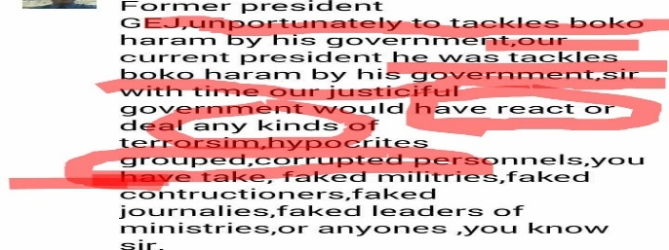
Post 1 contains a clear presentation of what the study anticipated and it contains lexical and grammatical errors which the study intends to analyse and correct. In terms of the lexical usage, there are instances of mis-spelt words such as: ‘unportunately’ for ‘unfortunately’, ‘justiful’ for ‘just’, journalies for journalists, ‘militeries’ for ‘military’ and other mis-placed item that makes the whole post unreadable and understandable. In terms of the grammar, the writer obviously does not have a good command of the tense system of the English language. There is a clear misuse of the present continuous form (the s- form). The word ‘tackles’ cannot come after to preposition and cannot be used to form the past form in a construction like: ‘he was tackles…’ Also, simple past items of ed 1 addition in words like react, deal, take and know should have been better written as reacted, dealt, taken and knew to reflect the tense and time aspect with which the statement was made. There are also instances where the past tense ed1 wrongly placed on words (faked for fake, grouped for group) these words as they are used in the post are not verbs. They nouns (group) and adjectives (fake) as such, they cannot be made to be in the past form by adding the -ed suffice.
A better way of presenting the message in the post would be: Former President GEJ’s government unfortunately could not tackle the problem of Boko Haram but the current President (Buhari) has tackled Boko Haram and has reacted and dealt with different kinds of terrorism, hypocritical groups, corrupt personals, fake journalists, fake leaders of the different ministries and the people you know that are corrupt.
Post 2

In post 2, there are misplaced and misspelt words starting with the word criticism which should have been citizen, then, ‘a degree holder’ does not communicate the right message in that context, ‘criminal acts’ should have been used in place of ‘criminal art.’ The first person personal pronoun I is missing in ‘…am an IT…’ there are cases of using the upper case wrongly in words like ‘Annalist’ (wrongly spelt), ‘Observer’ Diaspora. As they used in the statement above, the lower case would have been better for each of the first alphabets. Still on the lexical, the word Nigeria as used in … we are Nigeria… is wrongly used as the national adjective Nigerians would have been more appropriate.
In terms of the grammar, the post lacks good and effective punctuation marks. All through the post, there are instances where a full stop to mark the end of a declarative sentence would have been clearly used. For example after the name. There is also the wrong use of the of the s-form of the verb in ‘to condemns.’ A better way of saying this would be:
My name is Unuakhe Bello Oseni. A citizen of Nigerian from Uzaire in Estako West Local Government Area, Edo State. I am a graduate of Computer Science from Ambrose Ali University, Ekpoma. I condemn Nigerian indigenes in the diaspora who engage in criminal acts. We are Nigerians. Let us come together and reclaim the glory of our beloved nation. God bless Nigeria and PMB.
Post 3
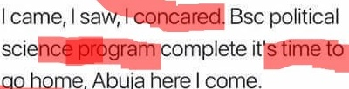
The first part of Post 3 contains a wrongly spelt version of the popular Julius Ceaser’s statement: I came, I saw and I conquered. In the post, the word conquered is wrongly spelt. The word programme is also wrongly spelt as program. In terms of grammar, there is a wrong use of the base form in program complete instead of programme completed then a full stop before starting the next sentence with a capital form. Also, there should have been a period after the home then a come after the word Abuja. That would have made the post read thus:
I came, I saw and I conquered. BSc. Political Science programme completed. It is time to go home. Abuja, here I come.
Post 4
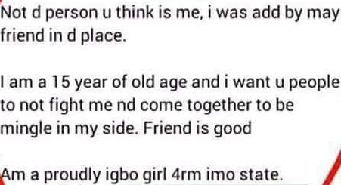
Post 4 is epic. It would be difficult to call this anything close to Standard English usage. In terms of the lexical items, some of them are missing. The post should have started with the first person personal pronoun ‘I’ and the verb ‘am’. Also, there is a wrong usage of the verb ‘is’ and the pronoun ‘me’ that follows. The adverbial form of the word proud was used instead of the adjectival form in ‘…am proudly igbo…’ There are also spelling errors; ‘may’ is used instead of ‘my’. There is also instances where the first personal pronoun I is written with the lower case which is a wrong way of writing in the English language. Also, proper nouns like Igbo and Imo State should be written with the first alphabet capitalized but that in not the case with post 4. A better way of saying this is:
I am not the type of person you think I am. I was invited into this group by a friend. I am a 15 years old girl. I don’t want quarrels. Instead, you guys should join me and mingle.
Post 5
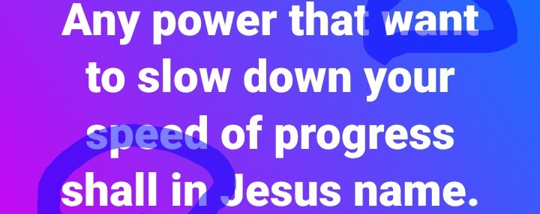
The first error in post five is a grammatical one. The word ‘want’ highlighted in the post is wrongly used as the s-form wants should have been the correct one looking at the subject ‘any power.’ For the right concord to be struck, want is not appropriate in the context. Also, the definite article ‘the’ is missing before the word ‘speed’ thereby making it ungrammatical as there is no clear reference. There needs to be a rearrangement in the lexical in ‘... Slow down your speed of progress…’ it should be ‘…slow down the speed of your progress…’ Lastly, there is a verbal item missing after the modal auxiliary verb ‘shall’ as it cannot stand alone. Because the verb is missing the last part of the post is not definite enough as nothing was said would happen to the ‘power’. If we are to re-write this, it would be:
Any power that wants to slow down the speed of my progress shall perish in Jesus’ name, Amen.
Post 6
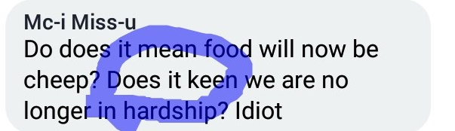
The first part of post 6 looks like it was a typographical error, using do and does one after the other. This makes it sound awkward and meaningless. Does should have been the correct question operator in constructions like this. Also, there is an error in the second sentence where ‘keen’ is used for the word mean. Still in the second sentence, there is a non- Standard usage in: ‘Does it mean we are no longer in hardship?’ The correct form should have been the word ‘suffering.’ The word hardship is understood anyway using our Nigerian English interpretation or variety but communicating this to other English users outside the country would be a little bit problematic. The correct form should be:
Does it mean food prices are cheaper now? Does it mean we are no longer suffering? Idiot!
Post 7
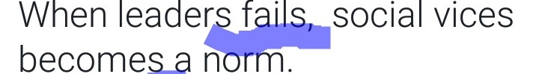
The main error in post 7 is the problem of grammar. In the English language, verbs take the s-form when indicating the regular actions of singular third persons and the base form of the verb is used when the verb is plural. In the post, the subject of the sentence is ‘leaders’ and it is plural in the way it is used in the post. So, the corresponding verbs should be plural to have a subject verb agreement. The verb ‘fail’ and ‘become’ should have been used for fails and ‘becomes’ respectively. The correct form should be:
When leaders fail, social vices become a norm.
Post 8
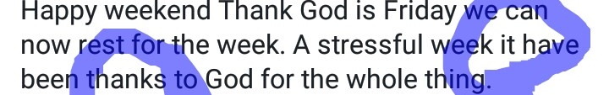
In the post above, there are some key lexical items missing thereby making the post incomplete. For example, ‘it’ is missing in ‘...thank God is Friday.’ Also, there are parts in the sentence that needs a full stop to help in the reading of the sentence. The first sentence can be broken into three different sentences and the second sentence can be broken into two sentences. It is wrong to capitalize the first alphabet in the word thank in ‘…Thank God is Friday…’ another error in the post is the wrong use of have instead of has which shows it is singular because the post say ‘… A stressful week…’ a better way of saying this would be:
Happy Weekend to you all. Thank God it is Friday. We can now relax for the week. It has been a stressful week. Thank God for the whole thing.
Post 9
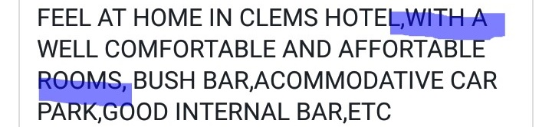
Post 9 is an advert which is one of the uses Nigerians use Facebook posts for but in this instance, the intention would not be well meant due to some grammatical and lexical errors. Firstly, there is a wrong use of the preposition ‘in.’ the right preposition for the expression is ‘at.’ There are also instances of wrong spelling in ‘Affortable’ and ‘acommodative.’ The right spelling affordable and accommodative would been better. There is also a break down in the collocation of words in ‘well comfortable…’ The common collocations are ‘well- furnished or very comfortable.’ With these errors corrected, the correct form would be:
Feel at home at Clems Hotel with a well-furnished, affordable, accommodative rooms and good parking space and bush bar.
Post 10
We end this analysis with a one sentence post above. Three errors can be identified here. The first is the wrong spelling of the word serious in the post. The second is the non capatalisation of the first alphabets of Igbo Etche in the post. The third has to do with the arrangement of the sentence entirely. To qualify a verb, adverb is used and this affect the nature of the word. The word serious as used in the post is supposed to be an adverb but it is the adjectival form that needs to used in that instance. To do that would be a re-ordering and addition of the words in the post to read as:
It is raining seriously at Igbo Etche
Findings
From the analysis we have carried out above, we present the following findings:
- Most Nigerian Facebook users do not care so much about applying punctuation marks especially the full stop in their posts. The few that do add punctuation only add it at the final position. That is, when they are through with the post. There are rare instances of the full stop being used to break unnecessarily long sentences that aid confusion.
- Spelling errors were also dominant. This is traceable to two issues. The first is the auto correct feature of most mobile phones which most Nigerians use to access Facebook. The second is laziness and laxity on the part of the users as they do not take their time to take a second look at their posts in order to effect the needed corrections.
- The third and the last is the fact that there is a low knowledge in the use of certain grammatical forms amongst some Nigerian Facebook users. Some these include when and how to use the s-form of the verb, the difference between has, have, and had, also the unnecessarily ellipsis of ‘I’ in ‘I am.’ Most of the post we saw used only ‘am’ without ‘I’ and when some used both, the ‘I’ had the lower case.
Conclusion
What we have done in this study is to highlight some posts from Nigerian Facebook users with clear attention on the lexical and syntactic errors in the posts. The study identified that errors are part of learning but it becomes bad when it is left uncorrected. As such the study is done with the sole aim of providing what should have been the right form to be used in the case of errors so that other users can learn from it.

References
Bakare, S. (2016). Lexical and syntactic errors in the English of social media platform users: a study of Facebook and Linkedin. An unpublished M.A thesis of the English Department, University of Lagos.

Brown, J.D. (1988). Understanding research in second language learning. Cambridge: Cambridge University press.

Kavaliauskiene, G. (2013). “Correction and self of written assignments at tertiary level.” Journal of language learning, 1; 2, 765-876.

Lee, H. (1997). English article deletion in Korean EFL learners' compositions. Working Papers in Educational Linguistics, 13(2), 41-50.

Llach. M. P. (2005). A critical review of the terminology and taxonomies used in the literature on lexical errors. Miscelanea: A Journal of English and American Studies,31, 11-24.

Llach. M. P. (2007). Lexical errors in young EFL learners: How do they relate to proficiency measures? Interlinguistica, 17, 63-73.

Nweze, I. (2013). ‘SMS Texting among GSM Users in Nigeria: A morpho-Syntactic Analysis.’ Research on Humanities and Social Sciences, 3; 15, 84-92.

Morret, H. (2011). Korean ESL Students’ Use of English Definite Articles. An unpublished Thesis of the Honors Program, Liberty University, Fall.

Ogomaka, p. (1992). Types of research. In Isangedighi and P.M.C Nwoke (eds). Educational research methods. Owerri: Totan publishers.

Olateju, M. (2006). ‘Cohesion in ESL classroom written texts.’ Nordic journal of African studies, 15(3), 314-331.

Okunrinmeta, U. (2014). ‘Syntactic and Lexico-Semantic Variations in Nigerian English: Implications and Challenges in the ESL Classroom.’ Open Journal of Modern Linguistics, 317-332

Rivers, W.M. (1988).The Psychologist and the foreign language Teacher. Chicago: Michigan University Press.

Williams, D. (1999). English language teaching: An integrated approach. Ibadan: Spectrum Books Limited.

