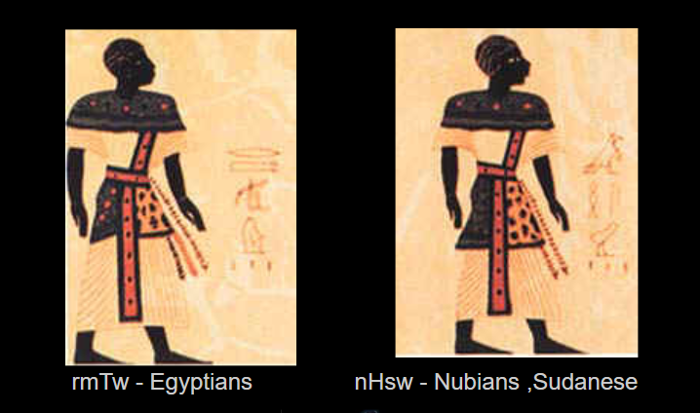

The Genetic Linguistic Relationship of Nubian Dongolawi with Pharaonic Egyptian (mdu ntr)

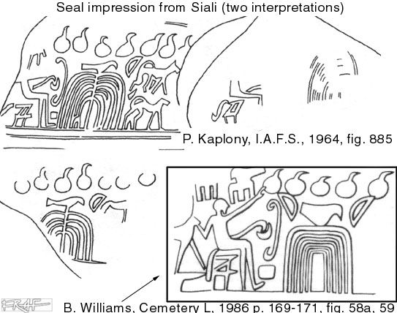
Neter Neb ,Kennard D Hartley
Student Institute of Kemetic Philology ,Instructor Rkhty Amen , Egyptian translations ,grammar and linguistics
Email : prntrlinguistics@gmail.com
American Public University ,Associates Program Business Management
kennard.hartley.edu / 4435009055
Dr. Nasir Satti PhD
Assistant Professor of Linguistics, Linguistics Department, University of Khartoum
Email : nassat204@gmail.com
Anna Gibson
Associates in Liberal Arts, Journalism at Wayne State University, Assistant Editor
The Genetic Linguistic Relationship of Nubian Dongolawi with Pharaonic Egyptian (mdu ntr)
Abstract
The present paper is a comparative linguistic study .It aims at investigating the relationship between Nubian Dongolawi language with Ancient Egyptian ( mdu ntr ) alongside showing affinity with other African languages as Dinka ,Kalenjin ( group ) ,Yoruba , Akan and Dogon Tommo So as well as Coptic . Utilizing the comparative linguistics method, we have established a number of sound correspondences between Nubian Dongolawi and Ancient Egyptian within the basic vocabulary (pronouns, body parts, verbs, and colors, senses, negation) to avoid borrowings and chance similarities. Morphological correspondences as the plural suffix stem and the adjective modifier construction all suggest a possible linguistic genetic relationship and possibly indicating the same predialectical mother tongue for Nubian Dongolawi and Ancient Egyptian.
Résumé
Résumé le présent document est une étude linguistique comparative. IL a pour but d’étudier la relation entre la langue nubienne Dongolawi avec l’égyptien ancien (mdu ntr) aux côtés de l’affichage des affinités avec les autres langues africaines comme Dinka, Kalenjin (groupe), Yoruba, Akan et Dogon Tommo si et copte. Utilisant la méthode de la linguistique comparative, nous avons établi un certain nombre de correspondances sonores entre Dongolawi nubien et égyptien ancien dans le vocabulaire de base (pronoms, parties du corps, les verbes et les couleurs, sens, négation) afin d’éviter des emprunts et similitudes de chance. Correspondances morphologiques comme la tige de suffixe pluriel et la construction de modificateur adjectif tous suggèrent une possible linguistique relation génétique et ce qui indique peut-être la même langue maternelle predialectical pour Dongolawi nubien et égyptien ancien.
Tables of Contents
1.1 General Overview: Introduction
We explain the comparative linguistic methods giving an example of initial w>w/u correspondences.
2.1 Linguistic Demonstration and Methods
We give examples of the method and linguistic demonstrations such as what’s found in Dr. Théophile Obenga’s work. As we shall see, this type of phonetic regularity is found by establishing sound laws. We apply this same methodology.
2.2 Ancient Egyptian and Nubian/Dongolawi Phonetic Correspondences and Explanations of Sound Change
We’ve utilized the comparative method of establishing sound correspondences within basic vocabulary items. We have established phonetic regularity distributed in over 9 separate sets of sound laws, creating a large set of sound paths.
3.1 Morphological Correspondences: Plural Stem and Adjective Modifiers (noun + plural stem, noun +adj)
Morphological suffixes indicating plurality and the attached adjective modifier are both observed in Dongolawi Nubian and Ancient Egyptian grammar.
3.2 Shared pronouns found in Ancient Egyptian and Dongolawi (Nubian) Pronouns:
-I/-k/-T/-nu
Four pronouns have been observed to be identical based on genetic correspondences.
4.1 Body Parts (Historical Etymology): Comparative Vocabulary with Nubian, Ancient Egyptian, Dogon, Dinka, Yoruba, and Coptic and *Proto Nubian
Similarities can be seen in terms that refer to body parts. Basic vocabulary indicates a close relationship as will be demonstrated throughout this paper
5.1 Linguistic Conclusion: Commentary
The results section describes the genetic relationship based on primary research. They confirm that a high frequency of sound correspondences exists between the Nubian Dongolawi and Ancient Egyptian language basic vocabulary.
Basic Notation
One used basic notation while seeking to explain the linguistic data. One will explain phones as” []”, and Meta - phonemes -correspondence between languages as “//”. One will also use “[]” to explain phonetic realizations “{}” to explain morphological attachments. For Egyptian transliteration standards we are using basic Manuel de Codage (MdC ) . Symbols using “+” are for added stems at the beginning or end of word roots, - is for deletion of sound and “< >” is for basic terms orthographic spellings < mdu > words. The symbol “>” is for correspondences. The” >” points to the derived sound change, certain cognates have numbers that indicate a footnote insertion with more information on the item.
- [ ] – phones , meta phonemic realizations across languages
- / / - meta phonemes across languages
- { }- morphological attachments
- + - added sounds at beginning or ending of words
/ - / - deletion of sounds
- < > - basic orthographic spellings
- > - for correspondences sound laws ,points to derived sound change
- ~ - reduplication or used between meta phonemes
- red – Red bold are correspondence patterns
Introduction: 1.1 General Overview
To begin, we will use the comparative linguistic method to establish sound correspondences between the Nubian Dongolawi and Ancient Egyptian language.
(The work of the American linguist Professor Greenberg, particularly in connection with his 'Afro-Asiatic' language family, cannot be regarded as invalidating the argument, for he ignored one vitally important methodological rule, namely the establishment of phonetic correspondences” I. Fodor ).”
The correspondences found in this work prove that the Nubian Dongolawi and Ancient Egyptian languages both show possibly a genetic relationship by establishing phonetic correspondences. Establishing phonetic correspondences is what show the relatedness between two or more languages. We observe the domesticated dog having similarities between Nubian Dongolawi and Ancient Egyptian (mdu ntr).

Ancient Egyptian < whr > dog
Nubian Dongolawi < wel > dog
Kenuzi < wel > dog
Meriotic < wel > dog
Dogon Tommo So < wo ~ wo > dog bark
Dinka < ayol > bad dog
Yoruba < abo > wolf
Proto Bantu < *bua > dog
Other Nubian languages show the sound change of /w/ ~ [ b ] - [ m] - [p ] .The w can be realized as an [b ] sound in Kadaru < bɔl > dog . The determinative for Ancient Egyptian < whr > or < uAhr > is identical to the Nubian artifact (Siali Seal) being the dog glyph has a bent or curled tail small head and small pointed ears. In Dogon Tommo So < wo - wo > Dog bark indicates onomatopoeia which is possible for this word to have its origins in the sound the dog makes. Onomatopoeia can lead to chance similarities (Dimmendaal 2011) in other languages but in this case the evidence using the comparative linguistic methods we may assume that the term in Ancient Egyptian < wAhr > dog and Nubian Dongolawi < wel > dog is much more than similarities by chance. The evidence suggest that the dogs are identical in shape, tail, head and ears also by the fact that Nubian Dongolawi and Ancient Egyptian shows possible evidence of a genetic relationship linguistically by adducing sound laws fully demonstrated in this research with initial w>w/u correspondences. Consider the w>w/u initial correspondences below.
w>w/u Ancient Egyptian | Nubian Dongolawi
whr | wel | dog
wr | owr | chief / king
wt | ewdy | mummy wrap /mummify
wAyt | warr | distant thing/far
wAwty | wissi | star
wa | weiri | one
wpt | oupur | open
wdd | ur | brain/head
awy | owi | two
The Ancient Egyptian term < whr > dog with Nubian Dongolawi < wel > dog one may ask of the [h] in the term < whr > dog. We find in Nubian Dongolawi vowel /e/ has a possibility of corresponding with Ancient Egyptian [h] or a sound change of the lenition of [h] to a /e/ sound, however the explanation of sound change we find regularity.
Ancient Egyptian | Nubian Dongolawi
mht | mere | mass of water /pond
bhn | mer | to cut
whr | wel | dog
2.1 Linguistic Demonstration and Methods
Here we demonstrate phonological and morphological regular sound change by use of comparative method. The data establishes regular correspondences between Dongolawi and Egyptian. We also include linguistic data of regular sound correspondences between Dongolawi, Dinka, and Egyptian languages. By use of the comparative method one can begin to show that Sudanic and Egyptian languages may have the same pre-dialectical parents, making them genetically related to one another.
Sound Laws observed, Initial ,medial and final:
Dongolawi ( Nubian ) - w>w,r>d, m>p/b, k>k ,k>r, S>S, S>s, s>s, t>r , t>d, n>r, b>b
Dinka - r>l, m>m, k>k
Morphology :
noun + adjective ,noun + plural
Pronouns :
-i/-k/-T/-nu
Body Part Terms :
12 body part similarities
Specifications : Basic vocabulary
Basic vocabulary is the foundation of linguistics and is least likely to be borrowed. You may also read Goddard’s article on a critical review of lexical universals in order to get a better understanding of this. He made a list of words, including ‘I’, ‘this’, ‘one’, ‘big’, ‘good’, ‘true’, ‘sweet’, ‘hot’, ‘man’, ‘mother, ‘tree’, ‘water’, ‘sun’, ‘wind’, ‘ear’, ‘say’, ‘do’, ‘go’, ‘sit’, ‘eat’, ‘give’, ‘die’, ‘maybe’, and ‘because’.These universals are some of the terms proposed by Goddard that he used to construct a basic vocabulary useful for some comparisons in this research. An example of a basic vocabulary to be used to find regular correspondences is listed below. Dr. Nasir Satti also states that basic vocabulary is to be used and cultural terms can be borrowed easily. The Dongolawi terms come directly from Dr. Nasir Satti, a native Nubian Dongolawi speaker and professor in linguistics in the University of Khartoum. The Dinka’s vocabulary is extracted from the dictionary compiled by linguist Roger Blench, in which a large number of vocabulary was made available.
Sun
Mouth
Work
Name
most terms found in this paper are carefully selected to stay as close as possible to basic vocabulary and items that are not easily borrowed. A list of some basic lexical items is:

Nose Burnt Speech Horse Night Mummify Me (pronoun)
Face Place Death Walk/Run Black Person Cut We (pronoun)
Head Tongue Tomb Father You (pronoun) Smell Of (genitive)
Leg Eyes Mother Sun Daughter Flood (water) Sperm
Land Big Dance Name Mountain Hair Vagina
Work Man Cat Mouth Flood Drag/Push Skin
Black love God Small Earth Black land Hand
Initial r>r  r>n | Ancient Egyptian | Nubian Dongolawi | Coptic | Dinka | Kalenjin | Dogon | Yoruba
: | - ra -  work  : | -tatti-  shift of work | - ra - work | - loi -  work | - roor -  job | - nára - work r>n | - aró -  work
: | - ra -  sun | - il -  sun | - rē -  sun | -ruel -  be hot (sun) | - raat -  sun | - ne -  sun r>n | - ra -  heat
: | -ra -  mouth, speech | - el -  tooth | - ro - mouth | -röl -  speech | - le -  voice | - nɔ -  mouth r>n | - ọrọ -  throat
: | - rn -  name | - erri -  name | - ran - name | - rin - name | - reneet - reincarnation name | - naniye-  name r>n | - oruko -  name n>k
In Dinka, <ruel> ‘to be hot’ (sun) is similar to other sound changes. This is an example of something called epenthesis, when a sound element is added to the end of the term (rue +l). Similar cases can be found throughout the dialects of Dinka. In Northwestern Dinka <röö> ‘men’ is pronounced with a form of epenthesis, as in Southwestern Dinka <röör> ‘men’. We know epenthesis is the gain or insertion of speech sounds at the end of words. This seems to be a case of “paragoge” which is the addition of sound to the end of the word and observed as a type of epenthesis. Another example is the Southwestern Dinka <rö> which in the variant form would be <röt> + t, the insertion of the [t] at the end of the word. In Egyptian we find the term <rr> ‘man’ which is the same as the Dinka rendition of the term of <röör>, also defined as ‘man, men’. In Northwestern Dinka, they pronounce the word as <röö> which may fall under the category of a sound change that lost sound. In Dongolawi <il> ‘sun’ and <el> means ‘tooth’. In Dongolawi < erri > means name n>r. These terms allow us to see that changes can occur through time. In Yoruba the term for name is <oruko>. We find correspondences of Egyptian [n] corresponding with Yoruba [k] to show validating evidence that Yoruba language corresponds with Egyptian.
n=k (initial) | Egyptian | Yoruba
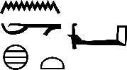 | -nxt-  strong | -okun-  strong
 | -nkyt-  cut in pieces | -kán-  break
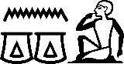 | -ngg-  cackle, cry of goose | -kegba-  cry, scream
The vocabulary we use is basic and from it we can began to establish sound correspondences. This linguistic website www.christianlehmann.eu noted some important data regarding basic vocabulary and its linguistic purposes to represent the core of the lexicon. The basic vocabulary has a variety of applications in linguistics:
“Quantitative criteria: The items are the most frequent ones by certain standards. Moreover, their dispersion (distribution over styles, registers, genres etc.) is rather equal. Semantic criteria: The items represent central lexical fields like designations of persons and important animals, color terms, kin terms, body part terms etc.; and within each of these fields, the most basic lexemes, in terms of lexical field structure, are chosen.”
Methods

Comparative Linguistic Method: Establishing Correspondences
We apply the comparative linguistic method and the rules of regularity found in Grimm's Law. We also explain sound changes seen in the Nubian Dongolawi and Ancient Egyptian languages. This provides evidence toward our claim that Dongolawi and Ancient Egyptian both have same pre-dialectical parent. Below is an example of Obenga’s work in which he establishes sound correspondences with Yoruba and Egyptian. He established six correspondences in phonology and identical morphological sequences. Correspondences may produce a phonetic identity where both sounds are the same, we can see this in the graph below with Egyptian /b/ and Yoruba /b/ (stops).
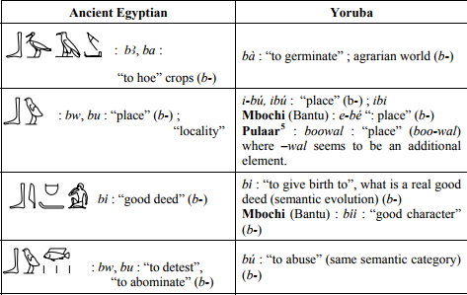
Phonetic identity can be established in Nubian Dongolawi and Ancient Egyptian as Dr. Obenga’s framework. Obenga shows three occurrences of the velar /k / seen in items as same form and meaning. Below one will show three occurrences of the velar /k/ between Egyptian and Dongolawi. This shows that we are operating in identical methodology which is proper linguistic methods of establishing phonetic regularity.
k>k Phonetic Identity | Ancient Egyptian | Nubian Dongolawi
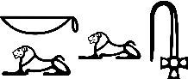 | -krr-  burnt, burnt offering (?)  Dinka < lɔk > flame  ( metathesis ) | -kr-  burnt  Nubian Dongolawi  < ker > ember
 | -kAr-  shrine, sanctuary  Dinka < ariak > place of offering for the totem | -Aker-  place
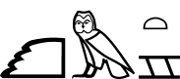 | -km-  black (cultivated) land  Dinka < akam > kind of swamp grass  Demotic < km > black land  Coptic < khme > black land | -koba-  black extension of fertile land
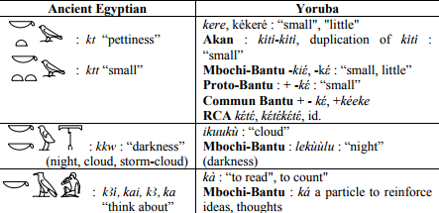
Ancient Egyptian and Modern Yoruba: Phonetic Regularity by Theophile Obenga k>k
Over time, sound changes can disrupt the appearance of similarity between two related languages. This can cause words that are inherently the same to appear different on the surface. Sound correspondence is the key that determines whether these words we are comparing are chance similarities, borrowings, or if the regularity of sound change will reveal a genetic cognate. We eliminate chance similarities by establishing these correspondences in large sets of basic vocabulary. Dr. Théophile Obenga mentions the reason we apply this method in his research paper (Ancient Egyptian and Modern Yoruba: Phonetic Regularity).
Obenga states:
“Thus, the task of historical linguistics is basically grounded in the hypothesis of the regularity of phonetic laws and sound correspondences. A series of lexical facts is always required in order to eliminate chance similarities. A series of lexical data gives to the comparison its systematic appearance.”
When sound laws are found in a large number of basic words corresponding elements eliminates chance similarities. Through time, sound change can destroy the similarity between languages. Words that were originally identical may appear to be different. We provide an example below:
V. Sanskrit < duvas > two
Latin < duo > two
Armenian < erku > two
Greek < dwa:ron > a long time
Armenian < erkar > long
Greek < dwi > fear
Armenian < erki > fear
Example by Gjk Campbell Dunn
We can see that the explanation of this is seen in recurrent correspondences from Greek - dw - to latin - du - to Arm.- erk. Though the segment in Armenian is -erk - and does not resemble the Sanskrit, Greek, or Latin, it's evident that ‘dw’ and ‘erk’ corresponds. In chapter 5 (Sound Correspondences) Dunn gives the example of correspondences on page 17: Chapter 5 (Sound Correspondences) using the three sounds to show regularity. Dunn mentioned that there is a debate among linguists regarding just how many correspondences are needed to be considered regular sound correspondences. It was later deduced that over five occurrences is significant. Though in Dr. Obenga work he uses no less than 6 occurrences per set in this paper we use more than 9 occurrences.
2.2 Ancient Egyptian and Nubian/Dongolawi Phonetic Correspondences
In this section we observe phonological correspondences between Dongolawi and Egyptian. From these correspondences we find sound change regularity in a large set of words indicating that Dongolawi and Egyptian may have a shared pre-dialectical parent language. This evidence raises and answers very important questions regarding the nature of the relationship between Egyptians and the Sudanic peoples. The (>) sign is an indication of regularity among consonants the // is an indication of meta - phonemes across languages. The consonants marked in (red) shows regularity patterns found in the large sets of vocabulary. r>d, m>p, k>k, t>d, S>s, S>S, k>r correspondences are more than six (Obenga) which makes genetic relationship more likely. These historical sound changes seek to explain the meta -phonemic realizations. For instance, the initial meta-phoneme /r/ is realized as an [d] sound in Dongolawi because of the observation of historical sound change. A high frequency of basic vocabulary correspondences can be found. Over 50 correspondences help establish that phonologically a genetic relationship is in place. Some cultural terms may show correspondences which indicates borrowings but some terms can be seen that shows the contrary view, such as within the term < water > (which is basic) but also < flood >. According to Nile Valley inhabitants this term is less likely to be borrowed among the tribes because this term was known and the groups had no reason to borrow the term from each other. The best explanation is that they are cognate. The pronouns and body parts may be possible cognates in which the body parts are similar at a high frequency. This is crucial data when establishing similarities between terms that are not likely borrowed. This indicates a possible relationship with all the data combined. (See: Conclusion)
Egyptian uniliteral /r/ corresponds in high frequency with Dinka /l/ making [l] a meta -realization of Egyptian /r/. These type of meta -phonemic patterns (called Meta phonemes) can be observed in initial positions and final positions corresponding with precise regularity.
Sound Law: r>l
r>l | Ancient Egyptian | Dinka
 | -ra-  work, to do (Amen 3,15) | -loi-  to do work
 | -rkAu-  flame | -lȯk-  fire
 | -rx-  science, knowledge | -lëk-  Inform, information
 | -ryt-  sky, ceiling, roof | -luat-  cloudy sky, clouds
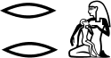 | -rer-  to nurse | -leel-  nurse
 | -rx-  to slay | -lek-  stab
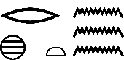 | -rxt-  to wash | -lak-  bath, wash
In Dinka we find phonetic identity within correspondences, Egyptian  < rmT > ‘people, man, Egyptians’ (natives) and in Dinka < raandie > ‘person’, we also see this in Egyptian <rm > ‘people, man, persons, humanity’ and in Dinka < rem > ‘youths, generation’. This same type of correspondences exists with Egyptian and Dongolawi. The /r/ in Egyptian is an [d] in Dongolawi. The r=d fortition appears regularly indicating a strong case of a genetic relationship since correspondences appear in over 25 occurrences.
r>d | Ancient Egyptian | Nubian Dongolawi
 | -er-  mouth | -ed-  tongue  Dinka(röl) throat
 | -rmT-  man | -adem-  man  Dongolawi (irim) Man  Dinka (raan) husband  Dogon Tommo So (nde) man
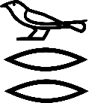 | -wrr-  great, large | -duul-  big  Dinka (lɔl) large
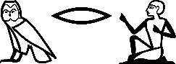 | -mr-  chief Officer | -amda-  chief  Dinka (mar) govern
 | -irty-  eyes | -diri-  tearful eyes, sad look  Dinka (luith) look at, peep
 | -rid-stairs (determinative used in high, high hill) | -diri-  ascend
 | -ruruti-  gods | -dirti-  crown of god
 | -rdi-  to give | -tir-  to give  Dogon Tommo So < deere > stretch out hand
 | -pr-  walk, come | -poad-  run
In Ancient Egyptian there is regularity found with [r] corresponding with Dongolawi [d] in initial and final positions. This can be found in large sets of words. The /d/ in Dongolawi can also alternate with [t] when corresponding with Egyptian [r]. Instead of [r] = [d], in some cases the /d/ can be phonetically realized as [t].
An example is given below and it will serve as a demonstration of [d] and [t] alternates. These alternatives suggest phonetic realizations of Egyptian /r/~ [d][t]. We can see this in Ancient Egyptian < sqdut > ‘sail’ with Dongolawi Nubian < sqr > ‘sail’. It can also be seen in Ancient Egyptian < udd > which translates to ‘brain, cerebellum’ with Dongolawi Nubian < ur > ‘head’.
r>t | Ancient Egyptian | Nubian Dongolawi
 | -irty-  eyes | -diri-  Tearful eyes
 | -sr-  high official | -sat-  High official
 | -rdi-  to give | -tir-  To give
 | -pr Aa-  king | -patar-  nobility
Many scholars have found ancient Nubian, Meroitic and Egyptian (l, r, n, d) alternates. Evidence of this type of interchange exists also with Egyptian [n] corresponding with Dongolawi [r] in which we will review later after we show the m>m correspondence of Egyptian and Dinka and m>p in Egyptian and Dongolawi. The Egyptian /m/ is phonetically realized as identical with Dinka /m/ and the normal correspondences of [r] >[l]in phonetic final correspondences are clearly seen. This indicates a natural correspondence and gives strong evidence to that Dinka and Ancient Egyptian have the possible same pre-dialectical parent. It is observed here showing the genetic ties that Ancient Egyptian called Egypto -Nubian have with the so called Eastern Sudanic branch. This same fortition of r>d can be observed in Ancient Egyptian and Dogon Tommo So. Ancient Egyptian < rm > people with Dogon Tommo So < nde > man, Ancient Egyptian < rdi > to give with Dogon Tommo So < deere > ‘extend hand’, Ancient Egyptian < ra> ‘work’ with Dogon Tommo So < daa > ‘take apart’. In Dongola I’d-t’-can both be expressions of /r / as observed regularly among various African languages. Dimmendaal with Twi < e-ti > and Yoruba < o-ri >. Dimmendaal mentions that the root initial /l/ in Nen language corresponds with /t/ in Luba or Nyamwezi t>l.
m>m | Ancient Egyptian | Dinka
 | -mr-  swampy land | -mɔra-  fallow field
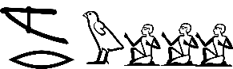 | -mrw-  worker(servant?) | -mëlui-  worker
 | -mr-  milk pot | -miel-  milk off
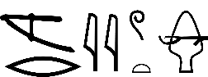 | -mryut-  mythological mulberry tree  < mr > , morus tree | -melat-  shrub with edible berries
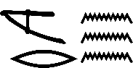 | -mr-  Inundation, flood | -mol-  rise (of a river)  Dongolawi <mere> lake, pond
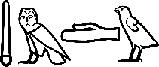 | -mdw-  words, say | -amaath-  voice  Coptic < moute > speak  Dongolawi < ned > tongue (speech)
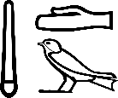 | -md-  falsehood | -mɛth-  deceive  Nubian Dongolawi < mursi > a lie
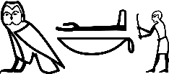 | -mak-  to protect (defend) | -mak-  fight
In his work “Ancient Egyptian and Modern Yoruba: Phonetic Regularity” Obenga demonstrates 5 cases of regular correspondences with labial nasal [m]. We follow the laws of regularity found in Grimm’s Law, but this case, we have initial labial nasal [m] seen in phonetic identity m=m. This makes chance similarity virtually impossible. In Egyptian, the [m] makes a regular sound change into Dongolawi [p].
m>p | Ancient Egyptian | Nubian Dongolawi
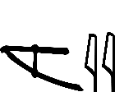 | -mry-  lover, love | -pale-  love, marriage
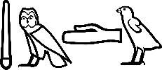 | -mdw-  words | -pdou-  religious speech
 | -mr-  tomb, pyramid | -dip-  pyramid, tomb
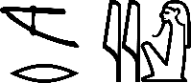 | -mry-  name of several gods | -pru-  holy, sacred
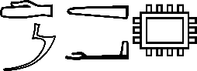 | -dma-  fortress | -dippi-  fortress
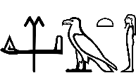 | - mdiAt-  dead body | -pr-(ij) collective death. J marks frequency of action  collective death
In Dongolawi, < dip > is a metathesis form for ‘pyramid’ with Egyptian < mr > ‘tomb, pyramid’. We find in Dongolawi term < pr (ij) >, or ‘collective death’ and the term < mdiAt > in Egyptian in which elision drops the - iAt in Dongolawi. In both Dinka and Dongolawi phonetic identity of the velar [k] with Egyptian [k] in its initial position both correspond. Meriotic terms are used which also demonstrates clear correspondences. The term < km.t > or ‘Black irrigated soil’ can be found in Dongolawi as < mog > or ‘Black extension of land’ and < koba >,’Black extension of land’. The ‘m’ and ‘b’ are seen in sound correspondences. In Dongolawi < mog > is also the metathesis form of ‘black extension of land’. We see this again in Ancient Egyptian < ibar > ‘horse’, and Dongolawi < murti > ‘horse’.
Initial /m>b Ancient Egyptian | Nubian Dongolawi
mut | buru | mother /daughter  (Dinka –ma-mother)
msu | bita  ( mes ) | baby, child/baby  (Dinka -meth - child)
mAliA | bel | flee/keep away from place
makhA | bokki | to turn the back on /to hide
mrt | baris | sickness/ vomit
ms | bes | son/brother  (Dinka –meth-son)
We also see many forms of the term ‘dancing’, which is an important social and cultural element within majority of African traditional systems. We see this term shared between the Ancient Egyptians and the Nubians. In Ancient Egyptian < ibA > ‘dance’, corresponds with Dongolawi Nubian < baan > ‘dance’, and the Ancient Egyptian < bastt > ‘cat headed deity’ is found in Dongolawi as < sab > or ‘cat’ there’s also another variation in Dongolawi demonstrated in the word < bissa > which also means ‘cat’. From these correspondences, we see the gemination of the [s] to a [ss] or a t>s.
Ancient Egyptian | Nubian Dongolawi
mAAt | missi | sight/see  (Dinka – moth-see)
bastt | bissa | cat deity/cat
mrt | baris | sickness/vomit
msu | bita | baby, child/baby
Other variations can be found in the ‘p’ and ‘b’. Dongolawi alterations ‘psa’ into ‘sab’. According to Budge, Bastet is said to be honored throughout the Sudan. The Egyptian ‘[b]’ also corresponds with Nubian ‘[b]’ in the term corresponding to ‘father’. We find the Ancient Egyptian < baba > or ‘father’ with the Nubian < bab > ‘father’. Also, we see phonetic identity observed in the [p] of Ancient Egyptian and [p] of Dongolawi. The ancient Egyptian term < wpt > ‘open’ corresponds with Dongolawi Nubian < oupur> ‘to open
k>k | Ancient Egyptian | Dinka
 | -kat-  vulva, vagina, mother | -kai-  woman who birthed child
 | -ka.t-  place, district | -kat-  garden shelter
 | -ka-  double | -kiet-  imitate, copy
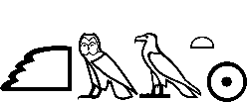 | -kmAt-  end of period (moment) | -kam-  time, distance
Egyptian < ktt > girl Egyptian < kyAur > carriers of Gold
Meriotic < kdi > lady Meriotic < kl > bear, carry
Dongolawi < kari > woman Dongolawi < ker > pick up
Dinka < tik > woman Dinka < ket > carry on shoulders
k>k | Ancient Egyptian | Dongolawi (Nubian)
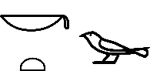 | -kt -  small | -ken -  small
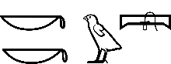 | -kku-  darkness | -ukku-  night
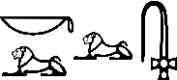 | -kl-  burnt offering | -kr-  burnt
 | -kmt-  Black (mud) soil | -koba -  Black extension of land
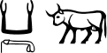 | - ka -  bull | -kur-  bull
 | -kt-  female cow | -eket-  female sheep
In Dongolawi, metathesis is observed in the term <kub> ‘boat’ and in Ancient Egyptian <bik> ‘Hawk Boat. Also, to note we have correspondences of k>g in which Ancient Egyptian [k] can correspond with Dongolawi Nubian [g]. Ancient Egyptian < keke > darkness, night with Dongolawi Nubian < ugu-ugu > night , Ancient Egyptian < kar > shrine, sanctuary with Dongolawi Nubian < agar > place, Ancient Egyptian < km > to bring to end with Dongolawi Nubian < gumei > last part of night , Ancient Egyptian < km > black land /earth with Dongolawi Nubian < moga > black extension of land . Terms for colors are another indication that a group that may be directly related. The color spectrum of the group would also be retained within the living African languages. Because colors in Egypto - Sudanic held very important religious overtones. Colors were often used in toponyms. For instance, ‘black fertile soil’ is retained in Dongolawi as < moga > ‘black extension of land’ or < koba > in which the [m] and [b] alternates back and forth. Colors can be adjective modifiers in both Egypto - Sudanic grammar and Dongolawi. We find that the color black is used here to modify the noun which corresponds to the Egyptian term for Black person found in the Demotic text as < rmt km> ‘black man’. This form of morphology is also found in Dogon-Tommo So, Dongolawi, and Demotic Egyptian using colors to describe the ethnic phenotype of the people. In Dongolawi, the initial [k] appears to be dropped and as in similar sound change occurrences with [r] this rule applies to people as well. In Old Egyptian and within the Egyptian Hieratic Kahun Papyrus, the adjective noun < kmtu > means ‘Blacks’, or ‘Black people’ and in the Demotic Egyptian it functions as the adjective modifier <rmt km > or ‘Black person’. In Dongolawi color adjectives can be nouns and used as proper nouns (names of persons). This also is true for Dinka < col > ‘black’ and < col > name of a man called Black. In Egyptian this < km > would be also used as an honorific title as in names of < Ppy anx km > ‘the Black Man’ Pepy Anx in which < km > is used as an adjective modifier to modify the cartouche which is a noun. We know this by grammar rules of the adjective modifier r>d-d / k>r-g. Examples of adjective modifiers in Egyptian, Nubian and Dogon.
Demotic Egyptian < rmt km > Black Person
Dongolawi Nubian < adem urumei > Black man
Dogon (Tommo So) < nde gem > Black person
In Dongolawi the adjective noun < urumei > ‘black’ corresponds in morphology as an adjective modifier as Ancient Egyptian. In both terms the adjective follows the noun. We see < rmt km > black person and < adem urumei > ‘black man’. The Dogon Tommo So term < nde gem > also means black person. This is an example of the Noun + Adjective relationship. In Dongolawi the /k/ is dropped and the /r/ must be an innovation to take its place as in the example presented earlier of k>l in the comparisons of Hawaiian and Maori. The adjective noun < kmtu > found in the Kahun Papyrus should translate as “The Blacks, Black People”. When seen in context we have the normal contrast of Black and Red with < dSrt > Red Land. Here, Satti provides information about his native language Dongolawi. According to Satti, color terms can often be used for names of people. For instance, < desse > or ‘green’ can be a name of a woman, as well as < geilei > ‘red’. In proto-Nubian < *u̚dum > is called ‘black.
Adjective noun
Ancient Egyptian < kmtu > Black people
Demotic Egyptian < kme > Dark person
Dongolawi Nubian < urumento > Black man n+t assimilation
Coptic Sahidic < kam > Black person
Dinka < col > A male name that mean Black
Examples of k >r adjectives ,adjective nouns and pronouns
Ancient Egyptian < km > Black
Dongolawi < urumei > Black ( Proto Nubian < *u̚dum > Black )
Coptic Sahidic < kame> Black
Dogon Tommo So < gem > Black
Dinka < col > Black
Ancient Egyptian < -k > you, your ( pronoun )
Dongolawi < -r > you, your ( pronoun )
In Ancient Egyptian the /k/ corresponds with the Dongolawi /r/. Dongolawi dropped the /k/ sound and could have possibly established /r/ in its place. The pronouns in the Egyptian /k/ also corresponds with Dongolawi /r/ sound, demonstrating regularity. In Kalenjin groupings the Egyptian /r/ also appears as /k/. We have the Kalenjin term < kath > ‘strong’, seen in correspondence with the ancient Egyptian < rwd > ‘strength’. The term ‘name’ in the Kalenjin group is < kayna >, and <rn> in Ancient Egyptian. All adjectives in Egyptian can be nouns. In Dongolawi, < urumento > ‘black person’ has a /m/ and /n/ epenthesis added n+t (nt) and possible assimilation of n and t. The ‘[n’] may appear before the pronunciation of ‘[t]’ and there are other examples in Dongolawi that have this assimilation. By adding the /r/ sound before [t] r+t (rt) assimilation is demonstrated. Each case has evidence in the Nubian Dongolawi languages. Ancient Egyptian /t/ corresponds with Dongolawi /d/ in initial and final consonant positions. (See: 4.1Body Parts - Ancient Egyptian < rd > ‘leg’ with Dongolawi Nubian < -rti > leg.
t>d | Ancient Egyptian | Dongolawi (Nubian)
 | -tu-  mountain | -duu-  large
 | -tmy-  cut | -dem-  cut
 | -tA-  land, country | -da-  country
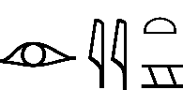 | -iryt-  land | -arid-  earth
 | -ta mri-  Land of flood, inundation | -de meere-  flood
 | -wt-  mummy, mummy wrap | -ewdy-  mummify
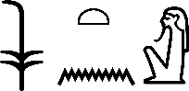 | -nswt-  ntr (King), chief | -samed-  chief of farmers
Of course, phonetic identity correspondences is highly likely with Ancient Egyptian < ta > bread with Nubian Dongolawi < ati > bread. Ancient Egyptian < tunnu > child with Nubian Dongolawi < tundi > child. Ancient Egyptian /t/ corresponds regularly with Dongolawi (Nubian) /d/ in final and initial position. In Egyptian the final /n/ corresponds with Dongolawi /r/ for terms such as the Egyptian term < Sn > hair and the Dongolawi < sher > ‘comb hair’. These are clear examples of n>r and r>n correspondences as written here: The Egyptian term < irt > ‘eye, look’ with Dongolawi ( Nubian ) < nal > ‘see’, Ancient Egyptian < ntr > ‘god’ with Dongolawi < rtt > ‘god’ , Ancient Egyptian <xenu> ‘child’ with Dongolawi < kenna > ‘child , In Ancient Egyptian < xered > child with Dongolawi Nubian < kentot > child ,the { -tot } is an diminutive suffix . Ancient Egyptian < init > wife of Staba, mother of Harpokrates with Nubian Dongolawi < nein > mother. Ancient Egyptian < nu > drink with Nubian Dongolawi < nˈiː > drink.
Ancient Egyptian | Nubian Dongolawi | n>r/l, r>n
Sn | Seer | hair/comb hair
Snt | sılaː-dɛ | circle/round
ntr | artti | god, deity
nswt | rswt | Leader/king
rn | erri | name
tn | ter | you (pronoun)
xny | kare | kind of fish/fish
wbn | bel | to rise / rising of celestial body
gann | kall | eating/type of eating
xrd | kenna | child
wrt | onti | moon
irt | nal | eye/see
The genetic relationship obeys linguistic principles such as the regularity found in Grimm's Law. In Egyptian, the initial /s/ corresponds with Dongolawi /s/ in its initial position. We also see the Egyptian /s/ shows correspondences with the aspirated /S/ and Dongolawi /s/. This sound seems also to alternate as we evaluate Dongolawi variations. For instance, we can see this in the variations between Egyptian < sti > or ‘bow’ and Dongolawi < sti > ‘bow /sword’ and the Dongolawi variation of < shr > ‘bow’
S~[sh]-[s] | Ancient Egyptian | Dongolawi (Nubian)
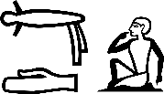 | -Sd-  to read aloud | -sharei-  protest speech(loud)
 | -Sb-  mix | -shabbe-  to act together
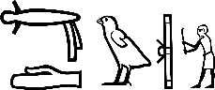 | -Sdu-  drag away | -shieti-  drag, pull
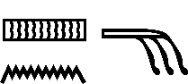 S>s | -Sn-  hair | -seer -  Kind of hair
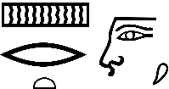 | -Srt-  nose | -soriŋ-  nose

s>s | Ancient Egyptian | Dongolawi (Nubian)
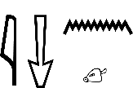 | -isn-  to smell | -sunde-  smell
 | -sr-  official | -satti-  official, scholar  Dinka < acɔ̈r > wizard
 | -st-  bow | -shar-  bow
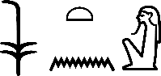 | -nswt-  ntr (god king), national leader | -samed-  chief of farmers
 | -sa-  son | -assi-  nephew
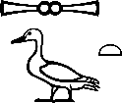 | -sa(t)-  daughter | -essi-  sister, niece  Dogon Tommo So < saa > sister
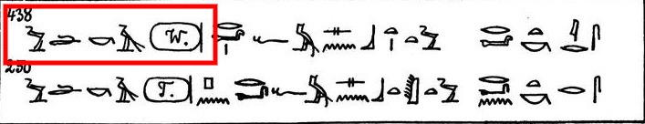
Ancient Egyptian < Snt > circle with Nubian Dongolawi < sılaː-dɛ >round. From the basic vocabulary shown above we’ve found numerous correspondences in large sets of words, such as the terms sister, bow, smell, nose , hair, child, eye, mummify, earth ,cut, night, black, woman, love, speech, house, hand, people, moon etc. The correspondences appear in large sets of basic words and more research will be uncovered .This shows the possibility of an linguistic genetic relationship between Nubian Dongolawi language and Ancient Egyptian .It seems that the correspondences recovered was by far not difficult . The two languages appear related from the correspondences found in over 50 basic items in its phonology. No other explanation can be devised other than the fact that and high frequency of correspondences exist in its most basic vocabulary. Chance similarities are ruled out do to the use of basic terms and borrowings is ruled out do to a high number of correspondences proving a case for a linguistic genetic relationship.
3.1 Morphological correspondences: Plural Stem and Adjective modifiers (noun + plural Stem, noun +adj)
Morphology is the study of word forms and structures. For instance, Egyptian plurality is a case when a word or noun has an attached stem {w} or {u} indicate more than one (noun + plural stem). This exists in Dongolawi (Nubian) which helps indicate plurality.
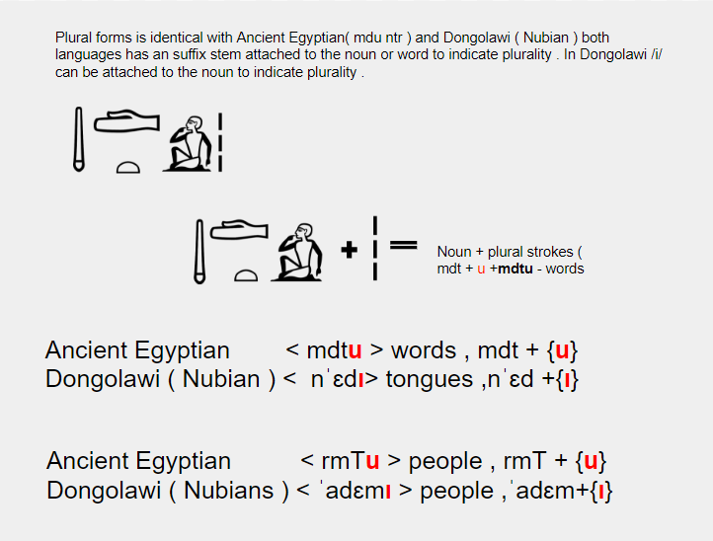
All of Dongolawi plural stems ({i}, {ncha}, etc.) attaches itself to the noun or word identical to plural markers in Ancient Egyptian. The Egyptian language can also duplicate symbols to indicate plurality normally seen in high frequency in Old Egyptian. Worterbuch’s dictionary recorded these old forms of S43. This is Gardiner code for the stick glyph in which you find them duplicated.
 Ancient Egyptian words seen here are also duplicated in Dongolawi (Nubian). One can find a duplicated version of plurality < ned ~ nad > tongues. Another case of morphological correspondences is the identical form of adjective modifiers in which the adjective follows the noun. In Ancient Egyptian and Dongolawi both adjectives for the term ‘black’ can modify nouns. This is found in Ancient Egyptian < km > ‘black’ and Dongolawi (Nubian) < urumei > ‘black’.
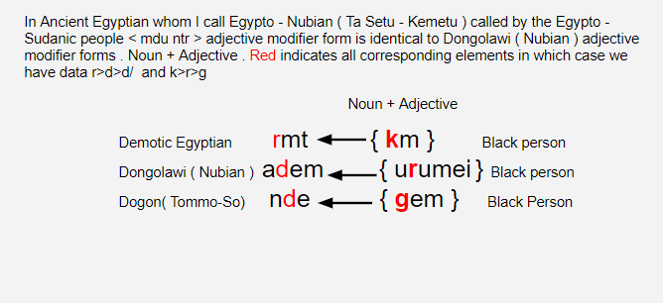
Both Ancient Egyptian and Dongolawi languages make use of the stem attached to the noun or term to indicate plurality-noun + stem. They both utilize the adjective modifier construction with an adjective that follows the noun and modifies it: noun +adjective. The negation particle in Ancient Egyptian < nn > ‘not’, is a negation particle that corresponds to Dongolawi Nubian < mn > ‘not’. The [m] can be seen to alternate with [n].
3.2 Shared pronouns found in Ancient Egyptian and Dongolawi (Nubian) Pronouns:
-i/-k/-T/-an
One will share identical pronouns found in Ancient Egyptian and Dongolawi (Nubian) from Dr. Rkhty Amen, Mejat Wefa Conversation Book, page 26. Here, she lists the pronouns found in Ancient Egyptian. It must be accepted that more pronouns may can be found between Ancient Egyptian and Dongolawi. Understanding the corresponding sound paths can assist with delianting sound changes between these two languages that seem to point toward a parent language.
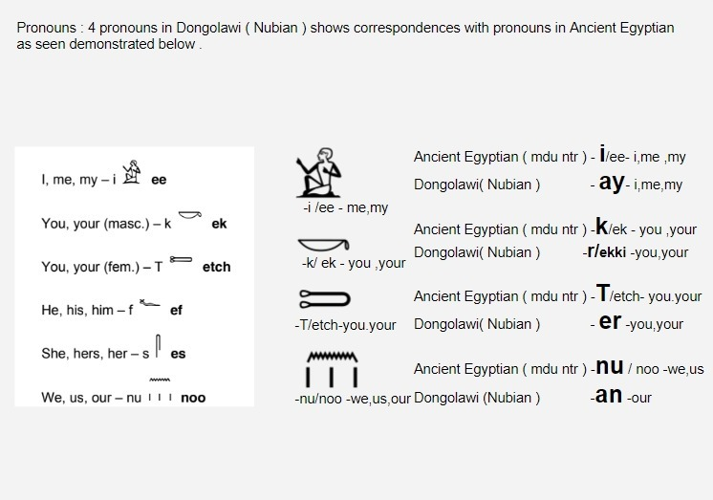
The ‘k>r’ correspondence explains the sequence of Egyptian pronoun -k / ek ‘you, your’ and Dongolawi -r ‘you, your’. The ‘-T /etch’ in Egyptian is variated or allophonic with the /t/ sound. We see an example of this in the Egyptian term < rmt > ‘person’ and Egyptian < rmT > ‘person’. This may have motivated the sound change of T > r where we find frequent t>r correspondence, k>k motivates in Ancient Egyptian < ek > “you “which is a suffix pronoun and it cannot stand alone but in Middle Egyptian we have < ek,> “you” that can function as an object of a preposition {n.k} = to “you” in Old Egyptian < kA > = “you” can function as { ud kA } “you place” indirect object of a verb which functions similar as an object and sound with Dongolawi Nubian < ekki > “you” as an object in Nubian Dongolawi. In Nubian Dongolawi it consists of two parts which are “you” (object) ek + ki (object marker). An example of Old Egyptian {ud kA} = “you” place is found in Pyramid Text 438.
Ancient Egyptian {ek/Ka/kAk} can be objects of verbs and prepositions similar to Nubian Dongolawi {ekki} you as an object Ancient Egyptian < tn > you with Dongolawi Nubian < ter > ‘you’. The n>r motivates the Ancient Egyptian pronoun < nu > we, us our for Dongolawi Nubian < ar > we also find Ancient Egyptian < nu > we, us, our and Dongolawi Nubian < an > ours.
4.1 Body Parts: Comparative Vocabulary with Nubian and Egyptian with 6 other African Languages
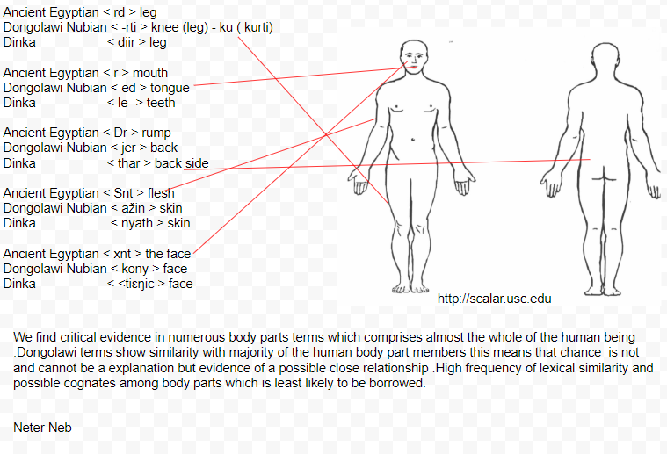
The motivation for the high frequency of similarities is due to sound paths already established in this work. The sound correspondences suggest a close affinity between Nubian Dongolawi and Ancient Egyptian. These similarities in basic vocabulary suggest a high frequency of affinity eliminating chance. We also eliminate borrowing by confirming similarities in other related languages like Yoruba, Dogon Tommo So, Dinka, and Kalenjin. Using sound paths adduced in this paper and observing correspondences already established, we find that these body part terms also exist in other African languages. This gives us some etymology by examining the meanings in these potential cognates. For example: Ancient Egyptian < Sn > hair, corresponds with Dongolawi Nubian < ser > ‘hair’. From this we can see a sound change ‘S>s /n>r’. In Dogon Tommo So < sìlì-ý > ‘hair point’ - ku prefix S>s /n>l, Yoruba < irun > ‘hair’ S>r? /n>n, < isa irun > ‘follicle’, Dinka < dul > ‘type of hair’ S>t>d / n>l < nak > ‘feathers’ S>k/n>n. From the range of etymology, we can discern various terms such as ‘kind of hair’, ‘hair point’, ’hair’ ,’follicle’, ’feathers’. As the linguistic professor consulted for this article, Dr. Satti possesses first-hand knowledge of Nubian sound paths and alternations. Using his understanding of the language it’s been shown that ‘S>s>t>d>r’ can all alternate in Nubian languages (Dr. Nasir Satti). Etymology is also explained by examining the extensions of meanings in variations of terms within each language or dialect.
Hair example :Initial S>s>s>r>d>s / Final n>r>l>n>l>m
Ancient Egyptian < Sn > kind of hair
Dongolawi Nubian < ser > kind of hair
Dogon Tommo So < sìlì-ý > hair point - {kù} prefix
Yoruba < irun > hair ,< isa irun > follicle
Akan /Twi < nwi > hair ,elision deletion of - s
Dinka < dul > type of hair do < nak > feathers
Kalenjin < suumey > hair ,fur < saayaantet > tail ,hair |
With a deep understanding of the sound paths ( sound laws ) demonstrated by the comparative methods we observe already established correspondences and possible sound changes that can be shown in other world languages S>s>s>r>d>s / n>r>l>n>n>l>m
1- Eye example : Initial r>i>n>l>t>r>r>n / final t>r>l>th >r>n>t
Ancient Egyptian < irty > eye ,look
Dongolawi Nubian < nal > eye
Coptic < eier > eye
Dinka < luith > look at
Dogon Tommo So < táárá > look < gire > eye
Yoruba < rí > see
Kalenjin < rit > look ,squinty eye < laabto > pupil < koonte > eye
2- Hand example : a>i:>n>w>ei
Ancient Egyptian < a > hand
Dongolawi Nubian < i: > hand
Dogon Tommo So < nǎ > hand ,arm
Yoruba < ọwọ́ > hand
Kalenjin < ei > hand
3- Mouth example: r>r>l>l> ŋ>n>k
Ancient Egyptian < r > mouth
Dongolawi Nubian < el > tooth < ed > tongue
Coptic < ro > mouth
SW Dinka < le-k > teeth SE < lëi > teeth SW < aro -l >throat
Dogon Tommo So < áŋá > mouth < ìnú > tooth ,Nanga< nɔ̌ > mouth , Jamsey < ònó > interior of gums < ìrⁿé > tooth
Yoruba < ẹnu > mouth
Akan/Twi < ano > mouth
Kalenjin < kuu- > mouth -t /r>k
4-Nose /face example : S>s>th>s>s>s / r> ŋ>r>s>r /t>ŋ>ŋ>d>t
Ancient Egyptian < Srt > nose ,face
Dongolawi Nubian < soriny > nose
Dinka < thaŋ > side of face
Dogon Tommo So < sɛ́rɛ́dɛ́ɛ́-n > straight nosed < sùgùlù téyⁿ > face
Yoruba < sise >nose bleed < çjôçlêjô > nosey ?
Kalenjin < Sēruut > nose < ser > nose < tokeet > face
5-Leg example : r>r>k>d>t>d>>r>k/d>t>rt>r>l>d>s>ld
Ancient Egyptian < rd > leg
Dongolawi Nubian < kurti > knee (leg)
Coptic < rat > foot
Dinka < diir > leg
Yoruba <àtẹ́lẹ̀ > sole of foot
Dogon Tommo So < dɔdɔ > knee
Akan/Twi < ɛserɛ > thigh
Kalenjin < keeldo > foot, leg < Ooreet > foot track
6-Head Example : d>r>r>d>th>t>t / d>n>ŋ>r>k
Ancient Egyptian < wdd > cerebrum ,head ,brain
Dongolawi Nubian < ur > head
Yoruba < orí > head ,top
Dogon Tommo So <dáná > head <dáá nɛ > top
Dinka < thaŋ > side of forehead
Akan/Twi < etire > head
Kalenjin < taako > top
7-Back example : D>j>th>j>h>k>r/ r>r>r>ŋg>n>r>t
Ancient Egyptian < Dr > rump
Dongolawi Nubian < jer > back
Dinka < thar > back side
Dogon Tommo So < jɔ́ŋgɔ́ > upper back
Yoruba < ẹ̀hìn > back ,back bone
Akan/Twi < akyire > back
Kalenjin < root > backbone < let > behind
8-Flesh/skin example: initial S>ž>s>ç>th >s / medial n>n>nd>n>n>m/final t>t
Ancient Egyptian < Snt > flesh
Dongolawi Nubian < ažin > skin
Dogon Tommo So < sande > animal skin
Yoruba < ẹran > skin
Dinka < nyath > skin < acï nyath nɔk > skin, rough skin
Kalenjin < Sumeet > goat skin < siirēēt > leather skin (worn by elders)
9-Face ,nose - Example : initial- x>k>d>t>k /medial- n>n>m>ŋ>m /final- t>t>s
Ancient Egyptian < xnt > the face ,front ,nose
Dongolawi Nubian < kony> face
Dogon Tommo So < kínú > nose < dìmmú > forehead
Dinka <tiɛŋic > face ,< tueŋ > front
Kalenjin < komas > face ,flank part
10- Vagina example : initial h>k>d>t>k / medial m>m>m>m>l>m / final t>t>t>t
Ancient Egyptian < hmt > uterus ( vagina )
Dongolawi Nubian < kumat > vagina
Dogon Tommo So < dúmmɔ́ > vagina
Yoruba < ômô > uterus <òbò> vagina
Dinka < aluat > mouth of vagina < yany > vagina
Kalenjin < mukut > vagina < mokol > vagina, woman genital
Akan < boo > euphemism for vagina’
11-Sperm example : initial d>t>d>dh >k / final d>r>l>t>th > t
Ancient Egyptian < dAdA> emission of seed (sperm)
Dongolawi Nubian < teiri > sperms
Dogon Tommo So < dɔ́lɔ́ > testicles
Yoruba < àtọ̀ > sperm
Dinka < -dhieth > sperm - lac
Kalenjin < kiiti > testicles
Akan < kɔtɪ > ‘penis’
12-body
Ancient Egyptian < xat > body
Nubian Dongolawi < jitat > body
Conclusion written by Dr. Nasir Satti PhD
In conclusion ,the study found a genetic relationship between Mdu Ntr and Nubian Dongolawi . Many sound correspondences were established. Sound correspondences is the regularity found between two or more languages in which we observe in numerous basic vocabulary to eliminate chance resemblance and similarities. Numerous sound correspondences are found in pronouns, verbs, body parts, and basic items that would be nearly impossible to be borrowed like hair, eye, sperm, vagina, face, skin, back, mouth, leg, we, you, me, adjective modifier construction (morphology), plural stem, sister, baby, girl, mother, father, big, love, walk, open, night, small, earth, flood, mummify, fish, moon, name, pull, smell, death. A possible genetic relationship is indeed established between Nubian Dongolawi and Pharaonic Egyptian.
References
- Amen,R. ( 2013 ) ,Mejat Wefa Conversation Book English to Medu Neter
- Bennett,R. ( 1998 ) ,Comparative Semitic Linguistics: A Manual
- Blench,R. ( 2005 ),Dinka-English Dictionary
- Blench,R. ( 2005), Baŋgi me, a language of unknown Affiliation in Northern Mali , Cambridge
- Budge,E.A.W. ( 1978 ), An Egyptian Hieroglyphic Dictionary, Vol. 1
- Budge,E.A.W. ( 1978 ), An Egyptian Hieroglyphic Dictionary, Vol. 2
- Cahill,L and Tiberius,C. ( 2002 ) ,Cross-linguistic phoneme correspondences
-Crowley, T. ( 1997 ) , An Introduction to Historical Linguistics
- Crum,W.E. ( 1939 ) , A Coptic Dictionary
-Campbell-Dunn,G.J.K. ( 2004 ),Comparative Linguistics: Indo - European and Niger - Congo
- Dimmendaal,G.J. ( 2011 ) ,Historical Linguistics and the Comparative Study of African Languages
- Diop,C.A. ( 1973 ) mentions : Negroes were responsible for building the prehistoric and historic Egypto-Nubian civilizations.' (Obenga, 1973, p. 102.) The peopling of Ancient Egypt And The Deciphering Of Meroitic Script
- Erman,A. and Grapow,H. ( 1905 ) ,Wörterbuch der ägyptischen Sprache
- Faarlund,J.T. ( 2012 ) ,A Grammar of Chiapas Zoque
- Fakinlede,K.J.( 2003 ) ,Yoruba : Modern Practical Dictionary ,Yoruba - English / English - Yoruba
- Faulkner,R.O. ( 1962 ) ,A concise dictionary of Middle Egyptian
- Gardiner,S.A.H.( 1927 ) ,Egyptian Grammar: Being an Introduction to the Study of Hieroglyphs
- Goddard,C. ( 2001 ) ,Lexico-semantic universals: A critical overview
- Griffith,F.L. (1898 ) ,Hieratic papyri from Kahun and Gurob (principally of the middle kingdom)
- Hock H.H and Joseph B.D.(1996 ), Language History, Language Change, and Language Relationship: An Introduction to Historical and Comparative Linguistics
- Kambon ,O. ( 2005), Recurrent Sound Correspondences of Akan and Yoruba and their Significance for Proto-Benue Kwa (East Volta-Congo) C1 Reconstruction ( Akan body terms )
- Sethe ,K ( 1908 ) , Die Altaegyptischen Pyramidentexte Pyramidentexte nach den Papierabdrucken und Photographien des Berliner Museums
- Leahy,A. ( 1994 ) ,Life in a Multi-Cultural Society: Egypt from Cambyses to Constantine and Beyond, pg 10 < rmt km > black man
-Obenga,T. ( 1974 ) ,The Genetic Linguistic Relationship Between Ancient Egypt and Modern Negro-African Languages
- Obenga,T.( 2007 ),Ancient Egyptian and Modern Yoruba : Phonetic Regularity
- Seroney,K.( 2009 ),Kalenjin Dictionary
- Starostin,G. ( 2017 ), Lexicostatistical Studies in East Sudanic I: On the genetic unity of Nubian-Nara-Tama
- Starostin,G. ( 2015 ),The Eastern Sudanic hypothesis tested through lexicostatistics: current state of affairs
- Starostin,G.( 2015 ) , East Sudanic family: Nubian group (11 lists),Tower of Babel Database
-Tatomir,P.( ? )abstract : The presence of horse in ancient Egypt and the problem of veracity of the horseshoe magic in the ancient Egyptian folklore and mythology, Hyperion University Bucharest , pp. 321-340
- UNSECO.( 1978 ) , The General History Of Africa Studies And Documents The Peopling Of Ancient Egypt And The Deciphering Of Meroitic Script
- Voogt,A and Rilly,C.( 2012 ) ,The Meroitic Language and Writing System
- The Oriental Institute Chicago. (2001) ,The Demotic Dictionary of the Oriental Institute of the University of Chicago

UNESCO ( 1978 )
Starostin,G.( 2015 )
Goddard,C. ( 2001 )
Budge,E.A.W. ( 1978 ) , Faulkner,R.O. ( 1962 ) , Gardiner,S.A.H.( 1927 )
Crum,W.E. ( 1939 )
Blench,R. ( 2005 )
Seroney,K.( 2009 )
Blench,R. ( 2005)
Fakinlede,K.J.( 2003 )
Crowley, Terry. (1997)
Hock H.H and Joseph B.D.(1996 )
Obenga, T.( 2007 )
Hock H.H and Joseph B.D.(1996 )
Obenga, T.( 2007 )
Bennett,R. ( 1998 )
Bennett,R. ( 1998 )
Blench, R. (2005)
Campbell-Dunn, G.J.K. (2004)
Dimmendaal, G.J. (2011)
Hock H.H and Joseph B.D. (1996)
Campbell-Dunn, G.J.K. (2004)
Campbell-Dunn, G.J.K. (2004), pg. 17
Amen, R. (2013)
Dimmendaal, G.J. (2011)
Cahill, L and Tiberius, C. (2002)
Campbell-Dunn, G.J.K. (2004)
Budge, E.A.W. (1978)
Voogt, A and Rilly, C.( 2012 )
Obenga,T.( 2007 )
Dimmendaal,G.J. ( 2011
Dimmendaal,G.J. ( 2011 )
Tatomir,P.( ? )
Budge,E.A.W. ( 1978 )
Starostin,G. ( 2015 )
Campbell-Dunn,G.J.K. ( 2004 )
Griffith,F.L. (1898 )
Leahy,A. ( 1994 )
The Oriental Institute Chicago. ( 2001 )
Faarlund,J.T. ( 2012 )
Crum,W.E. ( 1939 ) pg. 110
Allen ,J.P.(2014 )
Faarlund,J.T. ( 2012 )
Starostin,G.( 2015 )
Erman,A. and Grapow,H. ( 1905 )
Starostin,G.( 2015 )
Kurt Sethe 1908
Nasir Satti (2008 - 2009). Grammatical Analysis of Dongolese Phrases and Clauses .Unpublished PHD Thesis. University of Khartoum.

