National and Ethnic Identity as Discursive Styles in Selected Social Transformation Advocacy in Nigeria
Abstract
This paper examines the agency of national and ethnic identities in social transformation campaigns in Nigeria. Data for the study comprise advocacy texts that touch on anti-corruption crusade, entrenchment of democratic values and security of lives and properties. The data were drawn from speeches and jingles, Facebook posts, tweets and covered the period July 2013 to July 2018. The five-year span was informed by the wide gamut of negative realities in the nation at the time frame which led to increased mediatisation of social transformation messages in the nation. The analysis shows that the discourse participants deploy linguistic resources to construct the two identities as a strategy for strengthening the messages of social transformation in Nigeria. The paper reveals that national identity is invoked in the discourse to appeal to the sense of collective in the people of Nigeria to value their nation by embracing acts that would foster social transformation. The paper further shows that ethnic identities are meant for the purpose of unification of Nigerians in order to appeal to all the ethnic groups to embrace the crusade for social transformation in the country.

Introduction
The inextricable relationship between language and the society makes language a major agent for social construction owing to its ability to influence human ideas and thoughts just as the society also shapes language. This article projects the former role of language in shaping the society grounded in the Sapir-Whorfian idea of linguistic determinism which says that our thinking is determined by our language (van Troyer, 1994: 164). Of particular interest in this article is the role of language in engendering social change in human societies. Social change is an important feature of human societies which has profound impact on the totality of a particular society and its people. Greenwood and Guner (2008: 1) simply define social change as “a shift in the fraction of society ascribing to a particular attitude or mode of behavior”. Social change could thus be either positive or negative. While the literature shows that there are many predisposing factors of social change, this study pays attention to the role of language as an agent provocateur of social change. Since language is an aspect of culture and at the same time, an index of culture, we argue, very strongly, that it can provoke social change.
The present study in particular examines the agency of national and ethnic identities in the discourse of social transformation in Nigeria. The premise of the study is that identity as an interpersonal element of language use can also be deployed for mobilising people to embrace certain ideas and ideals. Even though the discourse of social change in Nigeria is largely ideational, it also features a significant use of interpersonal elements as the discourse participants deploy identity construction in order to strengthen the meanings in the texts and appeal to the audience to receive the message of the advocacy positively. Therefore, the discourse of social transformation in Nigeria is a useful domain for marking identity construction for functional purposes in the society. This functional quality of identity construction makes it worthy of scholarly exploration which the present study seeks to achieve. While previous studies on language and identity in Nigeria have focused on military barracks and the youth (Akande 2016; Mensah and Nkamigbo, 2016), hip-hop music (Adetunji 2011; Gbogi 2016) and nativisation of English (Kehinde 2004; Ayeleru 2011; Ayoola 2014 etc.), there is a dearth of research on the construction of identity for strategic social transformation advocacy in the nation. Thus, this study seeks to explore the use of identity construction in the discourse of social change in Nigeria.

2. Language and Identity
Identity is a construct that has received a great deal of attention from diverse academic traditions such as sociology, psychology, anthropology, linguistics, among others. According to Edwards (2009: 15), scholars have noted ‘a “veritable explosion” of interest in identity’. Essentially, identity is concerned with the perception of an individual in relation to certain groups that he or she belongs to. According to Djite (2006: 6), identity refers to the everyday word for people’s sense of who they are. Such a perception could be individual in which a member of a group, whether a family, culture, society views him or herself in relation to other members of the group as a distinctive entity or as sharing certain features of such a group. Therefore, while one could have personal identity, there are also forms of identity such as religious identity, social identity, ethnic identity, gender identity, among others.
Edwards (2009: 20) captures the relationship between language and identity by stating that “since language is central to the human condition, and since many have argued that it is the most salient distinguishing characteristic of our species, it seems likely that any study of identity must surely include some consideration of it”. According to Joseph (2004), the early 80s marked a time that there was an explosion of interest in the linguistic elements of identity in language use. From the linguistic perspective, Kroskrity (1999: 111) remarks that identity refers to the linguistic construction of membership in one or more social groups or categories. Omoniyi (2011: 260) asserts that “Language use is a parameter in determining identity, whether of individuals or groups”. The reality of the reflection of identity in language is incontestable and has been for long. The sociolinguistic concept of idiolectal variation for instance elucidates how the features of the language of an individual mark out such individual without having to make recourse to physical features. The same principle of language as an index of identity is reflected in the concepts of sociolect and dialect. However, with the recent interest in language and identity from the critical discourse analysis perspective, the focus on the relationship between language and identity is mainly on how such a relationship is used in mediating certain socially contentious subjects in the society by using language to represent social actors in certain ways in order for readers to interrogate and understand their roles in the subject of attention.

3. Perspectives on Language and Identity in Nigeria
Nwagbo (2015) studies identity patterns in the language use of Liberian refugees in Oru Camp, Ogun State of Nigeria by showing the attitudes of the refugees to their indigenous languages and the language of their host community. The study shows that the refugees exhibit strong positive identity for their indigenous languages while demonstrating negative attitudes towards Yoruba which is the language of their host community. The paper argues that through such display of attitudes, the discourse producers maintain their identity while resisting the identity of their new community. The implication of this is that successful acculturation does not take place which would hinder diversity that is very important for cross-cultural relations. Beyond the traditional studies on language and identity in Nigeria such as Nwagbo’s reviewed above, there are others that focus on nativisation of English (Adejumobi 1999; Kehinde 2004; Ayeleru 2011; Abdullahi-Idiagbon & Olaniyi 2011; Ayoola 2014) or the popularisation of indigenous languages (Igbokwe 2013; Emeka-Nwobia 2015 etc.). There are also a few studies on language and identity from a discourse perspective.
Adegoke (2011) also studies language and identity in Nigerian hip-hop music. The paper argues that Nigerian musicians deploy language in a way that popular music is creolised and indigenised to give it a peculiar national identity. The paper shows that popular music in Nigeria reflects the socio-political issues characteristic of a development nation such as Nigeria. Even though the author refuses to categorise popular music as of the resistance tradition, he argues that since it reflects the challenges of a postcolonial African state, it reflects national identity.
Mensah and Nkamigbo (2016) also examine language and identity in the context of youth linguistic behaviour in Calabar, Cross River, Nigeria. The study shows how sexual metaphors are used among the youth to mark a peculiar identity for themselves as sleazy and sexually active. The authors remark that sexual metaphors are used by the youth to describe sexual activities and the gatification derivable from it. The authors conclude that the use of such sexual metaphors is aimed at enhancing intimacy among the youth, asserting masculine hegemony through the cultural privileges of the dynamics of sexual activities and to assert youth-centred collective essence.
Gbogi (2016) examines language and identity in the youth sub-culture in Nigeria using the Nigerian hip-hop music. The study shows that language is used to create cultural, political and multilingual identities in the music and to sustain “the in-groupness of a growing urban youth sub-culture in Nigeria”. The paper shows how the artistes project their cultural and individual identities through rhetorical strategies such as ambiguity and indirection and how they use ghetto names to construct political identities for themselves in a developing nation such as Nigeria.
While the studies reviewed above show that language and identity has received some attention in linguistic research, the subject has not been explored in the context of Nigeria’s discourse of social transformation, and especially from a critical discourse analysis perspective.

4. Theoretical Framework
This study is grounded in critical discourse analysis (CDA) focusing on Fairclough’s (2013) dialectical-relational and Machin and Mayr’s (2012) critical multimodal approach which draws heavily on Fairclough’s approach. Therefore, the discussion of identity in the discourse transcends the descriptive view of it as attention is paid to the role that identity serves in discourses for power negotiation and ideological projection. CDA emphasises the idea that language, which is always social, is used to do ideological work and always bears the structures of power and identities in its environment of use because it is socially constitutive and constituted (Fairclough & Wodak, 1997:258). According to Wodak and Meyer (2009:27), Fairclough’s dialectical relational approach to CDA “focuses upon social conflict in the Marxian tradition and tries to detect its linguistic manifestations in discourses, in specific elements of dominance, difference and resistance”. The approach provides affordances for the analysis of discourses by focusing on the dialectical relationships between semiotic systems and social practices. In the context of the present study, social practice refers to the peculiar desires of the participants in Nigeria’s discourse of social transformation to construct identity for themselves for various motivations.
Fairclough (2015:129) lists the linguistic features that can be used for critical discourse analysis as entailing, vocabulary, grammar and textual structures. Therefore, in the analysis of the data, we pay attention to the expressive values of lexical and grammatical resources for identity construction in the discourse.
Machin and Mayr’s critical multimodal approach extends the general principles in critical discourse analysis as it shows that the principles of CDA can also be applied to the analysis of visual texts. For this study, we find its treatment of language and identity useful as a guide, as we draw on the representational strategies enunciated by the authors. Such representational strategies are personalisation and impersonalisation, individualisation and collectivisation, specification and genericisation, nomination and functionalisation, use of honorifics and anonymisation,

5. The Data Corpus
Data for the study comprise texts on aspects of social transformation campaign in Nigeria in the context of democracy, restoration of values, corruption compiled as a small corpus. The data were drawn from speeches, radio commentaries, jingles, printed texts, interviews, tweets and comments on online newspapers and covered the period March 2013 to March 2018. The five-year span was premised on the fact that Nigeria witnessed numerous challenges in the areas of insecurity, financial misappropriation and democratic impropriety while the data sources were chosen because they are the most popular media for the delivery of messages on social transformation in Nigeria. A substantial part of the data was self-collected through visits to television houses, radio stations, libraries, the office of the National Orientation Agency in Nigeria and personal recording of poster and billboard messages. Data for the study were obtained from the government (state actors) and civic engagement from the public (non-state actors). We consider the state actors as government functionaries from the President down, members of the opposition party who are in the legislature, government parastatals (National Orientation Agency, Ministry of Information, Nigeria Police, Independent National Electoral Commission and National Drug Law Enforcement Agency). On the other hand, non-state actors are individuals and private organisations that contribute to the discourse of social transformation in the nation. Below, we present the various parts of the corpus and the amounts of words in each item of the corpus.

State actor Corpus

Text Type | Number | Text Tokens
Speech | 8 | 6,079
Radio Commentaries | 8 | 2,855
Jingles | 15 | 1,829
Printed Materials | 8 | 2,132
Total |  | 12,895
Non-state Actor Corpus
Text Type | Number | Text Tokens
Speeches | 5 | 1,080
Interviews | 5 | 7,552
Jingles | 5 | 467
Newspaper Comments |  | 1629
Tweets and Facebook Posts | 45 | 2,047
Total |  | 12,775

6. Analysis and Discussion

6.1 National Identity and Social Transformation Campaign in Nigeria
The discourse of social transformation in Nigeria being one that focuses on a national concern which borders on restoration of sanity in the national, public and individual lives in Nigeria for the proper development of the Nigerian people and nation, is such that exhibits the Nigerian national identity. As shown in the discussion of ideology in the last chapter, since the ideologies of nationalism and nativism are strongly expressed by Nigerians, they use language to construct a peculiar identity for themselves as Nigerians, among other forms of identities expressed, through their linguistic choices. The national identity created in the discourse serves as a symbol of national unity and unification of purpose in the campaign for social transformation in the nation. Below is a multimodal text that serves the purpose:

Figure 4: Multimodal Text from State Actor (NOA)
The jingle produced reads:
Everyone is calling out for change but nobody wants to change. True change begins with the individual. So look in the mirror and ask yourself, who me? Yes you. Are you doing the right thing to change Nigeria? Let the change begin with you. Be positive, be patriotic, be right, make a change. Do the right things always to transform Nigeria, Nigeria. Do the right thing to transform Nigeria. (Italics mine)
State Actor Jingle (NOA)

In the multimodal text above, a distinct Nigerian identity is created to emphasise the fact that the primary target of the audience is Nigerians and that the message is intended to capture an issue that concerns the nation Nigeria. This is a way of delimiting the readership to Nigerians alone and defining the content of the text as important to them. A critical look at the text shows that the nation Nigeria is indeed focused in it just to emphasise the significance of the message for the nation. Omoniyi (2011) discusses the concept of focusing in the relationship between discourse and identity as the fronting and foregrounding of certain markers of identity in a text to create certain meanings. A close look at the visual component of the text shows that through colour, a peculiar Nigerian identity is created as the green colour which is the primary colour of the flag of the nation is given salience. Similarly, “white” which is the second colour of the Nigerian national flag is foregrounded as the coat of arms of the nation is presented in white in the visual image. This use of colours is not accidental; the colours are intentionally given prominence to construct a peculiar Nigerian identity for the text and to signify that the message is for Nigerians.
Beyond the colours which label the text as of a Nigerian concern, the presentation of the coat of arms of Nigeria in the image also gives a distinct Nigerian identity to the text. The coat of arms of course is an emblem of the nation which functions like a signature on anything in which it is displayed as distinctly Nigerian. Similarly, in the written component of the text, the word “Nigeria” occurs three times to project that the text has a Nigerian character. This also serves the purpose of focusing in identity construction as any lay reader of the text is able to discern without having read the full content that the text dwells on Nigeria.
It is remarkable that the Nigerian identity is adequately given to the text and this can also be said to be expressive or suggestive of the source of the text. It might be said that the Nigerian identity is so vividly constructed in the text because the text emanates from the government of the nation whose primary responsibility is furthering the goals, aspirations and dreams of Nigeria and its citizenry. The text is produced by the National Orientation Agency, which is a parastatal created by the government of Nigeria to sensitise the Nigerian people about government policies and activities so that those policies and activities could be well accepted by the people. The conscious construction of the Nigerian identity by the National Orientation Agency is even reflected by the fact that the agency also marked out the text as distinctly produced by them. The name of the agency “National Orientation Agency” and its acronym “NOA” both appear strikingly in the text in order to show to the public that the agency is responsible for the message and not other possible agencies such as Ministry of Information or Ministry of Culture.
The lexical and syntactic resources used in expressing the actions required of Nigerians for the nation to develop are constructive. Such lexemes as “positive”, “patriotic”, “right” and change” are used to align certain attitudes and attributes with what Nigerians should be for their nation to transform significantly. This shows that Cillia, Reisigl and Wodak’s (1999) idea of national identity reflects in the discourse of social change in Nigeria as their paradigm recognises constructive strategies. Similarly, the syntactic structuring of the expressions in which the lexemes feature reveals the elements of persuasion captured by the persuasive linguistic elements which Cillia et al. (ibid) subsumed under constructive strategies. Below is another text that reflects national identity in the discourse:

I welcome you all to this important occasion of the launching of the National Reorientation Campaign, called ‘Change begins with Me”. Nigeria is passing through a challenging moment where hardly anything works in a normal manner. Many have attributed this phenomenon to the total breakdown of our core values over the years.
State Actor Speech

There is the construction of a Nigerian/national identity in the text above through the proper noun “Nigeria” and the collective pronoun “our”. The mention of “Nigeria” in the text clearly shows one that the content of the text is related to Nigeria. The thematisation of “Nigeria” in the second sentence of the text further gives prominence to the identity that is being created in the text. Such thematic appearance of “Nigeria” immediately makes the reader to know the focus of the text. It is interesting that in the text, the speaker who is the President of Nigeria also projects national identity through the use of the collective pronoun “our”. The pronoun “our” is used to humanise the Nigerian people and give them a sense of belonging by their President. Cillia, Reisigl and Wodak (1999) refer to this strategy for marking identity as constructive identity as in the words of the authors such strategy “invite identification and solidarity with the ‘we-group’”. It portrays the people of Nigeria as one united people in spite of their ravaging challenges. Therefore, the president creates a collective identity for Nigerians through the representational strategy that Machin and Mayr (2012: 80) refer to as collectivisation, making them appear generic.
The representation of Nigerians as one whole united people and the identification of the President with the people through the strategy can be said to have the ideological effect of manipulating and persuading the people by the President in line with his desire on the matter. This is because the reality of the Nigerian nation is that there is so much division, part of which the government has even been alleged to be guilty of. For instance, many people have criticised the government on lopsided appointments and more recently the undue favouritism and protection of the Fulani herdsmen who killed innocent people in Benue State. Therefore, the “our” used by the President might be seen as the normal “sexy” use of language by politicians to attract and deceive the people. Below, we present another text for illustration on the construction of national identity in the discourse. The text is however a multimodal one produced in the context of the campaign for the patronage of local products by Nigerians:
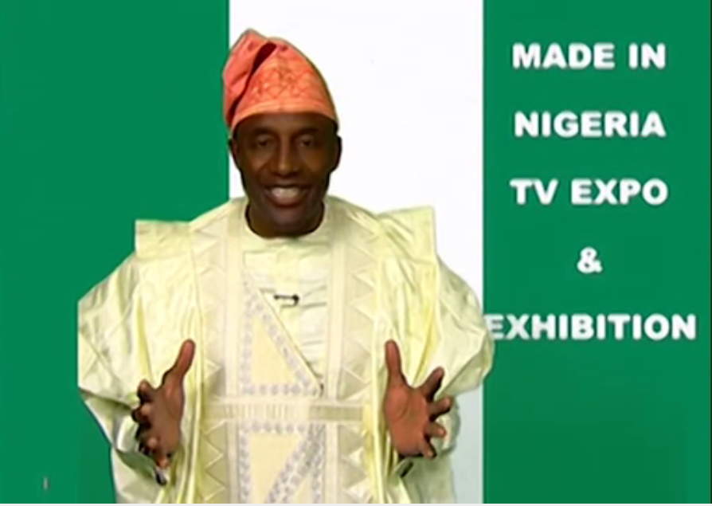
Figure 5: State Actor Text (NTA)

In the text above, the text producers complement the audio sounds in the production based solely on the need for Nigerians to patronise local contents with certain verbal and visual signifiers that project the Nigerian image. This depiction synchronises with Jones (2015) account of authentification as a marking identity, as the text producers try to evoke the feeling of authenticity in Nigerians through their subscription to indigenously Nigerian attires which serves as a metaphor for Nigerians’ patronage of local contents. Apart from the fact that the salient background of the actor in the multimodal text is used to give visibility to Nigerian identity as that is the colour of the national flag of Nigeria, the dressing of the actor in the image also reinforces the Nigerian identity being constructed in the text. Even though the dressing does not represent the entire range of dressing styles characteristic of Nigeria and Nigerians of various ethnic groups, it marks a notable typical dressing style in the country that is indigenous and even cuts across the major ethnic groups in the nation. The word “Nigeria” in the limited verbal text in the image also contributes to constructing a vivid Nigerian identity as it shows that the subject of the text is of significance for Nigeria.
It is remarkable that the construction of identity for Nigeria in the discourse is not only positive or neutral but actually sometimes negative. This even though one may consider unpatriotic reflects the perception of the discourse participants about the true situation or character of their country. These negative associations can in fact be said to trigger many of the campaigns for social change in the country and the virile civic engagement in the nation. Below is an example of a negative identification given to Nigeria by a discourse participant in reflection of his frustration at the Nigerian nation:
It is safe to say today that honesty, hardwork, Godliness have given way to all kinds of manifestations of lawlessness and degeneration in our national life.
State Actor Speech

The text above which is produced by the President of Nigeria, Muhammadu Buhari, constructs a negative image for Nigeria. The impression created of Nigeria by the text producer is that of an entity characterised by absolute lawlessness and uncivility. And it is remarkable that such a negative ascription to Nigeria has a high tendency of being taken seriously by the international community owing to the substance and position of the person who produces the text. The usual reaction to such a negative construction is likely to be that if the President of a country could speak of his country like this, then that must be totally true. This thus can be said to be a reflection of Cillia et al. (1999: 161) idea of destructive strategy as the declaration by the President negates the campaign during the regime of his predecessor that Nigerians are great people.
It is even more remarkable that the manner in which the President made the declaration is assertive as he uses the adjective “safe” to describe his proclamation. The fact that he considers it safe in his own judgment as the number one citizen of Nigeria tends to make one think that Nigeria is an all-round home of insanity, lawlessness, inhumanity, without any taints of positivity. The collectivisation and genericisation invoked in the construction of a negative identity for Nigeria makes the effect of the identity more vivid and pungent. By using the nominal group expression “our national life”, where the collective pronoun “our” is used to involve every single Nigerian in the negative reality and the adjective “national” to generalise that the negativities manifest in every sphere of the Nigerian society, the President paints a picture of an overwhelming label of disorderliness for Nigeria. This however is contestable because even though such identified negative attitudes may manifest largely in the country, it is obviously not the case that every Nigerian is involved and that it happens in every aspect of the Nigerian life.

5.2 Ethnic Identity as a Reinforcer of the Message of Social Change
Ethnic identity refers to certain features that associate a particular person with members of an ethnic group in contrast to members of other ethnic groups. Ethnic identity is also expressed through language as dialect for instance has for many years been an index of ethnic identity. In the civic engagement of Nigerians and the discourse of social transformation in Nigeria generally, ethnic identity becomes inevitable in view of the fact that Nigeria is a multi-ethnic society. Any discourse that seeks to have national significance on a national issue must reflect the ethnic diversity of the Nigerian nation in view of the fact that none of the ethnic groups wishes to be seen as inferior to another or be shortchanged in the process of mediating a crucial national issue. Similarly, it is common that many Nigerians, while using the English language naturally, reflect their ethnic identities as such features are noticeable in their use of the language most especially at the phonological level. Beyond the phonological level of marking identity in the discourse however, ethnic identity also manifests in sociolinguistic and discourse features such as code-switching, the use of indigenous languages and even proverbial use of language. Below we consider a text that expresses ethnic identity in the discourse:

Hear the call. Call to change. Stand up, Nigeria. Change is here. It’s going to stay. Change begins with you. O ya make we go. Asiko ti to, so let the change begin from within. Lokaci yayi. O ge ruwo la. Change begins with you and me. Change begins with me. Change begins with me.
State Actor Jingle

The text above indexes how ethnic identity is marked through the discourse style of code-switching. Whereas the Nigerian identity is well created in the text through the mention of the word “Nigeria”, the text producer also intentionally identifies with specific ethnic groups in Nigeria through the use of the languages associated with those ethnic groups alongside the English language in the text. In this instance, unlike Grad Fuchsel and Martin Rojo (2003) who indicate that ethnic identities serve the purpose of polarisation, the ethnic identities in the text serve a unification or nationalistic purpose. This can be said to be a conscious strategy to appeal to those segments of the country to consider themselves as important to the change agenda of the nation and actively involve themselves in the activities or vision of the government of the nation regarding the desired change in the nation. This approach to the construction of ethnic identity in the discourse negates Kang’s (2004) idea on ethnic identity as various kinds of self-categorisation. For instance, there is the use of Yoruba language in the text in the expression “Asiko ti to”. The expression creates the vivid impression that Yoruba people are actively involved in the change agenda of Nigeria and are fully interested in partaking in it without any delays.
The use of the particular Yoruba expression is also symbolic in view of the fact that in the typical traditional Yoruba settings, the concept of “asiko” (time) is taken seriously as it evokes a sense of predestination which should be given sufficient attention. Therefore, recourse is made to the folklore and cosmology of the Yoruba as a strategy for creating ethnic identity in the text. The Yoruba culture being such that believes in the existence of destiny values “asiko” (time), and thus holds that at the appropriate time for a particular event to take place, such event is bound to happen and it cannot be changed. Therefore, the sense is conveyed through the expression that the time for Nigeria’s social transformation is here; it cannot be changed and everybody should support it.
The use of the indigenous expression “lokayi yayi” is also meant to foreground another ethnic or cultural group in the Nigerian nation. The expression is Hausa and since the Hausa are very populous and have a proud heritage, it is pertinent to reflect them in the discourse with a view to giving them a sense of belonging in the campaign for social change in Nigeria. Similarly, the use of “Ogeru wola” is targeted at identifying with another ethnic group in the Nigerian society, especially from the Southeastern part of the country. Through the conscious appeal to the segment of the Nigerian nation by the use of the expression, the people of the region would feel happy to associate with the campaign for social change in Nigeria. It is significant that there is the use of Pidgin English in the text as this can also be said to be a strategy of appealing to some segments of the Nigerian society. Even though many people of different ethnic groups now use pidgin for communication especially in cosmopolitan cities like Lagos and Abuja, there is a sense in which pidgin is primarily associated with the people of Southeastern Nigeria. There are for instance many Igbo people who acquire pidgin as their mother tongue because it is the language of the home. Therefore, the use of pidgin in the code-switched text can be said to be a conscious strategy of giving a sense of belonging to the Igbo people who primarily use pidgin in the Nigerian society.
This construction of ethnic identities in the text is significant considering the fact that the text is produced by an arm of the government, National Orientation Agency. It shows that the government is conscious of the need to give due recognition to different ethnic groups for the purposes of cross-ethnic solidarity and national cohesion which are required for the advocacy campaigns of the government for social change to be successful. The fact that the text producers value the various people of Nigeria in the campaign for social change in the nation also reflects in the use of the pronouns “you” and “me” in the text. In fact, the use of “you” and “me” in the text is significant, as it shows that the text producers, NOA, subsequently realised that they needed to include themselves in the audience of the message since they are also Nigerians. In this case, the government does not exclude itself as part of the change needed for the Nigerian society as opposed to an earlier jingle in which the government focused only on the citizens as the ones who need to change. Below is another text that features the construction of identity in the discourse:

Wow o, wo bi, ago mejo lo ti lu yi, mo de si maa gbero lona. So o maa kuro lona abi kii n ran e lowo si gutter ni? Ha ha, buoda alapupu , mo le fo hin, mo le fo hun ni n je ki ologinni ko si kanga. Crown FM loni ka sare owo mo niwonba ka ma ba fi emi ara wa ohun ero wewu. Translation:
See it is already 2 p.m. and I am still going to pick people on the road. Will you leave the way or should I hit you such that you fall in the gutter? Ha ha, the bike rider, I want to do this, I want to do that in a hurry makes one to get into trouble. Crown FM says that we should pursue material gains modestly so that we don’t endanger the lives of passengers and our lives.
Non-State Actor Jingle

The text above shows how certain aspects of the discourse of social transformation are completely rendered in a particular indigenous language to create ethnic identity. The text above even though focuses on an issue that has wide significance in Nigeria is rendered in Yoruba language by the text producer. The use of the Yoruba language limits the readership in this instance as it indicates that the text is specifically for the Yoruba readers who are valued by the text producer. In this instance, the text producer is a radio station that is based in Ile-Ife, the ancestral home of the Yoruba. Therefore, it can be said that going by the location of the producer of the text, they are showing profound affinity with the Yoruba culture and ethnic group through the expression of the message of patience among motorcyclists in the Yoruba language.
To show that ethnic identity is consciously constructed in the text, we present some images of a particular jingle in the discourse:
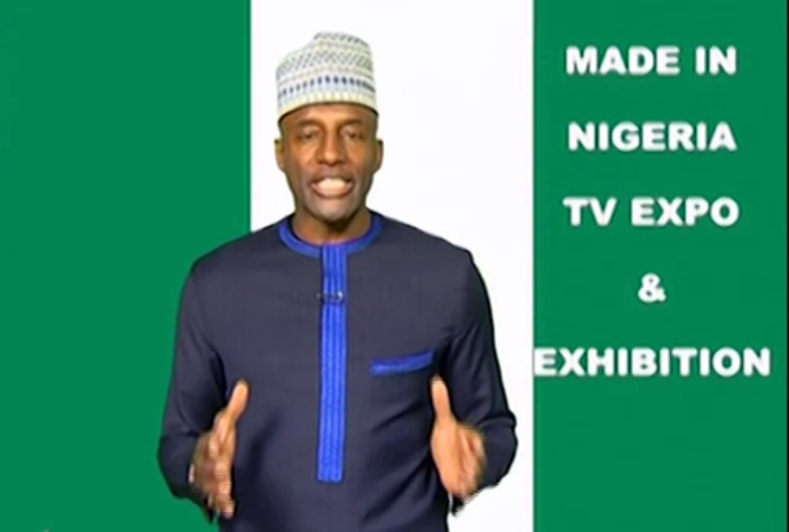
Figure 7: State Actor Jingle (NTA)

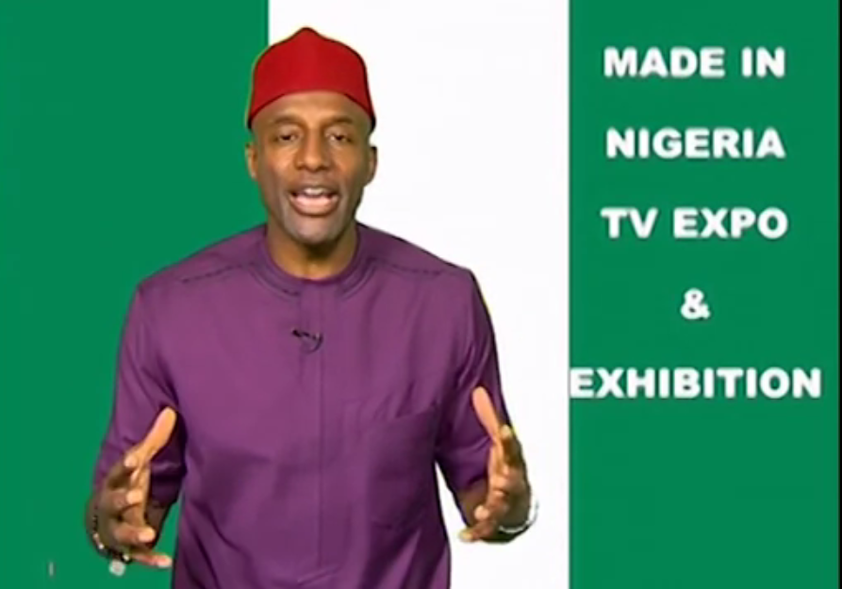
Figure 8: State Actor Jingle (NTA)

The images above which are drawn from the jingle on the need for Nigerians to patronise local contents referenced under the discussion of national identity earlier are used to create, in addition to national identity, ethnic identities. As already mentioned, even though the images essentially are intended to promote local products for the benefit of Nigeria, attention is paid to the construction of ethnic identities mainly for the reason of demonstrating sensibility to the ethnic diversity of Nigeria in order to appeal to the people from the various ethnic groups. Similarly, such could avert the ethnic bickering that could ensue if a particular ethnic group is projected at the expense of another. Since the Yoruba, Igbo and Hausa ethnic groups are the major ethnic groups in Nigeria, the three are represented in the jingle through the clothes and styles of dressing that typically serve as identification for people of the ethnic groups. The dressing style in figure five earlier presented reflects the dressing style of the Yoruba which is used to give prominence to Yoruba identity as a subset of the Nigerian identity which the discourse producer intends to strengthen. Similarly, in figure 7, the dressing style of a Hausa man, especially the cap, is used to index the Hausa culture while in figure 8, the rep cap which is typical of the Igbo culture is used to mark the Igbo identity in the discourse. All of this shows that dressing as a kind of non-verbal communication serves the purpose of identity construction in discourses, and in particular, the discourse of social change in Nigeria. It also shows that unlike Grad Fuchsel and Martin Rojo (2003), ethnic construction does not only feature discursive practices and goals of polarisation but can also be deployed for unification. Finally on ethnic identity, we present another datum for exemplification:
There is difference between Igbo leaders and Abuja political contractors. Ndi Igbo and Biafra in general, demand #BiafraReferendum to decide over their future which is a democratic process to dissolve this abominable entity called Nigeria in peace. #SupportBiafraReferendum
Non-State Actor Tweet

The text above represents another example of how ethnic identity is constructed in the discourse of social transformation in Nigeria. The text specifically shows how ethnic identity is projected in the discourse not for the purpose of unification of the various ethnic groups in Nigeria but for the assertion of the will of a particular ethnic group. Thus, the kind of ethnic identity projected in the text can be said to be characterised by Bucholtz and Hall’s (2005) strategy of distinction for identity marking. Nigeria as a multi-ethnic nation has often battled with inter-ethnic agitations and agitations for cessation of certain ethnic groups from the federation, especially the Igbo. The campaign for the cessation of the Igbo from Nigeria has been vociferous lately as many Igbo people have often called for the establishment of Biafra nation. Therefore, in the discourse of Nigeria’s social transformation, especially where the insanities of the political leaders are referenced, there is often the tendency for Igbo people, i.e., non-state actors to foreground their agitations for cessation from Nigeria as their own model of social transformation. As can be seen from the text, Nigeria is referred to as “abominable” by the text producer, showing lack of interest in and disdain for Nigeria. This is a way by which the text producers disalign themselves from other people in Nigeria through the strategy of distinction theorised by Bucholtz and Hall (2005).
The fact that this tendency is popular among the non-state actors is indexed in the first sentence of the text where the text producer draws a distinction between Igbo leaders in government and those closely affiliated to them and other hand Igbo leaders who are not in government and are championing the call for the establishment of the Biafran nation. The distinction is meant to serve the purpose of negative other representation (van Djik, 2003) of the Igbo leaders in politics and those affiliated who benefit from government as unworthy people who are not genuinely the leaders of the Igbo but common opportunists. On the other hand, the text producer constructs a positive image for Biafran agitations by positively representing the Igbo leaders associated with Biafra as the worthy and true leaders of the Igbo, thus projecting Biafra as a worthy cause and giving prominence to the ethnic identity of the Igbo. Therefore, in the discourse, it has been shown that Bulcholz and Hall’s (2005) identity marking strategy of distinction serves both the purposes of positive self-representation and negative other-representation. Certain lexical resources are also used in the text to construct an Igbo identity for the text. For instance, Igbo naming lexemes such as “Ndi Igbo” and “Biafra” are used while “Biafra” is foregrounded through the expression “SupportBiafraReferendum” and “Biafrareferendum” which are foregrounded through the noticeable colour blue and enclosement with the hashtag to give prominence to the Igbo ethnic group in the text.

7. Conclusion

This paper has tried to analyse the construction of national and ethnic identities in the social transformation advocacy texts in Nigeria. The analysis shows that the discourse participants deploy linguistic resources to construct the two identities as a strategy for strengthening the messages of social transformation in Nigeria. The paper reveals that national identity is invoked in the discourse to appeal to the sense of collective in the people of Nigeria to value their nation by embracing acts that would foster social transformation. This sense of collectivisation is achieved through linguistic elements such as the inclusive plural subject “we” and the possessive plural pronoun “our” which is used to refer to certain aspects of the national identity in Nigeria. The paper also shows that through the use of semiotic resources such as Nigerian clothes and dressing styles, the text producers encourage Nigerians to embrace their identity and contribute to social transformation in the country through the patronage of Nigerian made products.
The paper further shows that unlike in many other studies where ethnic identities are constructed for the purpose of establishing difference, the construction of ethnic identity in this study is meant for the purpose of unification of Nigerians in order to appeal to all the ethnic groups to embrace the crusade for social transformation in the country. This is given attention due to the high heterogeneity of ethnic groups in the nation. Prominent markers of ethnic identity in the discourse the use of indigenous language, the use of pidgin English, naming lexemes and the use of peculiar clothing cultural clothing materials and dressing styles. The study concludes that the construction of national and ethnic identities is strategically deployed to impress the message of social transformation on Nigerians with a view to conditioning them to embrace it.

References
Abdullahi-Idiagbon, M. & Olaniyi, O. (2011). Coinages in Nigerian English: A sociolinguistic perspective. African Nebula, 3, 78-85.
Adegoke, A. (2011). Language and identity representation in popular music. International Journal of Innovative Interdisciplinary Research, 1, 150-164.
Adejumobi, M. (1999). Routes: Language and the identity of African literature. The Journal of Modern African Studies, 37 (4), 581-596.
Akande, A. (2016). Multilingual Practices in Nigerian Army Barracks. African Identities, 14(1), 38-58.
Ayeleru, B. (2011). Linguistic innovation in the new West African Europhone novel: Between interlanguage and indigenization. California Linguistic Notes, XXXVI (I), 1-32.
Ayoola, K. (2014). “Things fall apart as the avant-courier of the Nigerian variety of English”. In C. Anyadike & K. Ayoola (Eds.) Blazing the Path: Fifty Years of Things Fall Apart (pp. 192-207). Ibadan: HEBN Publishers.
Bulcholz, M. & Hall, K. (2005). Identity and interaction: A sociocultural linguistic approach. Discourse and Society, 7(4-5), 585-614.
Cillia, R., Reisigl, M. & Wodak, R. (1999). The discursive construction of national identities. Discourse and Society, 10(2), 149-173.
Djite, P. (2006). Shifts in linguistic identities in a global world. Language Problems and Language Planning, 30(1), 1-20.
Edwards, J. (2009). Language and Identity: An Introduction. Cambridge: Cambridge University Press.
Fairclough, N. & Wodak, R. (1997). Critical discourse analysis. In T. van Dijk (Ed.) Introduction to Discourse Analysis (pp.258-284). London: Sage Publications.

Emeka-Nwobi, N. (2015). The place of indigenous Nigerian languages in national development. Research on Humanities and Social Sciences, 5(12), 112-116.
Fairclough, N. (2009). “A dialectical-relational approach to critical discourse analysis in social research”. In R. Wodak & M. Meyer (Eds.), Methods of critical discourse analysis (pp. 162-186). London: Sage Publications Limited.
Fairclough, N. (2013). Critical Discourse Analysis: The Critical Study of Language. New York: Routledge.
Fairclough, N. (2015). Language and Power. London: Routledge.
Gbogi, T. (2016). Language, identity and urban youth sub-culture: Nigerian HIPHOP Music as an Exemplar. Pragmatics, 26(2), 171-195.
Grad Fuchsel, H. & Martin Rojo, L. (2003). “Civic” and “ethnic” nationalist discourses in Spanish parliamentary debates. Journal of Language and Politics, 2(1), 31-70.
Greenwood, J. & Guner, N. (2008). Social change. IZA Discussion Papers, 3485, 1-67.
Igbokwe, B. (2013). Language and identity: A case of Igbo in Nigeria. International Journal of Development and Management Review, 8(1), 144-158.
Joseph, J. (2004). Language and Identity: National, Ethnic, Religious. Basingstoke: Palgrave Macmillan.
Kehinde, A. (2004). English and the postcolonial writer’s burden: Linguistic in Femi Fatoba’s My Older Father and Other Stories. West African Review, 6, 75-90.
Krey, P. (1997). The impact of language on the society. Retrieved from http://www.scholardarity.com/?page_id=1069.
Kroskrity, P. (1999). Identity. Journal of Linguistic Anthropology, 9(1-2), 111-114.
Lacan, J. (1997). Ecritis: A Selection. London: Tavistock.
Machin, D. & Mayr, A. (2012). How to Do Critical Discourse Analysis: A Multimodal Introduction. London: Sage.
Mensah, E. & Nkamigbo, L. (2016). All I want is your waist: Sexual metaphors as youth slanguage in Nigeria. Sociolinguistic Studies, 10 (1-2), 177-198.
Omoniyi, T. (2011). “Discourse and Identity”. In K. Hyland & B. Paltridge (Eds.), The bloomsbury companion to discourse analysis (pp. 260-276). London: Bloomsbury.
van Djik, T. (2003). Ideology and Society: A Multidisciplinary Approach. London: Sage.
Van Troyer, G. (1994). Linguistic determinism and mutability: The Sapir-Whorf hypothesis and intercultural communication. Jalt Journal, 6(2), 163-178.
Wodak, R. & Meyer, M. (2009). “Critical discourse analysis: history, agenda, theory and methodology”. In R. Wodak & M. Meyer (Eds.), Methods of critical discourse analysis (pp. 1-33). London: Sage Publications Limited.

