A Crosslinguistic Study of Body Part Expressions in Ancient and Contemporary Afrikan Languages: Akan, Yorùbá, Kiswahili and  mdw nTr

Abstract: This study aims to discuss body part expressions in Akan (a Ghanaian language), Yorùbá (a Nigerian language), Kiswahili (a Tanzanian language) and  r n Kmt ‘lit. the language of the Black Nation’. The paper addresses the common worldview whereby the concept and its articulation maintain a close connection to the literal real-world referent (the body part in question). The data is taken from collections of previously attested oral and written texts. The study demonstrates that there is a shared worldview continuum from ancient to contemporary Afrikan languages as manifested in body part expressions and that degree of proximity and similarity can be charted along a fundamental interrelation/fundamental alienation continuum.

Keywords: body part expressions, fundamental alienation, fundamental interrelation matrix, continuum

Introduction

“They say a picture is worth a thousand words but you know, I feel like I grew up in an environment where a person could use a few words and it felt like a thousand pictures.”
– Okunini Keith Cross (Hutcheson and Cullinan 2017)

This paper is a cross-linguistic study of body part expressions in ancient and contemporary Afrikan languages. Specifically, the comparative analysis will address these expressions as attested in Akan, Yorùba, Kiswahili, Mdw NTr.
Akan is a language spoken by approximately 9,100,000 in Ghana with 8,100,000 of these L1 users. It is also spoken in La Côte D’Ivoire and Togo. The two main subdivisions of Akan are Mfantse and Twi. Mfantse dialects include: Agona, Anomabo Fanti, Abura Fanti, and Gomua while the Twi dialects include: Ahafo, Akuapem, Akyem, Asante, Asen, Dankyira, Kwawu (Ethnologue 2020a). In this paper, examples will be drawn primarily from the Asante Twi dialect.
Yorùbá is one of three major languages of Nigeria. It is spoken by 42,000,000 in Nigeria, with L1 users estimated at 40,000,000 in Nigeria as of 2018. L2 users are estimated at 2,000,000 with total users in all countries amounting to 42,472,860. Yorùbá dialects are Oyo, Ijesha, Ila, Ijebu, Ondo, Wo, Owe, Jumu, Iworro, Igbonna, Yagba, Gbedde, Egba, Akono, Aworo, Bunu (Bini), Ekiti, Ilaje, Ikale, Awori, Ào and Standard Yorùbá which is spoken and used in education, the media, and social contexts generally (Ethnologue 2020b). It is also spoken in Sierra Leone, Benin and Togo with its westernmost contiguous variant—known as Kiliji—spoken in Ghana (Brindle, Kropp Dakubu and Kambon 2015). It is also used in the Diaspora by heritage speakers as a ritual language in Brazil, Cuba, Trinidad and Tobago, and Puerto Rico, among others. The Standard Yorùbá orthography will be used throughout the paper.
Kiswahili is the national language of Tanzania with over 47,000,000 speakers in that country alone. L1 users are estimated at 15,000,000 in Tanzania (2012) with the remainder comprising L2 users (32,000,000). Total users in all countries are estimated at 98,523,010 with 16,223,010 as L1 users and 82,300,000 as L2 users. Dialects include Mrima (Mtang’ata), Unguja (Kiunguja, Zanzibar), Pemba, and Mgao (Kimgao). Other countries in which Kiswahili is spoken widely include Kenya, Uganda, Rwanda, Burundi, and Congo (DRC) (Ethnologue 2020c). Standard Kiswahili (based on the kiUnguja dialect) orthography will be used in this paper.
Mdw Ntr is the written variant of the classical spoken language known indigenously as r n Kmt ‘language of the Black nation.’ Its usage was attested from ca. 3200 bce with its last variant, known as Coptic, used as a spoken language until the mid-1800s ce. Coptic continues to be used as a liturgical language (Allen 2013). As a member of the Négro-Égyptian language family, cognates of the language are found in many contemporary Afrikan languages throughout the continent (Obenga 1993). Mdw Ntr examples will be drawn from Vygus (2015) from the stage of the language referred to in egyptological circles as so-called “Middle Egyptian.”

This cross-linguistic study aims to demonstrate not only body part expressions common to the languages under study, but to also demonstrate the common worldview that underpins the manifestation of body part expressions throughout space and time among  Kmt(yw) ‘Black people.’ This will then be framed with regard to what we term the Fundamental Interrelation/Fundamental Alienation Continuum with Fundamental Interrelation typical of the worldview of Kmt(yw) ‘Black people’ and with fundamental alienation typical of the  aAmw ‘eurasians’ worldview.

Fundamental interrelation Fundamental alienation

“Physicalistic” conventionalized B.P.E. | Optional Idiomatic B.P.E. | “Mentalistic” etymologically opaque sounds
Interrelation between thought and body Separation between thought and body
Figure 1: Fundamental Interrelation / Alienation Continuum

This continuum will be discussed in the conclusion with specific examples from the body of the paper given to demonstrate what is meant in each instance.
This paper is organized by means of introduction, conceptual framework and methodology, data, and, finally significance and conclusions.

Conceptual Framework and Methodology
In terms of methodology, we engage in purposeful sampling (Patton 2002, p. 230) of body part expressions from several sources and from the four languages delineated above each rendered in the standard orthography of the language in question. With regard to body part expressions included, we will focus on conceptual and semantic parallels or at least near parallels cross-linguistically. Secondarily, we will look for identical or similar lexemes. Further, we will deal with dimensions of proximity as a measure of similarity between people: We will deal with biological proximity, cosmological proximity and cultural proximity, all of which are shown below in what we term the Fundamental Interrelation Matrix (cf. Kambon and Dzahene-Quarshie 2017):

Table 1: Fundamental Interrelation Matrix
 | Conceptual/Semantic Similarity | Contextual Similarity | Lexical Similarity
Physiological proximity
Cosmological proximity
Cultural proximity

The purpose of this matrix is to facilitate the charting of similarities and proximity in the case of each body part expression across various dimensions. Before inclusion in the comparative study, we use evaluative criteria of Conceptual/Semantic Similarity (similarity of meaning and the concept conveyed by the body part expression), Contextual Similarity (similarity of the context in which the body part expression is used), and Lexical Similarity (similarity of lexemes with specific regard to the body part in question). These criteria are then juxtaposed with intersecting considerations of Physiological proximity (same options available for expressing embodiment), Cosmological proximity (closeness with regard to how the worldview is expressed), Cultural proximity (closeness in terms of cultural outlook as manifested through body part expressions). These dimensions of similarity are expressed in terms of what we coin in the pragmatics context as fundamental interrelation. The implications of fundamental interrelation in this regard is founded upon conceptualizations of our relation between ourselves and that which is around us in nature as affirmations of being and reality as opposed to alienation from them and negation thereof. In the next section we will look at data exemplifying the cross-linguistic phenomenon of body part expressions in the languages under study.

Data
We being this study with looking at body part expressions on a literal level, which is not so much conceptual, metaphorical or analogical as other expressions that we will cover below. This can be found in the following examples:

- Head as experiencer of pain

Akan
- a-ti-pae-ɛ
nmlz-head-split-nmlz
‘headache’ (Agyekum 2019: 34)
Yorùbá
- Orí fífọ́
head nmlz.break
‘headache’ (Fashagba 1991: 164, 314)
Kiswahili
- Kichwa ki-na-ni-uma
7-head 7sm-pres-1om-hurt
‘headache’ (Dzahene-Quarshie 2016: 96)
Mdw Ntr
- 
gs tp
side head
‘headache’ (Vygus 2015: 492)

Each body part expression, here, is basically more or less straightforward; dealing with the head as the experiencer of pain, because it is actually what literally experiences the pain. In Akan, this is rendered as atipaeɛ ‘headache (lit. head-split).’ In Yoruba this is rendered as orí fífọ́, which literally translates to head breaking. Again, this is because it is the head that literally feels the pain, so it is, of course, reflected in the way of expressing headache. And in Kiswahili, we find kichwa kinaniuma, which is literally head-hurting.

However, the core of this paper deals with body part expressions in terms of metaphors and connections that are, perhaps on the surface, less straightforward. However, we find that, whereas in non-Afrikan languages these expressions are not conventionally connected with a specific body part affected, in each instance of the Afrikan languages included in this study, body part expressions are the standard and oftentimes, the only way of expressing the concept in question.

An example of this is found in (2) below:

- Heart as Seat of Thought/Remembrance/Knowledge

Akan
  - Nea ɛda m’akoma so
rel 3sg.inan.lay 1sg’heart top
‘That which lays on my heart’ (i.e., what one is thinking about) (Agbeshie 2018)
Yorùbá
  - èrò ọkàn mi
thought heart 1sg.poss
‘thought of my heart’

  - fi í sọ́kàn
take 3sg.obj lat.heart
‘put it in the heart’ (remember it)
Kiswahili
  - Ku-wapo moyo-ni, ha-lipo ma-cho-ni.
inf.exist heart-inside, neg.exist pl-eye-inside
‘Something can be in the heart without being seen.
(lit. What you do not see, you can remember in your heart).’ (Scheven 2012)
Mdw Ntr
imt ib
that which is in heart
‘thought, idea, wish’ (Vygus 2015: 1382)

In Akan in (2a) nea ɛda m’akoma so ‘what one thinks about (lit. that which is that which lays on my heart).’ Conversely, in English one would say that something is ‘on my mind’ whereby the ‘mind’ is an abstract entity disembodied and dissociated from a specific body part. In Yorùbá, as shown in (2b) we see èrò ọkàn mi ‘my heart’s thought.’ Again, it is the heart that does the thinking. There is also the conventionalized body part expression fi í sọ́kàn ‘remember it (lit. put it in the heart).’ In Kiswahili, we find you can say kuwapo moyoni, halipo machoni ‘something can be in the heart without being seen (lit. what does not exist in the eye, exists in the heart).’ This is yet another instantiation of the idea of the heart as the seat of remembrance. In Mdw Ntr, we find imt ib ‘thought, idea, wish (lit. that which is in the heart).’ Each body part expression deals with the heart as the seat of thought, remembrance and/or knowledge. This again goes to a shared worldview in that in non-Afrikan languages like English, for example, it is the head that knows, it is the head that thinks so forth and so on. But in these various Afrikan languages separated by significant spatial and temporal distance there is a relationship between the heart and all of these functions. Further, each instance, the source body part from which the expression is derived is transparent.

- Eye as Signifier of Displeasure

Akan
- ani bɔne
eye bad
‘evil eye’ (Asumasɛm 2017)
Yorùbá
- gba ojú ibi
receive eye bad
‘To incur displeasure of another person.’ (Fabunmi 1985: 27)
Kiswahili
- ma-cho ma-baya
pl-eye pl-bad
‘evil eye’ (Mackenzie 2013)
Mdw Ntr
- 
smH
‘one with evil eye’ (Vygus 2015: 971)

Now you also have the idea of an eye as a signifier of displeasure for more or less obvious reasons. All of us know how it is if you want to ‘cut’ your eye at someone.

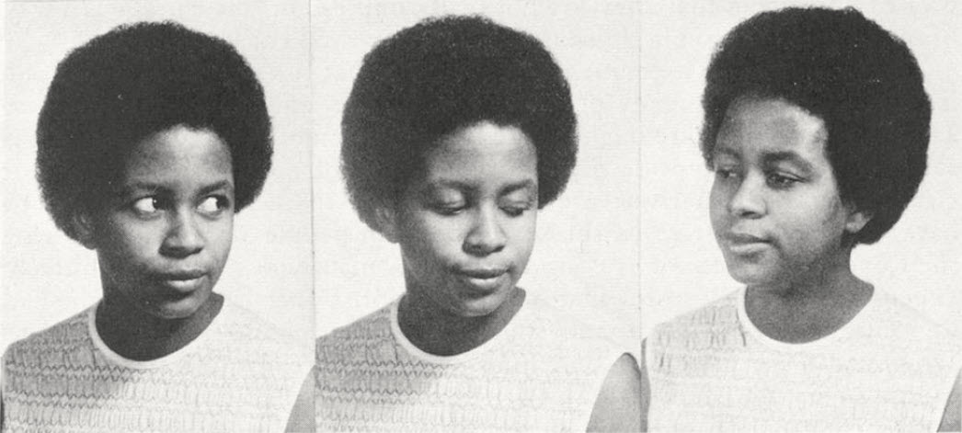
Figure 2: Sequence of movements in a cut-eye. Note accompanying suck-teeth (in this case, closure is made with the tongue against the alveolar ridge). (Rickford and Rickford 1976: 276).

In Akan the term ani bᴐne translates to ‘bad eye.’ This can be seen in the way that a person looks at another with disdain by ‘cutting’ one’s eye at them as shown in Figure 2. In Yoruba you can also say gba ojú ibi which is to literally ‘receive bad eye.’ In Kiswahili, the exact same concept is conveyed by macho mabaya. In the case of Mdw Ntr, we have where the word itself has an eye as the determinative showing the body part to which the concept is associated.

The basic idea is that each of these different languages is using the same means in order to express the concept. In languages steeped in a worldview of fundamental alienation, however, expressions such as these would be considered idiomatic with a disembodied, often etymologically opaque, abstract term divorced from being and reality considered to be the standard term.

- Heart as experiencer of Happiness

Akan
- akoma-tɔ-yam/a-bo-tɔ-yam
heart-fall-stomach/nmlz-chest-fall-stomach
‘rejoicing of heart/happiness’ (Agyekum 2019: 209, 210)

Yorùbá
- ọkàn yọ̀
heart rejoice
‘heart rejoices’

Kiswahili
- moyo wa furaha
heart gen joyfulness
‘heart of joyfulness’

Mdw Ntr
- 
nDm ib
sweet heart
‘joyful, cheerful, content, to rejoice, be glad’ (Vygus 2015: 645)

Awt ib
long heart
‘happiness’ (Vygus 2015: 285)

In Akan, we see examples such as akoma-to-yam or abo-tɔ-yam ‘heart fall stomach’ or ‘chest fall stomach,’ which connote that the body-part experiencer of happiness. Similarly, in Yorùbá one can find examples such as ọkàn yọ̀ where it is the heart that rejoices and is the experiencer of the happiness. We notice that there cannot be an option of ìka yọ̀ ‘the finger rejoices’ or èjìká yọ̀ ‘the shoulder rejoices’ to come out with any type of meaning to any Yoruba speaker. As such, it is not arbitrary, it is rather a common expression as a manifestation of a common worldview whereby the standard way of expressing the concept is with embodiment rather than for embodiment to be a secondary or tertiary poetic option.

In Kiswahili one says moyo wa furaha ‘heart of joyfulness’ and again the heart is the experiencer as opposed to any other body part that could arbitrarily be the assigned standard experiencer. Also, in the case of Mdw Ntr, there are terms such as nDm ib ‘joyful, cheerful, content, to rejoice, be glad (lit. sweet (of) heart)’ and Awt ib ‘happiness (lit. long (of) heart).’

- Heart as experiencer of courage

Akan
- abo-tee
chest-straight
‘courage’

- akoma-tii
heart-tough
‘fearlessness’ (Agyekum 2019: 209, 210)

Yorùbá
- ṣe ọkàn gírí
do heart suddenly
‘to summon courage’ (YFAP 2018)

Kiswahili
- kuji-pa moyo
refl-give heart
‘give oneself heart’ (encourage)
- a-na moyo
3sg.have heart
‘have courage’

Mdw Ntr
- 
nxtw ib
stiffness/hardness heart
‘courage, valour, bravery’ (Vygus 2015: 737)
- 
makA ib
roasted heart
‘brave’ (Vygus 2015: 327)
In the preceding examples, we see that the heart is also the experiencer of courage, In the Akan examples, we see expressions like abotee ‘chest straight’ and akomatii ‘heart tough’ to denote abstract terms ‘courage’ and ‘fearlessness,’ respectively. In Yorùbá one can say, ṣe ọkàn gírí ‘do heart suddenly’ again, rendering clearly visible the body part associated with courage. In Kiswahili again you have body part expressions like kujipa moyo ‘to give oneself heart’ and ana moyo ‘he/she has heart.’ Similar expressions are found in Mdw Ntr nxtw ib ‘courage, valour bravery (lit. stiffness/hardness of heart)’ and makA ib ‘brave (lit. roasted (of) heart),’ where, again, we see a direct linkage between the so-called abstract concept and the tangible body part associated with the concept.

- Heart as experiencer of cowardice/worry/anxiety

Akan
- akoma-tu-o
heart-fly-nmlz
‘consternation, despair, fear’ (Agyekum 2019: 210)

Yorùbá
- ọkàn/àyà pa-mi
heart/chest kill/rub-water
‘heart/chest turn to water’ (to have great fear) (Babalola 1979: 2)

- mi-kàn
jolt-heart
‘jolt/shake heart’ (to be afraid) (Fabunmi 1985: 43)

Kiswahili
- h-a-na moyo
neg-3sg-have heart
‘he/she is without heart/timid, too cautious, cowardly’

Mdw Ntr
- 
rdi ib m sA
cause/give heart in back
‘be anxious’ (Vygus 2015: 33)
- 
Hwa ib
short heart
‘be apprehensive’ (Vygus 2015: 1224)
In example (6) we see the Akan example akomatuo glossed as the disembodied abstract terms ‘consternation, despair, fear,’ however, in Akan, we see the body part in question rendered literally as ‘heart fly.’ In this, we can see the heart flying up out of the chest referring to the feeling that one has if someone shocks, scares, or surprises one. In Yorùbá, this is expressed in ọkàn/àyà pa-mi which is literally for the heart turn to water. In the AAA dialect, there is an expression where someone may say “my heart don’t pump no water’ meaning I am not a coward, relating a similar embodied idea missing from the term ‘coward.’ In Yoruba there is also mikàn translating to ‘jolt heart’ or ‘shake heart.’ Compare this to the English gloss ‘to be afraid’ which fails to convey any such body part that is affected by the feeling. As mentioned previously, in Kiswahili, we find ana moyo to say he/she possesses heart connoting that the person is courageous. Conversely, one can say hana mo yo, that ‘he/she is without heart,’ conveying that the person is timid, too cautious or cowardly—again disembodied alienated abstract terms devoid of meaning with regard to that which actually is tangible and exists. In Mdw Ntr as well, the heart is also the experiencer of ‘cowardice, worry and anxiety’ but these ideas are conveyed with rdi ib m sA, literally, ‘cause heart in back’ or for the heart to be taken aback. This is how the abstract disembodied concept of ‘cowardice’ is conveyed in conventionalized form. There is another form Hwa ib literally translating to ‘short (of) heart’ conveyed in English as ‘to be apprehensive.’ Again, we see the stark contrast between languages with a worldview grounded in fundamental interrelation vs. those grounded in fundamental alienation.

- Head as top, principal, best

Akan
- ti-tire
head-head
‘influential person, renowned’ (Agyekum 2019)

Yorùbá
- olórí
owner-head
‘chief of any group of people or organization, the headman, the principal of a school, the president, the master in-charge’ (Fashagba 1991: 159)

Kiswahli
- kichwa cha habari
head gen news
‘headline’

Mdw Ntr
- /
tp
head
‘best of, head, headman, chief, top, principal, first, high priest, best quality linen’ (Vygus 2015: 13)
- 
tp Hsb
head counting
‘correct method, reckoning, norm’ (Vygus 2015: 16)
In Akan you have titire literally ‘head-head’ serving as a partial duplication analysis glossed as ‘an influential person, renowned [person].’ It can also be used for that which is important. Meanwhile, in Yorùbá the way to say the ‘chief of any group of people or organization’ is olórí; which is literally owner of the head. This comes from oní+orí yielding olórí, again translating as ‘headman, principal of a school, president, master, in-charge’ n.k. In Kiswahili, we finally have a case where English catches up with an Afrikan=Black language as ‘headline’ finally includes a body part in the expression just as we find in the term kichwa cha habari ‘headline.’ Finally, in Mdw Ntr we find / tp ‘best of, head, headman, chief, top, principal, first, high priest, best quality linen.’ There is also tp hsb, translating as correct method, reckoning or norm but literally as ‘head (of) counting’; it is used to refer to the utmost method of doing something. Therefore, we find this very clearly time and again: the exact same concept expressed in the exact same way cross-linguistically in instance after instance.

Significance and Conclusions: Afrikan Languages as Manifestations of The Afrikan=Black Worldview
The first author, Okunini Ọbádélé Kambon, first developed a desire in this project before actually even beginning study of the Akan language formally—somewhere around 1998 or 1999. At that time, I was actually interested in Afrikan Philosophy in general and, in reading Nana Kwame Gyekye’s African Philosophical Thought: The Akan Conceptual Scheme I came to the conclusion that there is no way to understand worldview without first understanding language. In the book he says that:
The English language, brimful of mentalistic expressions has misled thinkers into an ontology of the mental…It can be seen that the mentalistic [English] expressions …translated into Akan actually become physicalistic expressions. In Akan, that is, the mentalistic expressions in English actually refer to the body or some organs of the body such as the eyes, chest, stomach, heart, ears, head, etc., but the words of the original sentences in English made no reference to parts of the body (Gyekye 1987: 165-168).

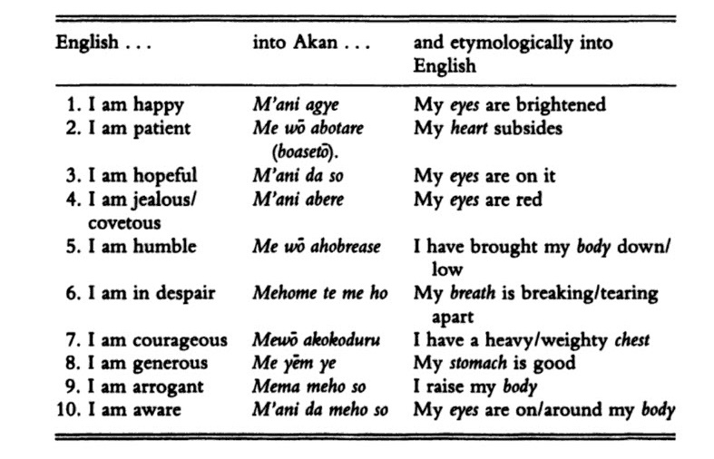
And he gives examples of this such as m’ani agye, which he glosses as “my eyes are brightened,” literally ‘my eyes have received’ (Gyekye 1987: 166). The reason why the affected body part, in this instance are the eyes can be seen when, for instance, one gives a gift to a child and we see the child’s eyes light up referring to pupils dilating and eyelids widening. So, indeed, the physicalistic expressions are actually expressing the part of the body that is affected by the feeling/emotion. This is not a poetic or idiomatic way of saying these expressions. These are the standard way of expressing the feeling/emotion. Upon reading of this, I found this concept to be so profound because growing up as a child in the u.s. I did not know any language other than english and, from childhood, as an L1 speaker of the language, I always had a feeling that english was so impoverished and devoid of meaning. I felt like it was a meaningless language because even as a L1 speaker, a native speaker, if you have a word like happy, for instance, you cannot break it down for it to mean anything to you. It is morphosemantically opaque. That is to say, it is not like ha means something to you and ppy means something to you. Or angry is not like ang means something to you and ry means something to you. It is rather, just like a bunch of sounds that you just hear in context and have to figure out what they mean on that basis. But when I came across this language and this linguistic phenomenon, I was of the opinion that this is the most profound thing ever. Because you can actually get a sense of the part of the body that is experiencing whatever the “mentalistic” emotion is. So you can say abotare or abotrԑ coming from bo chest and tare to lay horizontally (in Akuapem Twi) or understand it as trɛ ‘wide’ (in Asante Twi) depending on which dialect you are speaking. So, if one looks at any equivalent concept in English, even native speakers do not really even know what these words mean in a deeper sense to be able to trace it to something tangible—something affirming of being and reality. Even with an etymological dictionary, oftentimes one word is simply defined by more abstract words leading to an endless web of words as exemplified below. This leads to a negation of being and reality often understood as fundamental alienation.
Table 2: Group B mentalistic expressions translated into and out of Akan (Gyekye 1987: 166).
Table 3: Explanations that fail to explain: Etymologies that are abstract, opaque, and disconnected from being/reality
English Word | Etymology
fear (n.) | Middle English fere, from Old English fær "calamity, sudden danger, peril, sudden attack," from Proto-Germanic *feraz "danger" (source also of Old Saxon far "ambush," Old Norse far "harm, distress, deception," Dutch gevaar, German Gefahr "danger"), from PIE *pēr-, a lengthened form of the verbal root *per- (3) "to try, risk." (Harper 2020a)
disgust (n.) | 1590s, "repugnance excited by something offensive or loathsome," from Middle French desgoust "strong dislike, repugnance," literally "distaste" (16c., Modern French dégoût), from desgouster "have a distaste for," from des- "opposite of" (see dis-) + gouster "taste," from Latin gustare "to taste" (from PIE root *geus- "to taste; to choose"). The literal sense, "distaste, aversion to the taste of," is from 1610s in English. (Harper 2020b)
sadness (n.) | early 14c., "seriousness," from sad + -ness. Meaning "sorrowfulness" is c. 1500, perhaps c. 1400. (Harper 2020c)
surprise (n.) | also formerly surprize, late 14c., "unexpected attack or capture," from Old French surprise "a taking unawares" (13c.), from noun use of past participle of Old French sorprendre "to overtake, seize, invade" (12c.), from sur- "over" (see sur- (1)) + prendre "to take," from Latin prendere, contracted from prehendere "to grasp, seize" (from prae- "before," see pre-, + -hendere, from PIE root *ghend- "to seize, take"). Meaning "something unexpected" first recorded 1590s, that of "feeling of astonishment caused by something unexpected" is c. 1600. Meaning "fancy dish" is attested from 1708. (Harper 2020d)
happy (adj.) | late 14c., "lucky, favored by fortune, being in advantageous circumstances, prosperous;" of events, "turning out well," from hap (n.) "chance, fortune" + -y (2). Sense of "very glad" first recorded late 14c. Meaning "greatly pleased and content" is from 1520s. Old English had eadig (from ead "wealth, riches") and gesælig, which has become silly. Old English bliðe "happy" survives as blithe. From Greek to Irish, a great majority of the European words for "happy" at first meant "lucky." An exception is Welsh, where the word used first meant "wise." (Harper 2020e)
anger (n.) | mid-13c., "hostile attitude, ill will, surliness" (also "distress, suffering; anguish, agony," a sense now obsolete), from Old Norse angr "distress, grief, sorrow, affliction," from Proto-Germanic *angaz (from PIE root *angh- "tight, painfully constricted, painful"). Cognate with German Angst. Sense of "rage, wrath" is early 14c. (Harper 2020f)
trust (n.) | c. 1200, "reliance on the veracity, integrity, or other virtues of someone or something; religious faith," from Old Norse traust "help, confidence, protection, support," from Proto-Germanic abstract noun *traustam (source also of Old Frisian trast, Dutch troost "comfort, consolation," Old High German trost "trust, fidelity," German Trost "comfort, consolation," Gothic trausti "agreement, alliance"), from Proto-Germanic *treuwaz, source of Old English treowian "to believe, trust," and treowe "faithful, trusty," from PIE root *deru- "be firm, solid, steadfast." (Harper 2020g)
joy (n.) | c. 1200, "feeling of pleasure and delight;" c. 1300, "source of pleasure or happiness," from Old French joie "pleasure, delight, erotic pleasure, bliss, joyfulness" (11c.), from Latin gaudia "expressions of pleasure; sensual delight," plural of gaudium "joy, inward joy, gladness, delight; source of pleasure or delight," from gaudere "rejoice," from PIE root *gau- "to rejoice" (cognates: Greek gaio "I rejoice," Middle Irish guaire "noble"). (Harper 2020h)

In the examples above as well as the related etymologies, there is not a body part expression in site. While embodiment may be said to be universal, abstract disembodiment with an endless web of words defined by nothing more than other words as evinced in eurasian languages clearly is not.

As demonstrated in the Data section of this article, the body parts chosen are not random, haphazard or arbitrary given that we have these different four languages that are using specific parts of the body to do it. In these cases, there is often no abstract disembodied word unless it was borrowed and/or imposed by a language of aAmw ‘eurasians’ with strings of sounds and grunts that fail to tie back to reality and being.

According to Ɔbenfo, Nana Marimba Ani, she deals with the eurasian worldview in terms of dichotomization. In her words, dichotomization is “a mechanism which accompanies objectification. It is the splitting of phenomena into confrontational, conflicting parts. It facilitates the pursuit of power over other, and is therefore suited to the European asili” (Ani 1994: xxbiii). Going into further detail, she argues that:

This idea of control is facilitated by first separating the human being into distinct compartments (“principles”). Plato distinguishes the compartments of “reason” and “appetite” or “emotion.” Reason is a higher principle or function of woman/man, while appetite is “more base.” They are in opposition to one another and help to constitute, what has become one of the most problematical dichotomies in European thought and behavior. This opposition results in the splitting of the human being. No longer whole, we later become Descartes’ “mind vs. body.” The superiority of the intellect over the emotional self is established as spirit is separated from matter. Even the term “spirit” takes on a cerebral, intellectualist interpretation in the Western tradition (Hegel) (Ani 1994: 32).
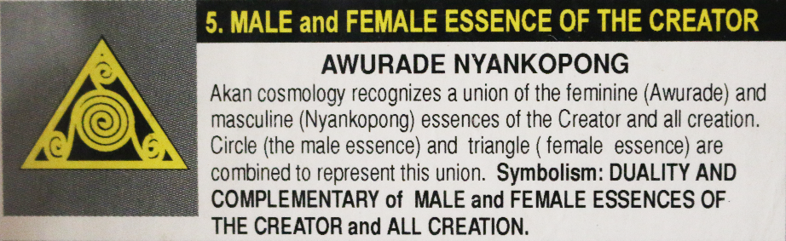

Basically this is what is found throughout eurasian thought as enshrined in ideas of god vs. devil, man vs. nature, man vs. woman, man vs. god, mind vs. body, sacred vs. secular/mundane, n.k. In each instance they are in conflicting parts and they are against each other. When we look at Afrikan languages, it becomes clear that creation and procreation are seen as analogous processes and that, therefore, the Creator necessarily has complementary masculine and feminine aspects. This worldview is not difficult to understand as it is abundantly clear to all that in the natural order of life and reality, a woman and a man are both complementary aspects of the Afrikan whole necessary to create life. This is attested, for example, in the Akan language, wherein Awurade (feminine) and Nyankopɔn (masculine) combine to form the totality of the creative force that is both the source of all life and which also permeates all life (Ofori-Ansa 1997). A similar conception is found among the Ga, who refer to the Creator as Ataa (father) Naa (mother) Nyoŋmɔ. This idea is also attested in Fɔngbè whereby the Creator is known as Mawu (feminine) Lisa (masculine), again demonstrating the Afrikan worldview based on reality as it actually is whereby, we know (not believe) that both the feminine and the masculine are the complementary opposites necessary to create life.
Figure 3: Awurade Nyankopɔn Goldweight (Niangoran-Bouah 1984, Ofori-Ansa 1997).
It is also clear that what obtains in traditional Afrikan societies as shown in the few examples above is also manifested in classical  kmtyw ‘Black people’ societies like of  Kmt ‘Land of Black People.’ In  Xmnw, for example, the original eight  NTrw in the beginning were the male/female pairs of  Imn and  Imnt (representing masculine and feminine aspects of hiddenness),  Kkw and  Kkwt (representing masculine and feminine aspects of darkness),  Nnw and  Nnwt (representing masculine and feminine aspects of wetness), and  HHw and  HHwt (representing masculine and feminine aspects of infinity). A similar understanding pervades the creation story of  iwnw whereby from  Itmw come forth 4 sets of male/female pairs respectively. These are 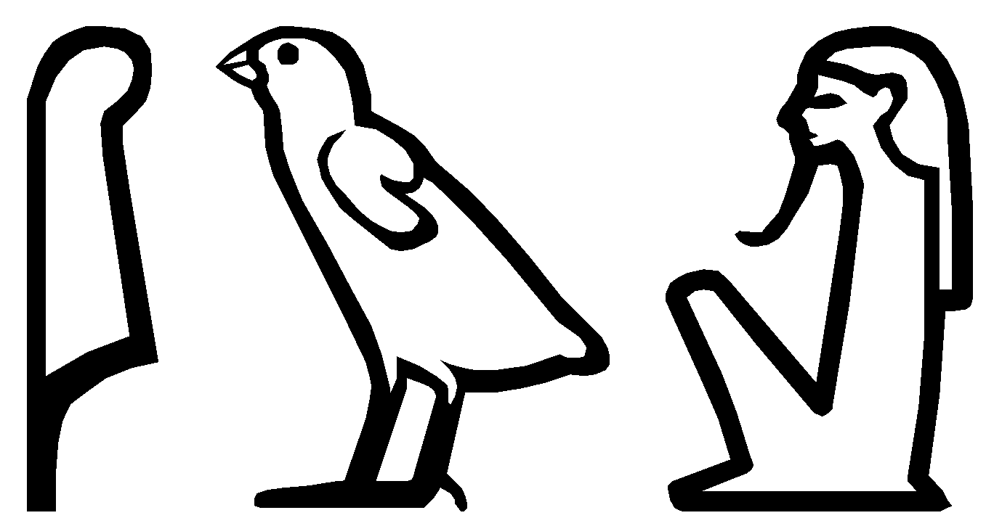 Sw (air) and  tfnt (moisture);  Gb (earth) and  Nwt (sky and that which is contained therein);  Isir (rulership) and  Ist (motherhood and the foundation of rulership); and 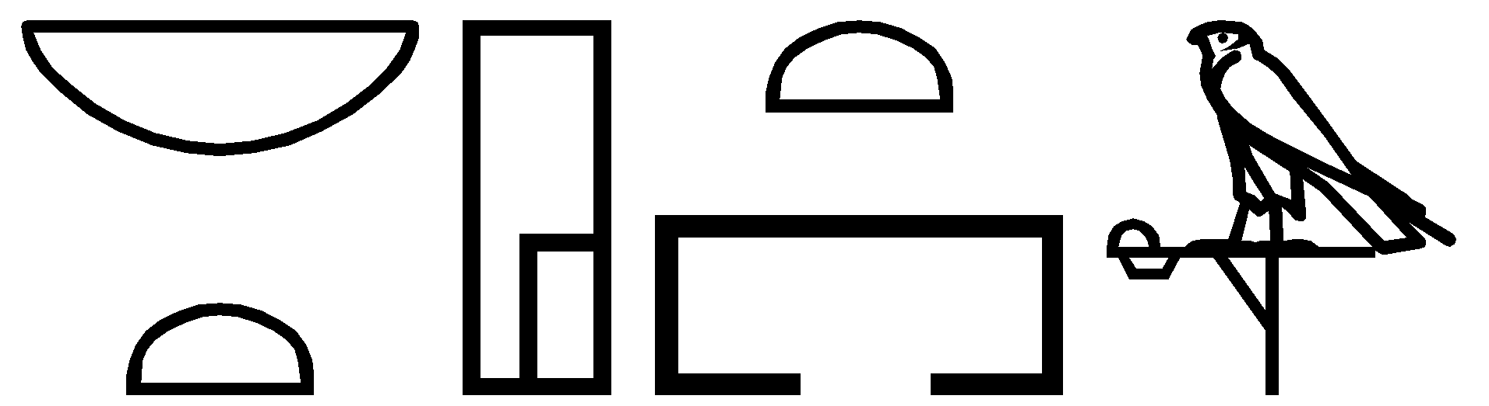 nbt-Hwt (care and protection) and 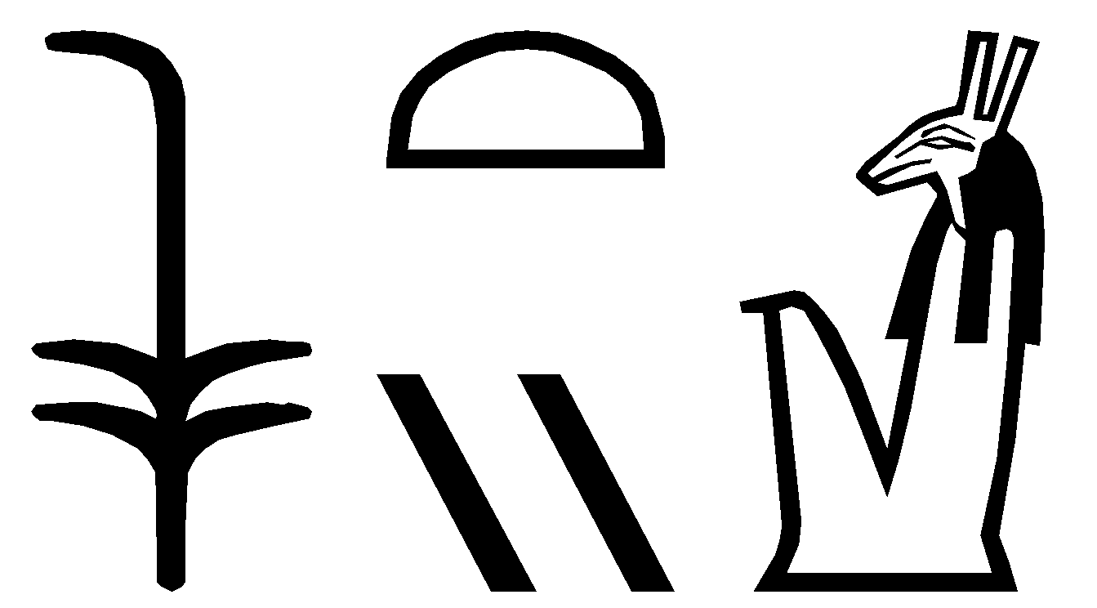 stx (military might and strength). Thus, complementarity in this way is a manifestation of fundamental interrelation, whereby dichotomization is a manifestation of fundamental alienation whereby one part is alienated from its own complement.

In short, the reason for these mentalistic expressions is because of the eurasian/aryan worldview that necessitates dichotomization between one and its opposite and the two are necessarily in conflict. Nana Jedi Shemsu Jehewty, in describing fundamental alienation and eurasian thought articulates it thusly:

In sum the [a]ryan worldview in antiquity which includes the classical greeks is based on fundamental assumption of cosmic conflict, hostility between male and female principles, patricide and infanticide, alienation between god and man, warfare between man and nature, competition and strife among men, slavery as a natural human institution, this Eurasian orientation that is deep embedded in the Aryan worldview can be called fundamental alienation (Carruthers 1999: 42).

This means that one is alienated from nature. Through the process of dichotomization, that which is artificial is assigned the value of good while Nature is bad. Endemically eurasian worldview is wrapped up on the in the notion of original sin when one’s highest goal is to escape into an imaginary place on an imaginary cloud called heaven and get away from the sinful world. But the eurasian worldview is not only not universal, it is also wrong.

This brings us back full circle to the Fundamental Interrelation/Alienation Continuum exemplified below with corresponding examples from Akan and English.

Fundamental interrelation Fundamental alienation

“Physicalistic” conventionalized B.P.E. | Optional Idiomatic B.P.E. | “Mentalistic” etymologically opaque sounds
Interrelation between thought and body Separation between thought and body
akomatuo ‘heart fly’ fear
ayamhyehye ‘stomach burn-burn’ apprehension
anidasoɔ ‘eyes-lay-on’ hope
tirimuɔden ‘head-inside-hard’ cruel
asomdwoeɛ ‘ear-inside-cool’ peace
Figure 1: Fundamental Interrelation / Alienation Continuum with Examples from Akan and English

Essentially, we readily see fundamental interrelation on the side of Kmt(yw) ‘Black people’ and fundamental alienation on the aAmw ‘eurasians’ side. The utility of the continuum is that it shows a gradient and not necessarily a sharp dividing line as seen in the eurasian necessary and sufficient conditions model. According to Osam (1994)

The classical theory which goes back to Aristotle, classifies entities according to necessary and sufficient conditions. This means that a certain category, for example, is defined by specific features; and each of the features is considered necessary for the definition of that category. For an entity to be said to belong to that category it must have all of the defining features of that category, otherwise it cannot be put in that category. The sufficiency of the defining features lies in the fact that an entity can be considered to belong to the category if it possesses each defining feature of the category (10).

The power of the continuum/gradient is that some languages may tend towards physicalistic conventionalized body part expressions where there is an interrelation between thought and the body—the part of the body that experiences the feeling. In the middle, there are languages that have optional idiomatic body part expressions. On the opposite side of the continuum, we find these mentalistic etymologically opaque sounds where there is a separation between mind (itself an abstraction) and body. As shown in Table 3, for the terms given as well as the etymologies, body parts are missing from terms for feelings and emotions as there are no parts of the body or anything else tangible that exists in reality that any of those words point to. While such a language is on the far side of the fundamental interrelation/alienation continuum including the latin script with which it is written, interestingly even the writing system of r n Kmt ‘language of the Black nation,’ Mdw NTr, is an affirmation of being as the written elements are entities that exist within nature. The use of determinatives in the language is another means of reinforcing the connection between the sign and the signified. Thus, rather than an endless web of words, we have an endless web of being. Interestingly, among the Akan, one of the mmrane (praise names) of the Onyame is Ananse Kokurokoo ‘The Great Spider’ as it is understood that all of being is interconnected. This idea is encapsulated in the proverb which states Wode wo nsa ka ananse ntentan a, na ɛpusu ne nyinaa translated as ‘If you touch the spider web it shakes the whole edifice.’ So, essentially, this is fundamental interrelation—the understanding that touching one part affects the other and vice versa.

Along similar lines, Table 1 introduced the Fundamental Interrelation Matrix. At this point, it should be abundantly clear how each example of the article demonstrated conceptual, contextual, and lexical similarity with respect to other languages under study. Further, it should be clear that there is a high degree of physiological proximity, cosmological proximity, and cultural proximity as manifested in the body part expressions discussed within this article.

In the future, other languages can be added to augment this preliminary study of correspondences between body part expressions across space and time. Wolof, in particular may be a fruitful language to look into as it has examples such as:

- xol sëdd ‘heart cool’ (satisfied)
- tàng xol ‘hot heart’ (frustrated)
- dëgër bopp ‘hard head’ (obstinate)
- bët xonqee ‘eye red’ (feel bad) (Bondéelle 2011: 17-34)

Another language to add to the comparative study could be AAA, which has expressions like:

- I got mad heart to buck a friend and go for dolo (Scientifik 1994)
- the shook hearted kids who shouldn't started (Bahamadia 1996)
- So remember in your heart, I'm here for you (Boys 1992)

In this paper, we have presented a cross-linguistic study of body part expressions in Akan (a Ghanaian language), Yorùbá (a Nigerian language), Kiswahili (a Tanzanian language) and r n Kmt ‘lit. the language of the Black Nation.’ We found that expressions are manifestations of what we term fundamental interrelation where the concept maintains a clear relationship with the literal real-world referent (the body part in question). The study demonstrated that there is a shared worldview from classical to contemporary languages of kmtyw ‘Black people’ as manifested in body part expressions.

References

Agbeshie, Medikal &. 2018. "Wrowroho." soundcloud.com: AMG ONE PHAME.
Agyekum, Kofi. 2019. Akan Body Parts Expressions. Accra: Adwinsa Publications.
Allen, J.P. 2013. The Ancient Egyptian Language: An Historical Study: Cambridge University Press.
Allen, James P. 2014. Middle Egyptian: An Introduction to the Language and Culture of Hieroglyphs. Cambridge: Cambridge University Press.
Ani, Marimba. 1994. Yurugu: An African Centred Critique of European Cultural Thought and Behavior. Trenton, NJ: Africa World Books.
Asumasɛm. 2017. "Ani Bɔne." YouTube/AdomTV. (https://www.youtube.com/watch?v=pCKMnLBOxyU).
Babalola, A. 1979. Akojopo Alo Ijapa Apa Keji [Collected Tales of Tortoise, Part Ii]. Ibadan: Oxford University Press.
Bahamadia. 1996. "3 Tha Hard Way." in Kollage. New York: Chrysalis/EMI Records.
Bondéelle, Olivier. 2011. "From Body to Emotion in Wolof: A Phraseology Process." Encoding emotions in African languages:17-34.
Boys, The. 1992. "I'm Yours." in The Saga Continues... Los Angeles: Motown.
Brindle, Jonathan, M. E. Kropp Dakubu and Obadele Kambon. 2015. "Kiliji, an Unrecorded Spiritual Language of Eastern Ghana." Journal of West African Languages 42(1):65-88.
Carruthers, Jacob H. 1999. Intellectual Warfare. Chicago: Third World Press.
Dzahene-Quarshie, Josephine. 2016. "Inalienable Possession Constructions in Akan and Kiswahili." Kiswahili 79(1):93-105.
Ethnologue. 2020a, "Akan: A Language of Ghana", Web: Ethnologue.com. Retrieved 7 May 2020, 2020 (https://www.ethnologue.com/language/aka).
Ethnologue. 2020b, "Yoruba: A Language of Nigeria", Web: Ethnologue.com. Retrieved 7 May 2020, 2020 (https://www.ethnologue.com/language/yor).
Ethnologue. 2020c, "Swahili: A Language of Tanzania", Web: Ethnologue.com. Retrieved 7 May 2020, 2020 (https://www.ethnologue.com/language/swh).
Fabunmi, Michael Ajayi. 1985. Yoruba Idioms. Ìbàdàn: African Universities Press.
Fashagba, Joseph Ajayi. 1991. "The First Illustrated Yoruba Dictionary." Toronto: J.A. Fashagba.
Gyekye, Kwame. 1987. An Essay on African Philosophical Thought - the Akan Conceptual Scheme. Cambridge: Cambridge University Press.
Harper, Douglas. 2020a, "Fear", Web. Retrieved 7 May 2020, 2020 (https://www.etymonline.com/word/fear).
Harper, Douglas. 2020b, "Disgust", Web. Retrieved 7 May 2020, 2020 (https://www.etymonline.com/word/disgust).
Harper, Douglas. 2020c, "Sadness", Web. Retrieved 7 May 2020, 2020 (https://www.etymonline.com/word/sadness).
Harper, Douglas. 2020d, "Surprise", Web: Etymonline. Retrieved 7 May 2020, 2020 (https://www.etymonline.com/word/surprise).
Harper, Douglas. 2020e, "Happy", Web: Etymonline. Retrieved 7 May 2020, 2020 (https://www.etymonline.com/word/happy).
Harper, Douglas. 2020f, "Anger", Web: Etymonline. Retrieved 7 May 2020, 2020 (https://www.etymonline.com/word/anger).
Harper, Douglas. 2020g, "Trust", Web: Etymonline. Retrieved 7 May 2020, 2020 (https://www.etymonline.com/word/trust).
Harper, Douglas. 2020h, "Joy", Web: Etymonline. Retrieved 7 May 2020, 2020 (https://www.etymonline.com/word/joy).
Hutcheson, Neal and Danica Cullinan [Director]. Year. Talking Black in America. (https://smackslide.com/slide/this-is-your-presentation-title-talking-black-in-america-wpgtz2).
Kambon, Ọ and Josephine Dzahene-Quarshie. 2017. "Twiswahili or Kiswatwili: A Study of Parallel Proverbs in Akan (Twi) and Kiswahili." Ghana Journal of Linguistics - Special Issue 6(2):116-53.
Mackenzie, Bill. 2013, "Selected Kiswahili Idioms / Sayings", Web: AngelFire. Retrieved 22 October 2019, 2019 (http://www.angelfire.com/yt/chibilamsane/REVISED_SELECTED__KISWAHILI__I_D_I_O_M_S_aUG._2013.htm).
Niangoran-Bouah, Georges. 1984. The Akan World of Gold Weights: Abstract Design Weights. Abdijan, lvory Coast: Les Nouvelles Editions Africaines.
Obenga, Theophile. 1993. Origine Commune De L'egyptien Ancien, Du Copte Et Des Langues Negro-Africaines Modernes. Paris: L'Harmattan.
Ofori-Ansa, Kwaku. 1997. "Weights of Wisdom: History, Uses and Symbolism of Akan Goldweights." Hyattsville, MD: Sankɔfa Edu-Cultural Publications.
Osam, E. Kweku. 1994. "Aspects of Akan Grammar: A Functional Perspective." Ph.D. Thesis, Linguistics, University of Oregon, Eugene.
Patton, M.Q. 2002. Qualitative Research & Evaluation Methods: SAGE Publications.
Rickford, John R and Angela E Rickford. 1976. "Cut-Eye and Suck-Teeth: African Words and Gestures in New World Guise." The Journal of American Folklore 89(353):294-309.
Scheven, Albert. 2012, "Swahili Proverbs: Methali Za Kiswahili", Web: Center for African Studies, University of Illinois at Urbana-Champaign. Retrieved 12 November 2019, 2019 (http://swahiliproverbs.afrst.illinois.edu/love.html).
Scientifik. 1994. "Lawtown." in Criminal. New York: Definite.
Vygus, Mark. 2015. "Middle Egyptian Dictionary." Web: Pyramid Texts Online. Retrieved.
YFAP. 2018, "Àjà Ló L'ẹ́.Rù", Web: yorubaforacademicpurpose.blogspot.com. Retrieved 7 May 2020, (http://yorubaforacademicpurpose.blogspot.com/2018/05/aja-lo-leru.html).

According to Allen (2014), “The traditional transcription of these two signs, tp, is now known to be wrong” Allen, James P. 2014. Middle Egyptian: An Introduction to the Language and Culture of Hieroglyphs. Cambridge: Cambridge University Press., p. 30. For our purposes, we will follow standard dictionary transcriptions with Allen’s point duly noted.

