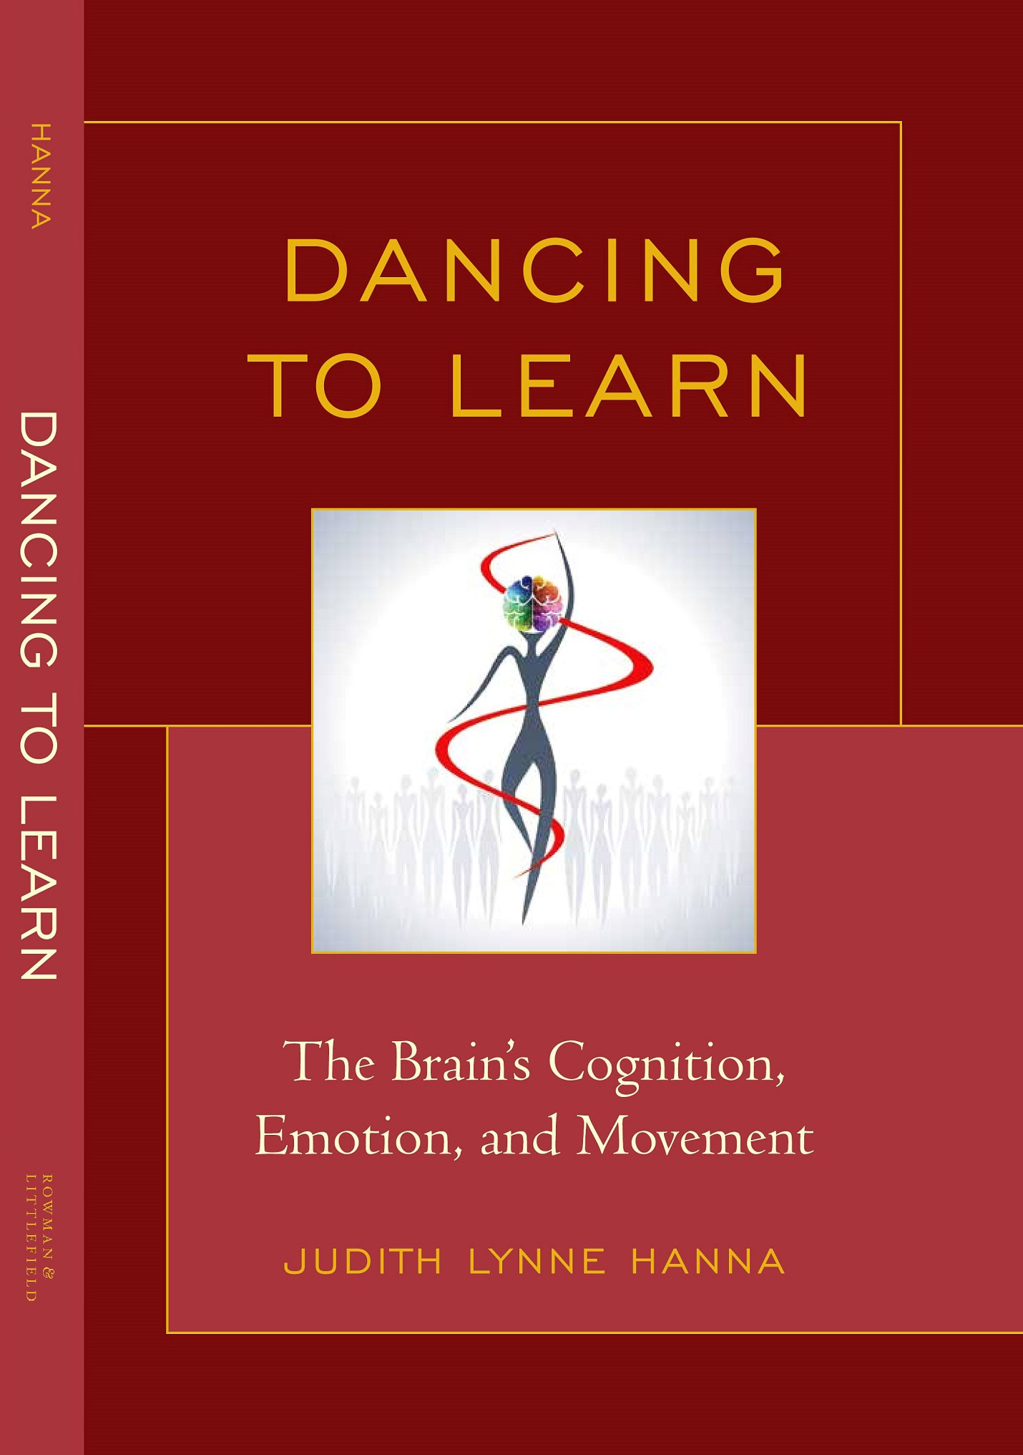
Lanham, MD: ROWMAN & LITTLEFIELD 800 462 6420 https://rowman.com/ISBN/9781475806052
ISBN 978-1-4758-0604-5 (cloth) ISBN 978-1-4758-0605-2 (paperback)
Dancing to Learn: The Brain’s Cognition, Emotion and Movement is groundbreaking. Interdisciplinary 21st century neuroscience suggests that the brain “choreographs” dance-maker, dancer, and spectator. The book synthesizes new research in neuroscience with knowledge in the arts, humanities, social sciences, and education to offer illuminating insights about dance as a compelling medium of education for everyone.

Key premises are (1) dance is nonverbal language affecting similar places and learning processes in the brain as verbal language, thus a powerful means of communication; (2) dance is physical exercise that sparks new brain cells (neurogenesis and neural plasticity, the brain’s amazing ability to change throughout life); and (3) dance is a means to help us cope with stress that can motivate or interfere with learning.

The book explores venues for learning dance and other subjects, dance as an art, liberal art, and applied art, as well as a vehicle to find self, cultural, regional, and national identities. The goal is to enlighten educators, dancers, and the general public, as well as to encourage scientists to explore further the underpinnings of dance.

Endorsements

Dancing is a powerful human act—perhaps no other human endeavor so thoroughly integrates our capacities for movement, artistic expression, social communication, meaning-making and emotional feeling. Dancing to Learn explains why this is so, and in the process teaches readers how to utilize dance to promote human development and social change… A great read for anyone interested in embodiment, culture and learning, whether or not they dance. ​
Mary Helen Immordino-Yang, PhD. Associate Professor of Psychology at the Brain and Creativity Institute and Rossier School of Education, University of Southern California
Judith Lynne Hanna is a tireless champion of the body, dance and its ability to touch our pleasure spots and panic buttons. She has given us this new treatise, an elegant and magisterial synthesis …that should finally put to rest any doubt that dance is essential to a cultivated, emotionally and spiritually balanced and brave contemporary society - the one we are always seeking to become!
Bill T. Jones. Artistic Director/Co-Founder/Choreographer New York Life Arts and Bill T. Jones/Arnie Zane Dance Company, writer, educator, awards winner, and honorary doctorates

…The potential of dance to foster deep thinking and learning is especially potent…. providing nonverbal language mechanisms as important to learning as verbal language. Judith Lynne Hanna takes the idea of dance to promote learning to new levels with Dancing to Learn: The Brain’s Cognition, Emotion, and Movement. Recent findings from the brain sciences suggest that dance promotes…the growth of new brain cells and vital skills for learning including attention, memory, and cognitive flexibility. Hanna provides numerous examples of how dance education programs and dance-integrated strategies in non-dance subjects can enrich students’ educational experiences in formal and informal settings. …
Mariale M. Hardiman. EdD Professor, Johns Hopkins University School of Education;
Author of Brain-Targeted Teaching for 21st Century Schools

Dancing to Learn is pioneering, situating us in current neuroscience and other disciplinary research related to dance, demonstrating the orienting and mobilizing power of dance, and suggesting several possible pathways forward for the benefit of every learner and society as a whole. Dr. Hanna's work is a challenging and thoughtful examination of the educational importance of one of humankind's oldest and most unifying practices, and should be read by parents, educators, policy-makers, dance-skeptics, and dancers alike.
Blake Martin, PhD, teacher in York University’s Dance Department; scientist at Accelerated Learning and Retention Project, DRDC

Contents
Acknowledgements

Prelude: To Dance Is Cognitive, Emotional, and Moving
Brain Scientists Study Dancers and Spectators
Knowing About Dance --Triangulating Knowledge Disclosure
Steps toward Understanding Dance as a Learning Medium
Chapter 1. The Brain ”Choreographs” Dance-Maker, Dancer, and Spectator
Cultural Conceptualization of Dance
The Moving Body Aids Human Evolution
Dancing Nourishes a Ravenous Brain
Architecture of the Brain
Neurons – Atoms of Thinking
Sparking -- Neurogenesis
Dance Embodies Cognition
Senses, Interoception, and Perception
Vision, an Especially Important Sense
Mirror Neurons
Mind and Consciousness
Memory
Dance in Mind, Space, Pace, and Aging
Verbal and Nonverbal (Dance) Languages of Thought
Comparison of Languages
Many Languages and Dialects of Dance
Thinking through Language
Multilingualism in Dance
Feeling and Emotion
Stress
Recollection/ Reconsolidation of Emotion
Motivation and the Pleasure of Dance
Encore
Chapter 2. The Mentality and Matter of Learning through Dance
The Brain Sustains Dance Languages
Powerful Hand Communication
More Body Parts, More Powerful Dance
Declarative, Procedural, and Social Knowledge for Dance
Music and Dance Together
Packing and Unpacking Meaning in Dance
Symbolization
Dancing a Science Dissertation
Dimensions of Meaning in Dance (Probing with a Semantic Grid)
Dance in the Moment and Memory
Visual Images and Mindfulness
Perception of Emotion
Thinking through Memorable Images of Dance
Dance Sparks Brain Networks and Learning for Old and Young
Dance Lowers Risks for Brain Deterioration
Performing Arts in General
Acquisition of Learning Skills through Dance
Creativity
Challenges
Prompting Creativity
Encore
Chapter 3. Brain-Changing Dance Venues: From Street/Studio/Classroom to Stage and Back
Multi-linguistic Dance: Plethora of Genres
Many Ways of Learning Dance
Pre-School Dance
Academic Schools
A Performing Art - Dance as a Discipline
Pre-professional Dance
Dance Company Schools and Outreach Programs
Arts Magnet Schools
Program within a School
New York City Public Schools
Cluster School Program
A County-Wide Multifaceted Program in all Public Schools
A Liberal Art – Dance Integrated with Other Subjects
University Dance Education
Performing Arts Organization Offerings
John F. Kennedy Center for the Performing Arts
Lincoln Center Institute for the Arts in Education
Washington Performing Arts Society
Young Audiences
National Dance Institute (NDI)
ArtsConnection Young Talent Dance Program/ English Language Literacy Program
Community Based Dance Programs
Dance Teacher Preparation
Private Dance Studios, Conservatories, and Teaching Artists
Dance Education Lab
Pulse Ontario (Canada) Dance Education Conference
National Registry of Dance Educators
State Dance Certification
In-service Workshops
National Dance Education Organization
Encore
Chapter 4. The Dancing Brain Leaves No One Behind
An Applied Art
Personal Development through Dance Aids Learning
Engaging Dance and Changing Behavior
Assessing Non-dance Learning through Dance
Children’s Own Dance as a Diagnostic Tool
Transfer of Dance Learning
Dimensions of Transfer
Brain Action
Teaching for Transfer
Research on Transfer
Tools for Dance Learning
Media, Cyberspace, and Social Networks
Distance Learning
“Pen and Paper”
Movement Analysis
Dance Curriculum, Standards, Assessment, and Evaluation
Dance to Cope with Stress
Bad Stress – Distress
Good Stress - Eustress
Dance a Stressor
Escape
Encore
Chapter 5. Mind and Emotion in Learning Self, Cultural and National Identities
through Dance
Dancer Identity, Career, Transitions, and Dance-related Options
Gender and Sexual Orientation
Who Is On-stage? Females
Males in Dance
Culture
Black/White Interaction
Regional or National Identity
Applying Cultural Diversity
Selecting Dances
Cultural Appropriation
Playing Anthropologist to Learn about a Culture’s Dance
Encore
Finale and Révérence
Dance -- Cinderella of Education and Brain Science
Plié: Ready to Soar in Brain and Body
Figure 1. Elements of Dance
Figure 2. Ways of Conveying Meaning in Dance (Semantic Grid)
Appendix 1: Tools to Discover the Dancing Brain
Appendix 2: To Dance in a Classroom, Even for Non-Dancers
References Cited
Index

About the Author JUDITH LYNNE HANNA earned a PhD in anthropology from Columbia University, degrees from Michigan State University and UCLA, and teacher certification from the State of California. She is an Affiliate Research Professor in the Department of Anthropology at the University of Maryland, an educator, author of numerous books and articles, long-time dance student, and dance critic.
She has taught dancing and about dance to non-dancers, dancers and academics in addition to other subjects. Hanna’s books include To Dance Is Human, Partnering Dance and Education, and Dancing for Health. Her hundreds of articles appear in, e.g., Educational Researcher, Dance Research Journal, and Current Anthropology. See www.judithhanna.com

Reviews:

Henley, Matthew, Journal of Dance Education 16(1):36, 2016
Man, Lora Wilson, American Journal of Dance Therapy, 37:197-200, 2014
Ehrenberg, Shantel, Dance Research Journal 48(1):167-169, April 2016
Gould, Dawn, Imaginemag!,A South African Arts & Culture Magazine 2015
Gould, Amy, Imaginemag!
http://imaginemag.co.za/?p=195

