Information Structural Projections and labelling in EkeGusii

Abstract
Labelling of information structure constructions exhibits asymmetry, with some focal elements receiving labels whereas some focal constituents and the entire set of topical ones do not in EkeGusii. The EkeGusii data shows that some focal and topical features in some categories are not visible to label search due to being spread over discontiguous constructions in the case of topic and failure of the default focus reading to be docked on the phonetically realized focus marker, or the Goal features of topical categories being more salient. If some information structural, topical or focal, information in some categories is not deleted before output a given sentence will surface as gibberish. The EkeGusii language has a focus marker that is overtly realized ex-situ (in left peripheral position) and in a low focus position because it bears a feature [+ Prominent] that renders it interpretable at both the Conceptual-Intentional and Articulatory-Perceptual interfaces. The ex-situ focus position allows for the goal and the probe to be labelled (or re-labelled) as a Focus Phrase (FocP) because the scope of the focus reading is narrowed to a single lexeme.

Keywords: labelling, Information structure, Topic, Focus, Syntax-Pragmatics Interface

1.0 Introduction
With the theoretical shift from the endocentric system used in the Principles and parameters theory, in which the X-bar trees utilized words to determine labels, to the minimalist Bare Phrase Structures (Chomsky, 1995 a;1995b) there has been need to re-examine how some theoretical constructs are used. The labels were assigned automatically using an endocentric criteria till it was realized that invisible functional categories could also provide labels as per the Cartographic program (Rizzi, 1997; Cinque,1999), especially where empty categories play a role in the interpretation of the output. With the extension of projection to cover invisible functional heads such as the Complementizer (C), Tense (T) and others, which is pursued extensively the Cartographic program (Rizzi,1997; 2004; Cinque, 1999) the use of pragmatic function heads were considered a universal given. Among the functional projections stipulated by the Cartographic approach are the information structural heads: Top⁰ and Foc⁰, and phrases: Topic Phrase (TopP) and Focus Phrase (FocP) which are now contested in some research work being turned out.

In current work in the Minimalist Program (Chomsky, 1995a; 1995b) labelling is separated from structure building and a labelling algorithm was stipulated that determines how labels are assigned. Labelling is considered to be executed using a labelling algorithm, defined as a form of minimal search, and third factor aspects like Agree (cf. Chomsky, 2000; 2001). Collins (2008) posits a Locus Principle which is assumed to constrain how lexical items can be accessed for labelling. The locus principle states that the probe/ selector have to be saturated before they can be used in a derivation. The locus is a feature of lexical items, but in Polysynthetic languages this may be extended to inflectional affixes which are introduced to derivations by narrow syntax. The notion of Agree is assumed to involve Probe (the syntactic object that has some uninterpreted feature (uF) and a Goal (which has an agreeing feature) that drive how features determine the process of internal merge. Agree is not obligatory, but is a factor that is available in languages with strong agreement features such as EkeGusii.

The main question in this paper is to determine what actually determines the labelling of some information structural features and not others in the output. Information structure is a sentence wide phenomena, every category, be it affix or an entire lexeme encodes an information structural feature. In this paper we argue that some additional feature is involved in determining whether the information structural feature should be labelled.

In this paper I aim at examining how information structure functions (which are construed as features in minimalist literature), that is, Topic and Focus are used to assign labels in the output of EkeGusii sentences. EkeGusii realizes a projectible Focus Phrase in the left-periphery and in a low focus position. One of the most contested information structural positions is the low focus position has been proposed for a number of languages such as Italian in Romance languages (Belleti, 2001, 2004), for Malayalam (Jayaseelan, 1999) and a number of Bantu languages (see Van der Wal, 2006; Aboh,2007; Carstens & Mletshe, 2015; Selvanathan, 2019 to mention some). Cheng and Downing (2012) and Buell (2007) consider the low focus position to be absent in Zulu. In this paper I argue that the only pragmatic function accessible to labelling in the EkeGusii language is the Focus Phrase due to the effect of edge features [+ Prominence, + Salient] which induce the overt realization of the focus marker which agrees with the lexical item which is a target of focussation. Some constituents, affixes, or lexemes that bear the feature [+ Focus] are however not visible to labelling because they may render the sentence to being gibberish in the Conceptual-Intentional (CI) interface. The topical elements are entirely inaccessible to the labelling labelling algorithm.

The paper is organized as follows: section (2.0) gives background information on EkeGusii and the EkeGusii data that will be used in this paper; section (3.0) reviews some selected works that examine the relationship between information structure and labelling; section (4.0) gives a brief theoretical background that informs the analysis of this paper and section (5.0) examines the empirical evidence on the interaction between information structure functions , Topic and Focus, with labelling in the EkeGusii language.

2.0 Preliminaries
2.1 EkeGusii
EkeGusii is a JE 42 Bantu language spoken by around 2.8 M+ people in Kenya not including those who live outside the two counties of Nyamira and Kisii (given the flaws in the current demographic reports in Kenya Census reports suppressing linguistic data in the country due to avoiding ‘tribal profiling’) and those who live and work in the diaspora.

2.2 Information Structure in EkeGusii

The classification is based on Lambrecht’s constructionist approach which classifies focal constructions into default, argument and predicate focus (cf. Lambrecht, 1994). In Lambrecht (1994) the focus of sentence is defined as the element of information that is added to a pragmatic presupposition whereas topic is the Given element. The focus constructions cited in this section are based primary data on work done in consultation with five respondents who are native speakers of EkeGusii for a thesis in the year 2010.

.2.1 Focus Constructions
EkeGusii has overt marking of focus using a focus marker which is distributed most of the constructions, namely: default focus (1), argument focus (3-4) and predicate focus (2). Default focus constructions are entirely new to hearer in that they provide new information. An example of a default focus is as in (1) below.

(1.) Moraa nigo agorete eyaanga enkoro. (Default Focus)
Moraa n-igo a-gor-et-e e-yaanga e-nkoro
Moraa Foc-PTL 1SG-buy-PERF-FV 9SG-dress 9SG-old
‘Moraa bought a dress old.’
In EkeGusii the focus marker can be used to mark partially moved phrases as in (2) below.
(2.) a. Moraa nagorete eyaanga. (Predicate Focus)
Moraa n-a-gor-et-e e-yaanga
Moraa Foc-1SG-buy-PERF-FV 9SG-dress
‘Moraa bought (not sell) a dress.’

b. Moraa neyanga agorete. (Predicate Focus)
Moraa n-e-yanga a-gor-et-e
Moraa Foc-9SG-dress 1SG-buy-PERF-FV
‘Moraa a dress (not shoes) bought.’
The focus constructions can be formed by moving the arguments that are focused from the complement position of the predicate to a sentence initial position (the left periphery) as in the sentences given in (3) below.
(3.) Neyanga Moraa agorete.
N-e-yanga Moraa a-gor-et-e.
Foc-9SG-dress moraa 1SG-buy-PERF-FV
‘A dress (not shoes) Moraa bought.’
Focussed modifiers in EkeGusii can pied-pipe their arguments as well be pied pied as demonstrated in the sentences in (4) below.
(4.) (i.) Moraa nigo agorete eyaanga enkoro. ( default focus)
Moraa n-igo a-gor-et-e e-yaanga e-nkoro.
Moraa Foc-PTL 1SG-buy-PERF-FV 9SG-dress 9SG-old
‘Moraa bought a dress old.’
(ii.) Eyaanga nenkoro Moraa agorete. (Predicate focus with pie-piped argument)
E-yaanga n-e-nkoro Moraa a-gor-et-e.
9SG-dress FOC-9SG-old moraa 1SG-buy-PERF-FV
‘It is an old dress Moraa bought.’
(iii.) Neyaanga enkoro Moraa agorete. (Predicate focus with pied-piped modifier)
N-e-yaanga e-nkoro Moraa a-gor-et-e.
FOC-9SG-dress 9SG-old moraa 1SG-buy-PERF-FV
‘It is dress old Moraa bought.’

2.2.2 Topical constructions
Topical constructions in EkeGusii come in two varieties, those that involve some reduction process like being realized as bound affixes (in 5 i.below) or deleted in the surface (in 5 ii. below), or those that are remnants after the focal elements are focus marked as in the constructions covered in (1-4) above. The demarcation of the focal and topical in the language is rendered difficult because the distribution of both is not clear cut. In multi-categorial verbs, both topical and focal affixes are realized side by side.
(5.) (i.) Moraa naomogorera eyanga.
Moraa n-a-mo-gor-er-a e-yanga
Moraa Foc-SA-OM-buy-PERF-FV 9SG-dress
‘Moraa bought for her a dress.’

(ii.) Namogorera eyanga
PRO n-a-mo-gor-er-a e-yanga
PRO Foc-SA-OM-PERF-FV 9SG-dress
‘I / Moraa bought for her a dress.’
3.0 Literature Review of some Selected Works
Labelling is assumed to be necessary for syntactic objects to be interpretable at the SM and CI interfaces (Chomsky, 2001). Hence it is considered to be necessary that every syntactic atom involved in the derivational history should be labelled for either the syntactic object to be derived or frozen. In relation to information structure, currently, there is no agreement that the information structural functions, Topic and Focus should project or label syntactic objects. There are three approaches to the labelling information structure constructions: one which considers there to be labels for both pragmatic functions (Rizzi, 2004), or only for focus (cf. Totsuka,2019; ), or none whatsoever (Nakashima, 2019).

The researchers who assume the Cartograhic approach (Rizzi, 2004; Cinque, 1999) consider the labelling Algorithm (Chomsky, 2013, 2015) to be applicable to topicalization and focalization. The Cartograhic works construe multiple specifier configurations in which focalized phrases occupy Spec-Foc and topicalized ones Spec-Top in the left periphery or in the root clause. In Totsuka’s (2019) account of English constructions, focalization is labelled as Q ( it has a question (Q) feature) whereas Topic has a unlabelled (XP, YP) structure. Nakashima (2019) considers the focus and topic constructions to be labelless. Nakashima follows the position taken by Chomsky et. al.(2019) in which he states that topic and focus are properties of configurations that are not available either in the lexicon nor in the narrow syntax. They are interpretations of topic-comment structure that is only visible to the C-I interface.

4.0 Theoretical Background
In this paper we adopt a label driven account to derivation of syntactic structure which was introduced in Chomsky (1995) and brought into focus in addressing the problems of projection in Chomsky (2013, 2015) . In the system stipulated, Merge is considered to apply freely and is defined as shown in (6) below.
(6.) Merge (α,β) → {α,β}
In (6) two elements are merged to form a unordered two member set which is unlabelled. Set Merge merges two lexical items to form a set.

In cases where a lexical items merges with smaller atomic atoms, as in cases where it takes on some kinds of clitics or affixes, which may be incorporated (Baker,), a separate operation referred to as pair merge (PM) (see Chomsky, 2000) is given. Pair merge takes two computational atoms and yield an asymmetrical and ordered pair as schematically represented in (7) below.

(7.) Pair Merge (α,β) → <α,β>

The operations Set Merge (SM) and Pair Merge (PM) involve searching of computational atoms from the lexicon and combining them in a workspace in a process termed as External Merge (EM), whereas an already constructed construction is copied and reused in the narrow syntax by the operation internal merge. External Merge is considered to create argument structure whereas internal merge is involved in the formation of discoursal movement (e.g topicalization, focus movement, inversion etc.) and scopal interpretation, what Chomsky terms the ‘duality of semantics’. In this paper, most of the movements are considered to be the product of internal pair merge (IPM) (cf. Richards, 2009)
The definitions of merge has been revised into the operation MERGE which executes the function of mapping workspaces onto other workspaces recursively till the derivational procedure is terminated (cf. Chomsky, 2019a,b,c; Chomsky et. al. 2019).

(8.) MERGE WS=[X,Y] onto WS’=[XY]

In the current theoretical stipulations, the assignment of labels is not tied to the MERGE operation. labelling is executed using a Labelling Algorithm (LA) which is considered to be basically minimal search accompanied by third factor aspects such as Agree. Chomsky (2013) posits that labelling takes place as follows in (9) below.
(9.) a. {H, XP}→{_{HP} H, XP}
b. i. {XP, YP}→{XP{_{YP} t, YP}}
ii. {XP, YP} →{YP{ _{XP} XP, t}}
c. {XP_{<F>}, YP_{<F>}}→{_{FF/}ϕϕ{ XP, YP}

In (9a.) the Syntactic Object (SO) is labelled using the head, H, which labels a maximal projection XP. In (9b) the labelling is determined by either of the projects, in (9b. i)b it the first phrasal category, whereas in (9b. ii) it is the second, in both cases one of the phrases is internally merged to facilitate labelling. In (9c.) we have a case where the SO consists of a set of two phrases that share features, in this case the features are used to determine the label, in the literature feature sharing is given as: ϕϕ.
The instances of labelling given in (9) above work with the assumption that projections should be somewhat assigned labels for them to be interpretable in the SM (Sensory-Motor) and CI (Conceptual-Intentional) interfaces. In the literature, there are proposals of cases where labelling fails (Citko, 2008), or the alternative is a case of relabelling or mislabelling (Cecchetto & Donati, 2010, 2015). Donati (2016) points out that it is the case that some syntactic objects are unlabelled because the label is only required for objects to be visible for syntactic processing, once that is done, then labels can be avoided. Cases of adjunction are considered to be universally unlabelled by Hornstein and Nunes (2008) and Hornstein (2009). Besides the case of adjunction, root clauses and any other clauses in the output should be represented without labels as per Donati (2016).

5.0 Analysis
5.1 labelling of Focus Constructions
In labelling of EkeGusii focus constructions the overt realization of the focus marker plays a role. However, as will be illustrated below, the overt realization of the focus marker renders the focus feature interpretable at the interfaces, the C-I and A-P interfaces, in argument, and predicate focus constructions with the exception of the default focus construction. Hence the realization of overt focus markers is not a sufficient requirement for the determination of the labelling of the constructions, scopal considerations are also a factor in determining whether a label is relevant for the demarcation of information structural interpretation at the C-I interface.

5.1.1 Focus raising to the Left Periphery
The EkeGusii language simple sentences ( that is SVO, SVO_{d}O_{i}, SVA, SVOA) involve the raising of any one of the predicate complements or internal arguments and adverbials to the left periphery. The verb (term focus) however does not move to the left periphery and will be considered in section 5.1.2 below as a case of partial raising to a low focus position.

Consider the predicate focus construction (given in 10 below), which involves the raising of the internal argument functioning as the object of sentence (or complement of the verb) to the left periphery is labelled as FocP. The EkeGusii internal arguments are raised to the sentence initial positions for the focus marker (n- or m-) to be affixed to them as shown in (10) below. The focussed constituent is formed by the adjunction of the argument to the focus marker in the C phase which is not cancelled after the external argument is internally merged.
(10.) Neyanga Moraa agorete
N-e-yanga Moraa a-gor-et-e.
Foc-10SG-dress Moraa 1SG-buy-PERF-FV
‘A dress (not a car) Moraa bought.’
(10’) {C{Foc’ Neyanga{C {RP Moraa {Foc’ nigo { T < agorete> {AgrP <agorete>{v*P {NP_{EA} Moraa { v* { V -gorete {v-R √-gora {NP_{IA} t}}}}}}}}}}
The sentence given in (10) above can be considered to have been formed by a series of transformation applying to a base construction such as in (11) below.
(11.) Moraa nigo agorete eyanga
Moraa n-igo a-gor-et-e e-yanga.
Moraa foc-PTL 1SG-buy-PERF-FV 10SG-dress
‘Moraa bought a dress’
The set of transformations that convert (11) to (10) above include the movement (internal merge) of a copy the focussed internal argument eyanga ‘dress’, that has been raised to the left periphery, feeding the deletion of the focused particle nigo as illustrated in (10’) above. The raised element is relabelled as FocP as per Cecchetto and Donati (2015) using the label Goal algorithm they propose. However the arguments that are given in the literature do not allow for the relabelling. The incorporation of the focus marker to the argument is a case of adjunction that involves internal pair merge. It is argued that such process involving the pair merge operation does not avail constituents that can be labelled (see Hornstein et. al., 2008). In Baker (1988), the notion of transparency condition is stipulated in which only the Goal is the one that is the label of incorporated syntactic objects.

5.1.2 Partial Focus Raising
The EkeGusii sentence also has a low focus position (or Immediate before Verb) position to which elements within the predicate can move to. The position is also occupied by a non-focal particle nigo in out-of-the-blue focus contexts. The case in which there is partial movement the particle -igo in the base construction is substituted by the elements raised from within the predicate. Consider the sentence in (12) below.
(12) Moraa neyanga agorete.
Moraa n-e-yanga a-gor-et-e
Moraa Foc-10SG-dress 1SG-buy-PERF-FV
‘Moraa a dress (not skirt) bought’
(12’) {Moraa { Foc’ neyanga {T agorete {SAGr agorete { v*P {NP Moraa { v* {V -gorete {v*-R { v, √ -gora {NP {n, √eyanga}}}}}}}}}}}}
- The argument eyanga ‘dress’ raises from the complement.
- The particle igo is substituted with the argument in the focus position.
The low focus position is available for the adjunction of the verbal components to as illustrated by the sentences in (13) below.
(13.) a. Moraa nagorete eyanga.
Moraa n-a-gor-et-e e-yanga
Moraa Foc-1SG-buy-PERF-FV 10SG-dress
‘Moraa bought (not sold) a dress.’
b. Moraa nkogora are chiyanga.
Moraa n-ko-gor-a a-r-e chi-yanga
Moraa Foc-INF-buy-FV 1SG-COP-FV 10PL-dress
‘Moraa does buy clothes/dresses.’
The low focus position does not accommodate the modifiers of arguments as shown in (14) below.
(14.) a. *Moraa nenyia agorete eyanga.
Moraa n-e-nyia a-gor-et-e e-yanga
Moraa Foc-1SG-new 1SG-buy-PERF-FV 10SG-dress.
‘Moraa new (not old) bought dress’
b. *Moraa eyanga nenyia agorete.
Moraa e-yanga n-e-nyia a-gor-et-e
Moraa 10SG-dress Foc-10SG-new 1SG-buy-PERF-FV
‘Moraa dress new (not old) bought’

5.1.3 Focussation of Adjuncts

Adjuncts realized as complements in root clauses behave the same way as arguments in EkeGusii. Consider the examples given in (15) below.
(15) a. Mokua nigo aagachete enyomba buya. (Default Focus)
Mokua n-igo a-gach-et-e e-nyomba buya
Mokua FOC-PTL 1SG-build-PERF-FV SG-house nicely.
‘Mokua build the house nicely.’
b. Mokua mbuya aagachete enyomba.
Mokua m-buya a-gach-et-e e-nyomba
Mokua Foc-nicely 1SG-build-PERF-FV SG-house
‘Mokua nicely( not badly) build the house.’
c. Mbuya Mokua aagachete enyomba
M-buya Mokua a-agach-et-e e-nyomba
Foc-nicely mokua 1SG-build SG-house
‘Nicely (not badly) mokua build the house.’
d. *Mokua aagagachete enyomba mbuya.
Mokaya a-g-agach-et-e e-nyomba m-buya
Mokaya 1SG-build-PERF-FV SG-house FOC-nicely
‘Mokua build the house nicely (not badly)’
e. *Buya Mokua aagachete enyomba
Buya Mokua a-agach-et-e e-nyomba
nicely mokua 1SG-build SG-house
‘Nicely (not badly) mokua build the house.’
f. *Mokua buya aagachete enyomba
Mokua buya a-agach-et-e e-nyomba
mokua nicely 1SG-build SG-house
‘Nicely (not badly) mokua build the house.’

The example (15b) shows that the low focus position is occupied by a focussed adverb, and in (15b) it is moved to the left-periphery. Whereas, the adverbial cannot be realized in-situ (as in c), nor be realized in the focus positions without the focus marker (m-). The derivation of an adjunct construction is considered not to involve the set merge operation, but is considered to be a product of pair merge (cf. Chomsky, 2004). This is so because in the languages considered, like English, the adjuncts behave like they are not part of the clause, that is, they are freely merged to the body of the clause without variation in meaning. In EkeGusii, the character of similar adjuncts is restricted in movement just as the arguments are and can be derived using the standard operation, merge as per its subtypes, Internal and external merge.

Assuming that focussed adverbs are internally pair merged to the focus marker (m-) in the high and low focus positions raises no significant labelling problem once the adjunct is raised from its adverbial position. The adverb itself is externally pair merged to the verb root after first merge as demonstrated in (16) below and then cyclically raised to the left periphery.
(16) {CP { FocP mbuya { Mokua { T agachete {AgrS agachete {v*P {NP mokua { R, v* {v, √-agacha { N’{NP {n, √enyomba {AP{A t_{i} }
The graphical representation of the derivation is as given in (17) below.

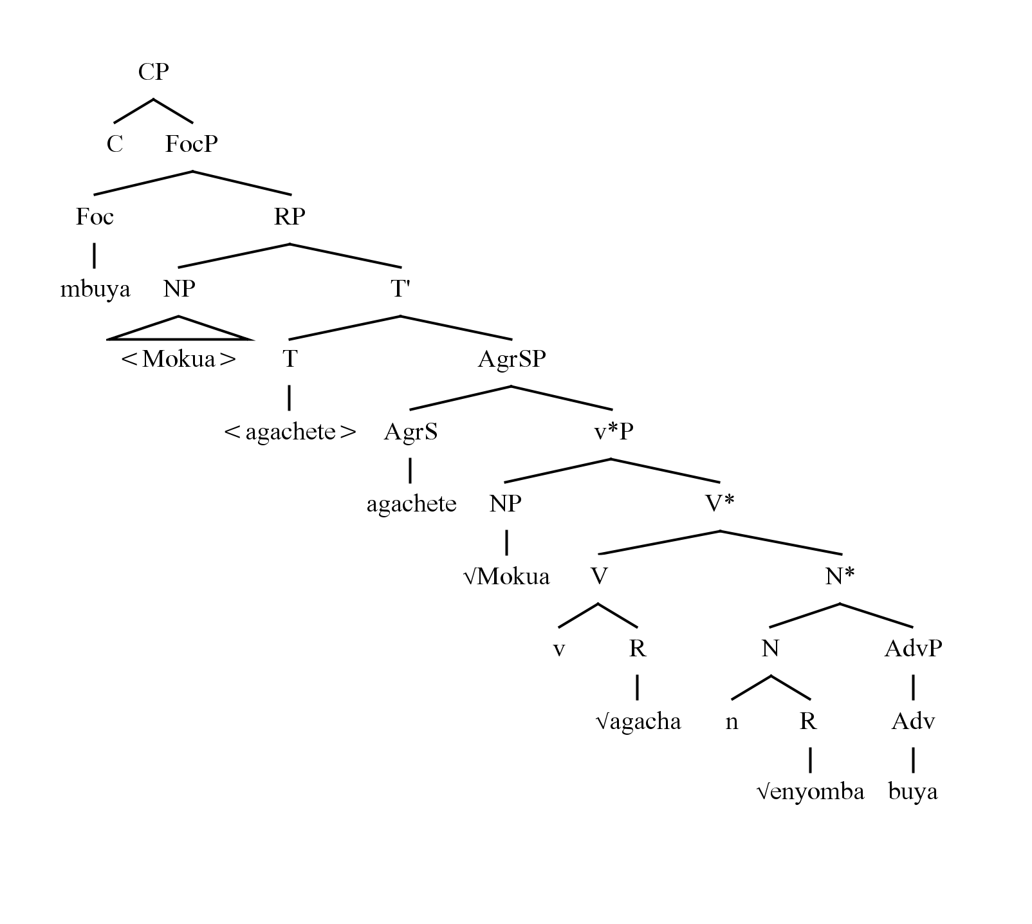

5.1.4 Labelling and Interpretation Failure
The cases considered in sections 5.1.1 to 5.1.5 involve the successful labelling and interpretation both at interfaces. In this section we consider a case in which there is a labelling failure due to pied piping (in 18 below), and a case in which the focP projection is not accessible to CI- interpretation in a case of default focus (in 19 below).

The internal merging induced by focus sometimes involves pied piping along of some elements which cannot be split, due to the adherence to the No Tampering Condition (NTC) which requires that syntactic objects be not available to further syntactic adjustments. In EkeGusii, whenever the constituents modifying the arguments in the complement of the verb are focussed they pied pipe the argument in which they are realized to the sentence initial position. Consider the sentence given in (18) below.
(18.)` Eyanga nenyia Moraa agorete.
E-yanga n-e-nyia Moraa a-gor-et-e.
10SG-dress Foc-10SG-new Moraa 1SG-buy-PERF-FV
‘The dress new (not old) Moraa bought.’
The base construction that the sentence is derived from is as given in (19) below.
(19.) Moraa nigo agorete eyanga enyia.
Moraa n-igo a-gor-et-e e-yanga e-nyia
Moraa FOC-PTL 1SG-buy-PERF-Fv 10SG-dress 10SG-new
‘Moraa bought a new dress’
The pied-piped phrase is derived as is shown in (20) below. It involves the movement of the modifier enyia ‘new’ to the sentence initial position FocP in the complementizer (C). The phase C is reactivated by verbal head v* which is covertly raised.
(20) {_{γ} eyanga_{j} {_{β} C {FocP n-enyia₁ {_{α} RP {NP Moraa { {T {v*P { V agorete {v*-R{v, R√gora { NP t_{j} {Q t_{i}}}}}}}}}}}}}}
- *{C {v* {FocP n-enyia_{i} {RP Moraa {FocP nigo {SAgrP agorete {T agorete {v*P { NP Moraa { V gorete {v*-R{v, R√gora{ NP eyanga t_{i}}}}}}}}.
- The low focus element nigo is deleted.
- The argument eyanga ‘dress’ is pied piped.
- The sentence is interpretable and is externalized.
The argument cannot be split by the focus induced movement since it yields gibberish at the interfaces. The movement of the nominal eyanga ‘dress’ however yields a unlabelled node (γ) in the new cycle. The nominal is moved merely to retain the asymmetrical structure, in which the focussed constituent plays the role of a complement. This can be adduced as evidence of the phasal status of some nominal constructions, since they obey the Phase impenetrability constraint (PIC).

The sentence (19) above is a case of default focus. The entire sentence is a realization of new information. It can be uttered in out-of-the-blue contexts or in answering the question what happened. Of note is that it bears a dummy focus constituent nigo after the subject. The constituent is never accompanied with the high intonation that accompanies the focussed construction, hence it is not interpreted at the articulatory-perceptual interface, nor in the C-I interface. Hence the default focus construction bears a focus Phrase label which is invisible to the interfaces. For that reason, we consider the realization of focus marking morphology not to be a necessary condition for the labelling of focussed phrases in the language.

5.2 Labelling Failure of Topic

In this section we will consider cases of topical constructions that involve raising from the object position into the verbal complex that are considered to involve both head-movement and incorporation. In all the cases in which there are modifications of lexemes to either affixes or null forms. Despite the visible effects of topic on constructions, the labelling of constructions in EkeGusii across a number of constructions does not support the projection of a Topic Phrase (TopP). In section 5.1.1 we propose an analysis of the null subject projection as involving deletion due to being topics.

5.1.1 Null Subjects
The EkeGusii subject is deleted in the output when it is topical. In previous Bantuist analyses it is assumed that the construction involves a pronominal form being incorporated into the verbal complex. We propose that the pronominal that is projected is a null PRO element. The PRO head is externally merged in second merge and then internally merged in order for its edge features to undergo valuation. In the Generativist literature the edge feature has been considered to be either the Extended Projection Principle (EPP) that requires that clauses must realize subjects. In non-Null subject languages the subject position is obligatorily filled, hence they replace the lexical form with expletives, whereas in Null-Subject languages the subject is deleted because of an ECM requirement.

In Null Subject languages like EkeGusii, it is proposed that the subject is deleted because they have a strong agreement feature. In Bantu literature the subject Marker is assumed to inherit the case feature of the lexeme that is deleted. In order for that to occur some form of roll-down of the nominative case is presupposed. In this paper we consider that as being a form of countercyclic movement which cannot be supported by the internal merge process. However, the availability of the subject marker makes it possible for the language to do away with overt subjects in the Sensory-Motor Interface (SM). The SM interface does not interpret the subject marker as a subject.

The deletion of the subject is a reflex of the interpretation of the topical feature. The question that we need to answer is whether the topical feature does have a designated position in the language. If the subject has a pronominal form that is affixal, then it will require some lexical form to be incorporated to, but that is not available in the Spec-T position of the language. This induces a gap in the language, and it resorts to the use of a null PRO element. The Focus construction has an overt form and designated criterial freezing positions as construed by Rizzi (2016). This is not the case for topic. Consider the null subject in inter-sentential contexts as given in (21) below.
(21.) 1. Mokua akarora Ongeri.
Mokua a-ka-ror-a Ongeri
Mokua 1SG-INF-see-FV ongeri.
‘Mokua saw Ongeri.’
- Akamoberekera.
- ka-mo-bereker-a
1SG-INF-OM-call-FV
‘He called him.’
The one-word sentence in (21-2) above has two topical objects, the reduced internal argument -mo- which is realised as an object marker in the complex verbal and the deleted subject PRO which is raised to the subject position. The sentence is generated as given in (22) below
(22.) a. {R {v,√berekera {NP -mo {n, Pron}
b. {v*{R {v,√berekera {NP mo-{ k, Pron}}
c. {v*-R -moberekera {v* {v,√berekera { NP -mo { n, Pron}}…
d. {v*P { NP PRO {v*-R moberekera {v*{R {v,√berekera { NP -mo { n, Pron}}…
e. {AgrP akamoberekera {v*P { NP PRO {v*-R moberekera {v*{R {v,√berekera{ NP -mo { n, Pron}}…
f. { T <akamoberekera> {AgrP akamoberekera {v*P { NP PRO {v*-R moberekera {v*{R {v,√berekera{ NP -mo { n, Pron}}…
g. {C { T <akamoberekera> {AgrP akamoberekera {v*P{ NP PRO {v*-R moberekera {v*{R { NP -mo { n, Pron}}…
h. {C {_{β} PRO{ T <akamoberekera {v*{R {v,√berekera{ NP -mo { n, Pron}}…

The graphical representation of the derivation is as illustrated in (23) below.
(23)
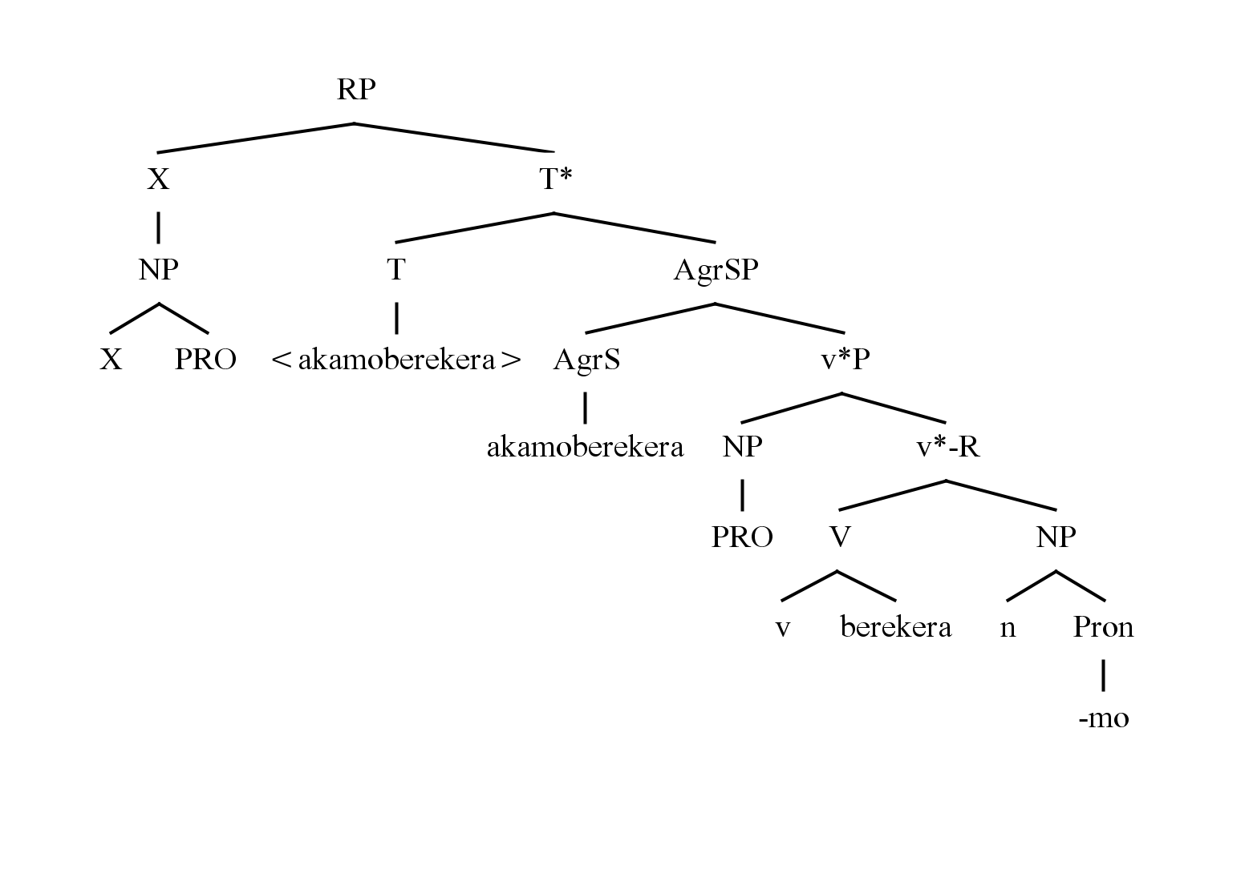

The projection of PRO is licensed by the edge feature, + Topic, which is a subset of Phi-features that are uninterpretable at the A-P interface alongside Case (+Nominative) and the EPP, which are deleted before transfer. In order for the Topic feature to be projected, there is need for it to have a phonetic correlate that makes it visible and a semantic effect that requires overt expression.

5.1.2 Topic and Pronominal Incorporation

Topical objects in the predicate are reduced to affixes and adjoined into the verb complex. Consider the example in (24) below.
(24.) 1. Moriasi akabwatera omenge engoko.
Moriasi a-ka-bwat-er-a omenge e-ngoko
Moriasi 1SG-INF-catch-APPL-FV omenge 10SG-chicken
‘Moriasi caught for Omenge a chicken’
2. Akamonyenyera.
- ka-mo-ye-nyeny-er-a
1SG-INF-OM2-OMi-slaughter
‘He-slaughtered-it- for-him’

(24’) Syntactic Derivation:
a. { v* {V {v, R √ nyenya { N {n, Pron -ye-}}…
b. { v* {V {v, R -kayenyenya { N {n, Pron -mo-}}…
c. { v* {V {v, R -kamoyenyenya { ApplP{v, -er-}}…
d. {{ v* {N{n, PRO{V {v, R -kamoyenyenyera }}…
e. {C {v* {N{n, PRO{V {v, R -kamoyenyenyera }}…
f. {C { T akamonyenyera {v* {N{n, PRO{V {v, R -kamoyenyenyera }}…
g. {C {N{n, PRO { T akamonyenyera {v* {N{n, PRO{V {v, R -kamoyenyenyera }}…
h. {C {N{n, PRO {AgrSP { AgrS akamonyenyera { T akamonyenyera {v* {N{n, PRO{V {v, R -kamoyenyenyera }}…
i. {ϕϕ {N{n, PRO {AgrSP { AgrS akamonyenyera { T akamonyenyera {v* {N{n, PRO{V {v, R -kamoyenyenyera }}…

5.1.3 Reflexive Structures
The EkeGusii reflexive starts of as a pronominal root structure which is externally merged with the verb in first merge. In order for its topical feature to be valued the pronominal {-e-} is then raised but seeks a defective head for merger. The landing position is within the verb where it is infixed. Consider the sentence in (25) below.

(25.) Moracha nigo eageti.
Moracha n-igo e-ag-et-i
Moracha Foc-PTL REFL-scratch-PERF-FV
‘Moracha scrached himself.’

(25’) Syntactic derivation
{C {moracha {Foc’ nigo {T eageti { AgrP eageti {v*P {NP moracha { V {v*-R {v, √ agia {N {n, √-e}}}}}}}}}}}}
i. Externally merge the reflexive pronominal -e to the verb root : { α {V {v ,√agia { N {n, √-e }
ii. Internally pair merge the reflexive to the verb {v*P { ReflP e-agia{ α {V {v ,√agia { N {n, √-e }}

The reflexive once it is adjoined to the verbal is relabelled as a ReflP in analyses that adopt a rich cartographic analysis, which considers the reflexive Phrase as a sub-label within the complex verbal. Similar landing positions are construed for aspectual elements such as the Perfective Phrase (PerfP). However, the head Topic Phrase is not considered as part of the complex split verbal projection.

(a)

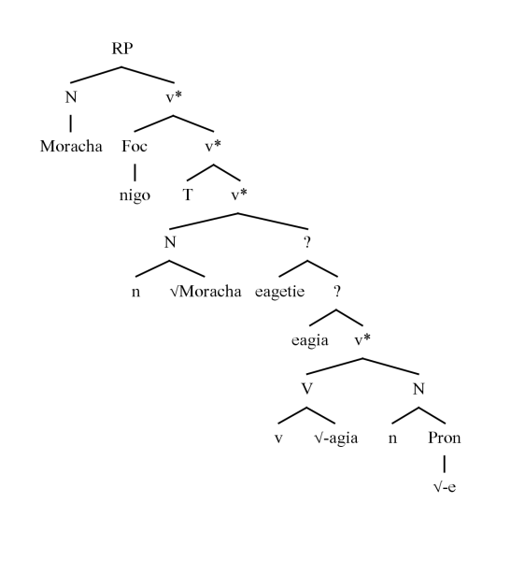

(b)
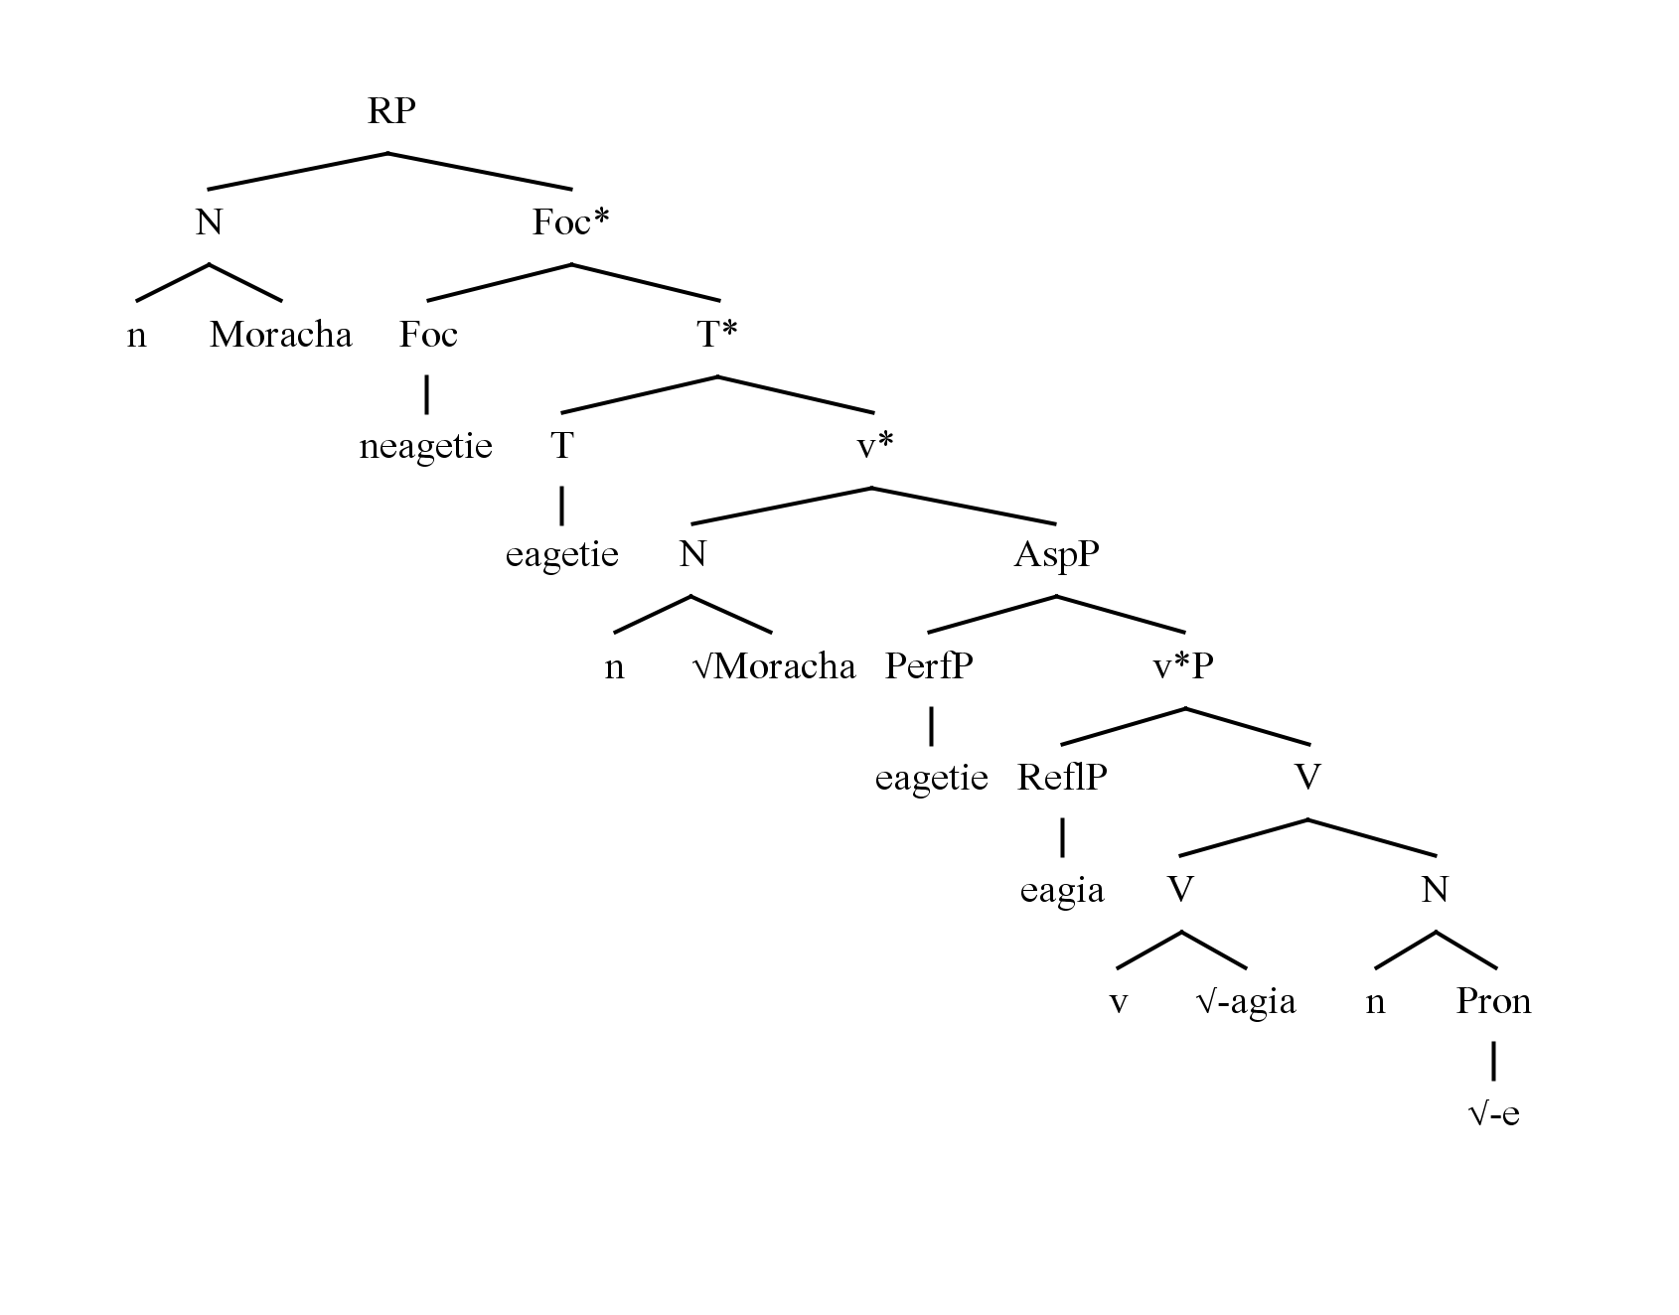

The verbal complex has the FocP as the highest projection due to the adjunction of the verbal with it along with the other heads which verb has successively been adjoined to in the derivation being unlabelled in the tree diagram. The criteria for labelling the verbal complex involves the overlooking the labels of previous positions, which are only visible to the C-I interface but are deleted in the phonetics (A-P interface). In some analyses (of Bantu data in feature Checking theoretic analyses) the practice is to only represent the affix with its label with the assumption that what we see in sentences is the product of further linearisation during the post-syntactic process of externalization (Ext.). In Ext. the affixes which are involved in the derivational process are then incorporated by a process of roll-down (a countercyclic movement). In this paper we avoid the utilization of roll down as was employed in transformational grammars to derive cases of complex verbs in the process of affix-hopping (cf. Radford, 1988).

6.0 Conclusion
In this paper the relationship between the realization of information structural functions, topic and focus is examined. The topic feature in and the focus feature in default focus contexts in EkeGusii are weak and do not license labels even in cases where information structural effects are overt, such as in being marked by overt morphology (affixes) as default focus or as reduced morphemes (affixes) in reflexives, reduced (affixal) objects and null subjects (as projections of PRO to meet the EPP requirement) . On the other hand, focus marking licenses labels and overt morphology in some cases of argument and predicate focus constructions that have a [+ Prominent] feature to the exclusion of other foci in those constructions. In the default focus construction we have an overt focus marker which even it is labelled as a FocP is not interpretable at the CI interface because it is [-Prominent]. The default focus construction is all new and its information value is not packed up in the labelled projection in the output. The data indicates that the notion of labelling as the driver of interpretation in the interfaces that is posited in current minimalist theory should be reconsidered.

References
Aboh, Enoch. 2007. Leftward Focus versus rightward focus: the Kwa-Bantu conspiracy. SOAS Working Papers in Linguistics: Bantu in Bloomsbury 15, 81-104.
Belletti, Adrianna. 2001. Inversion as Focalization. Subject Inversion in Romance and the Theory of Universal Grammar, eds A. Hulk & J. -Y. Polock. 60-90.
Belletti, Adrianna. 2004. Aspects of the Low IP Area. The Structure of the CP and IP. Ed. L. Rizzi. Oxford University Press.
Buell, Leston. 2007. Semantic and Formal Locatives: implications for the Bantu Locative Inversion typology. SOAS Working Papers in Linguistics 15: 105-120.
Carstens, Vicky. & Mletshe, L. 2015. Radical Defectivity: Implications of Xhosa expletive Constructions. Linguistic Inquiry 46. 2: 187-242.
Cecchetto, Carlo. & Donati, Caterina. 2010. On labelling: Principle C and Head Movement. Syntax 13.3: 241-278.
Cecchetto, Carlo. & Donati, Caterina. 2015. (Re)labelling. MIT Press.
Cheng, L. Lisa. & Downing, Laura, J. . 2009.Where’s the Topic in Zulu? In Helen de Hoop & Geertje van Bergen (eds.), Special Issue on Topics Cross-linguistically, The Linguistic Review 26, 2/3.
Cheng, L,Lisa.-S & Downing, Laura. J. 2012. Against FocusP: argurments from Zulu. Information Structure. Contrasts and Positions. Eds. I. Kucerova & A. Neeleman, 247-266. Cambridge University Press.
Chomsky, Noam..1995a. The Minimalist Program. The MIT Press.
Chomsky, Noam.1995b. Bare Phrase Structure. In Gvernment and Binding Theory and the Minimalist Program, ed. Gert Webelhuth, 383-439. Malden: Blackwell.
Chomsky, Noam. 2000. Minimalist Inquiries: the Framework. In eds. Martin R, Michaels, D., Uriagereka, J.. Step by Step. Cambridge, Mass.: MIT Press, pp. 89-156.
Chomsky, Noam. 2001. Derivation by Phase. In Michael Kenstowicz, ed. Ken hale: A Life in Language ,Cambridge, MA: MIT Press, pp. 1-52.
Chomsky, Noam. 2004. Beyond Explanatory Adequacy. In Structures and Beyond: The Cartography of Syntactic Structures, Vol. 3. Ed. Adriana Belletti, 104-131. New York : Oxford University Press.
Chomsky, Noam.2013. Problems of Projection. Lingua 130: 33-49.
Chomsky, Noam. 2015. Problems of Projection: Extensions. In E. D. Domenico, C.. Hamman & S. Matteini (eds.). Structures, Strategies and Beyond: Studies inn honour of Adriana Belletti. Pp. 3-16.
Chomsky, Noam. 2019a. Some Puzzling Foundational Issues: The Reading Program. Catalan Journal of Linguistics Special Issue : 263-285. <htps://doi.org/10.5565/rev/catjl.287>
Chomsky, Noam., Gallego, J. Angel. & Ott, C. Dennis. 2019. Generative Grammar and the Faculty of Language: Insights, Questions, and Challenges.
Citko, Barbara. 2008.Missing Labels. In Lingua Vol 118, No. 7. pp. 907-908.
Cinque, Guglielmo.1999. Adverbs and Functional Heads. Oxford University Press.
Collins, Chris. 2006. Eliminating Labels. In S .D. Epstein and D. Seely (eds.), Derivation and Explanation in the Minimalist Program, Blackwell, Oxford, pp. 42-62.
Epstein, Samuel David, Kitahara, Hisatsugu, & Seely, T. Daniel. 2016. Phase Cancellation by external pair-merge of heads. The Linguistic Review 33: 87-102.
Hornstein, Nobert. 2009. A Theory of Syntax: Minimal Operations and Universal Grammar. Cambridge: Cambridge University Press.
Hornstein, Norbert & Nunes. Jairo. 2008. Adjunction, labelling, and Bare phrase structure. Biolinguistics,2. 57-86.
Lambrecht, Knud..1994. Information Structure and Sentence Form: Topic, focus and the mental representations of discourse referents. Cambridge University Press.
XXXX. 2013. Information Structure in EkeGusii. Lap Lambert.
XXXX. 2018. Focus in EkeGusii. In Jadvpur Journal of Languages and Linguistics.
Nakashima, Takanori. 2019. On the Domain of Minimal Search for labelling. In Explorations in English Linguistics (33), 51-84..
Nomura, Masashi. 2019. Labelling and Pair-Merge of Heads. Nanzan Linguistics 15.
Oseki, Yohei.2015. Eliminating Pair-Merge. In 32nd West Coast Conference on Formal Linguistics
Radford, Andrew. 1988. Transformational Grammar. Cambridge University Press.
Richards, Michael. 2009. Internal Pair-Merge: the Missing Mode of Movement. In Catalan Journal of Linguistics 8: 55-73.
Rizzi, Luigi. 1997. The Fine Structure of the Left Periphery. In Element of Grammar, ed. by Lilian Haegeman, 281-337. Dordrecht, Kluwer.
Rizzi, Luigi. 2004. Locality and Left Periphery, In Structures and Beyond : The Cartography of Syntactic StructuresVolume 3, ed. By Adriana Belletti, 104-131. Oxford, Oxford University Press.
Rizz, Luigi. 2016. Labeling, Maximality and the Head-Phrase Distiction. In The Linguistic Review 33(1): 103-127.
Selvanathan, Nagarajan. 2019. The labelling Algorithm and Kirundi Inversion Structures. In Studia Linguistica pp. 1-29.
Totsuka, Masashi. 2019. Cartography Meets labelling Algorithm. In Phonological Externalization Vol. 4: 37-46.
Van Der Wal, Jan. 2008. Agreement in Thetic Sentences in Bantu and Romance. The Bantu-Romance Connection. A Coparative Investigation of Verbal Agreement , DPs and Information Structure. Eds. C. De Cat & K. Demuth, 323-350. Amsterdam: John Benjamins.

The locus Principle is stated in Collins (2008:46) as given below: Let X be a lexical item that has one or more probe/selectors. Suppose X is chosen from the lexical array and introduced into the derivation. Then the probe/selectors of X must be satisfied before any new unsaturated lexical items are chosen from the lexical array. Let us call X the locus of the derivation.
Abbreviations used in this paper are as follows: AUG - augment marker, Foc - Focus marker, FV - Final Vowel, INF - infinitive, LOC - Locative, PL - Plural, PERF - perfective, PRS - present, PST - past, SG - singular, Top - topic, IA - Internal argument, EA - external argument, .
The EkeGusii noun classes: Class Singular number Plural number 1 omo- omoremi (‘a farmer’) aba- abaremi (‘farmers’) 1b mo- taata (‘father’) aba- abataata (‘fathers’) 3 omo- omote (‘tree’) eme- emete (‘trees’) 5 eri- erieta (‘name’) ama- amarieta (‘names’) 7 eke- egesaku (‘clan’) ebi- ebisaku (‘clans’) 9 e- ekabira (‘tribe’) či- chikabira (‘tribes’) 9 e-n- endaagera (‘food’) či- chindagera (‘foods’) 11 oro- oroko (‘firewood’) či- chinko (‘firewood’ pl.) 12 aka- akaana (‘a small child’) 14 obo- obokombe (‘a hoe’) Ama- amakombe (‘hoes’) 15 oko- okogoro (‘a leg’) ama- amagoro (‘legs’) 16 a- ase (‘place’) 21 ñ ñamira (‘a place name’)
The PIC states that the complement of a phase is not available for further syntactic processes. The movement of the adjective, which is semantically subordinated to the noun, seems to partially obey both the PIC and No tampering condition, because it blocks the splitting of the complex NP but allows for internal merge to the left periphery.

