CONTEXT-MOTIVATED ENGLISH INTONATION CHOICES IN NIGERIA NATIONAL ASSEMBLY PLENARY SESSIONS

Abstract
Existing studies on Nigerian English Intonation have described the grammatical, attitudinal and accentual features of intonation, while the discourse feature of Nigerian English Intonation has not been duly examined. This present study explored the intonation patterns used at Nigerian National Assembly plenaries. Forty-one non-interrogative tone units of the twenty-four Nigerian federal legislators in the 8th parliamentary session (2015-2019) selected across the six geopolitical zones were analysed. Brazil’s (1997) Discourse Intonation Model (DI) formed the theoretical framework for discussing the intonation tunes deployed on the tone units and spectrograms were generated with PRAAT and the frequency of tone units were calculated in simple percentage. Sixteen participants demonstrated total conformity to DI, five performed on exact average while the remaining twenty conformed to grammatical intonation. The patterns of Nigerian federal legislators were not consistent with the communicative value of English intonation in discourse; rather, they were mainly concerned with structural patterns of these tone units. Thus, it was suggested that DI should be emphasised in schools at different levels to foster proficient use of intonation in context.

Keywords: Naturally-occurring speeches, Nigerian federal legislators, National Assembly plenary sessions, Discourse Intonation

- Introduction
Intonation is dynamic in nature and cannot always be regulated by grammatical rules, especially in the context of naturally-occurring or spontaneous speeches. McNeill et al. (2001) opine that “the organisation of discourse is inseparable from gesture and prosody” and that “[they are] different sides of a single mental communicative process”. Nigerian English, on the other hand, is a “variety of English which has often been suggested to differ from other varieties of English, especially in the area of prosody” (Gut, 2005: 154). By exploring the English intonation patterns in Nigerian National Assembly plenary sessions and how legislators make intonation choices, the study hope to assess their intonation patterns and their intended meanings.

- Review of Literature
Scholars have explored the prosodic features: stress, intonation and rhythm of Nigerian English. While many existing studies on English intonation patterns of Nigerian speakers have concentrated on rule-governed patterns, very few researchers seem to have explored the intonational choices of Nigerian speakers of English in spontaneous utterances. Jowitt (1991) avers that in an L2 situation, intonation patterns cannot be acquired as used by native speakers. They are consciously learnt and since their complexity — like stress timing tends to repel all but motivated learners, they go for the most unlearned part to account for the meaning which they could not achieve with the tunes. Further, lending credence to the observations of Eka (1985) that the most problematic area of Nigerian English phonology is rhythm, Udofot (1997) observes that pauses between intonation groups are shorter in Nigerian English than in British English. She notes that there is a preference for ‘end-stress’ in intonation phrases. Having studied the systematic differences in the intonational patterns between Nigerian English and British English, Jowitt (2000) enumerates the characteristics of Nigerian English intonation system:
- Fall predominates in a statement, WH- questions and command,
- Rise predominates in yes/no and tag questions,
- Complex tunes were seldom used, although there are some instances where the rise-fall is used for strong emphasis,
- End stress is a general rule for information group,
- Lexical words carry a pitch accent, and invariably pitch accents are relatively high.
- The core pattern for heads is an initial high pitch followed by down drift before the commencement of the nucleus.
- Where the core pattern includes a falling nucleus, it is a low-falling nucleus.

Education has been described as a fluid variable that can be affected by other variables. Adejuwon (2016: 33) commented that his data cannot be extended to all Nigerian users of English as there are Educated Nigerians who are more proficient in the use of English intonation than his participants. In addition to this, the context could have also affected the rendition of the participants; while some might be trying to impress the researcher, some might be afraid.
Furthermore, the study of Adejuwon (2003) revealed that the majority of Nigerian radio broadcasters in South-western Nigeria were unable to interpret intonation tunes played back to them. Also, they do not usually deploy these tunes while casting news. Buttressing the opinion of Adejuwon (2003), Atoye (2005) opines that the level of perception of intonation was higher than the level of interpretation of meaning in his study investigating the perception and interpretation of a subclass of sentence intonation by some Nigerian users of English. There is however a need to mention that the data read by the broadcasters were prepared by the researcher and this “could not be devoid of affectations” (Adejuwon 2016) or “observer’s paradox” (Labov, 1972).
Fajobi (2013) carried out an acoustic investigation of intonation in Nigerian English, concentrating on the extent to which Yoruba influences speakers’ spoken English. Her study examined on Yoruba-influenced-Nigerian-English intonation of eight Yoruba native speakers, four had lived in London for 25 years and the other four resided in Nigeria. She generated pitch contours from PRAAT software and her analyses were buttressed statistically using SPSS. The study thus found out that “to a very large extent and irrespective of where Nigerians speakers are located, Yoruba Nigerian English intonation relates more to Yoruba than to the native English intonation system” (Fajobi, 2013: 75). Although this study set out to explore Nigerian English intonation, it concentrated on the Yoruba Nigerian English. Also, there is a gap of discourse intonation.
Odeyemi (2016) examined context and Discourse Intonation in English medium product advertisements on radio and television in Nigeria. Using Discourse Intonation as his framework, he explored how Nigerians use intonation in radio and television advertisements. Jingles used in electronic media advertisements are sometimes scripted and usually recorded and edited after a series of rehearsals. This defines the utterances considered in his study as different from naturally-occurring utterances.
In a study on Natural Speech and Intonation Rule Patterns, with 200 tone units of selected Educated Nigerian speakers of English, Adejuwon (2016) concludes that there is a remarkable gap between the natural speech intonation patterns of educated Nigerian Speakers of English and formalised intonation rules. Using the Discourse intonation proposed by (Brazil 1997), two different groups of Educated Nigerians were studied. While the data of group A were electronic data recorded during television and radio interviews, the data of group B, the focus group were discussion-generated. According to him, DI is yet a strange model in the English intonation of Nigerian Educated speakers of English; thus, he concludes that educated Nigerian speakers of English, generally, lack the knowledge on the use of the discourse intonation model, and there is a disparity between their intonation patterns in natural speeches and the formalised intonation rules. His findings, therefore, corroborate some of the positions of Udofot (1997); Gut (2004), and Jowitt (2000). Although this study covers people from all walks of life, it does not include legislators and how intonation is used in the process of law-making.
Again, few scholars seem to have deployed the DI in the study of the English intonation patterns of Educated Nigerians. Thus, the study of Adejuwon (2016) and Odeyemi (2016) can be regarded as pioneering elaborate works on the discourse intonation patterns of educated Nigerian speakers of English. Adejuwon (2019) studied the conformity of the spontaneous speech intonation patterns of selected educated Nigerian speakers of English (ENSE) with their interactional context. Using David Brazil’s Discourse Intonation (DI) model, the study concluded that ENSE’s natural speech intonational choices were generally inconsistent and do not conform to DI. However, one gap that is yet to be adequately addressed is the contextual influence(s) on intonation (especially in the process of law-making), which DI can duly explore. By investigating how Nigerian federal legislators make choices from the intonation patterns, this study hopes to avoid observer’s paradox (Labov, 1972), affectations (Adejuwon, 2016), and generate reliable data to make plausible suggestions and contributions to the positions of scholars on Nigerian English intonation.

2. Brazil’s Discourse Intonation
The theoretical framework of this study is the discourse intonation approach to intonational analysis proposed by Brazil (1997). Brazil’s model elucidates the underlying principles regarding the communicative value of intonation in naturally-occurring interactions. The importance and relevance of DI have been acknowledged by many scholars. First, it provides the most satisfactory explanation for the intonation choices speakers make. The model is attractive because it is simple and has a powerful explanatory force; not only can it account for frequently-occurring patterns in conversation; it equally provides the exceptions to those patterns (Ranalli, 2002). It has a current appeal now because of its “top-down” and communicative orientation, foregrounding as it does the distinctiveness of particular speakers and contexts rather than linguistic universals (Bradford, 1992; Brazil, 1994; and Underhill, 1994). Cauldwell (2000) is of the opinion that DI gives a clear way of understanding naturally-occurring speeches and continues to gain researchers’ patronage across the globe as a current theory. Adejuwon (2016) says DI is concerned with the speakers’ moment-by-moment context-referenced choices. Thus, given the currency of this theory, its wide acceptance and profound relevance to naturally-occurring speech, the present adopts it. DI has four systems of speaker choice: prominence, tone, key and termination. The relationship between the four systems is that prominence fixes the domain of the three variables of tone and key or termination, all of which contribute to the communicative value of the tone unit (Brazil 1997).
I. Prominence
All tone units have one or two syllables that are prominent; a listener can perceive them as more emphatic than other syllables. In this sense, Brazil (1997, p. 7) views prominence as a feature which makes a syllable distinct from all other syllables within a tone unit. Adding to this, while the first prominent syllable in a tone unit is regarded as an onset syllable, the last prominent syllable which is the centre of operation of the tone unit is referred to as the tonic syllable (Brazil, 1997, p. 9). Although these syllables are subsets of prominent syllables, the onset syllable is complementary to the tonic syllable (Brazil, 1997, p.10). Put clearer, a tonic syllable is a syllable which is prominent and on which there is a major pitch movement (Adejuwon, 2016, p. 42). In transcription, prominent syllables are indicated with upper-case letters while all non-prominent syllables are represented by lower-case letters (Brazil, 1997, p. 13). Also, tonic syllables are indicated with underlining and an arrow symbol is placed at the beginning of the tone unit to specify the tune that is selected:

// I think on the WHOLE// that THESE ofFICials// do a reMARKably good JOB// (Brazil, 1997, p. 9)
II. Tone
Chun (2002) views tone as pitch change that characterizes the tonic segment of a tone group. Adejuwon (2016) defines tone as pitch movements distinguished by their particular direction or contour, and mentions that Brazil (1997) identifies five tones: falling, rising, fall-rise, rise-fall and level. Each tone unit has one or two “prominent syllables”. When there are two prominent syllables in a tone unit, the first one is called the onset syllable and the last one the tonic syllable. Both prominent syllables are indicated in upper-case letters and the tonic syllable is underlined as well. At the tonic syllable, pitch movement starts (Rannali, 2002).

//i think on the whole// that these officials// do a remarkably good job// we have to remember// that// they’re required// by administrative practice// to take these decisions// on paper// and// most often// when they get these decisions wrong// it’s because// they haven’t had the opportunity// of talking// face to face// with the claimant// and really finding// the facts// Brazil (1997, p. 6)
III. Key
This is the pitch-level system; it contributes to the description of intonation and projects
the relevant utterances made by the participants. Coulthard (1985, p. 101), as cited in Adejuwon (2016), avers that “key is a relative pitch level chosen by speakers for each tone unit from three choices: low, mid and high.” Brazil, (1997) views it as the choice associated with the onset syllable in a tone unit. Chun (2002) adds that these keys are indicated by an upward or downward arrow; key height is relative, though. The description differs depending on where the key movement occurs. She further observes that speakers make a potentially meaningful choice to pitch each successive tone group at, above, or below the level which for them can be regarded as “the baseline or norm”. The key selection of either ‘high’, ‘mid’, or ‘low’ projects the ‘contrasting, particularizing or adjudicating’, ‘asserting or concurring’, and ‘equating’ implications of the speaker within the context of interaction. In a discourse, high key sets up expectations whereas low key implies prerequisites. Brazil (1997, p. 43) lends credence that “the choice of mid key, which is a normal or unmarked choice in conversation, indicates that something is the case; high key which is a marked choice, has the import that it is not the case.” Cauldwell and Allen (1997, p. 6) also observe that “one speaker’s ‘mid’ pitch would be another speaker’s ‘low’ pitch” and values vary from speaker to speaker and with the context of the situation. This is what Adejuwon (2016) means by positing that the choice of mid key or high key has contrastive implications.
LOST a FORtune//
- // he GAMbled// and

- // he GAMbled// and LOST a FORtune//
(Brazil, 1997, p. 45)

Chun (2002) explains that at the beginning of utterances, high key can function to mark of the ensuing part of the discourse from that which has preceded it. On the one hand, high key can be used to commence a new topic or change the subject, both of which entail a type of contrast. On the other hand, low key is used in situations in which a speaker assumes that there is “equivalence” between two successive tone groups in the discourse. Low-key tone groups that occur medially and finally in utterances are generally uninforming, as they often signal previously known information.

IV. Termination
As key is related to the onset syllable, termination is associated with the tonic syllable, that is, the last prominent syllable (Brazil, 1997:11).
HAVE to re
// we MEMber// that they’re reQUIRED// by
adMINistrative PRACtice// to TAKE these deCISions// on
PAper
//
(Brazil, 1997:12)
In the example above, there are five tone units. The first tone unit has an onset with a high key and mid termination associated with the tonic syllable, and there is mid key and mid termination from second to fourth tone units. It suffices to emphasize that both the second and fifth tone units have one prominent syllable which serves as both the key and the termination. This becomes clearer in the fifth tone unit where the only prominent syllable has high key and high termination.

3 Methodology
In respect to the aim and objectives of this study, the data, the intonation tunes used by the study participants were identified and the frequency of occurrence was determined using simple percentage. Forty-one non-interrogative tone units are purposively selected for analysis from six excerpts based on their structural types and how central they are to the messages in these excerpts. Twenty-four Nigerian federal legislators constitute the participants for this study; twelve legislators from the Senate and the other twelve from the House of Representatives in the 8th Parliamentary Session (2015-2019 Administration). Following the provisions of the 1999 constitution of the Federal Republic of Nigeria, Nigerian legislators hold at least the First School leaving Certificate educational qualification, and are not younger than 35 years (for Senate) and 30 years (for House of Representatives). The present researcher, therefore, concentrates on those who hold educational qualification higher than SSCE given their demographic information on the website of the National Assembly (www.nassig.org/mp/profile). For the acoustic analysis, the selected utterances were played back on PRAAT software on the computer. Some of the visual representations of the tone units (spectrograms) extracted from the utterances in the excerpts were generated and discussed using DI as the framework.

4. Participants’ Intonational Patterns in Non-Interrogative Tone Units
There were 41 non-interrogative tone units produced by participants at different sessions. While 10 were produced with the referring tune, the proclaiming tune was used on remaining 31 tone units. Nigerian federal legislators seem to conform to DI in their patterns of tunes, especially in non-interrogative tone units.
Figure 1 (1A): PRAAT screen capture of “rules and procedures Thursday 26th, April 2018 is hereby approved”
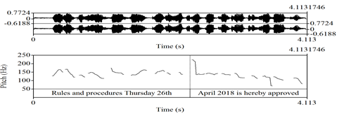
// p rules and procedures Thursday 26th/ p April 2018 is hereby approved//
First, complete compliance was noticed in some excerpts where participants used the proclaiming tune, referring tune or even both to either provide new information or establish common ground. The choice of proclaiming tune in the two non-interrogative tone units with both the non-sentence-final and sentence-final positions in 1A aligns with DI. The participant here made an announcement, and the information was regarded as new.

Figure 2 (4C): PRAAT screen capture of “I am not against this bill, I must repeat myself”
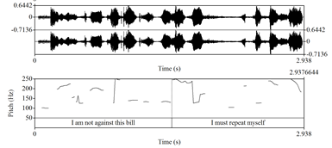
// p I am not against this bill/ p I must repeat myself//

Similarly, the utterance in Excerpt 4C has two tone units, and the two tone units were produced in a proclaiming tune. This was hugely in conformity to the DI; the participant expressed his personal opinion with the two tone units. Both the tone unit at the sentence-final and the one at the non-sentence-final positions were produced in the proclaiming tune.

Figure 3 (3A): PRAAT screen capture of “The only thing that we can draw from on this.”
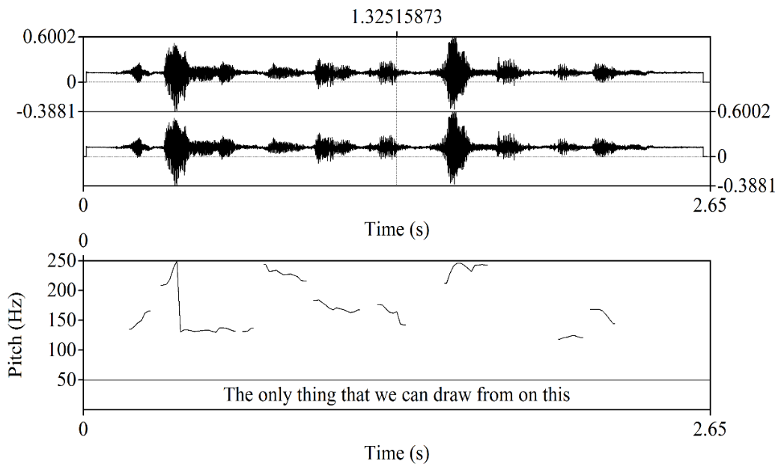
// p the only thing that we can draw from on this//

Figure 4 (3AII): PRAAT screen capture of “Is that we call on you?”

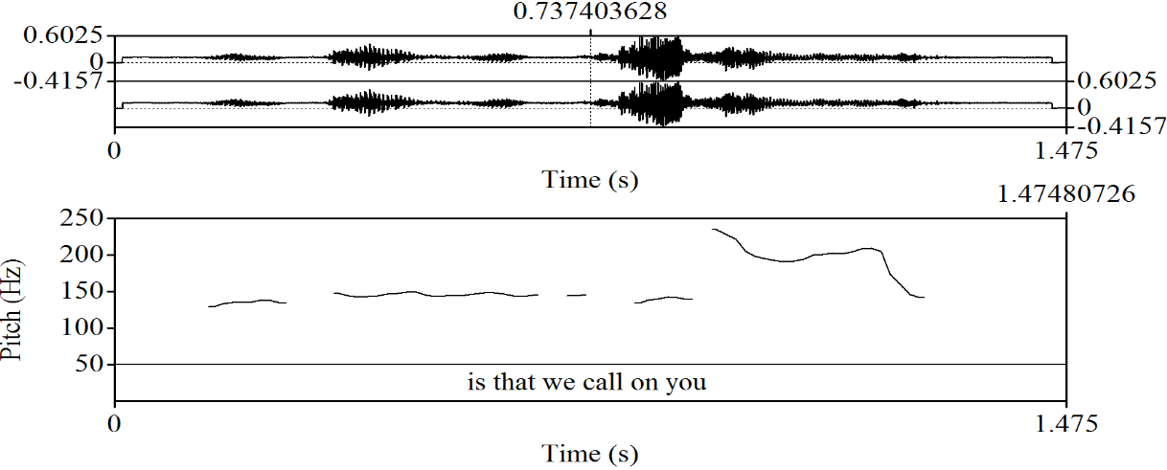
//p is that we call on you//

In Excerpt 3A, the two tone units were produced with the proclaiming tune. The participant used the proclaiming tune on both the non-sentence-final tone unit and the sentence-final one. Using the proclaiming tune on both tone units here suggest that their information are newly introduced to the context of interaction. Of course, in the debate, this participant said something different from earlier submissions; he suggested invoking a provision for the impeachment of the President. Thus, the choice of proclaiming tune here is in accordance with DI.

Figure 5 (4A): PRAAT screen capture of “In the same spirit that we passed this bill in the first place to once again pass it”
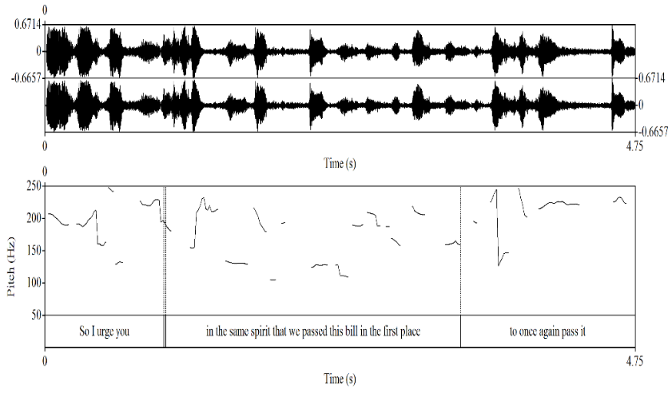
//r in the same spirit that we passed this bill in the first place/p to once again pass it//
This utterance was meant to remind other legislators that the bill had been passed before and to appeal that it should be passed again. The participant here, therefore, used both the referring and the proclaiming tune respectively. The choice of tune on the first tone unit is suitable, according to DI and so also is the choice of tune on the second tone unit giving the new information. It is important to mention here that the tone unit carrying the referring tune is non-sentence final and the one produced with the proclaiming tune is sentence-final.

Figure 6 (2A): PRAAT screen capture of “beloved son in whom you are well pleased”
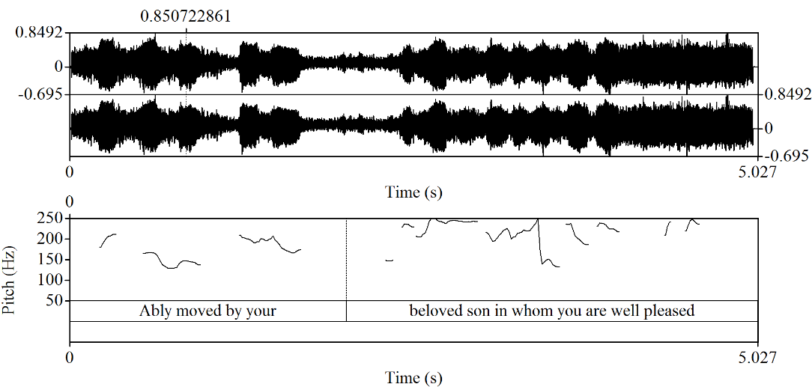
//r beloved son in whom you are well pleased//

Figure 7(2AII): PRAAT screen capture of “I so second”

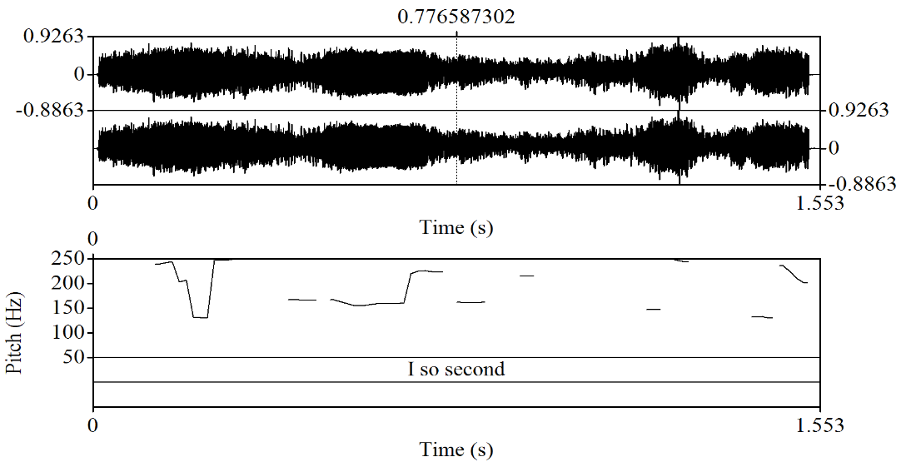
//p I so second//
In the first tone unit, the speaker alludes to a popular quote in the Bible and uses this to remind others of the shared knowledge. Therefore, the selection of a referring tune here conformed to DI; it was used to bring to remembrance that the legislator called to move the motion was the Speaker’s favourite. Further, in the second tone unit, the speaker draws her conclusion with a proclaiming tune. The participant expressed her support for a motion earlier moved; her use of the proclaiming tune here conforms to the provision of DI. Although the motion has been moved earlier, she brought fresh insights to the interactional context before she proceeded to support the motion.

Figure 8 (3B): PRAAT screen capture of “so i rise and support this motion”

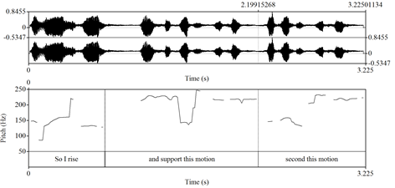
// r so i rise/ r and support this motion//
Participant 3B’s utterance has three pre-sentence final tone units. The first two tone units selected were uttered in the referring tone. The participant was contributing to the common ground; thus, his choice of the referring tone is appropriate and aligns with DI.

Figure 9 (3E): PRAAT screen capture of “Issue of mentioning of PDP is wrong”
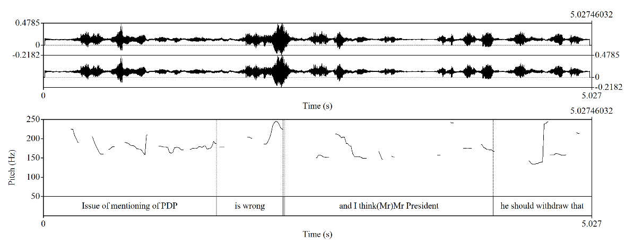
//r Issue of mentioning of PDP/ p is wrong//
The participant 3E appropriately used the referring tune on the tone unit which agrees with the common ground and a proclaiming tune on the new information. The utterance was preluded by a submission of another federal legislator’s submission. In 3E’s opinion, the first tone unit refers to the preluded submission while the latter tone unit shares his view.

Figure 10 (4G): PRAAT screen capture of “If this is going to make peace in your domain as the name connote”
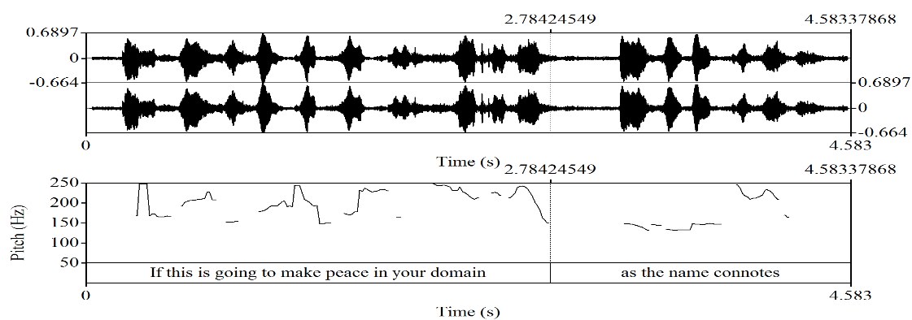
//p If this is going to make peace in your domain/ p as the name connotes//
The tone units here were said using the proclaiming tune. It suffices to add that the two tone units are non-sentence-final tone units; thus, the choice of such a tune on them calls for attention. Uttering the first tone unit with a proclaiming tune is in accord with the DI because the first tone unit, although a subordinate clause, provides new information. But placing the same tune on the second tone unit does not conform to the DI as the tone unit provides a piece of information already existing in the context of interaction and it is therefore expected that it is said in a referring tune. Using a proclaiming tune on the latter tone unit which is sentence-final tone unit suggests that the choice of the participant is hugely guided by the grammatical rules of intonation.
Figure 11 (3C): PRAAT screen capture of “I do not think we should impeach the president”
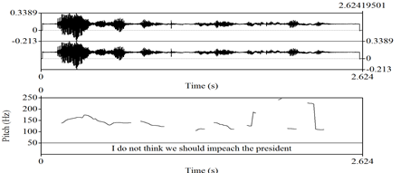
//p I do not think we should impeach the president //
Before this utterance was produced, the previous speaker lends support to another legislator who already moved for the impeachment of the president. However, this participant drove the argument to another side. The proclaiming tune was deployed in producing the only non-interrogative tone unit of participant 3C. This non-sentence-final tone unit is a contribution to an ongoing argument at the plenary and this choice of proclaiming tune makes the participant conform to DI.
Figure 12 (6A): PRAAT screen capture of “I do not think we should impeach the president”
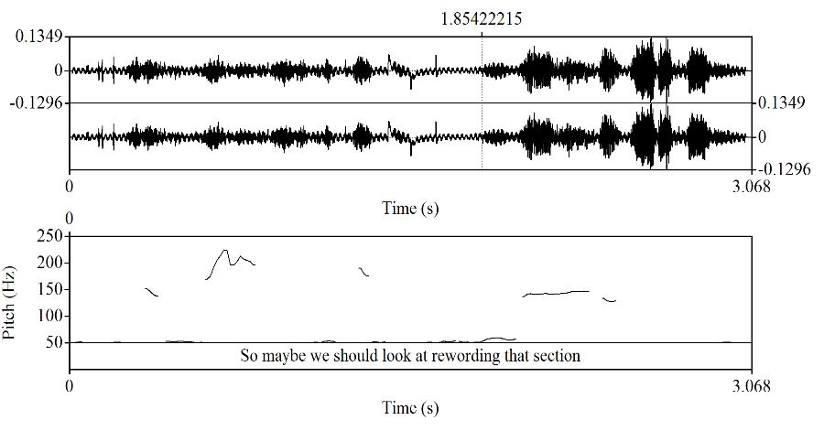
// p So maybe we should look at rewording that section//
The lone tone unit in this utterance expresses the speaker’s suggestion and contribution. Therefore, deploying a proclaiming tune here is in line with the DI. However, we should also add that the tone unit is a sentence-final one.

Figure 13(3G): PRAAT screen capture of “that the Nigerian Government which includes all of us”
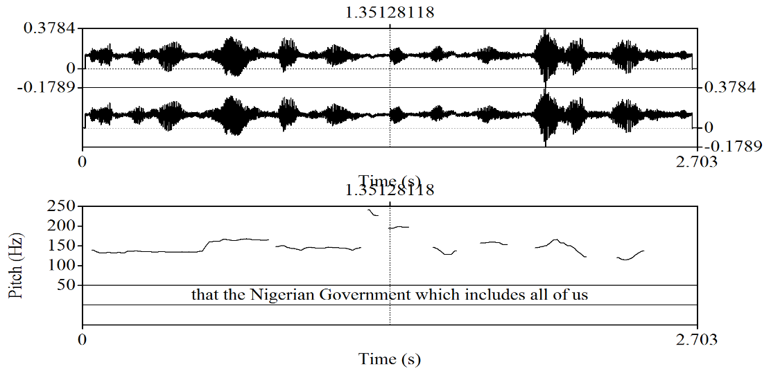
//r that the Nigerian Government which includes all of us//
This tone unit is a non-sentence-final and it expresses a shared knowledge. The participant referred to all the Nigerian federal legislators as part of the Nigerian government, and this is a known fact. Thus, the use of the referring tune here is in line with the DI.

Figure 14 (3G): PRAAT screen capture of “come up with a clear-cut strategy to deal with what is going on”
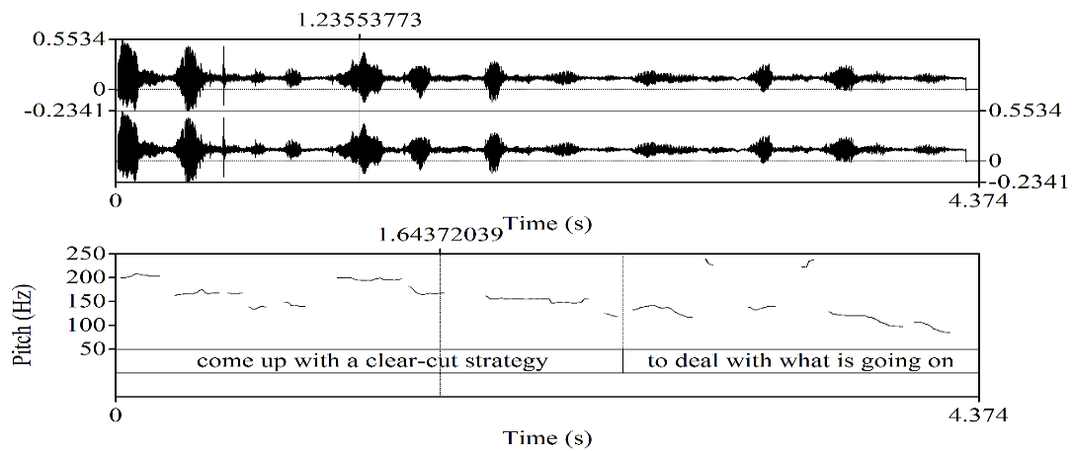
//p come up with a clear-cut strategy to deal with what is going on//
The sentence-final tune here has a proclaiming tune. This choice is appropriate since the speaker shares a personal opinion which is new in the interactional context. On the other hand, average conformity to DI was recorded for three participants as mentioned earlier (4E, 4F, and 6B). Participant 4E did not introduce something new to the context of interaction with the first unit yet he placed a proclaiming tune on it. However, the second tone unit, the participant shared a personal opinion with a proclaiming tune.

Figure 15 (4E): PRAAT screen capture of “I want to help re-echo the position of some of my colleagues”
-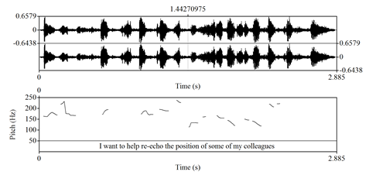
Figure 16 (4EII): PRAAT screen capture of “we should consider this bill”
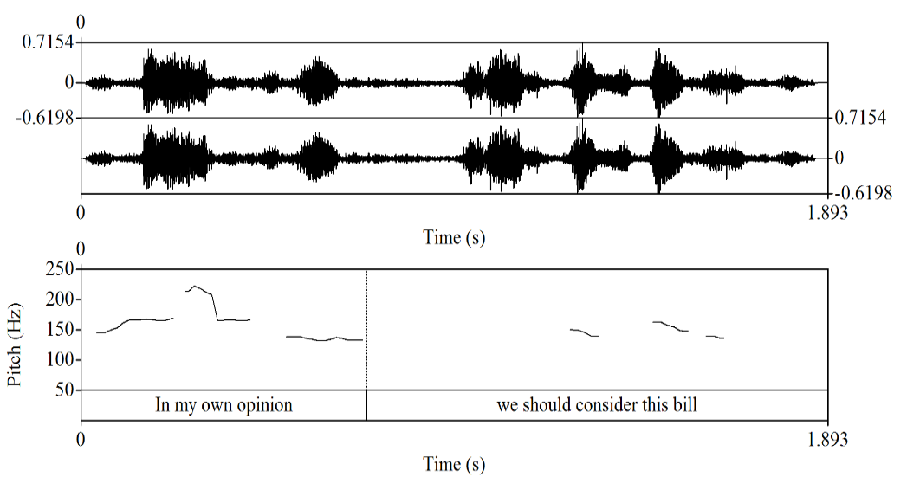
//p we should consider this bill//
Participant 6B used two tone units with both proclaiming and referring tunes respectively. Since the initial tone unit is a non-sentence-final tone unit, the choice of a referring tune here is appropriate following the provisions of grammatical intonation. However, because the information in these tone units are new in the context and are also the contributions of the speaker which have not been said before, they should both have the proclaiming tune (not only on the second tone unit) according to DI. Thus, this made the tone unit to be averagely in line with the DI.

Figure 17 (6B): PRAAT screen capture of “I will suggest that they take peace organisation back/p and do a holistic review”
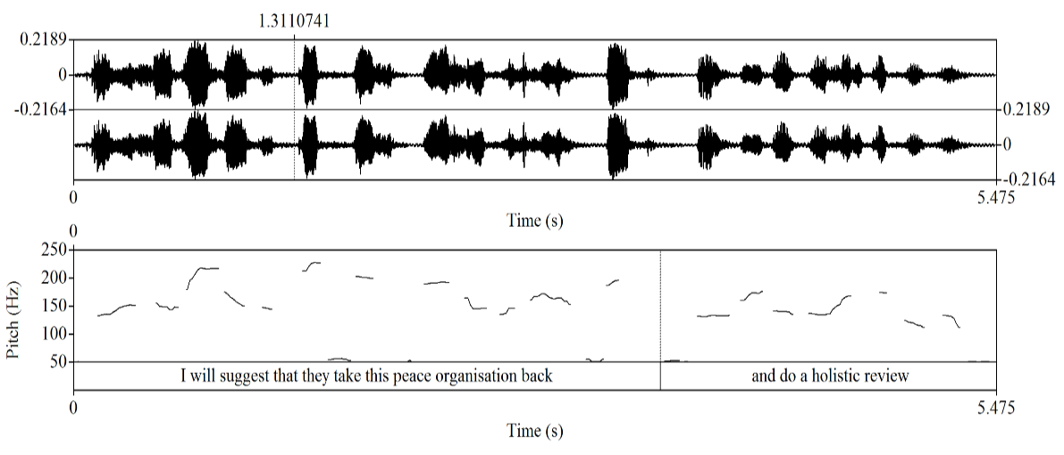
//r I will suggest that they take peace organisation back/p and do a holistic review/

Figure 18 (3D): PRAAT screen capture of “I oppose this motion because it’s politically motivated”
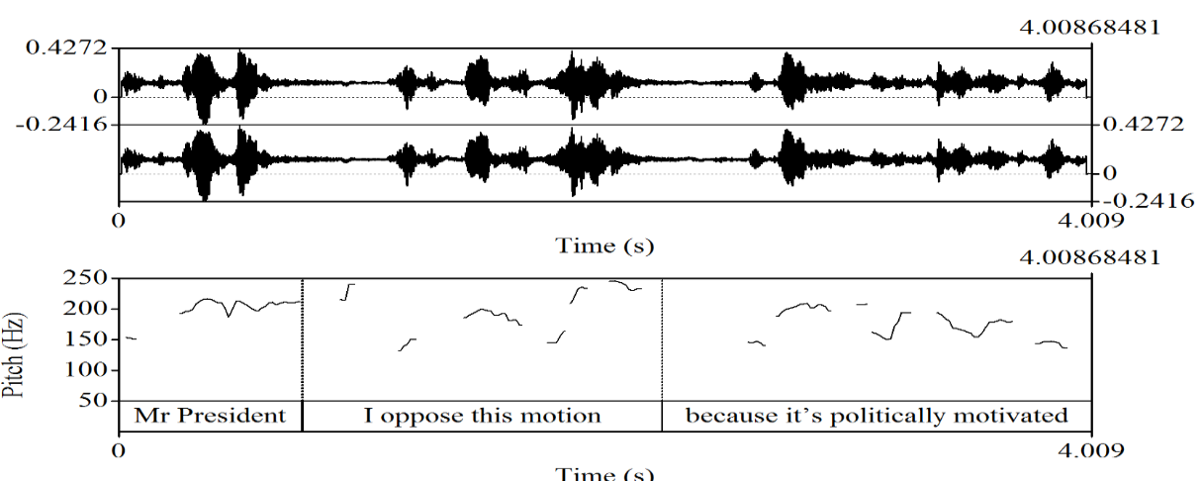
//r I oppose this motion/p because it’s politically motivated//
Also, participant 3D averagely conformed to the DI; the two tone units in that excerpts had one proclaiming tune and one referring tune respectively. Since the two tone units are new in the context of interaction, it is expected that the proclaiming tune is deployed.

Figure 19 (4B): PRAAT screen capture of “I personally endorse this movement”
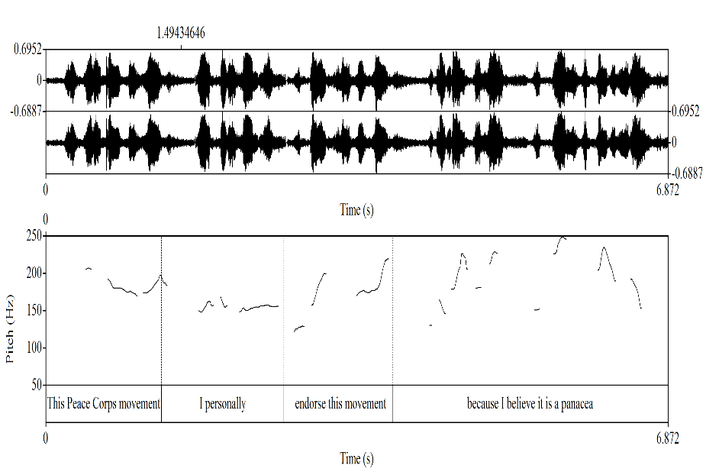
//r I personally/ r endorse this movement//
As stated earlier in this study, in DI, the referring tune is also used with disjuncts to show solidarity with other interlocutors; thus, the choice of a referring tune on the first tone unit conforms to the DI. However, the choice of a referring tune on the second tone unit, although a non-sentence-final tone unit, does not conform with the DI because the speaker has not shown his position about the subject of discussion before then.
In summary, 39% of the participants were completely in accord with DI, 12.2% had average conformity to DI while 48.8% conformed to Grammatical Intonation. Thus, a vast number of Nigerian federal legislators did not conform to DI in their intonational choices on non-interrogative tone units. While sixteen participants demonstrated total conformity to DI, five performed on an exact average and the remaining twenty conformed to grammatical intonation.

5. Conclusion
From the data collated, analysed and discussed, this study found out that the English intonation patterns of the Nigerian federal legislators on non-interrogative tone units largely conform to DI. They were able to use both the referring tune and the proclaiming tune to reiterate what was already known or previously said and to contribute new information respectively. The findings of this study buttress the classification of Nigerian English by Taiwo (2012). As classified by Taiwo (2012), Variety III, a variation of Nigerian English which is used by speakers with university education, is close to the Received Pronunciation (RP). As given on the official website of the National Assembly (www.nassig.org/mp/profile), majority of the participants of this study hold at least a university degree, and they were able to vary patterns of their English intonation patterns on the different structural types of tone units.
The patterns of Nigerian federal legislators, in summary, are not consistent with DI; rather they are hugely in line with the grammatical intonation rules. They seem not to be aware of the context-motivated intonation patterns. They are not conscious of the communicative value of English intonation in discourse but they are mainly concerned about structural types of their utterances and the kinds of tunes used with them. Thus, Discourse Intonation should be emphasised in schools. In addition to the grammatical based rules of intonation taught in schools, both the primary and secondary schools’ language syllabi should reflect DI. Nigerians should be made to understand how to properly use either the proclaiming or referring tune on any structural types of sentence and convey their intention(s) without being misunderstood.

6. Suggestions for Further Studies
As mentioned earlier, this study concentrated on the choice of tunes, which is just a component (tone) out of the four components of Brazil’s DI. Since DI provides three other components: termination, key and prominence, further researchers may base their studies on Nigerian intonation on these components. This will foster in-depth knowledge on the ongoing studies of English intonation of Nigerian speakers and second-language speakers of English language.

References
Adejuwon, A. O. (2003). The English intonation patterns of some radio broadcasters in Southwestern Nigeria. M. A. Thesis. Department of English, Obafemi Awolowo University, Ile-Ife.

________. (2016). Natural speech and intonation rule patterns of selected educated Nigerian speakers of English. PhD Thesis. Department of English, University of Ibadan, Ibadan.

_________. (2019). Discourse Intonation Patterns in the Non-Interrogative Utterances of Selected Educated Nigerian Speakers of English. Ghana Journal of Linguistics 8.2: 86-106, http://dx.doi.org/10.4314/gjl.v8i2.4

Atoye, R. O. (2005). Non-native perception and interpretation of English intonation. Nordic Journal of African Studies, 14(1), 26–42

Chun, D. (2002). Discourse intonation in L2. Amsterdam: John Benjamins.

Brazil, D. (1997). The communicative value of intonation in English. Cambridge: Cambridge University Press.

Eka, D. (1985). A Phonological Study of Standard Nigerian English. Doctoral dissertation, Ahmadu Bello University, Zaria.

Fajobi, E. (2013). “Acoustic Investigation of Intonation in Nigerian English.” Ibadan Journal of English Studies. 41-79.

Gut,. U. (2005). Nigerian English Prosody. English world-wide, 26(2), 153-177.

Jowitt, D. (2000). Patterns of Nigerian English Intonation. English World Wide, 21(1), 63-80

_______. (1991). Nigerian English Usage: An Introduction. Lagos: Longman

Labov, W. (1972). Sociolinguistic Patterns. Philadelphia: University of Pennsylvania Press.

McNeill, D., Quek, F., McCullough, K.-E., Duncan, S., Furuyama, N., Bryll, R., Ma, X.-F. & Ansari, R. (2001) Catchments, Prosody and Discourse. Gesture 1(1), 9-33.

Odeyemi, J. O. (2016). Context and Discourse Intonation in English medium product advertisements on radio and television in Nigeria. PhD Thesis. Department of English, University of Ibadan, Ibadan.

Ranalli, J. M. (2002). Discourse intonation: to teach or not to teach?. University of Birmingham. Retrieved from http://www.cels.bham.ac.uk/resources/essays/Rannali4.pdf

Taiwo, R. (2009). Polysemous usage in domesticated English varieties: A case study of the verb see in Nigerian English.Samara AltLinguo E-Journal #4. Available online at: http://samaraaltlinguo.narod.ru/ejournal/409_rtaiwo.pdf

Udofot, I. (1997). The rhythm of spoken Nigerian English. (Doctoral dissertation), University of Uyo, Nigeria.

Ufomata, T. (1996). Setting Priorities in Teaching English Pronunciation in ESL Contexts. http://pitch.phon.ucl.ac.uk/home/shl9/ufoma ta/titiE

