A CORPUS-BASED MULTIVARIATE LANGUAGE VARIATION ANALYSIS USING SELECTED ADULT EDUCATED NIGERIAN NEWSPAPER COLUMNISTS AS A CASE STUDY

Abstract
Language variation studies have, largely, been in the contexts of EMT speech communities, and the existing studies in ESL contexts (such as Nigeria) have predominantly adopted monovariate phonological approaches. In this study, a multivariate corpus-based approach was adopted to investigate language variation using selected adult educated Nigerian newspaper columnists, with gender and ethnicity as independent variables. 12 columnists were selected from different Nigerian online newspapers, comprising 6 males and 6 females, simultaneously representing 4 columnists (2 males, 2 females) from Igbo, Hausa and Yoruba ethnic groups. A total of 50,000 words were compiled from around 50 different newspaper columns of each columnist to make a sub-corpus, altogether making 600,000-word corpus, comprising 300,000-word sub-corpus for male and female genders, and 200,000-word sub-corpus for each of the 3 ethnic categories. 3 lexical variables: top ranking lexical items, lexical density and lexical diversity were used as dependent variables, which were comparatively examined in each sub-corpus. The resultant values from the exploratory analysis were subjected to statistical computation using Pearson Correlation Co-efficient to determine the correlation of each dependent variable with each of the independent variables in each sub-corpus. The results show in all cases that male and female writers, as well as writers representing each ethnic group, do not write exactly the same way (in terms of top ranking lexical items, lexical density and lexical diversity). But the identified differences were so statistically insignificant that such cannot be used to generalise that gender and ethnicity influence any of the lexical variables except only in the case of lexical density which correlates significantly with gender. It is therefore concluded that even though some levels of variation have been established like some other studies, these variations are not so statistically significant to characterise each type of language use against the other.

Keywords:
Language variation, corpus, gender, ethnicity, top ranking words, lexical density, lexical diversity.

- Introduction
The concept of “linguistic sex differentiation” is not something new in linguistic scholarship (Trudgill, 2000, p.65). Scholars have, at different times since the seventeenth Century, closely examined the human language with a view to identifying variations in language use as a result of speakers’ sex. The various outputs of such studies are gratuitously summed in the averment of Trudgill that “in many societies the speech of men and women differs in all sorts of ways.” (p.64). This has also been corroborated with the position of Newman et al. (2008) and O’Grady and Archibald (2015), who note that a large number of sociolinguistic studies on gender-based language variation identify structural and discoursal differences in the comparative languages of men and women in the society. Ethnicity has also been explored as a sociolinguistic variable for several decades, and what a large number of studies suggest is that “the separate identity of ethnic groups is signaled, not by different languages, but by different varieties of the same language” (Trudgill, 2000, p.45). Till date, sociolinguists have continued to explore these two broad hypotheses with sometimes more corroborative, and some other times, contrastive findings. With the advent of computers in the last century, linguistic scholarship, like many other domains of knowledge, has witnessed immense methodological innovations. These innovations not only now enhance data quantity, storability and retrievability, but also paves way for technology-enhanced analyses, with the characteristic advantages of analytical objectivity, precision and time efficiency.

The study reported here is an attempt to investigate gender and ethnicity based synchronic variation in the use of English in an English as Second Language (ESL) environment with the aid of corpus and corpus analytical tools. It is a synchronic (rather than diachronic) variation analysis because it focuses on specific groups of people who are categorical in gender and ethnicity, and who exist and use English at the same point in time. It is also corpus-aided because the data consisted of electronic collections of texts, which were representative samples of naturally occurring instances of language use per group, and which enabled us to “extrapolate linguistic frequencies and patterns” (Baker, 2010, p.6) for rigorous qualitative and quantitative analyses. The aim of the study was therefore to investigate language use among selected groups of educated adult Nigerians with a view to determining whether ethnicity and gender have (or not) effect on such language use per group. As corollary to this broad aim, the study more specifically attempted to determine the correlation between such lexical variables as top-ranking lexical items, lexical diversity and lexical density on one hand, and ethnicity and gender marked categories of language users, on the other hand, in the study.

1.1 Gender and ethnicity as sociolinguistic variables
Scientists have often traced male-female sex differences to biological and physiological configurations, with such claims, for example, that “females have two X chromosomes whereas males have an X and a Y chromosomes”; and that “female have more fat and less muscle than males, are not strong, and weigh less” (Wardaugh, 2006, p. 316). Linguists and social scientists, on the other hand, have continued to study such differences from socialisation practices, central to which is language. It is on this basis that the word “gender” is more applicable to this study rather than “sex” to reflect the sociological rather than biological perspectives of the study. Research directions in this area have been categorised into an understanding of exclusive gender features on one hand, and gender preferential features on the other. According to Meyerhoff (2006), an exclusive feature is associated with a particular user or group (in this case, a gender), while a preferential feature is distributed across speakers or groups, but being more frequently used by some than others.
Various sociolinguistic studies on gender differentiation in language use have referred to the seventeenth century documentation that identified two distinct languages used by men and women in the Lesser Antilles of the West Indies, a linguistic practice that resulted from a conquest “in which a group of invading Carib-speaking men killed the local Arawak-speaking men and mated with the Arawak women” (Trudgill, 2000; Wardaugh, 2006; Meyerhoff, 2006). As Wardaugh (2006) further notes, the children that emanated from this fusion grew up to speak two languages because the male children grew to learn Carib from their fathers, while the female children grew to learn Arawak from their mothers. The argument that two distinct languages exist in this scenario might not be valid because both versions were mutually intelligible to both male and female, hence Wardaugh’s submission that there was still only one language but with noticeable gender-based linguistic characteristics. Trudgill also corroborates this by saying that both male and female did not speak different languages, but “they spoke different varieties of the same language” (p.65).
Gender differentiation in language use has been examined from multidisciplinary perspectives not only of linguistics but also in such disciplines as anthropology (e.g. Philips, 1980), neuroscience (e.g. Shaywitz , 1995; Ullman, 2008; Wallentin, 2020), psychology (Singer, et al. 1977; Leaper & Ayres, 2007), etc. In linguistics, the subject has been investigated using sampled data from the two modes of communication (speaking and writing). In these modes too, gender differentiation has been examined at the different levels of language that include sound (phonetics and phonology), sentence structure (syntax), word formation (morphology), meaning (semantics) and social meaning (pragmatics). From the broad perspectives of linguistics too, Coates (2015) enumerated the various approaches from which the issues of gender and language have been studied to include, first, the deficit approach (with Lakoff, 1975 as an example), which attempts to identify women language reported to be characterised by hedges and unassertiveness in comparison to men language. Second is the dominance approach (led by West & Zimmerman, 1983), which views men as domineering in the society and seeks to identify evidential male hegemony and female subordination through linguistic practices. The third approach is the difference approach (with Humn, 1989 and Tannen, 1991 as examples). This approach treats male and female as distinct and symmetrical sub-cultures rather than an asymmetrical oppressor-oppressed relation. Coates (2015) further identifies the fourth approach as the dynamic approach, which sees gender as a social construct rather than as a given social category.
A great body of knowledge has been contributed to language variation scholarship from the various studies that have been documented in literature. Crawford (1995) observed that women speak considerably less than men in mixed-gender conversational contexts. Women’s speech has been identified to be characterised by hedges, possibility modals and unassertiveness (Lakoff, 1975; Rubin & Greene, 1992). Kuo (2003) observed that irrespective of the role played by a speaker in televised sports in Taiwan, the frequencies of pronominal use is gender-dependent, as male sports reporters, for example, use the second person singular pronoun much more than their female counterparts. Ladegaar and Bleses (2003) examined how Danish children of age cohorts 4, 6 and 8 years acquire past-tense morphology; reported gender differences; and argued that the occurrence of gender differences in language use at children’s early ages was due to the early institutionalisation of children and increased peer group influence in Denmark.
Lange, Euler and Zaretsky (2016) reported, from a study conducted in Germany involving over 10,000 male and female children aged 3 to 6 years, that while female children outperformed their male counterparts in grammar, vocabulary, sentence processing and speech comprehension, the male children varied significantly more than girls in language competence. Author (2016) examined meaning integration and organisation patterns in selected male-female authored fictional works. It was found that the narratives of male writers tend to be more syntactically and semantically complex while the narratives of female writers tend to be syntactically and semantically simple. Among studies with contrasting discoveries are Nemati and Bayer (2007) who investigated the use of intensifiers, hedges and tag questions in a corpus of selected English and Persian film-scripts and found that there was no gender-based statistically significant difference among the various groups investigated.
One other sociolinguistic variable of rising interest to scholars in addition to gender and other related issues is ethnicity. Various studies in variation analysis are concurrent in their submissions that language plays a very significant role in the construction and sustainability of ethnic identity. A speaker’s ethnicity has fundamental influence on their language, while a speaker’s language can sometimes be used as useful lens to determine their ethnic background. As noted by Fought (2011), ethnicity can provide a speaker or group of speakers the gift of an entirely new language or a rich and different dialect of a language. It can also result in a number of linguistic processes like code switching; and it may be associated with differences in language use.
A great volume of existing studies have findings that concurrently suggest some correlation between language and ethnicity. Some of the recent studies include O’Grady and Archibald (2015), Samara et al. (2017), Jeon (2017), Clothier (2019), Presnyakova (2020), Grama, Travis and Gonzalez (2021). O’Grady and Archibald (2015) observed that most sociolinguistic studies on the African-American English in New York, Detroit and Washington, DC in the late 1960’s concurrently identified “a linguistic system with remarkably similar structures, governed by similar linguistic constraints” (p.459). This suggests that African-American English, an ethnolect spoken by Americans of Afro-descent, varies considerably from the real American English. Kirkham (2017) studied the acoustic phonetic variation between the Anglo-native speakers and Asian speakers of the Sheffield English in the articulatory realisation of the British English liquids /l/ and /ʴ/. According to the study, there were “consistent F2-F1 differences in /l/ between Anglo and Asian speakers in non-final contexts” (p.1).
Clothier (2019) was a socio-phonetic study of the spoken varieties of the Australian English of both Anglo-Celtic Australians and Lebanese Australians with the aim of determining the allophonic and acoustic properties of /l/ as produced by each speaker group in natural conversations. The outcome of analysis shows evidential indication of positive correlation between ethno-cultural backgrounds and different ways of articulating the sound in speech. A geographically and thematically related study is Grama, Travis and Gonzalez (2021) which was also conducted on the Australian English. The focus of the study was on selected diphthongs of the Australian English and how the Anglo-Australians, Italian-Australians and Chinese-Australians. It was found that there were no “wholesale differences” in the use of these diphthongs in each of the three ethnolects, but identified some differences in the progression and social conditioning of changes over time.
The advent of computer in the last century has revolutionalised humans’ several ways of doing things. Comparing the pre-computer and post-computer eras in relation to linguistic scholarship, Moisl, Maguire and Allen (2006) noted that the traditional methods for searching, processing and interpretation of data have been overwhelmed by sheer volume, and a wide variety of computational methods has been developed in an attempt to make the deluge at least tractable. One emergent computer-aided method in relation to linguistic scholarship is the corpus, which now permeates all aspects linguistic inquiries. In sociolinguistics, a number of studies have adopted a corpus-based approach to variation analysis and this has proved to be veritable and productive in terms of analytical output. One of these studies is Moisl, Maguire & Allen (2006), which examined phonetic variation among different speaker groups and how such variations correlate with a number of social variables, using the Newcastle Electronic Corpus of Tyneside English (NECTE) in the Tyneside region of North-East England. With analytical focus on cluster patterns, the study established some level of phonetic variations among the different speaker groups, and further confirmed some level of correlation not only with speakers’ gender but also their socio-economic status.
A survey of existing literature on gender and ethnicity based variation studies leads to a number of evident revelations. One, majority of these studies are studies outside Nigeria, specifically in some of the advanced countries including but not limited to the United Kingdom, United States of America and Australia, which all have English as mother-tongue or first language. Two, majority of these studies investigated either only gender or ethnicity. Such studies that adopted multivariate approach are rare to find in literature. Three, not until the last one decade, variation studies have been predominantly traditional in approach, with manual and quite often scanty data and analysis (compared to large quantity electronic-based data collection and processing). This usually has inhibitory effect not only on the extent of output reliability but also on inferential generalisation based on emanating findings from such studies. As far as Nigeria is concerned, language variation studies have largely been restricted to the spoken English, with focus on articulatory differences and largely using ethnicity as variable. It is evident that studies that have concurrently investigated language variation in a multivariate way are either non-existent or very rare. This is where the current study derives its thematic and methodological differences. It is a language variation analysis, no doubt. But it is different, especially from other related studies in Nigeria by focusing on the written mode of language, adopting a multivariate approach to analysis, and being aided by the use of corpus.
- Research Methods
The analytical approach adopted in the study is both qualitative and quantitative; exploratory and confirmatory. A qualitative corpus-based study involves looking for patterned linguistic examples from the corpus while a quantitative corpus-based study involves a focus on corpus frequencies by means of frequency lists, concordances, measures of dispersion, and co-occurrence frequencies (Desagulier, 2017). The exploratory aspect of the study is closely related to the qualitative approach, where linguistic patterns such as top-ranking lexical items, lexical density and lexical diversity are identified across corpus, while the confirmatory aspect involves the use of statistical tools to determine inter-variable correlations using the comparative frequencies of investigated linguistic patterns. The focus of analysis is on the written mode of language. This is based on the position of Gries (2009) that a salient written expression may have a bigger impact on speakers’ linguistic systems than the spoken mode of communication.

2.1 Variables for Analysis
The main focus of this study is to determine whether (or not) both gender and ethnicity influence educated adult Nigerians’ use of written language. So, two independent variables (gender and ethnicity) and three dependent variables (top-ranking lexical items, lexical diversity and lexical density) are involved, thus making the study an exploratory corpus-based multivariate analysis. A research of this type requires sufficient language data and adequate linguistic evidence to make inferential generalisations. It is therefore best conducted with the use of corpus and corpus analytical tools, which not only allow large quantities of language data but also enable analyses at electronic speed, and without the stress associated with manual data processing. The idea of “top ranking lexical items” has been associated with corpus, and studies have come up with the most frequently used word-forms based on corpus data. For example, Carter and McCarthy (2013) identified twenty (20) most frequent word-forms in both spoken and written texts using the Cambridge International Corpus (top 10 shown in Table 1), with no significant variations from what other studies have documented.
Table 1: Ten most frequently used word-forms in spoken and written texts
(Carter & McCarthy, 2013, p.12)
Rank | Spoken | Written
1 | The | the
2 | I | to
3 | And | and
4 | You | of
5 | It | a
6 | To | in
7 | A | was
8 | Yeah | it
9 | That | I
10 | Of | he

Lexical diversity can be defined as the ratio of word types (that is, distinct words) to word tokens in a text, that is, how varied or how rich the vocabulary of a text is (Author, 2018). As noted by Johansson (2008, p.62), “the more varied a vocabulary a text possesses, the higher the lexical diversity of the text”. Lexical density is another lexical variable comparatively investigated in the study. It refers to the “comparative percentages of open-class items, content words or lexical words to closed-system items, function words or grammatical words in a text” (Author, 2018, p.80). Studies have suggested different ways of determining lexical density in texts (Ure, 1971, Halliday & Matthiessen, 2014). Both lexical diversity and lexical density have been used as variables to measure textual readability and comprehensibility (e.g. Ure, 1971; Johansson, 2008; Halliday & Matthiessen, 2014; Author, 2018) with the concurrent finding that the higher the lexical density and lexical diversity of a text, the higher the tendency for the text to be difficult to read and understand.

2.2 Corpus Development
The data used for this study comprised a specific, synchronic and unannotated 600,000-word corpus purposely developed for the study. Nigeria is an ESL speech community but with over eighty million people who use English through speaking and writing for different communicative purposes. In spite of the global advances in linguistic scholarship with the use of computers, Nigeria is one of the countries without a corpus of English. This is, however, not to say that Nigerians have not been working on corpus and corpora of different kinds. For example, the effort of Adegbite (2012) is acknowledged with their contribution to the development of the International Corpus of English with their compilation of the one million word Nigerian component. This output is, however, not an easily accessible stand-alone corpus that can be used for local studies by the emerging corpus linguists in Nigeria.
The 600,000-word corpus was developed using electronic texts compiled from major newspapers in Nigeria. This is because the focus of analysis was on naturally occurring written language by educated adult users and from a language use platform that is common to all subjects of investigation. Thus, a total of twelve (12) columnists were selected across Nigerian newspapers. For each columnist, a total of 50,000 words were retrieved from close to 50 different columns. Scholars’ views on corpus sizes vary. Hence, there is no agreed minimum or maximum in terms of corpus sizes. Desagulier (2017) advises, however, that “All in all, size matters, but if it is wisely used, a small corpus is worth more than a big corpus that is used unwisely.” (p.6). Even then, like most other corpus linguists, the extent of emanating generalisations from this study may be the limits of this corpus (Glynn, 2010; Desagulier, 2017). The selection was strategically structured as shown in Tables 1a and 1b.

Table 1a: Corpus Structure for Gender Variable
Male Gender |  | Female Gender
Columnists | Corpus size | Columnists | Corpus size
Columnist 1 | 50,000 | Columnist 1 | 50,000
Columnist 2 | 50,000 | Columnist 2 | 50,000
Columnist 3 | 50,000 | Columnist 3 | 50,000
Columnist 4 | 50,000 | Columnist 4 | 50,000
Columnist 5 | 50,000 | Columnist 5 | 50,000
Columnist 6 | 50,000 | Columnist 6 | 50,000
Sub-Total | 300,000 | Sub-Total | 300,000

Table 1b: Corpus Structure for Ethnicity Variable
Igbo Ethnicity |  | Hausa Ethnicity |  | Yoruba Ethnicity
Texts | Corpus Size | Texts | Corpus Size | Texts | Corpus Size
Columnist 1 | 50,000 | Columnist 1 | 50,000 | Columnist 1 | 50,000
Columnist 2 | 50,000 | Columnist 2 | 50,000 | Columnist 2 | 50,000
Columnist 3 | 50,000 | Columnist 3 | 50,000 | Columnist 3 | 50,000
Columnist 4 | 50,000 | Columnist 4 | 50,000 | Columnist 4 | 50,000
Sub-Total | 200,000 | - | 200,000 | - | 200,000

2.3 Software for Analysis
For the lexical analysis, WordSmith Tools (Scott, 2017) was used. The software has analytical features for Wordlist, Concordancing and Keyword analysis. The Wordlist feature was used to analyse each sub-corpus, and the output of this is a display of all word types and word tokens. While word-type refers to all distinct words, word-token refers to the frequencies of each word type per sub-corpus. The word type-word token output enabled the computation of Type-Token Ratios (TTRs) which were used to determine lexical diversity (Johannson, 2008). The comprehensive wordlist per sub-corpus was also used to retrieve the ten most frequent words per sub-corpus, and then each of these sets were comparatively determined in relation to what earlier scholars (e.g. McCarthy & Carter, 2006) have documented as “top-rank” lexical items. An example of the top-ranking lexical items displayed by WordSmith Tools for a sub-corpus in the study is shown in Fig 1.
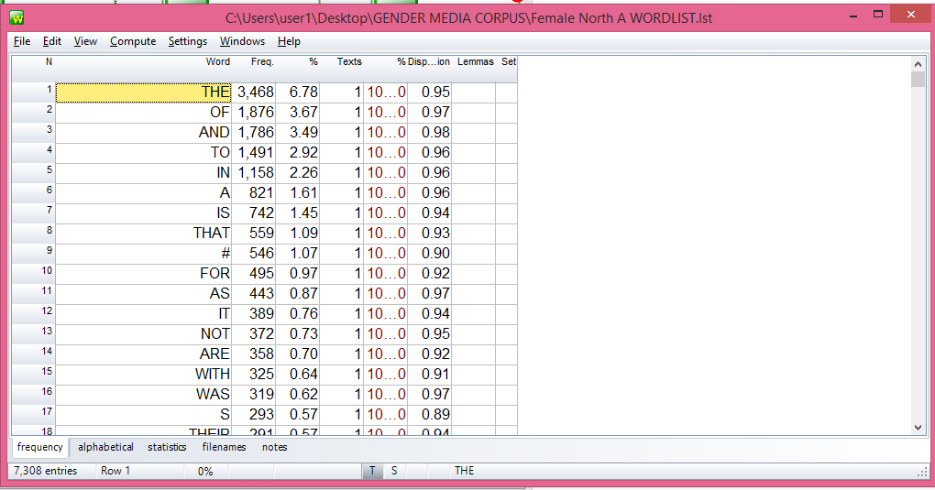
Fig.1: Top-ranking lexical items in a 50,000-word sub-corpus
The computation of comparative lexical densities across corpora was pretty tasking as it involved very intense and rigorous procedures. To enable this, the University of Lancaster’s free Part of Speech Tagger (http://ucrel-api.lancaster.ac.uk/claws/free.html) was used to analyse each sub-corpus into the various parts of speech. The outputs of the analysis were then categorised into eight (8) basic word-classes (that included articles, adjectives, adverbs, verbs, pronouns, prepositions, conjunctions, and determiners) and accordingly sorted and computed. Following Quirk et al (1973), the computed parts of speech were re-categorised into “open class items” and “closed system items”, and the comparative percentages of each category were computed. Thus, the higher the value for open class items, the higher the lexical density in the sub-corpus. A 100 percent effectiveness of the PoS tagger may not be guaranteed because some instances of tagging were found to be incorrect while some items were doubly differently tagged. For example:
- There_EX0 are_VBB several_DT0 depressing_AJ0 mysteries_NN2 (There tagged as Existential Particle).
- There_AV0 also_AV0 is_VBZ the_AT0 surge_NN1 in_PRP price… (There tagged as Adverb).
- Unending_AJ0 fuel_NN1 queues_NN2 (fuel tagged as noun instead of adjective)

However, the reliance on the software for part of speech tagging was solely because there were no other functionally similar items of software, and a manual analysis of the corpus into parts of speech might take several months to be accomplished. The guaranteed reliability level of the software put at 96-97% consistent accuracy documented by the software author (See https://ucrel.lancs.ac.uk/claws/) was thus considered to be manageable in this circumstance.

2.4 Statistical Analysis
The various outputs of qualitative analyses were subjected to quantitative computations using the Pearson Correlation Co-efficient, a statistical tool used to measure linear correlation between two sets of data. This was aimed at showing the degree of correlation between both dependent and independent variables in each case. Specifically for example, the various lexical density and diversity values per gender category had to be measured against each category of gender to confirm the correlational relationship for the respective categories. It is only a comparative statistical measurement of these variables that can confirm the kind of association (positive or negative) that exists between the variables investigated in the study.

3. Results and Discussion
3.1 Top-ranking lexical items across corpus
The Wordlist analysis automatically generated every word per text in the corpus and ranked them according to their frequencies. McCarthy and Carter (2006)’s list of ten (10) top ranking lexical items in written texts using the Cambridge International Corpus was used as the “control” model, while the identified lists of top ranking lexical items per text and per gender category are presented in Table 2.
Table 2: Comparative 10 Top Ranking Lexical Items per Text and Gender Category
Item/Rank | McCarthy & Carter, 2006 (Control) | Female Writers |  |  |  |  |  | Male Writers
Item/Rank | McCarthy & Carter, 2006 (Control) | Text 1 | Text 2 | Text 3 | Text 4 | Text 5 | Text 6 | Text 1 | Text 2 | Text 3 | Text 4 | Text 5 | Text 6
1 | the | the | the | the | the | The | the | the | the | the | the | the | the
2 | to | to | of | of | of | Of | of | of | of | and | of | of | of
3 | and | a | to | and | and | To | to | an | to | of | to | to | a
4 | of | that | and | to | to | A | and | to | and | to | and | and | and
5 | a | of | in | in | in | that | in | in | in | in | in | in | to
6 | in | you | is | a | a | and | that | is | that | is | a | a | in
7 | was | in | that | is | that | In | for | a | is | a | is | that | he
8 | it | and | a | that | for | Is | is | for | a | that | for | is | is
9 | I | is | for | for | is | they | a | that | on | for | as | as | it
10 | he | I | as | as | it | Not | as | be | for | Nigeria | are | for | that
Similarities |  | 7 | 6 | 6 | 7 | 6 | 6 | 5 | 6 | 6 | 6 | 6 | 8

Some inferences that can be drawn from the table above include the observations that all the twelve (12) texts show above-average similarities (at 60.2% overall average) to the “controlled” model of written discourse; and that only some thin variation between male and female gender texts (60.3% for female, 60.1% for male) can be observed. This marginal variation cannot be used to generalise gender-based variation in terms of top ranking lexical items in written texts. A common pattern across texts is the observation that top ranking lexical items in written texts are predominantly closed system items, which include, mostly, articles (the, a), coordinating conjunction (and), few common prepositions (to, of, in, and for), and in some cases, pronouns (such as It, he and I).
3.2 Comparative inter-gender determination of lexical diversity across corpus
The result of lexical diversity computation per text for both male and female sub-corpora is shown in Table 3. To derive this, the total distinct words per text were determined and the ratios of such values were calculated to get the value for Type-Token Ratio (TTR). There were 39,800 distinct words in the male sub-corpus as against 36,612 distinct words in the female sub-corpus.
Table 3: Word-type and Type-Token Ratios in 300,000-word Sub-corpus per Gender
Texts | Word Token | Male Corpus |  | Female
Texts | Word Token | Word Type | TTR | Word Type | TTR
1 | 50,000 | 5,663 | 8.8 | 5,292 | 9.4
2 | 50,000 | 6,093 | 8.2 | 6,163 | 8.1
3 | 50,000 | 6,191 | 8.0 | 7,308 | 6.8
4 | 50,000 | 6,187 | 8.0 | 5,851 | 8.5
5 | 50,000 | 7,610 | 6.5 | 7,142 | 7.0
6 | 50,000 | 8,056 | 6.2 | 4,856 | 10.2
Total |  | 39,800 | 7.6 | 36,612 | 8.3

The result of statistical analysis using Pearson Correlation Co-efficient to determine the correlation of gender with lexical diversity shows that there is a moderate relationship between the writers’ gender and lexical diversity since the correlation coefficient (r) is 0.314. This means that the writers’ gender has moderate effect on lexical diversity but the significance level is low at 0.321 (> 0.01), a clear indication that the correlation is not statistically significant. The comparative effect as determined is graphically presented in Fig. 2.
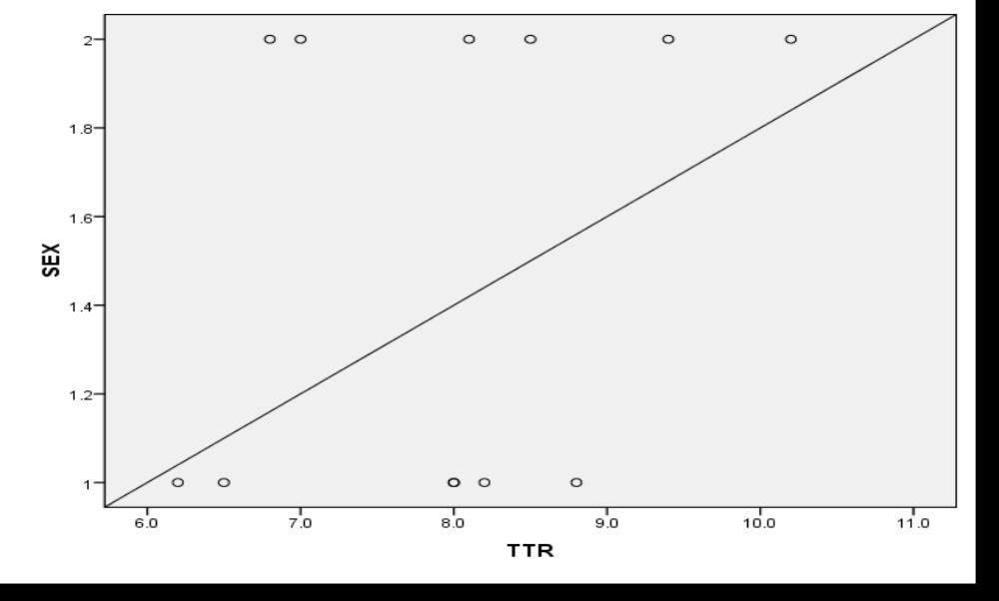
Fig. 2: Scatter diagram showing the effect of writers’ gender on lexical diversity
3.3 Comparative inter-ethnicity determination of lexical diversity across corpus
The result of lexical diversity according to writers’ ethnic background is presented in Table 4. This is based on a total of 200,000-word sub-corpus comprising two male writers and two female writers from one ethnic group (Igbo, Hausa and Yoruba) at 50,000 words per writer’s text. As the table further shows, the comparative averaged TTRs are 8.6, 7.8 and 7.4 for the Igbo, Hausa and Yoruba writers respectively.
Table 4: Word-type and Type-Token Ratios in 200,000-word Sub-corpus per Ethnic Group
Texts | Word Token | Igbo Texts |  | Hausa Texts |  | Yoruba Text
Texts | Word Token | Word Type | TTR | Word Type | TTR | Word Type | TTR
1 | 50,000 | 5,663 | 8.8 | 6,191 | 8.0 | 7,610 | 6.5
2 | 50,000 | 6,093 | 8.2 | 6,187 | 8.0 | 8,056 | 6.2
3 | 50,000 | 5,292 | 9.4 | 7,308 | 6.8 | 7,142 | 7.0
4 | 50,000 | 6,163 | 8.1 | 5,851 | 8.5 | 4,856 | 10.2
Total | 200,000 | 23,211 | 8.6 (Av.) | 25,537 | 7.8 (Av.) | 27,664 | 7.4 (Av.)

Ordinarily, the averaged TTR value for each group varies. But only a statistical test of significance can confirm the correlation between writers’ ethnic background and lexical diversity. The Pearson Correlation Co-efficient analysis of the values shows that that there is a weak relationship between the writers’ ethnicity and lexical diversity as the correlation coefficient (r) is -0125. The significance value of 0.699 (> 0.01) compared to the (r) value of -0125 indicates that the correlation is not statistically significant, thus implying that there is no enough evidence to say that writers’ ethnicity has effect on lexical diversity per text and any identified effect may just be by chance.
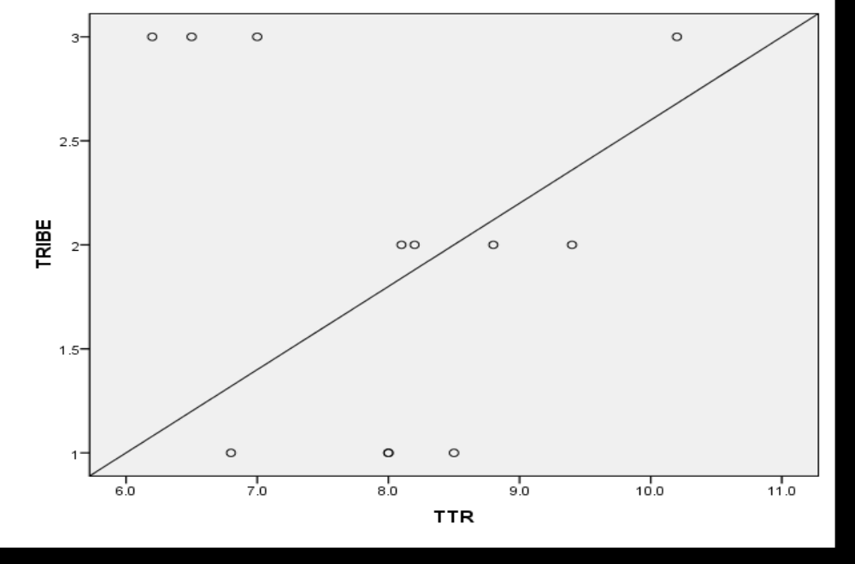
Fig. 3: Scatter diagram showing the effect of writers’ ethnicity on lexical diversity

3.4 Comparative inter-gender determination of lexical density across corpus
The respective values for lexical density per text and gender category are shown in Table 5. Again, these values were derived by determining the comparative percentages of content or lexical words (open class items) to those of grammatical or function words (closed system items). As shown, the averaged density value for the male gender is 59.3%, while that of the female gender is 52.3%.
Table 5: Comparative Lexical Density Values for Male-Female Genders
Texts | Density Values | Texts | Density Values
Male 1 | 66% | Female 1 | 56%
Male 2 | 59% | Female 2 | 54%
Male 3 | 60% | Female 3 | 53%
Male 4 | 57% | Female 4 | 50%
Male 5 | 58% | Female 5 | 50%
Male 6 | 56% | Female 6 | 51%
Ave. | 59.3% | Ave. | 52.3%

The result of Pearson Correlation Co-Efficient computation confirms a strong relationship between gender and lexical density at a correlation coefficient (r) of -0.783 which signifies a negative strong correlation. This means that the writers’ genders have strong effect on the percentage of lexical words to function words in the opposite way. Then the significance level of 0.003( < 0.01) shows that the correlation is statistically significant, meaning that there is a strong statistical evidence to say that genders have strong effect on lexical density. This is further graphically presented in Fig. 4.

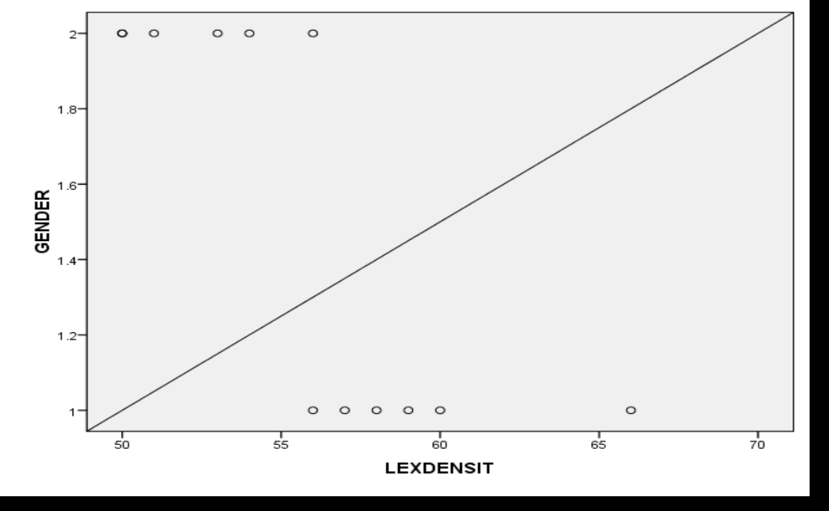

Fig. 4: Scatter Diagram Showing the Relationship between Writers’ Gender and Lexical Density

3.5 Comparative inter-ethnicity determination of lexical density across corpus
The comparative lexical density values for texts according to writers’ ethnicity are presented in Table 6, where four (4) writers were selected (2 males, 2 females) for each of the three (3) major ethnic groups used for the study. These show comparative averaged density values of 53.7%, 55% and 58% respectively for Igbo, Hausa and Yoruba ethnic groups.
Table 6: Comparative Lexical Density Values for Ethnicity-based Sub-corpus
Igbo Writer | Lexical Density | Hausa Writers | Lexical density | Yoruba Writers | Lexical density
Igbo 1 | 58% | Hausa 1 | 60% | Yoruba 1 | 66%
Igbo 2 | 56% | Hausa 2 | 57% | Yoruba 2 | 59%
Igbo 3 | 50% | Hausa 3 | 53% | Yoruba 3 | 56%
Igbo 4 | 51% | Hausa 4 | 50% | Yoruba 4 | 54%
Average | 53.75% | - | 55% | - | 58%

A statistical analysis of these values using Pearson Correlation Co-efficient shows a moderate relationship between the ethnicity of writers and lexical density since the correlation coefficient (r) is 0.467. This means that ethnicity has moderate effect on lexical density but the significance level of 0.136 (>0.01) indicates that the correlation is not statistically significant. In other words, the evidence provided by the analysis is not statistically significant enough to generalise that lexical density levels of texts are dependent on writers’ ethnic background. This is graphically shown in Fig 5.
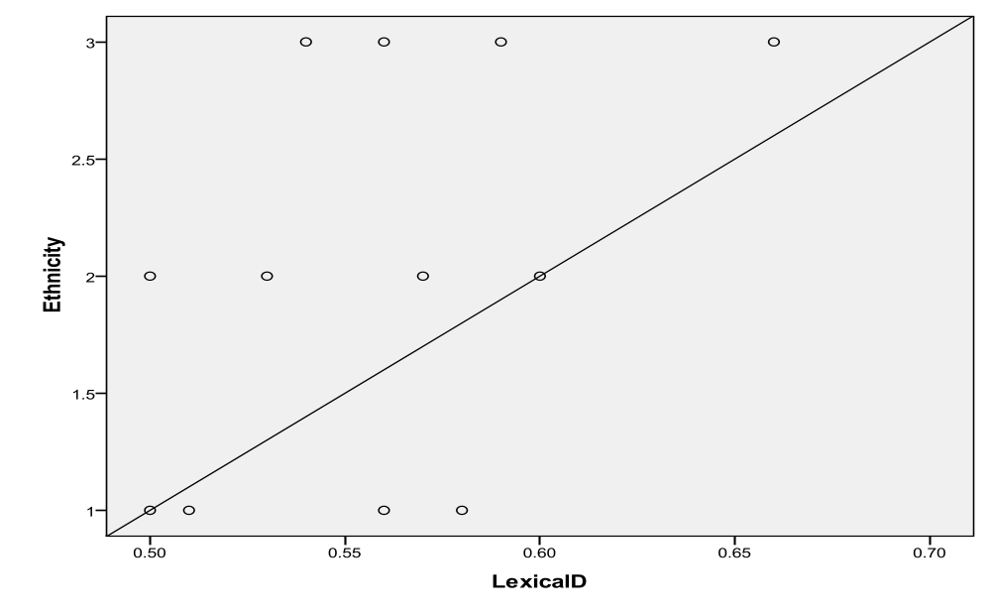
Fig. 5: Scatter Diagram Showing the Relationship between Ethnicity and Writers’ Ethnic Backgrounds
Altogether, the results of the various analyses have provided useful clues towards an understanding of language variation generally, and more specifically among community of users on the bases of gender and ethnicity. Some of the emergent general findings from these results can be summarised in the following ways. One, language variation is a sociolinguistic phenomenon that exists in speech communities, particularly where language users in such speech communities are differentiable on the basis of socio-demographic categories that include, but not limited to gender, ethnicity, age, socio-economic status, etc. For this study, language users’ gender and ethnicity have proved to be veritable socio-demographic variables for investigating language variation. Two, both gender and ethnicity can be used to investigate vocabulary-based variation in language use, and the kinds of dependent variables that can be comparatively investigated include top ranking lexical items, lexical density and lexical diversity. Three, the use of corpus and corpus analytical tools can enhance variation analysis in more scientific and reliable ways. As shown in this study, the use of corpus not only enabled the compilation of verifiable (and increasable) naturally occurring language data, but also enhanced the ease and objectivity of analyses with the aid of lexical analysis software.
More interestingly, the results have specifically shown, firstly, that male and female writings are not substantially different from other general forms of writing. This is evident in the comparative analysis of top ranking lexical items compared to what other studies have documented. The study has shown cross-corpus compatibility of 60+% with what McCarthy and Carter (2013) have observed as top ranking lexical items in written texts. With this broad compatibility, however, a marginal degree of variation has been observed between male and female writing even though such is not so statistically significant as to be able to generalise such textual distinction.
Secondly, both adult male and female users of English (as second language) do not use language in exactly the same way, although the comparative levels of variation and statistical significance determine inferential generalisability. For example, it was shown that in terms of lexical diversity, while the diversity ratio for male writers was 7.6, that of female writers was 8.3. The implication of these comparative values is that while the written language of male writers, on the average, characteristically contains a ratio of one distinct word to seven repeated words; that of female writers contains one distinct word to eight repeated words. This implies that lexical repetition (word tokens) tends to be higher in female writing than male writing; and that male writing tends to be slightly lexically rich and diverse compared to female writing. However, the statistical significance has been confirmed to be moderate and low, such that no categorical generalisation can be made that lexical diversity of texts vary on the basis of writers’ gender. Similar analytical output applies to writers’ ethnicity variable which also has varying values per writers’ group but such variations have been proven to be low in statistical significance to make distinctive generalisations. What these comparative findings clearly indicate is that though texts of male and female writers, as well as of adult educated people from the three major ethnic groups in Nigeria vary, such variations have proven to be statistically insignificant to generalise text differentiability on the bases of gender and ethnicity.
Thirdly, the comparative lexical density analysis also shows that male and female adult educated users of English do not write exactly the same way as shown by the comparative density variation values of 59.3% and 52.3% respectively. What this shows is that male writing is characterised by higher degrees of open class items compared to closed system items on one hand, and compared to female writing on the other hand, with the tendency for male writing to be characteristically, albeit relatively, dense and high in readability and comprehensibility compared to female writing. This trend is confirmed by the statistical analysis which shows the output correlation as being statistically significant. It is therefore safe to infer that lexical density is an indicator of vocabulary variation between male and female writing. In other words, a lexically dense text will be relatively characteristically difficult to read and understand, and the tendency is high that the text is attributable to a male author. In terms of ethnicity, even though the comparative density values also varied, the correlational statistic is not significant enough to generalise that writers’ ethnicities influence their density levels in texts.
- Conclusion
This study is an advancement of sociolinguistic variation studies particularly in an English as Second Language environment, and in an environment without corpus data. The significance of the study lies in its contributions to the study of gender differences in language use with specific focus on lexical patterns compared to many other studies that have concentrated on phonetic and discoursal patterns. The outcome of the study reinforces the importance, usefulness and productivity of corpus and corpus analytical tools for linguistic analyses. The various findings from the study are in some ways concurrent with some earlier reported findings on similar subject, but there are also some findings that are divergent to some of the existing studies.
Largely, the study aligns with such other studies as Kuo (2003), Newman et al. (2008), Lange et al. (2016), Wallentin (2020), etc., which have reported gender-based variation in language use. It also concurs with the findings of a number of existing studies on ethnicity-based language variation (including Fought, 2011; Clothier, 2019; Grama et al., 2021, etc.) all of which have reported that speakers’ ethnic background influences their language production and use in some ways. The statistical confirmation of moderate correlations between gender and lexical diversity, ethnicity and lexical diversity, as well as ethnicity and lexical density indicate that the identified variations are not statistically sufficient to conclude either that gender and ethnicity influence lexical diversity, or that ethnicity influences lexical density of texts. This position is concurrent with Nemati and Bayer (2007), who noted that there was no statistically significant difference between male and female in their use of intensifiers, hedges and tag questions in a corpus of selected English and Persian languages. What is statistically supported, however, is the generalisable inference (as limited to the data scope of the study) that an adult educated male user of English as a second language tends to use more open class items than his female counterpart. This typically makes male writing in this context lexically dense, with potential negative effect on textual readability and comprehensibility. It is thus concluded that though variations in male-female language have been, and are being established, the extent of variation is dependent on the variables used for measurement; and it is not all such variations that are statistically significant to make generalisable distinctive inferences.
REFERENCES
Adegbite, W. (2012). The ICE Nigeria corpus as a database for Nigerian English Studies.
Ife Studies in English Language, 10(1). Retrieved from: http://isel.oauife.edu.ng./upload/isel6.pdf
Baker, P. (2010). Sociolinguistics and corpus linguistics. Edinburgh University Press.
Carter, R., & McCarthy, M. (2013). Cambridge Grammar of English: A comprehensive guide
spoken and written English grammar and usage (7th Printing). Cambridge University Press.

Clothier, J. (2019). A sociophonetic analysis of/l/darkness and Lebanese Australian ethnic
identity in Australian English. In Proceedings of the 19th International Congress of Phonetic Sciences (ICPhS) (pp. 1888-1892).
Coates, J. (2015). Women, men and language: A sociolinguistic account of gender differences in
language (3rd Edition). Routledge Taylor and Francis Group.
Crawford, M. (1995). Talking Difference: On Gender and Language. Sage Publications.
Author, T. N. (2016). Grammar and gender: A comparative study of the integration and
organisation of meanings in selected male and female-authored prose works. International Journal of Applied Linguistics & English Literature, 6(1), 275-285.

Author, T. N. (2018). Lexical pattern, density and diversity in a University Convocation
Lecture delivered by Wole Soyinka. The Journal of Communicative English, 19, 78-89.
Desagulier, G. (2017). Corpus linguistics and statistics with R, Introduction to quantitative
methods in linguistics. Springer International Publishing.
Fought, C. (2011). Language and ethnicity. In Mestrie, R. (ed.) The Cambridge handbook of
sociolinguistics (pp. 238-257). Cambridge University Press.
Glynn, D. (2010). Corpus-driven cognitive semantics: Introduction to the field. In Quantitative
Methods in Cognitive Semantics: Corpus-driven Approaches, 1–42. Mouton de Gruyter.
Grama, J., Travis, C. E., & Gonzalez, S. (2021). Ethnic variation in real time: Change in
Australian English diphthongs. In Language Variation–European Perspectives VIII (pp. 292-314). John Benjamins.
Gries, S. T. (2009). What is corpus linguistics? Language and linguistics compass 3:
1225–1241. doi:10.1111/j.1749-818X.2009.00149.x.
Grob, L. M., Meyers, R. A., & Schuh, R. (1997). Powerful/powerless language use in group
interactions: Sex differences or similarities? Communication Quarterly, 45(3), 282-303.
Halliday, M. A. K., & Matthiessen, C. M. (2014). Halliday’s introduction to functional grammar
(Fourth Edition). Routledge.
Humm, M. (1989). The Dictionary of Feminist Theory. Harvester Wheatsheaf, London.
Jeon, L. (2017). Korean Ethnic Orientation and Regional Linguistic Variability in the
Multiethnic Context of Houston. In Korean Englishes in Transnational Contexts (pp. 93-114). Palgrave Macmillan, Cham.
Johansson, V. (2008). Lexical diversity and lexical density in speech and writing. A
developmental perspective. Lund University, Department of Linguistics and Phonetics Working Papers, 53, 61-79.
Kirkham, S. (2017). Ethnicity and phonetic variation Sheffield English liquids. Ph.D. thesis.
University of Sheffield, United Kingdom.
Kuo, S. H. (2003). Involvement vs detachment: gender differences in the use of personal
pronouns in televised sports in Taiwan. Discourse Studies, 5(4), 479-494.
Ladegaard, H. J. & Bleses, D. (2003). Gender differences in young children’s speech: The
acquisition of sociolinguistic competence. International Journal of Applied Linguistics, 13(2), 222-233.
Lakoff, R. (1975). Language and woman’s place. Harper & Row.
Lange, B. P., Euler, H. A., & Zaretsky, E. (2016). Sex differences in language competence of 3
to 6-year-old children. Applied Psycholinguistics, 37(6), 1417-1438.
Leaper, C. & Ayres, M. M. (2007). A meta-analytic review of gender variations in adults’
language use: Talkativeness, affiliative speech, and assertiveness speech. Personality and Social Psychology Review, 11(4), 328-363.
Meyerhoff, M. (2006). Introducing sociolinguistics. Routledge.
Moisl, H., Maguire, W., & Allen, W. (2006). Phonetic variation in Tyneside Exploratory
multivariate analysis of the Newcastle Electronic Corpus of Tyneside English. In Hiskens, F. (ed.) Language variation-European perspectives, Selected papers from the Third International Conference on Language Variation in Europe (ICLaVE 3), Amsterdam, June 2005 (pp. 127-141). John Benjamins Publishing.
Nemati, A., & Bayer, J. M. (2007). Gender differences in the use of linguistic forms in the
speech of men and women: A comparative study of Persian and English. Language in India, 7(9), 1-16.
Newman, M. L., Groom, C. J., Handelman, L. D., & Pennebaker, J. W. (2008). Gender
differences in language use: An analysis of 14,000 text samples. Discourse Processes, 45(3), 211-236, DOI: 10.1080/01638530802073712
O’Gardy, W., & Archibald, J. (2015). Contemporary linguistic analysis: An introduction (8th
Edition). Pearson Education Inc.
Philips, S. U. (1980). Sex differences and language. Annual Review of Anthropology, 9(1),
523-544.
Presnyakova, I. (2020). Linguistic variation and ethnicity in a super-diverse community: The
case of Vancouver English (Doctoral dissertation, Arts & Social Sciences: Department of Linguistics).
Quirk, R., Greenbaum, S., Leech, G. N., & Svartvik, J. (1973). A grammar of contemporary
English. Longman.
Rubin, D. L., & Greene, K. (1992). Gender-typical style in written language. Research in the
Teaching of English, 26, 7-40.
Samara, A., Smith, K., Brown, H., & Wonnacott, E. (2017). Acquiring variation in an artificial
language: Children and adults are sensitive to socially conditioned linguistic variation. Cognitive Psychology, 94, 85-114.
Scott, M. (2017). WordSmith Tools (Version 7.0). Stroud: Lexical Analysis Software.
Singer, D., Avedon, J., Hering, R., McCann, A., & Sacks, C. (1977). Sex Differences in the
Vocabulary of College Students. The Journal of Sex Research, 13(4), 267–273. http://www.jstor.org/stable/3812183

Shaywitz, B. A., Shaywltz, S. E., Pugh, K. R., Constable, R. T., Skudlarski, P., Fulbright, R. K.,
& Gore, J. C. (1995). Sex differences in the functional organization of the brain for language. Nature, 373(6515), 607-609.
Tannen, D. (1991). You Just Don’t Understand: Women and Men in Conversation.
Virago, London.
Trudgill, P. (2000). Sociolinguistics: An introduction to language and society (Fourth Edition).
Penguin Books.
Ullman, M. T., Miranda, R. A., & Travers, M. L. (2008). Sex differences in the neurocognition
of language. Sex differences in the brain from genes to behavior, 291-309.
University of Lancaster. CLAWS Part-of-Speech Tagger for English. Accessed at:
http://ucrel-api.lancaster.ac.uk/claws/free.html
Ure, J. (1971). Lexical density and register differentiation. In G. E. Perren & J. L. M. Trim
(eds.), Applications of linguistics. Selected Papers of the second international Congress of Applied Linguistics, Cambridge, 1969 (443-452). Cambridge University Press.
Wallentin, M. (2020). Gender differences in language use are small but matter for disorders.
Handbook of clinical neurology, 175, 81-102.
Wardaugh, R. (2006). An introduction to sociolinguistics (Fifth Edition). Blackwell Publishing.
West, C., & Zimmerman, D. (1983). Small insults: a study of interruptions in cross-
sex conversations between unacquainted persons, in B. Thorne, Kramarae, C. & Henley, N. (eds) Language, Gender and Society. Newbury House, Rowley, MA.

