A MINIMALIST APPROACH TO THE STRUCTURE OF KƗBHWANɈI DETERMINER PHRASE

Abstract
This paper pursues the Structure Determiner Phrase in Kɨbhwanɉi language by using a Minimalist approach. Specifically the paper sought to establish the functional categories that head the DP and to examine the order of modifiers within the Kɨbhwanɉi DP. Data were obtained from Makete District of Njombe region in Southern Highlands Tanzania. Data were collected through acceptability judgement, documentary review and focused group discussion (FGD). The study findings indicate that the functional categories which head the DP in Kɨbhwanɉi are: augments, the prenominal possessive formative –nya, and prenominal demonstratives. On the one hand, an augment and the formative –nya are restricted to occur pre-nominally with their nouns where they function as determiners. Therefore, they are not susceptible to any movement. On the other hand, prenominal demonstrative appears to have been raised from its original (base generated) position below D. It has also been found that, modifiers may range from a minimum of one to six. This yields the order (DEM)> (DISTR)> (POSS)>N> POSS> QUANT >DEM> NUM>ADJ > REL. However, the order of these modifiers is not rigid. For encoding emphasis or focus to some modifiers the order my change, thus making the order neutral.

Key Words: Structure, Minimalist, Bantu languages, Determiner Phrase, Kɨbhwanɉi

1. Introduction
This paper presents the Structure of Kɨbhwanɉi Determiner Phrase (hence forth DP) as part of current trends in analysis of DPs in languages that do not have articles. Kɨbhwanɉi is spoken in the Southern Highlands part of Tanzania particularly, in Makete District in the Kipengere Mountain Range West of the Bena, north of the Kinga and south of the Sangu. The language is classified in zone G60 in the Bena-Kinga group where it is assigned as G66 (Nurse 1988). Kɨbwanɉi is a homogeneous language used extensively by bhwanji speakers of all ages. The central speech form seems to be the one spoken in the villages of Matamba, Ikuwo, Magoye (Simile, 2013; Simile, 2017). Hitherto, the language has not been subjected into major linguistic research. There are a few linguistic documentations such as a paper on the study on hortative and imperatives in Vwanji (Mahali 2007), The Augment in Vwanji (Fitscher (2011), Phonological Aspects of Kibhwanji Phonology (Simile 2013) and Segmental Aspects of Kibhwanji Phonology: A Non Lenear Representation (Simile 2017. These few linguistic documents provided a pathway for conducting this study.
The objectives of this study are twofold: first, to examine the functional elements that stand as determiner ‘D’ categories. Second, to delineate the order modifiers in the Kɨbhwanɉi DP. The study builds on Abneys’ (1987) DP Hypothesis and later on advanced by Longobardi, (1991); and Bernstein, (2001). According to this hypothesis, the determiner heads the noun phrase. As such, the DP represents the extended, and maximal, projection of the lexical head. The DP hypothesis contrasts the traditionally held view that the noun phrase is the projection of the noun. In such cases, determiners occupy the specifier position of N. Additionally, this study shoulders on a Minimalism Program (MP), which emphasizes correspondence between the DP and IP (Chomsky 1995).

2. Research Materials and Methods
This study involved both primary data and secondary data collected in Njombe region (Southern Highlands of Tanzania). Specifically, the data were collected from three villages namely Matamba, Ikuwo and Magoye which are in Makete District which is the native land of Kɨbhwanɉi. The data were collected through three methods, namely; acceptability judgement, documentary review and focused group discussion (FGD). Participants of the study were five native speakers of Kɨbhwanɉi. As for primary data, a list of sentences containing various DPs were presented to the participants. In the first instance, each participant was asked to judge whether the sentences are correct and acceptable. Second, all five participants were brought together in a discussion (FGD) to level the idiosyncrasies that could be displayed from an individual respondent. Such questions like the following were asked: What do you call X in Kɨbhwanɉi? How do you say Y? How do you describe a person who is tall, small and angry in Kɨbhwanɉi?. Such questions provided information on the different realizations of the DP, co-occurrence possibilities of element(s) that form the DP. With regards to secondary data, a Bible written in Kɨbhwanɉi, three Bible story books written in Kɨbhwanɉi and one traditional tale book called “ɨkɨtabu kya Fipango fya Kɨbhwanɉi (The Book of Kɨbhwanɉi Tales)”, published in 2009 with thirty nine (39) short traditional tales were obtained. From these sources, various sentences with DPs containing coordinated nouns were extracted to complement the data obtained through acceptability judgement and focus group discussion.Dat were then analysed using descriptive framework.

3. The Concept of Determiner (D)
In linguistic literature, the term ‘determiner’ is related to three senses. First, a determiner is regarded as an element which appears with a noun either to the noun or to add extra information about that noun. In this definition, a determiner is considered the same as other modifiers such as relative clauses, adjectives, genitive constructions, articles, demonstratives, possessives, numerals, quantifiers, and adjectives are all viewed as nominal modifiers, an overarching class (Visser 2008). Second, a determiner entails a specific category incorporating items whose principal function is to restrict the reference of nouns with which they occur (cf. Alexiadou, et. al., 2007; Lyons, 1999). Looking at the determiner in this sense, Lyons (1999) argues that, a noun can be restricted so that it is understood to be as either definite or indefinite, specific or non-specific, identifiable or non-identifiable. In this sense, articles and possessives qualify as members associated to these functions. In addition, possessives and articles, cannot co-occur in the same NP (e.g. *my the house*) as because they occupy the same syntactic position that is why they are included in the category of determiner. This holds truth with English language many other Germanic languages in which according to Payne, (2006), a class of determiners include items, which mutually exclusive. According to Nweze (2014), determiners display a sensitivity of structuring the real world entities that speakers and hearers use when making their references explicit to one another. This structuring sets the restrictions with which the logical uniqueness of definite description holds. The third sense considers a determiner as a functional head that occurs as a specifier, and/or the complement of the head noun (Borer, 2005; Giusti, 2015). This head noun can be phonetically realised (overt) or unrealised (null). A phonetically unrealised head is termed a pro (Radford, 2009). For the purpose of this study, I employ the third sense of the determiner, in which according to Zamparelli (2000), the determiner projection turns out to be the category that introduces the noun phrase. Using this perspective, this study, therefore, shows that Kɨbwanɉi language, despite being an articleless language, in amenable to projecting a D (eterminer) functional category above nP.

4. DP Studies in Bantu Languages
Regarding the order of modifiers in world languages’ DPs, Cinque (2005) provides the structure which stands as a typological basis for DP structures across languages. He asserts that the underlying order is determiner + numeral + adjective + noun. However, there are other languages that exhibit a different order. Cinque notes that, if there are variation in order by other language this variation is accounted for by means of movement of modifiers or elements between the determiner category and noun. In Bantu languages, numerous studies have been conducted on the structure of DP (cf. Carstens 1991, 2008; Mose 2012; Basweti 2014; Ndomba 2017). Carstens (1991) studied the morphology and syntax of DP in Kiswahili language using the DP hypothesis. Carstens (1991) argues that the noun phrase in Kiswahili is embedded within two functional categories, namely number phrase (numP) and determiner phrase (DP). Carstens further proposes that in Bantu languages (Kiswahili inclusive), the noun rising to the empty determiner position yields the surface noun-initial order and that the genitive pronouns occupy the specifier position of the number phrase. Additionally, Carstens (ibd) proposed that in Kiswahili all arguments of N originate NP - internally. Carstens (2008) compared between Bantu languages and the Romance languages in such aspects as noun class and grammatical gender, derivational properties, ordering among nouns and their modifiers, and agreement pattern (concord) in DPs. Carstens (2008) concluded that Bantu and Romance share a common class gender system with gender-specific Spell-Out of number features. A second note is that gender/Class is an uninterpretable feature, without derivational functions despite some surface evidence to the contrary. Lastly, DPs of the two languages share a common structural design and that agreement in the DP-internal in both language families is the result of the Agree relation.
Ndomba (2017) investigated the configuration of the Determiner Phrase (DP) of Swahili using cartographic approach of the minimalism program. According to Ndomba (2017) the Swahili DP structure is underlyingly the same as the English DP except that in Swahili DP nP raises to Spec DP (XP movement). Second, it was revealed that the underlying order of the elements in Swahili DPs have the same underlying structure relations as the English demonstrative, numeral, adjective, and noun– those three beautiful children. Nevertheless, Ndomba cautions that the head noun-initial surface structure of Swahili elements stems from nP movement to the initial position, Spec DP, which results in the opposite order – children those three beautiful. Ndomba (ibd), departs from Carstens’ (1991), which posited that Swahili DP projects a null D to which the head noun raises (head-to-head movement). Instead, Swahili DPs are derived via the movement of XP functional category; NumP or nP to Spec DP via successive stages.
Basweti (2014) examines the Ekegusii DP in a view to ascertain the applicability of the M.P in analyzing the Ekegusii Determiner phrase. The study revealed that, the functional category heads the DP in Ekegusii and the NP stands as a lexical complement of the DP. Baswet further notes that, the principles of feature checking and full interpretation in the minimalist program are equally crucial in ensuring that Ekegusii constructions (DP and even the sentence) are grammatical (converge). This accentuates the fact that the MP is suitable in Ekegusii DP analysis. Regarding agreement and movement of elements, it has been revealed that, the agreement system in Ekegusii is best captured by feature checking. Meanwhile, movement of the elements is aimed at checking agreement that is between the noun and its determiners.

5. The Structure of Kɨbhwanɉi Noun and the DP
The structure of Kɨbhwanɉi noun consists of an augment (AUG), a class prefix (CL) and the noun stem(NS). Based on the distribution the following noun template can be established: AUG-CL–NS. Like many other languages in the Bantu language family, Kɨbhwanɉi has an articulated noun class system with nineteen (19) noun classes. Most nouns are assigned to two classes, one in singular and the other in plural, as shown in Table 1.
Table 1 Kɨbhwanɉi Noun Classes
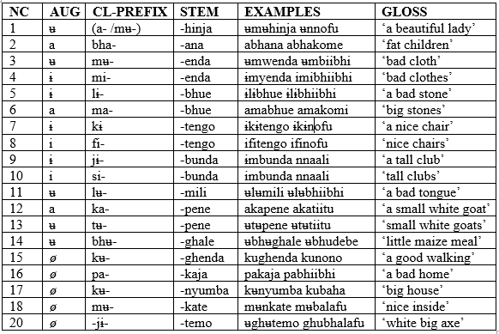
Source: Field Data

Table 1 above shows that the augment in Kɨbhwanɉi is one of the vowels a-, i-, ɨ- and ʉ-. The augment a- is found in classes, 2, 6, and 12 as shown in the following examples: a-bha-na ‘children’, a-ma-vue ‘stones’ and a-ka-pene ‘a small goat’. The augment i- is found in classes,8 and 10 as in the following examples: i-fi-tengo ‘chairs’ and i-mbunda ‘clubs’. The augment ʉ- is found in classes 1, 3, 11, 13, and 14 like in: ʉ-mʉ-hinja ‘lady’, ʉ-mwe-nda ‘cloth’, ʉ-tʉ-pene ‘small goats’, and ʉ-bhʉ-ghale ‘maize meal’. The augment ɨ is found in classes 4, 5, 7, and 9 like in: ɨ-my-enda ‘clothes’, ɨ-lɨ-vue ‘stone’, ɨ-kɨ-tengo ‘chair’, and ɨ-mbunda ‘club’.

5.1 An Augment as Determiner Category

The study has shown that one of the elements that can occur, as a determiner is an augment. According to de Velde (2019) the term ‘augment’ is used by Bantuists to refer to an element that precedes the class prefix of nouns and some adnominal or nominalised modifiers and that changes the class assignment neither of the noun, nor its lexical meaning, nor the syntactic positions it can occupy. The shape of the augment always corresponds to the vowel of the noun class prefix of the given class like most Bantu languages. As shown in example (1) bellow the vowels a-, ɨ- and ʉ- are the augments.
(1) (a). ʉ-mu-unu
AUG-Cl-person
‘person’

(b) a-bh-ɨmbi
AUG-CL2-singer
‘singers’

(c) i-my-aka
AUG-CL4-handle
‘big handles’

(d) ɨ-lɨ-vue
AUG-CL5-stone
‘stone’

Examples (1) (a-d) show that the augument in Kɨbhwanɉi occurs as a vowel. Data suggests that, the augment can be analysed as the spell-out of a determiner category dominating the DP in Kɨbhwanɉi. Consider the following examples.
(2) ɨmbunda
ɨ-ɸ-mbunda
AUG-ɸ-club
‘a club’

The Phrase Structure of the DPs above would be as follows”
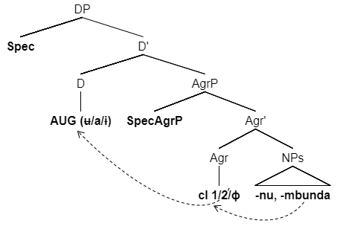
Example (2) above the Agree head merged (AgreeP) which is between the D and N hosts agreement features (ɸ-features) gender and number linked to the nouns. At the level of phonology, the augment (D) is an empty vowel syllable linked to extended projection principle (EPP) uninterpretable (_{u}V) feature. This (phonetically) empty position, depending on the parametric specifications selected by the language, may remain empty or be partially or fully realized as an epenthetic or copied vowel. As such, a case in (2a-c) may be represented as [DP _{u}V [GendP CV [NP]]]. As it can be seen in (2), the noun class prefix, (also Gender morpheme (Ndayiragije et. Al., 2012)), consists of a consonant and a vowel (CV). In this case, the CV template, is fully specified (interpretable) and the augment which is the determiner, is unspecified, hence, uninterpretable at PF. This suggests that the derivation of a noun such as ɨkɨtengo ‘chair’ will be represented as follows.

(3). ɨkɨtengo
ɨ-kɨ-tengo
AUG-Cl6-chair
‘a chair’
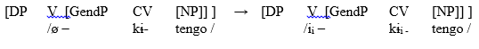
Example (3) above accounts for the fact that the augment copies the features of the vowel in the nounclass prefix as the result of agreement between the vowels in the noun class prefix and the determiner. An argument can be made that, the augment in Kɨbhwanɉi language is the syntactic head of the determiner phrase structure.

5.2 A Prenominal Possessive –nya as a Determiner

Kɨbhwanɉi language presents two types of possessives. The post nominal possessives and the pre nominal possessives. In this section, I present the pre nominal possessive, which is marked by the formative –nya. The possessive as a modifier of a noun in Kɨbhwanɉi language is canonically at the post nominal position. However, there is a case where the possessive marker –nya inhabits the position before the noun yielding a second type of possessive we have labeled a ‘pre-nominal possessive’. Semantically, the formative –nya expresses the idea of ‘the owner of,’ or ‘containing’.

This form consist of the augment of the noun class of the possessor plus the possessum. Consider the following examples:

(4) (a) ʉn-nya mʉ-ghʉnda jʉla akansuungʼha kange ʉ-nkami ʉ-jʉnge.
AUG-cl1-owner cl18-field DEM 3SG-send-PAST again
AUG-cl1-servant
“That owner of the field sent again another servant.”

(b) ɨ-supa ɨ-nya mafuta a-ma-n-ofu a-gh-a ndalama ny-inga
UG-cl9-bootle AUG-owner cl6-oil AUG-cl6-good AUG-cl6-
ASS cl9-money cl9-many
‘the bottle full of good, expensive oil.’

Examples (4a-b) above show that, as is the case with genitive constructions, the first constituent of the possessum does not have the augment. Instead, the augument is realized in the –nya formative. In this case, the following will be the morphological structure of the noun containing the formative –nya which marks possession in difference noun classes as shown in the following table:

Table 2: Morphological Structure of Kibhwanji Nouns Preceded by –NYA.
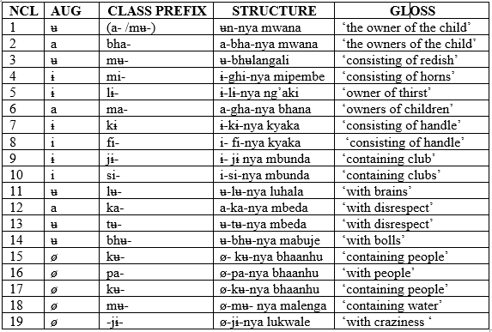

Table 2 above shows that, the root of the prenominal possessive determiner -nya occurs consistently with all noun classes including locative classes 16, 17, and 18. It does not change its form nor its position relative to the noun. As such the phrase structure of the noun containing the pre nominal possessive determiner will be as follows:

(5) ʉ-nya mwana
AUG-owner of cl1-child
‘owner of a child’

(6) | 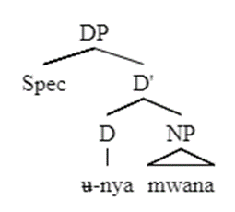

The tree structure in (5) above indicates that when the formative –nya is used to indicate possession, it deletes the augment that was primarily supposed to be accompanied with the noun –mwana. This means that the formative –nya is a special category, which functions as a determiner. It is base generated as a determiner since it appears within the slot where the augment is found. For that case, the prenominal possessive determiner –nya is in complementary distribution with the augment. Moreover, the formative –nya does not undergo any kind of movement because it is restricted to occur pre-nominally with its head noun where it functions as a determiner specifying the range of reference of the noun.

5.3 Pre-nominal Demonstratives as a Determiner
Data of Kɨbhwanɉi language show that, demonstratives are, canonically, occur at the post nominal slot in Kɨbhwanɉi DP performing a deictic function by showing relative location or distance of the referred entity in relation to the participants taking part in contextual discourse. However, there are cases where demonstratives appear prenominally. When they appear pre-nominally, they pose certain affects pertaining to the meaning of the DP. In this study, I argue that, preposed demonstratives, in Kɨbhwanɉi language functions as the definite article like the in English. This observation is in line with de Velde (2005) who clearly points out that the prenominal demonstrative is used as the definite article in some Bantu languages like Swahili. When it occurs pre nominally position it expresses the emphatic interpretation. Consider the following conversation be tween speaker A and B.:

(7) | A | ɨ-kɨ-nu kɨ-ki kɨ-no wɨ-koola?  AUG-cl7-thing cl7-what cl7-REL SM-crying  ‘what are you crying for?’
 | B | Ɨ-jɨ ng’ʉkʉ n-debe. Jɨ-fuile.  DEM cl9-hen cl9-small cl9-die-PAST  “This [SPECIFIC] small hen has died.”

In example (7) above between conversation A and B the demonstratives Ɨ-jɨ ‘this’ in B occurs at the pre-nominal position. The discourse reading of this utterance is that, both A and B have a pre conceived knowledge that there are more than one hen. Therefore, the use of demonstrative Ɨ-jɨ ‘this’ in Ɨ-jɨ ng’ʉkʉ n-debe. Jɨ-fuile. “This [SPECIFIC] small hen has died.” expresses the particularization of the specific hen which has died among many other hens which are implicitly known to be existing in the conversational discourse. Furthermore, the use of the pre-nominal demonstrative Ɨ-jɨ ‘this’ in this context entails an anaphoric reading in that the referent is now familiar to the discourse participants, hence expressing specificity and definiteness interpretation.

In terms of syntactic position, the prenominal demonstrative appears to have been raised from its original (base generated) position below D. Based on this view, the following would be the phrase structure of the DP containing preposed demonstrative for the phrase mwana ʉjʉ ‘this child’
(8). | 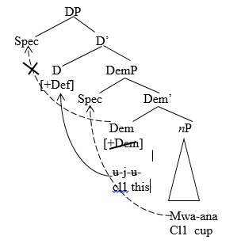
In example (9) above, due to definiteness feature, the demonstrative is raised obligatorily to the determiner position. As such, the rising of the nP to Spec DP is constrained and consequently the nP resides in Spec DemP. Moreover, the rising of the demonstrative to the D position marking definiteness preempts the application of an augment on the noun. This means that the definiteness function performed by the augment is now performed by the demonstrative. Hence, the two-grammatical categories are in complementary distribution.

6. Order of Modifiers in Kɨbhwanɉi Determiner Phrase
Kɨbhwanɉi Determiner Phrase structure may range from a minimum of one modifier, to a series of several modifiers. The modifiers include demonstratives, Possessives, quantifiers, adjectives, numerals, and relative clauses. Consider the data in the following table:

6.1 A DP with noun and a pronominal demonstrative

In the structure of a DP made of a noun and demonstrative, normally, the demonstrative proceeds the noun. This yields the Noun>Demonstrative (N>Dem) order. As demonstrated in the following examples:

(9). (a) A-bha-anhu bha-la
AUG-cl2-people cl2-Dem
‘those people’

(b) i-fi-ghono i-fi-o
AUG-cl8-time AUG-cl8-Dem
‘those times’

Example 9 above shows that when the DP is made up of a demonstrative and noun the noun precedes the demonstrative. This typical order of noun>demonstrative modification agrees with with majority Bantu languages such as Kagulu (Petzell 2008), (Nyakyusa (Lusekelo, 2009), Swahili (Ndomba, 2017), to mention but a few. However, there are possibilities, though not typical, for a demonstrative to precede the noun. Consider the following examples:

(10) (a) ʉ-jʉ mʉ-ghoosi kyang’aani
AUG-Dem cl1-man For sure
‘for sure this is a man’

(b) jʉ-la mʉ-kijʉbha ɨjɨle
Cl1-Dem cl1-lady has come
‘that lady has come’

Example 10 demonstrates the case where a demonstrative precedes the noun. As already established elsewhere, when the demonstrative precedes the noun it encodes emphasis. In this case, the demonstratives don not serve the deictic function but behaves as the determiner. This observation is similar to other Bantu languages like igiHa. According to Bichwa (2021), the appearance of demonstratives in the prenominal position in igiHA language assumes a referential function. In this case, it points back to an entity that has been mentioned earlier in a preceding discourse. Thus, prenominal demonstratives serves an anaphoric function.

6.2 The DP with Noun Possessive and Demonstrative

Kɨbhwanɉi language presents a case where there could be a DP made of a noun demonstrative and a possessive. In this case, it is a post nominal possessive being addressed and its order is Noun > Possessive >Demonstrative (N>Poss>Dem). The case in point is exemplified as follows:

(11) (a) ɨ-nyumba j-angu jɨ-la
AUG-house CL9-my cl9-Dem
‘that house of mine’

(b) ɨ-kɨ-maghe kɨ-la ky-ango
AUG-cl7-knife cl7-Dem cl7-mine
‘that knife of mine’

One can see that in 11 (a) the demonstrative is set to appear just after the possessive making the Poss>Dem order. This shows that when a possessive is added to the DP in Kɨbhwanɉi, the possessive precedes the demonstrative. On the other hand, it is possible to have the demonstrative precede the possessive for the same reason as in (11) above as it is shown in 11 (b). Speakers of Kɨbhwanɉi acknowledged that it is possible to make the possessive come after the demonstrative when one wants to make the referent specific or when you want to mark emphasis.

6.3 The DP with Noun Possessive demonstrative and quantifier

Canonically, the quantifier follows the possessive. This yields the Noun >Possessive >quantifier >demonstrative (N>Poss>Quant>Dem) order. Unlike numerals, which show the actual number of the head being referred, quantifiers do not show actual number of the noun they modify. Instead, they denote how many things a given statement is referring to in ‘generals’ (Anderson 1973). Kɨbhwanɉi language attests for three quantifiers -oni ‘all/both/whole’, -inga ‘many’, -debe ‘few/some’. Consider the following examples:
(12) (a) ʉ-tʉ-pene twa-ango tw-oni tu-la
AUG-cl13-goat cl13-Poss cl13-all cl13-Dem
‘all those small goats of mine’

(b) a – bha -anhu bha-ake bh –inga bha-la
AUG-cl2-people cl2-Poss cl2 –many cl2-Dem
‘those many many people of him/her’

(c) A-bha-na bha-ake bha-debe bha-la
AUG-cl2-children cl2-Poss cl2-few cl2-Dem
‘those few children of him/her’

In example (12), the quantifiers appear post-nominally. According to the respondents, any attempt to prepose the quantifiers would lead to ungrammatical constructions. In 12 (b) the quantifier inga ‘many’ is used without the augment. The augmented form is only used when a comparison is implied as in the following cases:

(13) (a) A-ma-aka m-inga gha-kilil-e.
AUG-cl6-year cl6-many cl6:go.by.:PF
“Many years went by.”

(b) A-ma-aka a-m-inga gha-kilil-e, gha-sighiil-e ma-debe.
AUG-Cl6-year AUG-cl6-manycl6-go.by-PAST cl6-be.left-PRS cl6-few
“Many years went by, a few are left.”
Examples in 13 (a-b) above show that the use of an augment marks specificity. While it is not possible to constitute a [±SPEC] contrast in the noun by the means of (not) using the augment in DPs that begin with a noun, it is possible for this quantifier. When using ‘many’ with the augment, it refers to an identified, i.e. specific group of entities. This does not hold true for contexts in which the quantifier is used without the augment.

6.4 A DP with Noun, Possessive, Quantifier, Demonstrative and Numeral

When numerals are added to a DP containing demonstrative, they follow the demonstrative. In this section, I treat numerals as separate modifiers (not belonging to the group of quantifiers) because they occupy a different slot in the syntax of the DP and can co-occur with the quantifiers in a single DP as exemplified in the following:

(14) a-bha-ana bha-ango bho-oni bha-la bha-bhili
AUG-cl2-child cl2-Poss cl2-all cl2-Dem cl2-two
‘all those two children of mine’

Example 14 above shows that the quantifier bhooni ‘all’ can occur with the numeral bhabhili ‘two’ in a single DP. When the demonstrative is introduced in the DP, it splits the general quantifier hnooni ‘all’ and the numeral bhili ‘two’. Thus, they occupy different slots in the DP structure with the numeral occupying the position after demonstrative, hence the resultant structure is N>Poss>Quant>Dem>Num. The structural derivation of this DP would be as follows:
(15) 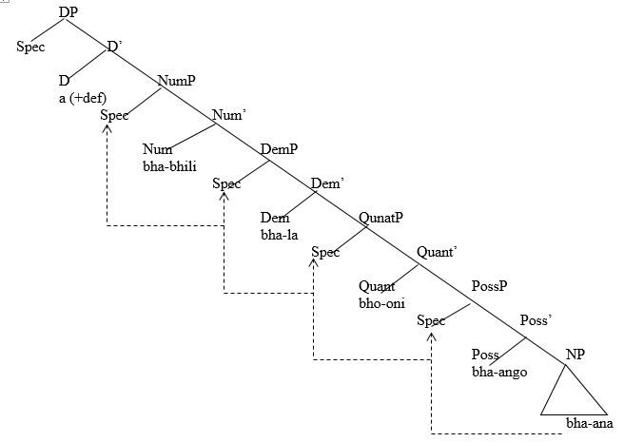
The structure in (15) above illustrates how the nP bhaana ‘children’ undergoes a cyclic movement from its underlying position, through Spec Poss, SpecQuant, SpecDem and rests at the SpecNum where it occupies its position for the DP order to be correct.

6.5 A DP with Noun, Possessive, Quantifier, Demonstrative, Numeral and Adjective

When an adjective is piled up to the DP containing Possessive, Quantifier, Demonstrative, and Numeral, it is preceded by numerals. As such, the resulting order of the modifier will be N>Poss>Quant>Dem>Num>Adj. However, it is worth noting that adjectives can be handled in two ways. First, as elements which are hosted by various functional categories (Cinque1993; Crism 1993). Second, as adjuncts of the NP (Alexiadou 2001; Radford 2004). Consider the following examples. In this paper, I use the second approach and consider the adjective as an adjunct of the NP. This option follows the argument that when they are handled as adjuncts they do not interrupt the movement within the DP during nP rising (Rizzi 1990; Alexiadou 2001).

(16) (a) ɨ-fɨ-maghe fy-ango fyoni fɨl-a fɨ-bhli fɨ-nono
AUG-cl8-knives cl8-Poss cl8-Quant cl8-Dem cl8-two cl8-good
‘all those two beautiful knives of mine’

(b) a-bhabhʉlanɨsɨbhʉa bha-ake bha-bhɨlɨ bha-nono
AUG-cl2-teacher cl2-Poss cl2-two cl2-good
‘the two good teachers of him/her’

The phrase structure for the DPs above would be as follows:
(17)
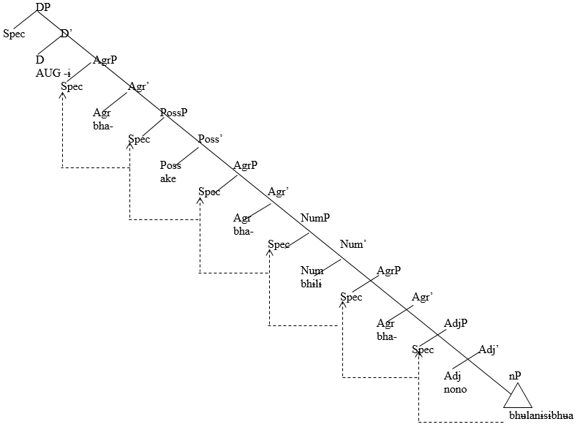
The structure in (17) above presents the fact that an adjective nono ‘good’ is generated as an adjunct of the nP bhabhʉlanɨsɨbhʉa ‘teachers. The noun (nP) moves cyclically to various specifier positions while checking its agreement features and lands to the SpecAgr.

6.6 A DP with Noun, Possessive, Quantifier, Demonstrative, Numeral and Relative clause

In Kɨbhwanɉi language, a possible DP may contain up to seven modifiers. The relative clause is the right most element in structure. Kɨbhwanɉi marks relative clause overtly by using a relative pronoun root –no ‘who, which, with which’. This can be presented in the following table:
Table 1: Relative Clauses Markers in Kɨbhwanɉi
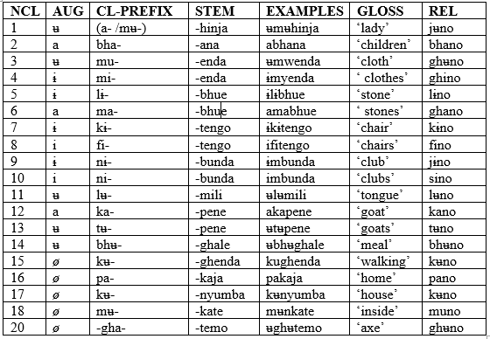
Source: The researcher (2022)
In table (2) above, the relative pronoun root -no takes the shape of the noun class prefix of the head noun the relative clause is modifying. The following examples illustrate this.
(18) (a) A – ma - lenga gha - no ghi-ghenda gha - li hatali
AUG-Cl6-water Cl6-REL SC-run SC-be dangerous
‘The water which is can be dangerous’

(b) Ɨ-fɨ-tengo fɨ-debe fɨno fɨdenyike fɨtagh-ilwe
AUG-cl8-chairs cl8-few Cl8-REL SM-bkoken SC-throw-PF
‘few chairs which are broken have been thrown’

In examples above, the relative markers ghano ‘which’ and fino which’ are marked outsive the verbal structure. This contrasts languages like Runyambo (Neckemia 2019), Runyankore-Rukinga (Asiimwe (2019), and Swahili (Ndomba 2017) in which the relative markers may be are part of the verb complex. Moreover, syntactically, relativized DPs are derived through the movement of head nouns (nP) from their base generated position to Spec DP. The case in point can be presented in the following structure-using example (18b).
(19)
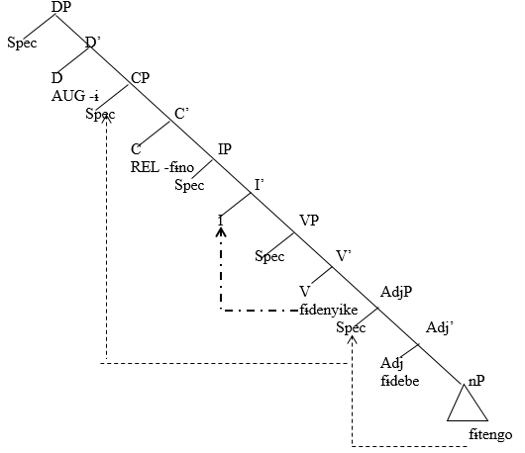

In (19), the relative word fɨno ‘which’ is generated under the complementiser ‘C’ which hosts abstract relative feature (+REL). Meanwhile, the relativized DP Ɨfɨtengo fɨdebe fɨno fɨdenyike ‘the small chairs which are broken’ is derived from the movement of the nP fɨtengo ‘chairs’ from its default position to SpecCP though SpecAdj is generated under C hosting [+REL] abstract features. The nP does not rise further to SpecDP because the D is already occupied by an augment which stands as a functional category heading the DP. In the same structure, there is the movement of the verb fɨdenyike ‘have broken’ to I in order to bestow to its tense features. When other modifiers are added to the DP containing relative clauses, the movement takes place in the same usual fashion in order to achieve a correct word order.

7. Summary and Conclusions
The study has pursued the Structure of Kɨbhwanɉi Determiner Phrase. The focus has been on establishing the functional categories which head the DP and to examine the order of modifiers within the Kɨbhwanɉi DP. It has been established that, Kɨbhwanɉi languages uses augments, the prenominal possessive formative –nya, and prenominal demonstratives as functional categories which realize the D. The augment and the formative –nya are not subjected to any movement because they are restricted to occur pre-nominally with their head noun where they function determiners specifying the range of reference of the noun. On the other hand, demonstratives which are, canonically, post nominal may appear post nominally where they function as English definite article the. Therefore, syntactically prenominal demonstrative appears to have been raised from its original (base generated) position below D. This paper has also pursued the order of modifier in Kɨbhwanɉi Determiner Phrase and how it is derived from the underlying structure through principles of movement. It has been noted that, modifiers in Kɨbhwanɉi Determiner Phrase may range from a minimum of one to six. This yields the order (DEM)>(DISTR)>(POSS)>N> POSS>QUANT>DEM>NUM>ADJ>REL. However, the order of these modifiers is not ridge. For encoding emphasis or focus to some modifiers the order my change, thus making the order.

Abbreviations

AUG | - | Augment
NCL | - | Noun Class Prefix
D | - | Determiner
Cl | - | Class Prefix
DP |  | Determiner Prase
NEG | - | Negative
PST | - | Past Tense
PF | - | Perfective
REL | - | Relative Clause
POSS | - | Possessive
DEM | - | Demonstrative

References
Abney, S. (1987). The English noun phrase in its sentencial aspect (PhD dissertation). Massachusetts Institute of Technology, Massachusetts: MIT Press.
Alexiadou, A., Haegeman, L., & Stravrou, M. (2007). Noun phrase in the generative perspective. New York: Berlin Mouton de Gruyter.
Baswet, et.al. (2014). The Ekegusii Determiner Phrase Analysis in the Minimalist Program. International Journal of Linguistics and Communication. Vol. 2, No. 3.
Bernstein, J. B. (2001). The DP hypothesis: Identifying clausal properties in the nominal domain. In M. Baltin & C. Collins (Eds.), The handbook of contemporary syntactic theory (pp. 536-561). Massachusetts.
Bichwa, S. S (2021). The Determiner Phrase Syntax of Igiha: A generative Approach. PhD Dissertation. Stellenbosch University.
Borer, H. (2005). Structuring sense: An exo-skeletal trilogy. Oxford: Oxford University Press.
Carstens, V. (1991). The Morphology and Syntax of Determiner Phrases in Kiswahili. Unpublished PhD. Dissertation, LosAngeles, University of California.
Carstens, V. (2008). The Structure of DPs: DP in Bantu andRomance. In C. De Cat & D. Catherine (eds.). The Bantu-Romance Connection: A Comparative Investigation of Verbal Agreement, DPs, and Information Structure, 131. Amsterdam: John Benjamins B.V: 131–166.
Chomsky, N. (1995). The Minimalist Program. Current Studies in Linguistics. Vol. 28. Cambridge, MA: MIT press.
Cinque, G. (2005). Deriving greenberg's universal 20 and its exceptions. Linguistic Inquiry, 3, 315--332.
Fischer, H. (2011). The Augment in Vwanji (G66).Unpublished Master’s Dissertation. Hamburg University.
Giusti, G. (2015). Nominal syntax at the interfaces: A comparative analysis of languages with articles. Cambridge: Cambridge Scholars Publishing.
Lyons, C. (1999). Definiteness. Cambridge University Press.
Mose, G.E. (2012). The Structure and Role of Determiner Phrase in Ekegusii: A Minimalist Approach. M.A Thesis Unpublished. Kenyatta University.
Ndomba, R. G. (2017a). The Structure and Derivation of the Determiner Phrase in Swahili. Unpublished PhD (Linguistics) Thesis, University College Dublin.
Nurse, D. (1988). ‘The Diachronic Background to the Language Communities of Southwestern Tanzania’, Sprache und Geschichte in Afrika , 9: 15-115.
Nweze, I.M. (2014). Determiner Phrase in the Igbo Language: International Journal of Social Sciences and Humanities Reviews. Vol.4 No.4, July, 2014; p.94 – 107. https:// www.ijsshr.com/ journal/index. php/I JSSHR/article/download/41/35.
Payne, T. E. (2006). Exploring language structure: A student’s guide. Cambridge: Cambridge University Press.
Radford, A. (2009). An introduction to English sentence structure. Cambridge: Cambridge University Press.
Simile, O. (2013). Phonological Aspects of Kɨβwanɉi. Unpublished M.A. Dissertation, University of Dar es Salaam.
Simile,O. & Upor, R.A. (2017). Segmental Aspects of Kɨβwanɉi Phonology: A Non-Linear Representation. Utafiti Journal. Vol 12, No 1 & 2 University of Dar es Salaam.
Visser, M. (2008). Definiteness and specificity in the isiXhosa determiner phrase. South African Journal of African languages, 28(1), 11-29.
Zamparelli, R. (2000). Layers in the Determiner Phrase. University of Rochester.

