A MINIMALIST ANALYSIS OF RELATIVE CLAUSES IN IFẸ̀

Abstract

A cosiderable amount of scholarly works have been carried out on the syntax of relativisation in Yorùbá but with little attention paid to how Ifẹ̀ forms its relative clauses, especially from the confiner of the latest theoretical requirements. This paper therefore, investigated the syntax of relative constructions in ifẹ̀ dialect detailing the strategies employed for them. Ten (10) native speakers aged 60 and above were purposively selected for structured oral interview based on their proficiency. Data were subjected to syntactic analysis using Rizzi’s Split CP Hypothesis of the Minimalist Program. Ifẹ̀ dialect operates kí as its relative marker, this is optionally dropped. When the dialect stacks two or more relative clauses in a complex sentence it optionally drops only the first relative marker, other are always visible to the PF interface. It operates Head Raising Analysis whereby the relativised argument DPs are copied to the clause left pripheral position to check the [+Rel] feature on the Rel⁰. Relativisable constituents are subject DPs, object DPs (comprising direct objects, objects in serial verb constructions and prepositional objects) genitive DPs and prepositional complements. Relativising a VP/predicate, the dialect either lexicalises the [+nominal] feature copied from the main verb at the clause left peripherial position or externally merges the nominalised form of a verb as the specifier of the RelP. Ifẹ̀ exhibits some dialectal variations lexically and structurally.

Keywords: Ifẹ̀ dialect, Dialectal variations, Relativisable constituents, Minimalist Program, Head
Raising Analysis

1. Introduction

The Ifẹ̀ dialect of Yorùbá is classified under Central Yorùbà (Adétúgbọ̀, 1982; Awóbùlúyì, 1998; Adéníyì and Òjó, 2005 among others). Ilé-Ifẹ̀ is geographically located on Latitude 7º 28¹ ON (7.466667) and Longitude 40º 34¹ OE (4.566667) situated in Ọ̀sun, one of the south-western states in Nigeria. There are different versions of the history of Ilé-Ifẹ̀, and they are essentially mythical. One of the prominent traditional beliefs about Ilé-Ifẹ̀ is that it is the common origin of all Yorùbá cities. All the various tribes within Yorùbá trace their origin from Òdùduwà and therefore believe that they migrated from the city of Ilé-Ifẹ̀. According to Abraham (1958:278), Ilé-Ifẹ̀ is accepted as the parent city of all Yorùbá people. Yorùbá dialects unlike standard Yorùbá began to attract the interest of language scholars over the last two decades. Therefore, adequate attention is still needed to be paid to research studies of Yorùbá dialects. This prompted Awóbùlúyì (1998) to call the attention of Yorùbá scholars to take the advantage of exploring Yorùbá dialects. As remarked by Olúmúyìwá (2006), ‘any endeavour in line with Awóbùlúyì’s appeal will invariably have immediate and long-term benefits for Yorùbá studies, especially on things that every dialect can teach us about the structure of standard Yorùbá’. Many of the items operated in standard Yorubá take their sources from its dialects. In line with Awóbùlúyì’s positions above, it is believed that our analysis of the syntax of relative clauses in the Ifẹ̀ dialect of Yorùbá will reveal many technicalities underlying the categorial status of both relative and focus constructions in Yorùbá, and consequently determine what their categorial status are. Relative clause structures are used to qualify deteterminer phrases (Bámgbóṣé, 1990; Laurel, 2000 and Óláńrewájú, 2007 among many others). According to Abney (1987), in the DP hypothesis, a relative clause is adjoined to a noun phrase (NP) within a DP. Generally, relative clauses are classified into two main types: restrictive and non-restrictive (appositive) relative clauses (Jackendoff, 1977 and Laurel, 2000 among others). To them, the two types are distinctively different both in syntactic an semantic respects. A post-nominal or head-initial- relative language allows a head noun to precede the relative clause while prenominal or head-final relative language do otherwise. English and Yorùbá belong to this second category unlike Chinese Mandarine which operates this first type (Wen 2020). Considering the relationship that holds between the head noun and its relative clause, the existing literature in natural language identify Head External Analysis (HEA) and Head Raisng Analysis (HRA), The HEA also referred to as standard analysis is a generative approach to relative clauses. The head noun is generated outside the restricting clause, indicating that there is no relationship between a head noun and the relative clause it precedes (Jackendoff 1977; Chomsky 1977; Cinque 2003; Wen 2020). The HRA also referred to as promotion analysis. The head noun is base-generated within the restricting clause before it is copied to the clause left peripheral position (Kayne 1994; Mun 1994; Borsley 1997). Yorùbá and some other members of Kwa family operate HRA. The paper comprises four sections; Section one discusses the introduction, in section two, the existing literature, particularly on the categorial status of relative and focus constructions in Yorùbá are discussed, the detailed analysis on the syntax of relative clauses is done in section three while the concluding remarks are done in section four.
:
2. Comments on the categorial status of relative focus constructions in Yorùbá

There are two different opinions on the categorial status of focus constructions in Yorùbá. Extant works like Owólabí (1983, 1987,1989), Yusuf (1990), Adéwọlé (1991), Ọláńrewájú (2008) and so on classify them as sentences, while Awobùlúyì (1987, 1992, 2013) classifies them as noun phrases. He claims that apart from the fact that both the so-called topical qualifiers (focus constructions) and relative clauses follow the same transformational processes, they are also similar in other identifiable respects. He therefore, proposes an alternative theory dubbed “The Insertion Theory” as the possible means of accounting almost satisfactorily for relative clauses. Awobùlúyì’s principal point in support of his argument is based on the occurrence of both focus and relative constructions as complements of the verb ṣe, as shown in the examples below:

(1) a. Kìí ṣe ìwé ni mo rà.
NEG do book FOC I buy
‘It was not a book I bought.’

b. Kìí ṣe ìwé tí mo rà.
NEG do book REL I buy
‘It was not the book I bought.’

It is equally important to note that both focus and relative constructions still exhibit some identifiable dissimilarities (Owólabí 1981, 1983, 1987, 1989: Adéwọlé 1991; Ọláńrewajú 2007, 2022). Suffice to note that 1a above is not structurally equivalent to its (1b) counterpart, and also (2) below:

(2) Èyí kìí ṣe iwé tí mo rà.
This NEG do book REL I buy
‘This was not the book I bought.’

Consequent upon this, (1b) unlike 1a is a phrasal category, it is not sentential. It is equally important to abstract from discussing the syntactic dissimilarities between (1a and b) types above to investigate some other underlying technicalities that factor the occurence of both ìwé ni mo rà and ìwé tí mo rà in (1a and b) above as the complements of the verb ṣe in (1 a and b). Complementing the veracity of the assertion of the existing literature that relative and focus constructions are of different categorial status, this works presents the following syntactic evidence:

i. A subject DP of the higher clause is always not visible to the PF interface when a focus construction occurs as the complement of ṣe unlike its relative construction counterpart. Let us consider the examples below:

(3) a. *Èyí kìí ṣe iwé ni mo rà.
This NEG do book FOC I buy

b. Èyí kìí ṣe iwé tí mo rà.
This NEG do book REL I buy
‘This was not the book I bought.

c. ? Èyí kìí ṣe pé iwé ni mo rà.
This NEG do that book FOC I buy

d. *Èyí kìí ṣe pé iwé ti mo rà.
This NEG do that book REL I buy

e *Èyí kìí ṣe pé iwé wọn.
This NEG do that book they

f. Èyí kìí ṣe iwé wọn.
This NEG do book they
‘This is not their book.’

Example (3a) is ill-formed because the verb ṣe sub-categorises a clausal complement. In (3b and f), ṣe takes a DP complement, therefore, the constructions are grammatical. Also, 3c is acceptable because the clausal complement has been nominalised by pé (a nominaliser), while 3d and e are ill-formed. A complementiser is never used to nominalise a DP in Yorùbá. The implication borne out of this is that whenever the spec TP of a higher clause is overtly realised, the predicate never sub-categorises a clausal complement, otherwise, the embedded clause is nominalised by a complementiser. A clause like (4) below is ill-formed in Yorùbá.

(4) *Oyè gbà [_{TP} Adé lọ ].
Oyè accept Adé go

The restricting clause in (4) above can only be licensed when nominalising it with a complementiser as shown in (5) below:

(5) Oyè gbà pé Adé lọ.
Oyè accept that Adé go
‘Oyè accepted that Adé left.’

ii. Occurrence of a relative construction in a complex sentence stacked with other qualifiers is another empirical evidence that depicts a structural difference between relative and focus constructions. This is shown in the examples below:

(6) a. Ìwé titun tí ó rà yìí kan náà ni o ń kà.
Book new REL he buy this one the FOC he is read
‘He was reading the same new book he bought.’

b. *Ìwé titun ni ó rà yìí kan náà ti o ń kà.
Book new FOC he buy this one the REL he is read

A sentence like (6b) above is never operated by Yorùbá speakers. It is ungrammatical because ó ń kà (focus construction) qualifies the DP ìwé. Ìwé ni ó ra forms the sentence frame in (6a) while the underlined items qualify the head noun ìwé.

iii. A clausal complement can be nominalised unlike a relative clause. This also provides a clear cut syntactic distinction between focus and relative constructions. Let us consider the examples below:

(7) a. Gbogbo wọ́n mọ̀ pé ìwé ni mo rà.
All they know that book FOC I buy
‘They all knew I bought a book.’

b. Gbogbo wọ́n gbà kí Olú lọ.
‘All they accept REL Olú go
‘They all accepted that Olú should go.’

c. Gbogbo wọ́n gbà pe Olú ti lọ.
All they accept that Olú has go
‘They all accepted that Olú has left.’

d. *Gbogbo wọ́n gbà pe Olú ti ó lọ.
All they accept that Olú REL he go

e. *Gbogbo wọ́n mọ̀ pé ìwé ti mo rà.
All they know that book REL I buy

f. Gbogbo wọ́n mọ̀ ìwé ti mo rà.
All they know book REL I buy
‘They all knew the book I bought.’

Only (7d-f) have embedded relative clauses in the examples above. Examples (7d-e) are ill-formed because a complementiser does not collocate with a DP, it nominalises a higher category like a sentence. The restricting clauses, that is, the clausal complements are all nominalised in each of (7a-c). A focus construction is nominalised in (7a), while simple declarative sentences are nominalised in (7b and c). The implication born out of these examples is that a relative clause with its head noun is already a DP unlike a focus construction.

iv. Awóbùlúyì does also adequately account for the reasons why a focus construction cannot occur as a clausal complement of other verbs in Yorùbá. Take for instance, the verbs mọ̀ ‘know’ and gbà ‘accept’, never subcategorise focus constructions as clausal complements as shown in the examples below:

(8) a. *Wọ́n mọ̀ ìwé ni ó rà.
They know book FOC he buy

b. Wọ́n mọ̀ pé ìwé ni ó rà.
They know that book FOC he buy
‘They knew that he bought a book.’

c. Wọ́n mọ̀ ìwé tí mo rà.
They know book REL I buy
‘They knew the book I bought.’

d. *Wọn kò gba ọ̀rọ̀ ni Olú sọ.
They NEG accept word FOC Olú say

e. Wọn kò gba ọ̀rọ̀ ti Olú sọ.
They NEG accept word REL Olú say
‘They did not accept what Olu said.’

Apart from ṣe, ‘be’ identified by Awóbùlúyì, jẹ́ is another lexical verb that exhibits this similar (syntactic) behaviour in Yorùbá. Let us consider the examples below:

(9) a. Bí ó bá ṣe ìwé ni o rà ...
If it ADV be book FOC you buy
‘If it was a BOOK you bought...’

b. Bí ó bá jẹ́ ìwé ni o rà ...
If it ADV be book FOC you buy
‘If it was a BOOK you bought .....’

Ontologically, ṣe, ,jẹ́ and the copula ni all meaning ‘be’ are closely related, perhaps, this permits ṣe and jẹ́ to subcategorise focus constructions as clausal complements. From the evidences discussed above, it crystal clear that the extant literature in support of Awóbùlúyì’s position still need more data for the sake of explicity. His discussion on the issue is characterised by is a survey of limited data, as Yusuf (1990) rightly remarks.

3. Strategies of Relativisation in Ifẹ̀

The Ifẹ̀ dialect operates the HRA, that is a process whereby the relativised constituent is copied to the clause left peripheral position to check the [+Rel] feature on the Rel⁰ through specifier and head agreement. The dialect operate kí in the place of tí operated by the standard dialect (Yorùbá). Ifẹ̀ dialect optionally drops the relative marker. Some other dialects classified under Cenral Yorùbá dialects also share this similar feature (Olúmúyìwá 2006; Oláńrewájú 2008).

(10) a Olú kí mo rí.
Olu REL I see
‘Olú that I saw.’

b. Olú ø mo rí
Olu I see
‘Olú that I saw’

c. Ìghan akẹ́kọ̀ọ́ kí ó sùn
They student REL RES sleep
‘The students that slept’

d. Ìghan akẹ́kọ̀ọ́ ó sùn
They student RES sleep
‘The students that slept’

The relative marker kí is not visible to the PF interface in each of the examples (10b and d) above. The entire relative clause, that is the restricting clause is headed by the Rel⁰ kí or its abstract form, and therefore, qualifies the preceeding noun in each of the examples above (Awóbùlúyì 1978, 2013: Bámgbóṣé 1990; Ajíbóyè 2005; Oláńrewájú 2008).

3.1 Argument Posititions Accessible to Relativisation in Ifẹ̀

Argument position accessible to relativisation in Ifẹ̀ are: Subject DP, direct object DP, prepositional object DP and genitive DP.

i. Subject DP

A subject DP is a noun, pronoun or DP that performs the action or acts upon the verb in a clause. Let us consider the examples below:

(11) a. Gbogbo òbí kí ọ́ ghá sí ilé ẹ̀kọ́
All parent REL RES come to house learning
Áll the parents that came to school’

b. Gbogbo òbí ọ́ ghá sí ilé ẹ̀kọ́
All parent RES come to house learming
Áll the parents that came to school’

The relative marker is not visible to the PF interface in (11a) unlike (11b). Also the spec TP is occupied by the resumptive pronoun after Operation Copy and Delete had been applied on the relativised DP gbogbo òbí ‘all parents’ to license the derivation from a crash. The spec TP is never left empty in the dialect (Ọlánrewajú 2017, 2022). The relativised DP is base-generated in the vP domain before it finally checks its [+Rel] feature at the spec RelP through sspecifier and head agreement in each of the examples in (11a and b) above. The dialect still operates a system whereby a relativised DP is externally merged at the clause left peripheral position of a clause. When this happens, a normal short pronoun occupies the spec TP as shown in the examples below:

(12) a. Ìgha akẹ́kọ̀ọ́ kí ghán ka ìwé righan
They student REL they read book they
‘The students that read their books’

b. Ìgha akẹ́kọ̀ọ́ ighán ṣe ìdánwò
They student they do examination
‘The students that wrote the examination’

The spec TP in each of the examples in (12a and b) above is filled with the third person plural subject pronoun. Therefore, a resumptive pronoun is not introduced because no DP extraction occours at the spec TP of the restricting clause. The relativised DP ìghan akẹ́kọ̀ọ́ ‘the students’ in the example (11a) externally merges with the derivation at the spec RelP before it is finally copied to the spec DP for onward feature valuation through the specifier and head (D⁰) agreement as shown in the phrase-marker (13) below:

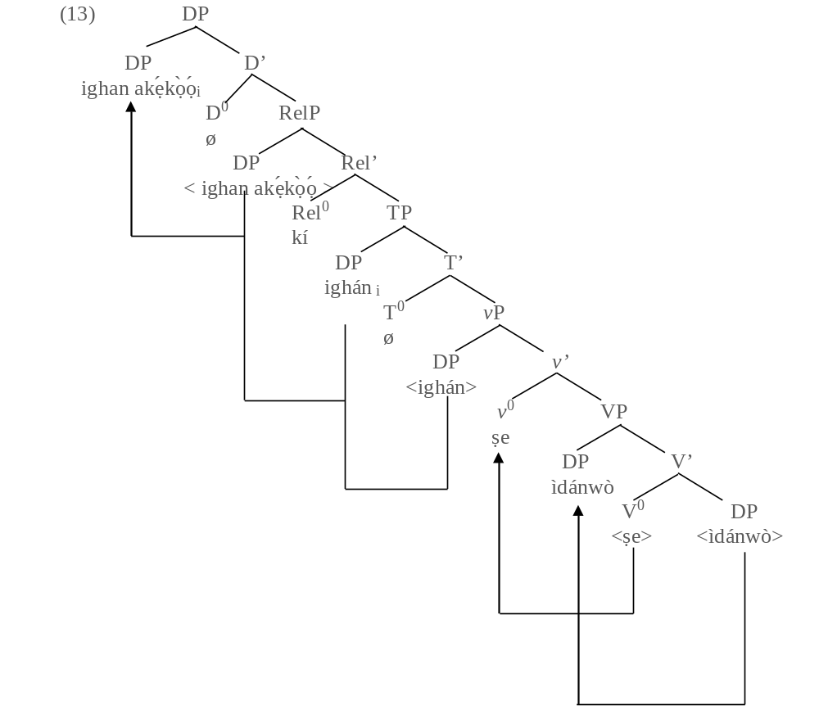
The relativised constituent ìghan akẹ́kọ̀ọ́ ‘the students’ in (13) above is visible to the probe (the abstract D⁰), with this, it is licensed from the Phase Impenetrablity Condition (PIC). Consequent upon this, only the relativised constituent is copied to the spec DP. An alternative way is to assume that the entire phase (the relativised noun and the restricting clause) is attracted to the clause left peripheral position to check the [+EF, nominal] on the D⁰ as shown in (14) below.

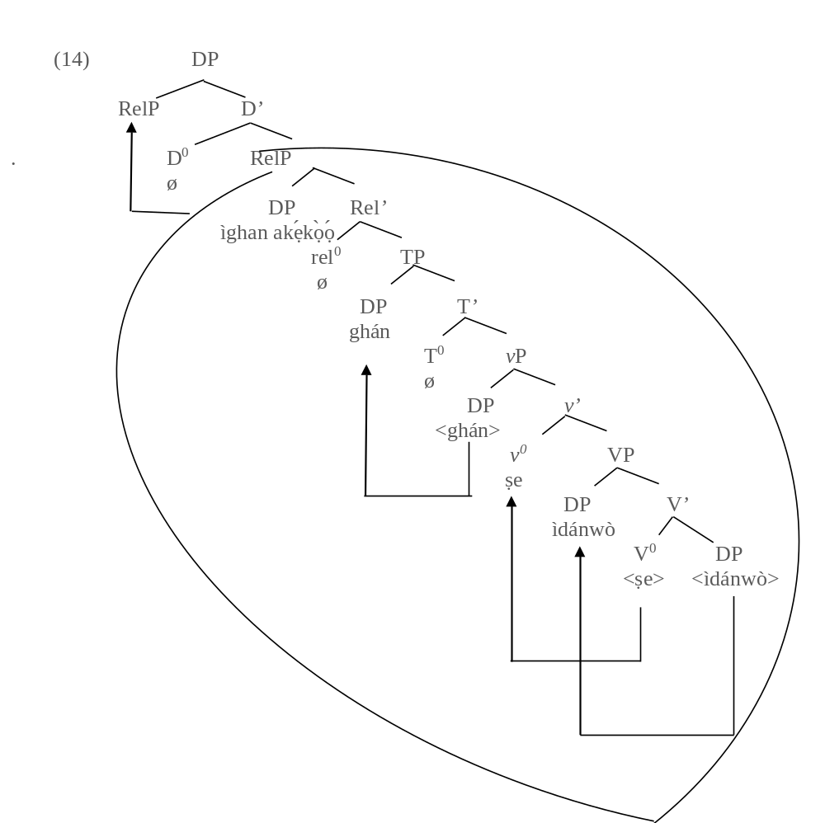

ii. Object DPs

A DP object could be a direct object of a transitive verb, an object in a serial verb construction or an object of a preposition. A direct object of a transitive verb is a noun, pronoun or a DP that receives the action performed by the subject of a clause. Let us consider examples (15a and b) below:

(15) a. Ìwé (kí) akẹ́kọ̀ọ́ rà
Book (REL) student buy
‘The book that a student bought’
b. Ejo (kí) Olú pa
Snake (REL) Olú kill
‘The snake that Olú killed’

The direct object ejò ‘snake’ in 6b is attracted to the spec RelP through the outer vP as shown in the tree diagram (16) below. The example in 15a also shares the similar process of derivation.

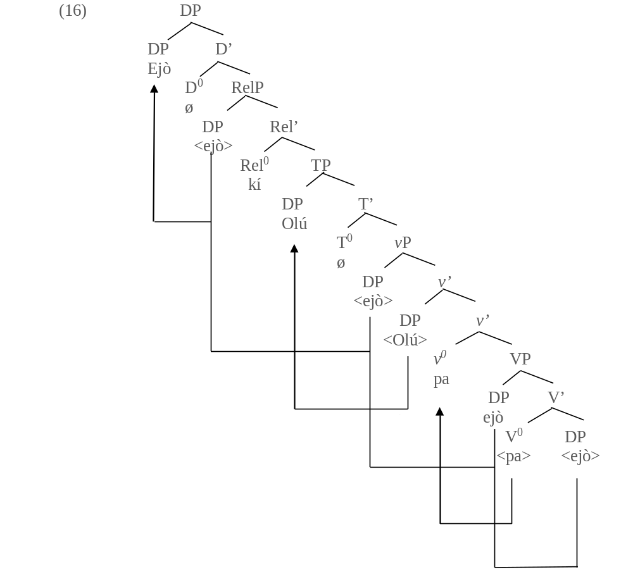

The derivation above goes thus: The lexical verb pa ‘kill’ merges with the direct object DP ejò ‘snake’ to from the V-bar in line with c-selection requirement of the verb. The direct object DP ejò is copied to the spec VP by Operation Copy and Delete for (case) feature valuation. The derivation proceeds by merging the abstract performative light v⁰ with the VP to project the v-bar, while the strong vF on the light v⁰ attracts the lexical verb to adjoin to itself. Then, the subject DP Olú is internally merged at the inner spec vP in line with the Predicate-Internal Subject Hypothesis (PISH), while the direct object DP ejò is copied to the outer spec vP so as to be licensed from the PIC. This makes it visible to subsequent syntactic operations. The derivation proceeds by merging the abstract T⁰ with the vP to project the T-bar. The T⁰ as a probe attracts the subject DP Olú to the spec TP to value its unvalued [+EPP, case] feature. After this, the Rel⁰ (kí) merges with the TP to project the Rel-bar. The Rel⁰ as a potential probe searches its c-command domain and attracts direct object DP ejò to the the spec RelP to value its unvalued [+nominal, Rel] feature. Finally, the abstract D⁰ merges with the RelP to project the D-bar. The D⁰ probes direct object DP ejò ‘snake’ (the relativised constituent) to the spec DP to value its unvalued [+ nominal, EF].
An object DP in a serial verb construction may also be relativised in Ife as also obtainable in Yorùbá.

(17) a. Olú làa gbé àga ghá.
Olú go carry chair come
‘Olú went to carry (get) a chair.’

b. Àga kí Olú làa gbé ghá.
Chair REL Olú go carry come
‘The chair that Olú went to carry (bring)’

(18) a. Oyè ju Bádé lọ.
Oye pass Bade go
‘Oyè is older than Bádé.’

. b. Bádé kí Oyè jù lọ
Bádé REL Oyè pass go
‘Bade that Oyè is older than’

(19) a. Olú mú ìwé ko Kọ́lá.
Olú give book meet Kọ́lá
‘Olú gave Kọ́lá a book.’

b. Kọ́lá kí Olú mú ìwé kò
Kọ́lá REL Olú give book meet
‘Kọ́lá that Olú gave a book’

In (17b), (18b) and (19b) above, the object DPs are relativised in serial verb constructions. The relativised constituent in (18b) is very similar to what Keenan and Comrie (1979) refer to as an object of comparism.

ii. Object DP of a Preposition

The examples below depict how object DPs in prepositional complements are relativised in Ifẹ̀.

(20) a. Olú fi owó mi sí àpò.
Olú put money me to pocket
‘Olú kept my money in the pocket.’

b. Àpò kí Olú fi owó mi sí
Pocket REL Olú put money me to
‘The pocket where Olú kept my money’

(21) a. Bíọ́lá ghà ní ilú ìbàdàn.
Bíọ́lá exist at town Ìbàdàn
‘Bíọ́lá is in Ìbàdàn town.’

b. (Ní) ìlú ìbàdàn kí Bíọ́lá ghà.
(At) town Ìbàdàn REL Bíọ́lá exist
‘Ìbàdàn town where Bíọ́lá stays’

(22) a. Olú ti ti Iléṣà ghá.
Olú has from Iléṣà come
‘Olú has come from Iléṣà.’

b. Iléṣà kí Olú ti ghá
Iléṣà REL Olú has come
‘Iléṣà that Olú has come from’

It is discovered that only the preposition sí is left orphaned as shown in 20b above. Therefore, pied-piping it alongside the relativised constituent would cause the derivation to crash. The prepositions ni and ti always get deleted as shown in (21b) and (22b). In (21b) the prepositional head ní is visible only to the PF interface and not the LF level of representation as evident in the English gloss. Although some native speakers still realise the prepositional head ni at the spec RelP, however, it is deleted in line with the Principle of Economy (of Effort).

iv. Genitive DPs

A possessor DP with its genitive qualifier (complement) can function as a subject of a sentence and object of a transitive verb or a transitive preposition. It is discovered that extraction of constituent is not allowed in genitive DP, as claimed in the existing literature (Read Arókoyọ̀ 2013; Ọláńrewájú 2022). Under minimalist assumption, the entire relativised DP is attracted to the clause left peripheral position when a genitive DP occupies a subject position. A relativised constituent is externally merged at the clause left peripheral position when a genitive DP functioning either as an object of a transitive verb or a transitive preposition comprises a possessor with the possessive pronoun rẹ̀ as its complement. Let us consider the examples below:

(23) a. [DP Okùn bàtà [_{D’} ø [_{RelP} <okùn bàtà> [_{Rel’} kí [_{TP} ọ́_{i} [_{T’} ø[_{vP} <okùn bàtà>[_{v’} já
[_{VP} <okùn bàtà> [_{V’ <}já>]]]]]]]]]].
Rope shoe REL RES cut
‘The shoe’s lace that was cut’

b. [DP Kúnlé [_{D’}ø [_{RelP} <kúnlé> [_{Rel’} kí [_{TP} Olú [_{T’} ø[_{vP} <Olú>[_{v’} rí [_{VP} ìyàó rẹ̀
[_{V’} <rí>[_{DP} <ìyàó rẹ̀>?]]]]]]]]]]]
Kúnlé REL Olú see wife his
‘Kúnlé that Olú saw his wife’

In (23a) above, the Operation Copy and Delete is applied on the relativised DP (genitive phrase) occupying the subject position. Therefore, it is consequently attracted to the spec RelP while the resumptive pronoun is externally merged at the spec TP to save the derivation from a crash. The subject position is alway visible to to the PF interface in the dialect. This principle is captured by the Subject Condition Constraint (SCC) under the previous models of generative syntax (Read Ndimele 1992; Mǖller 2008). In (21b), the relativised constituent enters the derivation at the spec RelP to check the [+ nominal, Rel] feature on the Rel⁰ through specifier and head agreement. The dialect does not allow extraction from a genitive DP as shown in the ill-formedness of (24) below. This is captured under the Complex Noun Phrase Constraint in the previous models of generative syntax.

(24) *[_{DP} Íyàó [_{RelP} <ìyàwó> kí [_{TP} Olú rí [_{VP} <ìyàó> Ayọ̀]]]]
Wife REL Olú see Ayọ̀

The example in (25a) below depicts how a relativised genitive DP functioning as a prepositional object is raised to the clause left peripheral position whereby the preposition (si ‘to’) is left stranded.

(25) a. Yèyé Òjó kí Bọ́lá ju ọọ́ sí ____
Mother Ojó REL Bọ́lá throw hand to
‘Òjó’s mother that Bíọ́lá waved’

b Òjó kí Bọ́lá ju ọọ́ sí yèyé rẹ̀
Ojó REL Bọ́lá throw hand to mother his
‘Òjó that Bíọ́lá waved his mother’

c. *Yèyé kí Bọ́lá ju ọọ́ sí ____ Òjó
Mother REL Bọ́lá throw hand to Òjó

Unlike (25a), the relativised constituent Òjó enters the derivation at the spec RelP in (25b). Example (25c) is ill-formed because the relativised constituent is extracted from a genitive DP (Ajíbóyè, 2005; Arókoyọ̀, 2013).

3.2 Predicate/VP Relativisation

A lexical verb or an entire predicate is also relativisable in Ifẹ̀ dialect as operated in standard Yorùbá. Similarly to the specifiers position of a focus phrase (spec, FocP), the specifier position of a relative construction (spec, RelP) only host [+nominal] feature in Yorùbá (Ìlọ̀rí 2010; Ọláògún 2016). Under minimalist assumption, two methods are identified for VP/predicate relativisation in Ifẹ̀; one, following Óláògún (2016) and Ọláńrewájú (2022), the [+nominal] feature is copied from the verb and lexicalised at the spec RelP, and two; the relativised item, that is, the nominalised form of the verb enters the derivation at the spec RelP before it is finally probed to the specifier position of the DP for feature valuation. Let us consider the examples below:

(26) a. Lílọ kí Olú lọ
Going REL Olú go
‘Olú’s going’

b. Fífọ̀ kí Ayọ̀ fọ ighan aṣọ rẹ̀
Washing REL Ayọ̀ wash they cloth his
‘Ayọ̀’s washing his cloth’

The second method above is adopted in this work because it upholds the Principle of Economy. Therefore, (26b) is phrase-marked as (27) below for the purpose of more clarity.

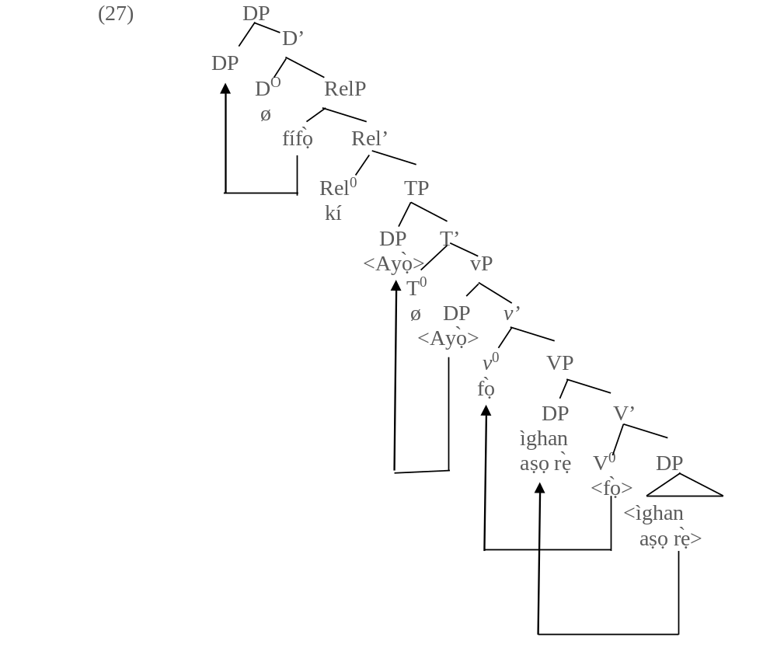
Fífọ̀ ‘washing’, the nominalised verb enters the derivation at the spec RelP before it is attracted to the spec DP for onward feature valuation. It is equally possible to assume that the entire RelP is copied to the spec DP in (27) above. However, that would be less economical than the methed adopted above.

3.3 Relativisation of Adverbs

Adverbs are also referred to as post-modifiers. Awóbùlùyi (2013) disregards items like kíákíá ‘urgently’, wéréwéré ‘urgently’ díẹ̀díẹ́ ‘gradually’ and so on as adverbs. He therefore idenfifies them as nouns. This study does not lay an emphasis on the categorial status of the afore-stated words. Examples are considered from ideophones which are undebatably categorised as adverbs in Yorùbá and its dialects (Awóyalé 1989).

(28) a. [_{DP} Gbì [_{D’} ø [_{RelP} <gbì> [_{Rel’} kí [_{TP} ọ́ [_{T’}ø [_{vP} <ọ́> [_{v’} dún [_{VP} <ọ́> [_{V’}
<dún>]]]]]]]]]].
NOM REL it sound
‘The gbì sound it produced’’

b. [_{DP} Kẹ̀ù [_{D’} ø [_{RelP} <kẹ̀ù> [_{Rel’} kí [_{TP} ìbọn ọ̀hún [_{T’}ø [_{vP} < ìbọn ọ̀hún > [_{v’} ró
[_{VP} < ìbọn ọ̀hún > [_{V’} <ró>]]]]]]]]]].
NOM REL gun that sound
‘The kẹ̀ù sound produced from that gun’

The relativised constituents gbì and kẹ̀ù are merged at the spec RelP to check the unvalued [+Rel, EF] feature on the Rel⁰ through specifier and head agreement in (28a and b) above. They are nominalised constituents. They have different feature properties from their adverbial counterparts in (29a and b) below:

(29) a. [_{TP} Ọ́ dún gbì].
It sound PSM
‘it produced a gbì sound.’

b. [_{TP} Ìbọn ọ̀hún dún kẹ̀ù].
Vehicle the stop PSM
‘The lorry stopped suddenly.’

3.4 Consecutivisation of Relative Clauses in Ifẹ̀

Two or more relative clauses can be stacked in Ifẹ̀ just like the standard dialect. Whenever this occurs, the first embedded clause drops its relative marker while others have theirs visible to the PF interface as shown below.

(30) a. [_{TP} Akẹ́kọ̀ọ́_{i} ọ́_{i} ra ìwé rẹ̀, ’ kí ọ́_{i} kà á ṣe dáadáa].
Student RES buy book his REL RES read it do good
‘The student that bought and read his book performed very well.’

b. [_{TP} Ọdẹ_{i} ø ọ́_{i} pa ejò, kí ó_{i} sè é, kí ọ́_{i} jẹ ẹ́ ti kú].
Hunter RES kill snake, REL RES cook it, REL RES eat it has died
‘The hunter that killed, cooked and ate a snake is dead.’

3.5 Focusing a Relative Clause

A relative phrase, that is a restricting relative clause with the head noun it qualifies can be focused in Ifẹ̀ dialect. A DP with its embedded relative clause occupies an argument position. Therefore, it can be focused just like other constituents specified [+nominal] feature. Let us consider the example below.

(31) a. Ọdẹ kí ọ́ pa ejò, kí ọ́ jẹ ẹ́ ni ó kú.
Hunter REL RES kill snake, REL RES eat it FOC RES die
‘THE HUNTER THAT KILLED AND ATE A SNAKE died.’

b. Akekọ̀ọ́ kí ọ́ ka ìwé rẹ̀ ni olùkọ́ yìn.
Student REL RES read book his FOC teacher praise
‘The teacher praised THE STUDENT WHO READ HIS BOOK.’

The two relative clauses stacked in (31a) above are relativised alongside the head noun they qualify (the DP ọdẹ ‘hunter’) The example in (31b) has an embedded relative qualifier. The tree diagram in (31) below is a better illustration of (30b).

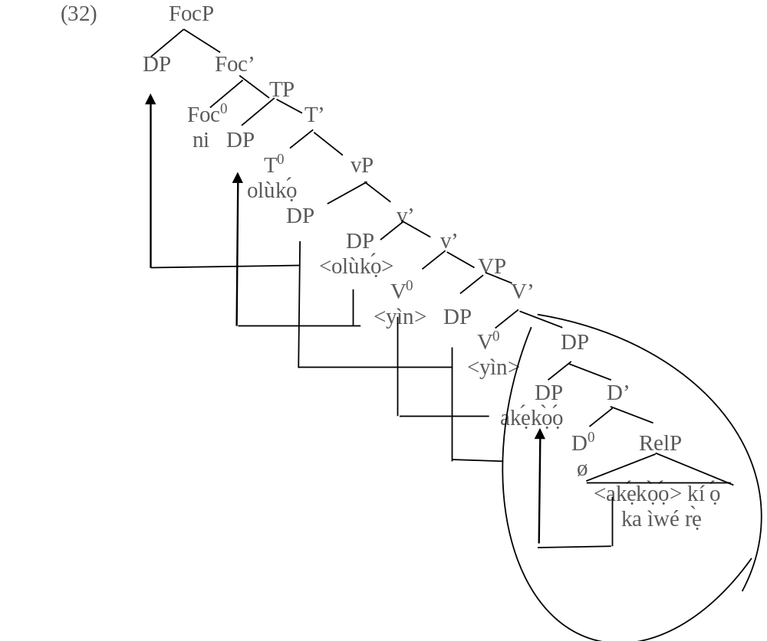

In (32) above, the entire DP, that is the relative clause and the head noun it qualifies is merged with the lexical verb yin ‘praise’ to satisfy the c-selection requirement of the verb, hence, it projects the V-bar. The DP is copied to the spec VP to check the case feature on the V⁰. The derivation proceeds by externally merging the performative light verb with the VP to project the v-bar. The strong vF on the light v⁰ attracts the lexical verb yìn to adjoin to itself while the subject DP, Olùkọ́ ‘teacher’ is externally merged at the inner spec vP in line with the PISH, which requires subject of a sentence to be base-generated within the predicate. After this, the relativised DP is internally merged as the outer spec vP so as to be licensed from the PIC and be visible for subsequent operations. The derivation proceeds by externally merging the abstract T⁰ with the outer vP to project the T-bar. The T⁰ as a probe searches its c-command domain for the DP olùkọ́, a matching goal and attracts it to the spec TP, where it values its unvalued [+case, EPP] feature. The derivation still proceeds by merging the Foc⁰ with the TP to project the Foc-bar. The DP comprising the head noun and the relative qualifier is attracted to the spec FocP to check the [+Q, EF] on the Foc⁰ through specifier and head agreement. The implication borne out of the derivation in (32) is that only DPs are hosted at the spec FocP unlike other categories with sentential status. Therefore, a focus construction cannot be relativised or focused. Another inference drawn from this it that constructions like (33a-b) feature what Owólabí (1989) identifies as linking particles.

(33) a. Olú kí ó dìde, kí ó dúró ni mo rí.
Olú REL RES stand REL RES wait FOC I see
‘i was Olu who stood up tha I saw.’

b. Olú ni mo rí kí ó n sùn.
Olú FOC I see that he is sleep
It was Olú I saw sleeping.

The underlined expression in (31b) is not a relative clause, therefore the kí that introduces it is not a relative marker, it only introduces the second clause. The underlined expression in (33b) behaves differently to the restricting relative clause in (34) below.

(34) Olú kí ó n sùn ni mo rí. .
Olú REL RES is sleep FOC I see
‘It was Olú who sleeping that I saw.’

The entire direct oject DP Olú kí ó n sùn is focused in (34) above. This system operates similarly in the standard dialect.

4. Conclusion

This paper has discussed the syntax of relativisation in Ife. The dialect exhibits some similarities with the standard dialect regarding the strategies it uses to forms its relative constructions. It is pertinent to note that they both share many things in common because standard Yorùbá is the conglomeration of all its dialects. (Awóbùlúyì 1998 and Olúmúyìwá 2006 amongst others) However, Ifẹ̀ dialect still features some dialectal variations with respect to how it forms its relative clauses. The fact that relative and focus constructions are formed in standard Yorùbá and its dialects using what some literature refer to as Head Raising Analysis is not an adequate reason to equate them having the same categorial status. Interestingly, using Minimalist Program as the syntactic framework, this paper also produced and discussed evidents revealing that a relative clause is a DP while a focus construction is a sentence in Ifẹ̀ dialect. This goes a long way in determining the status of relative and focus constructions in Yorùbá.

Abbreviations

ADV: Adverb
D: Determiner
DP Determiner Phrase
EF: Edge feature
FOC: Focus marker
LF: Logical form
NEG: Negative marker
NOM: Nominalisation
PF: Phonetic form
PSM: Post-modifier
REL: Relative marker
RelP: Relative phrase
RES: Resumptive pronoun.
T: Tense
TP: Tense phrase
VP: Verb phrase
vF: Verb feature
vP: Light verb phrase

References

Abney, Steven. 1987. The English Noun Phrase in Its Sentential Aspect. Ph.D Thesis.

Abraham, Roy. 1958. Dictionary of Modern Yorùbá. London. Oxford University Press.

Adéwọlé, Lawrence. 1991. “Heads Without Bars: A Solútion to the Sentential Status of Yorùbá
Focus and Relative Constructions”. Odu: A Journal of West African Studies III `16 No 88 pp 19-22.

Ajíbóyè, Oládiípọ̀. 2005. Topics on Yorùbá Nominal Expressions. Ph.D Thesis. University of British Columbia.

Awóyalé, Oláyíwọlá. 1989. “Reduplication of the Status of Ideophones in Yorùbá”. Journal of west African Languages. Vol. 19. Pp15-34.

Awóbùlúyì, Oládélé. 1978. Essentials of Yorùbá Grammar. Oxford University Press Ibadan,
Nigeria.

Awóbùlúyì, Oládélé. 1987. “Focus Constructions as Noun Phrases: A Reply”. Journal of the Yorùbá Studies Association of Nigeria. New Studies 1. 73-87.

Awóbùlúyì, Oládélé. 1992. “Issues in the Studies of Yorùbá Focus Constructions”. Journal of West African Languages xxii 2. 69-88.

Awóbùlúyì, Oládélé. 1998. .Àwon Ẹ̀ka-Èdè Yorùbá. Paper presented at the Conference of the Yorùbá Studies Association of Nigeria. Pastoral Institute, Ibadan. November 24–26.

Awóbùlúyì, Oládélé. 2013. Eko Girama Ede Yoruba. ATMAN Ltd. Osogbo.

Bámgbóṣé, Ayọ̀. 1990. Fonólójì àti Gírámà Èdè Yorùbá; Ibadan. University Press PLC.

Chomsky, Noam. 1977. “On Wh-movement”. Formal Syntax. Pp 71-132.

Citko, Barbara. 2014. Phase Theory: An Introduction. Cambridge University Press.

Cinque, Guglielmo. 2003.”The Prenominal Origin of Relative Clauses”. Workshop on Antisymmetry and Remnant Movement, New York University, Vol. 31.

Ìlọ̀rí, Falọ́runṣọ́. (2010). Nominal Constructions in Ìgàlà and Yorùbá. Ph.D Thesis. Department of Linguistics and Languages, Adékúnlé Ajásin University, Àkùngbá-Àkókó.

Jackendoff, Ray, 1977. X-syntax: A Study of Phrase Structure. Cambrige Mass: MIT.

Kayne, Richard. 1994. The Antisymmetry of Syntax. Cambridge Mass: MIT Press.

Keenan, Edward and Comrie, Bernard. 1979. “Noun Phrase Accessibility Revìsíted”. Language 55, 3. 640-664.

Laurel, Brinto. 2000. The Structure of Modern English: A Linguistic Introduction, John Benjamins publishing company, Amsterdam/Philadelphia.

Mǖller Gereon. 2008. Classic Constraints www.ui-leipzig.de/mullerg.
Mun, Alan. 1994. “A Minimalist Account of Reconstruction Asymmetries”. Proceeding of NELS. Vol. 24 pp 397-410.

Ndimele Ozo-Mecury. 1992. The Parameters of Universal Grammar. A Government and Binding Approach.Owerri. African Educational Service.

Ọláńrewájú, Emmanuel 2008. Relativization in Ifẹ̀. Long Essay. University of Ibadan.

Ọláńrewájú, Emmanuel. 2022. A syntax Focus and Interrogatives in Central Yorùbá Dialects. University of Ìbàdàn, Mphil Dissertation. Ph.D Thesis.

Ọláògún, Simeon. 2016. Information Structure Categories of Ǹjọ̀-kóo Language in Àkókó North- West of Oǹdó State, Nigeria. Ph.D Thesis. University of Ìbàdàn.

Olúmúyìwá, Tèmitọ́pẹ́ 2006. Àwọn Wúnrẹ̀n Onítumọ̀ Gírámà nínú Àwọn Ẹ̀ka-Èdè Àárín-Gbùngbùn Yorùbá. Doctoral Dissertation, Adékúnlé Ajásin University, Akungbá Àkókó.

Owólabí, Kọ́lá. 1981. “Focus Constructions as Noun Phrase: A Critique’’ Presented at the Linguistics and Nigerian Languages, University of Ibadan, Nigeria.

Owólabí, Kọ́lá. 1983. More on the Inadequacy of the Focus Constructions as Noun Phrases. Linguistic Analysis. vol 12, no. 4, 453-471.

Owólabí, Kọ́lá. 1987. “Focus Construction as NP: A Critique”. Yoruba (New series), No. 1 pp. 45-62.

Owólabí, Kọ́lá. 1989. “The Non-existence of Topical Qualifiers in Yoruba. Yoruba”. Journal of the Yoruba Studies Association of Nigeria (Special Edition) pp. 1-22.

Rizzi, Luigi. 1997. “The Fine Structure of the Left Periphery”. Elements of Grammar: Handbook in Generative Grammar. ed. L. Haegeman, Doerdrecht, Kluwer. pp281-337.

Rizzi, Luigi. 2001. “On the Position “Interrogative” in the Left Periphery of the Clause”. G. Cinque and G. Salvi (eds.). Current Studies in Italian Syntax: Essays Offered to Lorenzo Renzi. New York: Elsevier, 287-296.

Wen, Huiying. 2020. Relative Clauses in Mandarin Chinese. Ph;D Thesis. University of London.

Yusuf, Orẹ. 1990. “Yorùbá Copula Ni”. Journal of West African languages, 20(1): 83-93.

