SOURCES OF LINGUISTIC VARIATIONS AMONG DIALECTS OF
KIROMBO
XXXX
Abstract
This paper investigated the sources of linguistic variations among dialects of Kirombo. The study focused on general factors for linguistic variations among dialects of Kirombo. The study employed qualitative approach to collect data from four divisions of Rombo District, namely: Useri, Mashati, Mkuu, and Mengwe. The purposive sampling technique was used in the whole study to select Rombo District and the four divisions, households, and informants for the interviews. The sample size for the study was 10 informants who were determined by saturation point. The findings revealed that, the Mangi ruling systems and enmity, nature of geographical areas, social beliefs, distance and origin of elders are the major sources of linguistic variations among dialects of Kirombo. The study recommends that linguists should conduct research on other Bantu languages that are not extensively researched, particularly on the sources of linguistic variations.

Keywords: Linguistic Variation, Dialect, Language Variation and Kirombo.

Introduction
Based on classification system by Guthrie (1967), Kirombo is part of zone E60 and labelled E623 on the classification of Historical Classification of African Language which explains that the Chagga language belongs to the Niger-Congo language family. Muzale and Rugemalira (2008) claim that the Chagga cluster of languages is treated in a peculiar way as six languages, namely Mashami, Mochi, Vunjo, Woso, Rombo, and Uru are spoken in different areas of the Chagga homeland at the foot of Mount Kilimanjaro. Lewis (2009) discovered that Chagga do not speak a single language known as Kichagga, but rather a variety of languages such as Kimashami, Kiuru, Kirombo, Kimochi, Kivunjo, and Kikibosho. Lewis’ stance on the non-existence of a language known as Kichagga, but the existence of a Chagga culture with different languages such as Kimashami, Kiuru, Kirombo, Kimochi, Kivunjo, and Kikibosho is supported by Maho (2009) who classifies Kirombo as a language itself with four major dialects, namely: E623A * Useri (Kiseri), E623B * Mashati (Kimashati), E623C * Mkuu (Kimkuu), and E623D * Keni (Keni) on their divisons of Rombo district. However, Maho (ibid.) did not survey the sources of linguistic variations existing among the proposed dialects, he classified these dialects based on the divisions where these varieties are found.

- Sources of language variations research
Language variation is a phenomenon that can be found in any language on the planet (Abdel et al., 2015). Huber (1999) conducted a research on language differences in Ghana, and discovered the causes for Ghanaians speaking English differently in different places. Huber referred to varieties as pidgins. Again, the socio-historical context, was highlighted as the contact in trade among the Portuguese, Dutch, and English as a key element in the creation of several pidgins in Ghana. The study revealed the trade activities as the main source of language variation among Ghanaians in speaking English language.
Labov (1966) illustrates that diversity occurs not just along social lines, but also along the course of change for some language novelties. As a result, the field of dialectology has expanded to include not just geographic but also social diversity. Variationist linguists who have long been interested in the extent to which language culture follows the same paths as technical, political, and aesthetic culture regard dialects and sociolects as cultural elements (Chambers & Trudgill, 1998).
In the study on some linguistic variations in Kaonde, Mambwe (2008) used word/sentence list, notebook and audio-recording as methods of data collection. Divergence was thought to have had a key role in aggravating the linguistic distinctions across dialects. Because of their geographical proximity, the standard and Lubango - Solwezi dialects were found to have minimal linguistic differences, and convergence was shown to have played a role in diminishing linguistic differences between the two dialects.
The dialects emerge for a variety of reasons. On this aspect, Kipacha (2003) argues that geographical and social factors are the reasons for the emergence of dialects. Kipacha (ibid) explains that with geographical locations, speakers of a language can be scattered in different places probably by their personal preferences or even separated by geographical factors like island, river or political boundaries. Such factors cause speakers of one language to distance themselves hence communication decreases as their communication is limited thus resulting to a great possibility in the emergence of dialects.

Yohana (2009) investigated sociolinguistic differences in Chasu, in Same District. The data for the study were gathered using sociolinguistic interviews, wordlists, participant observations, and questionnaires. The study revealed that, Chasu has two dialects, namely, Northern and Southern Chasu, with contrasting sounds. Due to language contact with Gweno, the Southern Chasu switches from /s/ and /z/ to /Ɵ/ and /ð/ accordingly in their informal utterances. This study revealed that geographical proximity is an agent of either variation or similarity as a dialect can vary or differ from another because of its closeness or farness from another.

Mtallo and Rubagumya (2015) discovered that, the source of variations among Chagga linguistic variety is due to their geographical location, distinctions in origin, a lack of common socialization, and the presence of enmity between them.

- Methodology
This is a qualitative study that employed the descriptive research design. The qualitative approach was important for an in-depth and broad investigation of views, attitude and opinions of the Kirombo native speakers about the sources for linguistic variations in their area.

This study was conducted in Rombo District, particularly at Useri, Mashati, Mkuu and Keni. These areas have the indigenous of Kirombo speaking community since their arrival in Rombo. The areas also has had limited interaction from other language-speaking communities, which may have, in one way or another, affected other communities. This increased the chance for relevance of the data to this article.

The study involved 10 informants sampled through purposive technique. The three informant two males and one female from Kiseri and Keni dialects, and two informant one male and one female informant from Kimashati, and Kimkuu dialects. The sample was determined by saturation point; when the researcher did not find any new information from the addition of informants.

The data were collected through interview. Interview method made the informants feel free to provide more useful and in-depth information on the sources for linguistic variations among dialects of Kirombo.

The study at hand used qualitative methods of data analysis which was thematic approach. The researcher grouped themes based on similarities by taking the explored sources of linguistic variations which were similar in order to constitute a single theme. The similar themes were taken and grouped as a single entity constituted a single source of linguistic variations in the studied dialects.

All codes of conducts of a research work were complied in the whole processes of data collection and analysis. For instance, the objective of the study was clearly explained to informants so as to seek their consent to participate consciously and voluntarily in the research.

- Results and Discussions
This part presents and discusses the findings on the sources of linguistic variations among dialects of Kirombo. The study addressed experiences, attitudes, views, and opinions from Rombo elders on the reasons for linguistic variations in the dialects of Kirombo.

4.1 Mangi Ruling Systems and Enmity
The Mangis were great chiefs who governed large clan-based states. They controlled Chagga affairs even during the colonial times. In Rombo, there were different Mangis who were ruling different areas, such as Mangi Kakuria and Ndemasi who ruled Useri; Mangi Sengua and Latemba who ruled Mashati; Mangi Selengia and Kinabo who ruled Mkuu; and the great Mangi Horombo who ruled Keni and later on became the great Mangi whose name came to be after the district’s name Rombo because of his power, invasion, and the battles he won against Maasai and other rivals. These Mangis defended their territories and created two major issues which brought about variations in language.
The big issue was securing of land, in the sense that, anyone who wished to acquire land under Mangi system was supposed to provide something to the chief in order to be given a residential area. On this, one of the informants from Useri says:
Zamani ilikuwa hivi, kama ukitaka ardhi (yaani kiamba), ni lazima uende kwa Mangi. Utoe kitu kidogo akupe watu wake wakakuonyeshe mahali pa kuishi; vinginenvyo, usingeweza kupata eneo (Interview with informant B, Useri, 22nd July 2022)
In the past, if someone was in need of land, it was a must to meet with a chief (Mangi) and give a bribe-like stuff so that his men could show you place to build your house. Otherwise, someone could not be in a position to own a residential area (Interview with informant B, Useri, 22nd July 2022).
Based on the findings shown in the quotations above, some people from other places secured land through giving something to the Mangis. These were such as the Pare and Maasai who mostly took some areas in Useri, while the native speakers were still in the same area but with no contact with other people defending their lands. Therefore, this process of meeting with the chief for acquiring land discouraged movement of the people from one area to another within Rombo district, hence, every chiefdom upheld its own ways of speaking.
Another issue was cattle confiscation and land grabbing. Most of the elders died fighting for their confiscated cattle and land. For example, most of the elders from Mkuu died in Useri fighting for their land. This was revealed during interview with Mkuu elders where one of them revealed that their elders died fighting for their wealth:
“…babu zetu wengi sana wamefia hapo Useri wakipambania ng’ombe zao walizonyang’anywa…(Interview with informant I, Mkuu, 25th July 2022)”.
“…most of our grandfathers died in Useri while fighting for their confiscated cattle…(Interview with informant I, Mkuu, 25th July 2022)”.
This instance created enmity between the people from Mkuu and Useri, something which limited them from having full and frequent contact and socialization, hence variations. Mtallo and Rubagumya (2018) in their study on sources of language variation among the Chagga people found that the political unrest of Mangi’s rule engaged Chagga people in intense combat with Germans and started pacing around restlessly. Eventually, they disintergrated, and within the Kilimanjaro region, they settled in various geographical locations. Due to this circumstance, new vocabularies emerged that distinguished between languages spoken in different regions. The enmity between chiefdoms limited to large extent the chances of the people in Mkuu and Useri to contact as a result these people found themselves having variations in their speeches. However, the findings added a point to variationists who set out to discover patterns in the distribution of alternative ways of saying the same thing. The variationists find that, the social and linguistic factors are responsible for the variation (Schiffrin, 1994). However this result added to the theory that even political factor may lead to dialectal variations.

Figure 1.1 A photo showing the grave of the famous chief Horombo whose name was later given to the present district led to the name Rombo
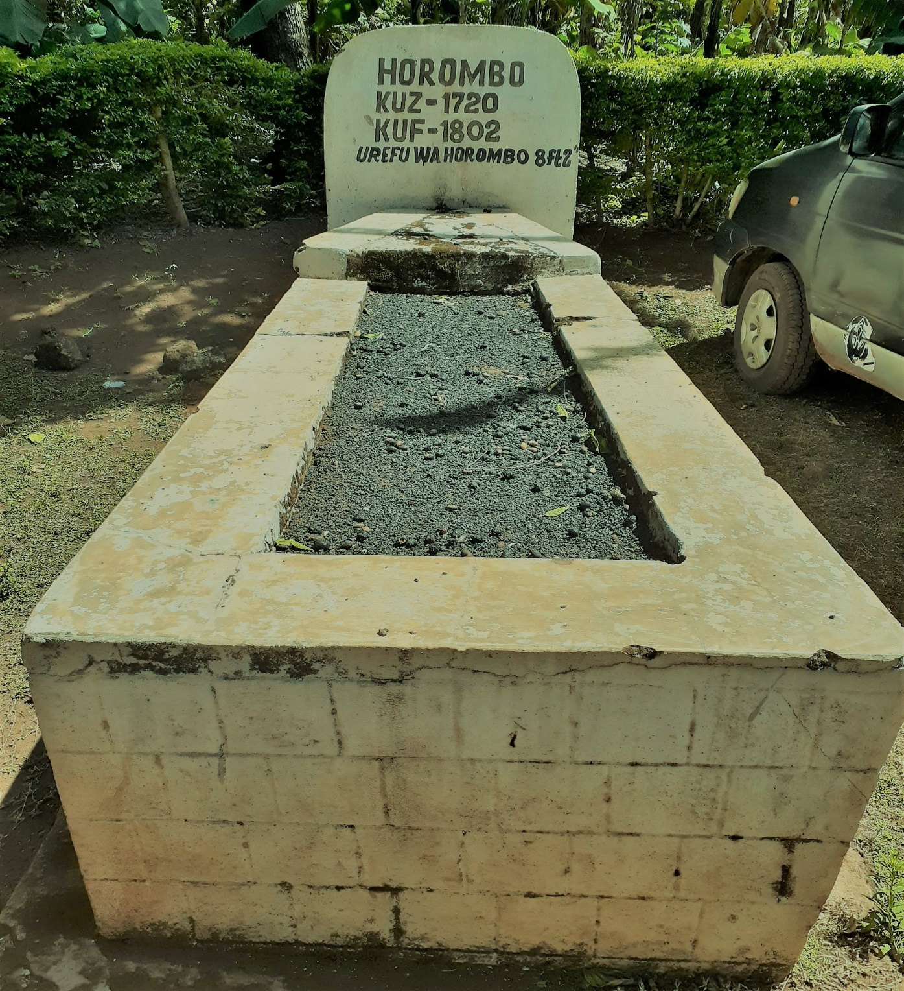
Source: Field Data (2022)

4.2 Nature of the Geographical Areas
The nature of the area of Rombo district is full of mountains and rivers which act as boundaries between one geographical area and another. The presence of these topographical features led to infrequent contact among Rombo speakers; hence, it became difficult for them to be uniform in speaking. It is worth noting that one of the characteristics of a language is the development of new vocabularies; hence, the Rombo speakers from Useri, Mashati, Mkuu, and Keni developed their own vocabularies separately. This is supported by what was quoted from an interview with one of the informants from Useri who said:
Mazingira yetu yana milima na makorongo (mito) mengi sana. Hata ukiangalia mipaka ya maeneo yetu, asilimia kubwa ni mito. Kwa hiyo, wazee wengi wa zamani walikuwa hawavuki kwenda kwenye maeneo mengine kiurahisi. Ndio maana hata hizi lugha zilitofautiana, maana walikuwa hawakutani. Ukiangalia mpaka kati ya Useri na Mashati, ni mto Mlembea; Mashati na Mkuu ni mto Ungwasi; na kule Mkuu na Keni ni mto Shia.Sasa, kwa namna hiyo, ni lazima watu watofautiane (Interview with informant A, Useri, 27th July 2022).
Our surroundings are full of mountains and valleys (rivers). Even when you look at the boundaries of our areas, by far and large; they are characterised by rivers. Thus, most of the elders did not easily cross to other places. That is why; these languages were different because there was no contact among people living in these areas. You see, the boundary between Useri and Mashati is the Mlembea River, Mashati and Mkuu are separated by Ungwasi River, and Mkuu and Keni are bordered by Shia River. Now, in that way, it was a must for these people to differ linguistically (Interview with informant A, Useri, and 27th July 2022).

Figure 1.2 A photo showing the Mlembea river, the border between Mashati and Useri where Kimashati and Kiseri dialects are spoken
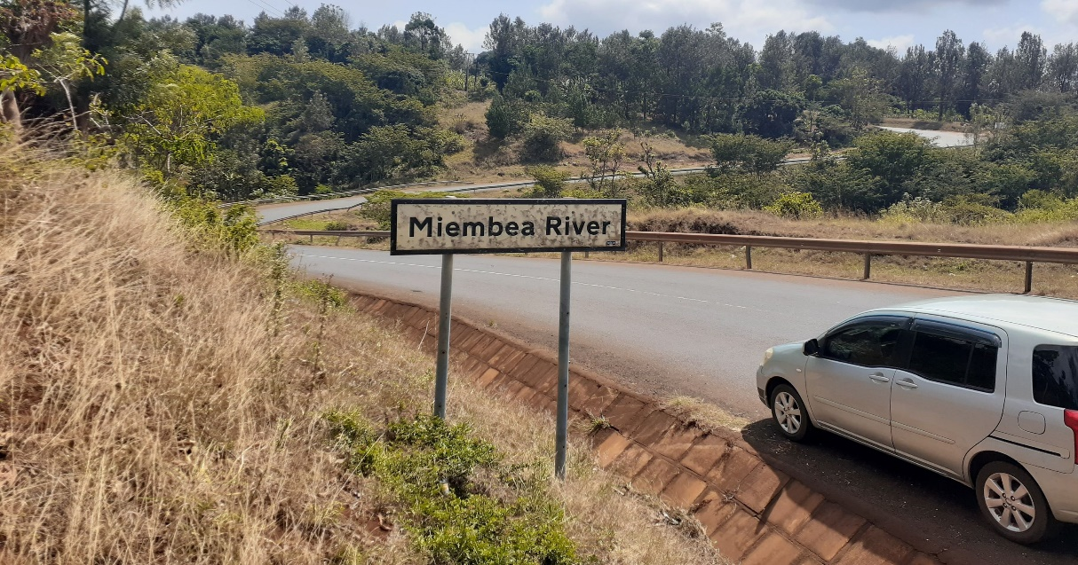
Source: Field Data (2022)
Figure 1.3 A photo showing the Ungwasi river, the border between Mashati and Mkuu where Kimashati and Kimkuu dialects are spoken
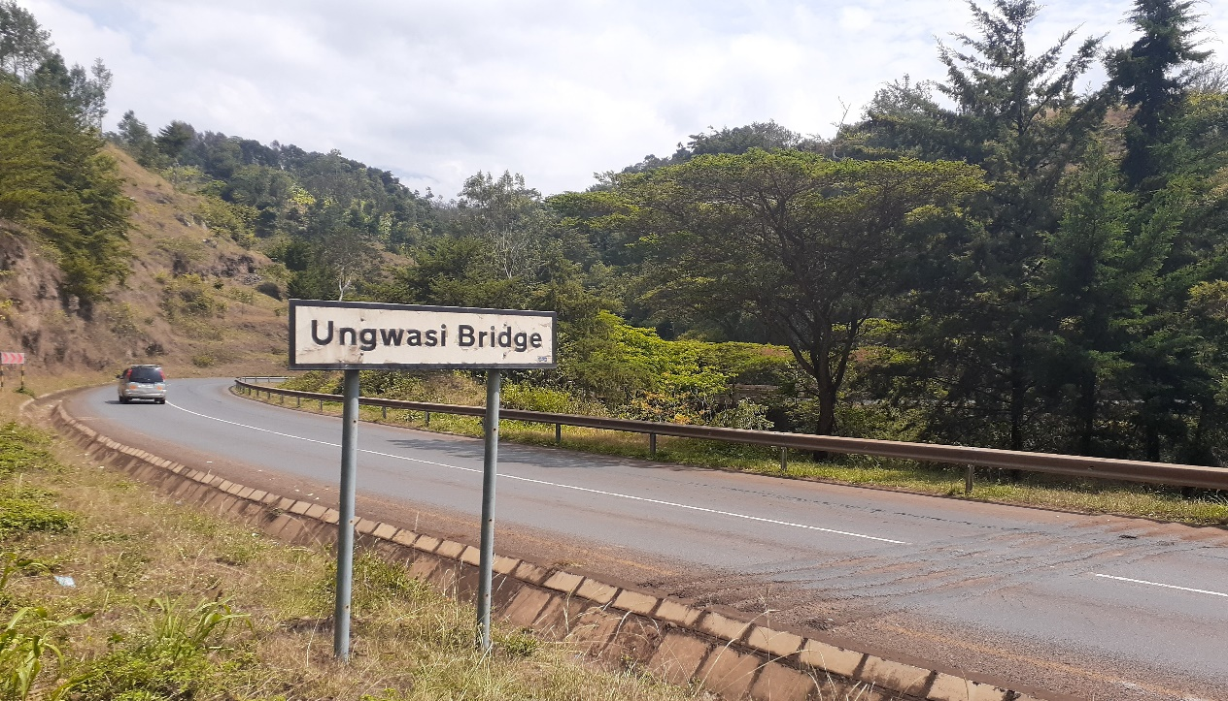
Source: Field Data (2022)

Therefore, based on the findings from the quotation above and the photos, the mountainous topography of Rombo district which is also characterised by many rivers; discouraged people moving from one area to another area. Once someone had a flat area for settlement and farming, such a person did not bother thinking of migrating to another place. This is because, by doing so, one would forfeit the opportunity to live in a flat land which he was already in possession. Thus, mountains and rivers limited the chances of Rombo speakers to move in other areas within the district. This resulting to variations in lexicon, pronunciation, and even semantics caused by this limited geographical mobility. These findings are in line to Matondo (2002) who studied Sukuma variants and discovered the four primary dialects of Sukuma which are Kemunasukuma (Northern dialect), Kemunang'weli (Western dialect), Kemunadakama (Southern dialect), and Kemunakiya (Eastern dialect). The major source for these dialects is geographical dispersion as these people lack frequent contact hence variations in speaking a language.

4.3 Hostility, Social Beliefs, or Prohibition of Inter-Location Marriages
There was an interesting story which was revealed through interview with the informants. Mostly, from all areas who disclosed that, in the past, it was strictly prohibited for men from one location to marry a woman from another location. This was caused by the social belief that, women from other locations had a tendency of killing their husbands once they had succeeded in life in order to inherit the wealth they had generated. This prohibition was mostly observed between Useri and Mashati which are adjacent to each other. Despite this fact no one was allowed to marry from another group. Regarding this prohibition, one of the informants from Useri disclosed it by saying:
Sisi watu wa Useri tulikuwa hatuoi Mashati kwa sababu wanawake wao ukifanikiwa wanakuua wewe mwanaume ili warithi mali wale na watoto. Vilevile, sababu nyingine ilikuwa ni kuepuka wanawake wa Mashati wasije kuolewa huku Useri wakatoa siri za huku kwa wale mamangi (Interview with informant D, Useri, 29th July 2022).
We people of Useri did not marry women from Mashati because once men had succeeded in life, their women killed them in order to inherit the wealth and enjoy it with the children. Also, another reason for avoiding marrying the women from Mashati by Useri men was to guard the secrets of the land that they should not get and spill some vital information of the area to their Mangi (Interview with informant D, Useri, 29th July 2022)”.
Another informant from Mashati, in countering this argument, said:
Kwanza, huku Mashati ulikuwa ukitaka kuoa wanakuuliza huyo mwanamke ni wa wapi Ukisema ni wa Useri tu wanakuambia hapana tafuta wa sehemu nyingine au wa hapahapa Mashati. Pia hapa Mashati wengi wetu tumeoana watu wa hapahapa. Ila siku hizi hayo mambo hayapo. Tulikuwa tunayasikia na kwa watu wa Machame. ila siku hizi watu wanaoana kutoka sehemu yoyote na hakuna shida hiyo tena (Interview with informant F, Mashati, 04th August 2022).
First, here in Mashati once men wanted to marry, they would ask where the woman was coming from. If you said she was from Useri, theywould tell you to find a woman from another place or just marry a woman from Mashati. Also, most of us here in Mashati have married women from here, but nowadays these things no longer exist. We were hearing that even the people of Machame had the same practice. But currently, people get married from anywhere and there is no any problem (Interview with informant F, Mashati, 04th August 2022)”.
Such beliefs of avoiding marrying what the called a ‘spy woman’ limited the Kirombo speakers from moving and marrying women from other localities. These cultural beliefs obstructed the contact between people from Useri and Mashati to meet and socialise with each other. Also, people from Mkuu and Keni did not have a tendency of marrying women from Mashati and Useri due to the same belief. This culture created a sort of avoidance among the Rombo speakers; as a result, they developed a variation in speaking the same language at various levels of language. Similarly, variationist linguists postulated the extent in which language culture follows the same paths as technical, political, and aesthetic culture regard dialects and sociolects as cultural elements (Chambers & Trudgill, 1998). This implies that culure or social beliefs trigger changes of language in different ways depending on the perceptions, attitudes and customs of the users of the language.

4.4 Distance and Proximity (Language Contact)
The farness or closeness of the areas was another source of linguistic variations in dialects of Kirombo, especially, with regard to lexical items and pronunciations. It was noted that Mkuu and Keni being close to a large extent share a lot of lexical items and sounds of the words because of their closeness. Mkuu and Mashati also showed resemblance of some features which has been influenced by their geographical proximity. The variation between Kiseri and Keni dialects was noted to be very great. This is because of their distance in locations from Keni to travel Useri. The long distance of these areas led to infrequent contacts between speakers from Useri and Keni, hence variations. This can be proved by the variations in pronunciation of words like kulima which is pronounced as /itema/ in Kiseri; as /itrema/ in Kimashati and Mkuu; and as /icema/ in Keni. The lexical variation between Keni and Kimkuu is very minor compared to Keni and Kiseri that is Keni and Kimkuu are lexically similar by 57.1%, but Keni and Kiseri are lexically similar by 21.5% only. Also, Kiseri and Kimashati, which are very close geographically, are lexically similar by 47.5%. The reason behind such variations or similarities is the distance between one speaking area and another. This means that the closer the dialects, the greater the similarities and the vice versa is true. These findings corroborate the findings by Yohana (2009) who studied the two Chasu dialects the north and south. Yohana found that the reason for contrasting sounds between the two dialects was due to their contact with Gweno. The study revealed that geographical proximity was an agent of either variation or similarity as a dialect could vary or differ from another because of its closeness or farness from another.
The farness or closeness of the areas was another source of linguistic variations in dialects of Kirombo, especially, with regard to lexical items and pronunciations. It was noted that Mkuu and Keni being close to a large extent share a lot of lexical items and sounds of the words because of their closeness. Mkuu and Mashati also demonstrated resemblance of some features which had been influenced by their geographical proximity. The variation between Kiseri and Keni dialects was noted to be very great. This is because of their distance in locations from Keni to travel Useri. The long distance of these areas led to infrequent contacts between speakers from Useri and Keni, hence variations. This can be proved by the variations in pronunciation of words like kulima which is pronounced as /itema/ in Kiseri; as /itrema/ in Kimashati and Mkuu; and as /iʧema/ in Keni. The lexical variation between Keni and Kimkuu is very minor compared to Keni and Kiseri, i.e. Keni and Kimkuu are lexically similar by 57.1%, but Keni and Kiseri are lexically similar by 21.5% only. Also, Kiseri and Kimashati, which are very close geographically, are lexically similar by 47.5%. The reason behind such variations or similarities is the distance between one speaking area and another. This means that the closer the dialects, the greater the similarities and the vice versa is true. These findings corroborate the findings by Yohana (2009) who studied the two Chasu dialects the north and south. Yohana found that the reason for contrasting sounds between the two dialects was due to their contact with Gweno. The study revealed that geographical proximity was an agent of either variation or similarity as a dialect could vary or differ from another because of its closeness or farness from another.

4.5 Origin of Elders
The origin of elders was reported through interview as one of the sources of linguistic variations in the dialects of Kirombo because some elders were born and raised in a given part of the district and established their own permanent settlements, expanded their generations, and the language of the place grew from one generation to another. Also, it was revealed that some of the elders were from Pare, Maasai, and Kamba tribes who migrated to Useri, Mashati, Mkuu, Keni, and other places of Rombo who used the then existing forms of language in the places of their settlements. This was revealed by one of the informants who said:
Mtu alikuwa anazaliwa anakuta lugha inazungumzwa na mababu zetu, na yeye anazungumza hiyohiyo kwa kila eneo. Kama ni wa Useri, anaongea lugha anayoikuta hivyohivyo na Mashati na maeneo mengine. Ila hata baadhi ya watu wengine huku asili zao siyo hapa, hata sisi huku; kwa mfano, mababu zetu siyo wazawa wa hapa Mkuu: Mababu wa mababu zetu ni watu wenye asili ya Wakamba. Pia hiyo Useri na maeneo mengine ya Rombo kuna familia za Wapare na Wamasai wengi ambao waliishi maeneo hayo tokea enzi za mababu zetu (Interview with informant X, Keni, 10th August 2022).
A person was born and found a language being spoken by our elders, and he or she spoke the same language and it was the same in every place, be it Useri, spoke the existing language. It was the same case with Mashati and other places. Even some of the people here are not Rombo natives. We, for example, our elders are not Mkuu natives: our great grandfathers are Kamba natives. Also, in Useri and other Rombo places, there are many Pare and Maasai families who dwelled in those areas since the days of our great grandfathers (Interview with informant X, Keni, 10th August 2022)”.
Therefore, the origin of elders who settled in a given place, for example, Useri led the next generation to speak the existing language that was spoken the same in other places but which later on made these people differ in speaking, as the way of speaking was determined by the nature of the elders and their place of residence as language is usually acquired from one generation to the next generation. These findings align to behaviourists who argue that language is learnt or acquired by imitating others who encourage or discourage the behaviour by their reactions or by rewards and punishment (Skinner, 1985). Moreover Vygotsky (1978) insist that, the conversations that children have with adults are important in developing their language and thought. Therefore through the rewards, punishment, and regular conversations with adults from various dialects of Kirombo made the Speakers to vary depending on their places of residence.
- Conclusion
This paper has provided some insights on the sources of linguistic variations among the dialects of Kirombo. The findings of this study revealed that despite the fact that the dialects of Kirombo vary in some linguistic levels, the speakers of these dialects understand each other (there is mutual intelligibility). Therefore this study recommends that linguists should conduct research on other Bantu languages that are not extensively researched, particularly on the sources of linguistic variations in order to enrich the body of knowledge particularly in Bantu languages.

References
Abdel, M.Q.A. S. (2015). An overview on dialectal variation.International Journal of
Scientific and Research Publications, Volume 5, Issue 6, June 2015 1 ISSN 2250-3153.

Chambers, J.K. & Trudgill, P. (1998). Dialectology (2nded.). Cambridge University Press.
p. 6. ISBN 978-0-521-59646-6.

Huber, M. (1999). Ghanaian Pidgin English, http://lingweb.eva.mpg.de/apics/images/o/oo/survey
Ghana.pdf (10th October, 2021).

Kipacha, A. (2003). Lahaja za Kiswahili. Chuo Kikuuhuria cha Tanzania, Dar es
Salaam, Tanzania.
Labov, W. (1966).The Social Stratification of English in New New York City.Washington D.C: Center for Applied Linguistic.
Lewis, M.P (Ed.) (2009). The languages of Tanzania project. Dar es Salaam: Languages of
Tanzania Project.

Maho J. F. (2009). The online version of the New Updated Guthrie List, a referential
classification of the Bantu languages 2^{nd (}ed).

Mambwe, K. (2008). Some linguistic variations of Kaonde: A dialectological study.
A master dissertation at the University of Zambia.

Matondo, M. (2002). Ethnologue: Languages of the world, http://www.linguistics.ucla.edu/
people/grads/matondo/swahilisukuma.html. (20 October, 2022)

Mtallo, G. & Rubagumya, C. (2015). The source of language variation among Chagga people
in Kilimanjaro Region, Tanzania.Vol. 04, No. 07: 68-78

Muzale, H. R. M. and Rugemalira, J. M. (2008). Researching and documenting the languages of
Tanzania. Languages, documentation and conservation 2(1): 68–108.
Schiffrin, D. (1994). Approaches to discourse. Oxford: Blackwell Publishers Ltd. Publishing Co.,
Ltd
Skinner, B.F. (1985). Cognitive science and behaviourism. British Journal of Psychology, 2
(1985), pp. 291-301.

Vygotsky, L.S. (1978). Interaction between learning and development. Cole, M., John-steiner,
V., Scribner, E. and Souberman, E. (Eds), Mind in society: The development of higher psychological processes, Harvard University Press, Cambridge, Ma (1978), pp. 79-91.

Yohana, R. (2009). A sociolinguistic analysis of variation of a rural African community:
Chasu in Same District, Tanzania. University of Cape Town, Cape Town.

