https://dx.doi.org/10.4314/gjl.v13i1.1

Disambiguating the Dentalisation TAG on pre-dental /t/ deletion in L2 English
Amos Mivojour Agboyinu
Oluwasegun Amoniyan

While the phenomenon is described as /t/ deletion in some linguistic environments, its occurrence before the dental fricatives has been labelled dentalisation. This suggests that /t/ invariably acquires dental features when it occurs before a dental sound in a cluster. This assumption for pedagogy implies that learners of English are likely to get confused over a dentalised variant of pre-dental /t/ at the phonetic input. To dogmatically retain this description implies that just as the alveolar /n/ is realised as [ŋ] and /m/ before velar and labial sounds, there should be a dental variant of /t/ before a dental sound in clusters. This work examined the dentalised(/t/) in predentalised contexts. It was found that the speakers deleted pre-dental /t/, thus, indicating that /t/ has no dentalised variants but gets deleted in the pre-dental environment. We suggested imposing the term dentalisation on pre-dental /t/ should be reviewed in non-native environments.
Keywords: Pre-dental /t/, dentalisation, dentalised /t/, pre-dental environment, /t/ deletion

1.0 Introduction
Variabilities in English sound have attracted elaborate discussion in the phonological literature from the perspectives of generative phonology and other linguistic theories. Among the linguistic phenomena identified as bases for sounds alternation in speech production are the need for articulatory ease, sound distinction, gestural constraints, language contact, phonotactic constraints, morphological modification, and language preference. When Chomsky and Halle (1968) argue that sound change is motivated (primarily) by the innate properties of the human mind and the interaction of these properties with the external world, similarly to this study, Giegerich (1992) suggests that the change is influenced by phonological and phonetic factors, such as the phonotactics of a language or the ease with which certain sounds can be produced. He argues that sound changes are often the result of the gradual modification of sound patterns in response to these factors. Meanwhile, Browman and Goldstein (1989) argue that sound changes are often the result of changes in the coordination of the articulatory gestures that produce speech sounds. Schane (1973) suggests that social and cultural factors, such as prestige and identity, often drive sound change. He argued that people might adopt certain pronunciation patterns or dialects to signal their alignment with a social group or to distinguish themselves from others (Awonusi, 2004; Bybee, 2003; Fromkin, Rodman, & Hyams, 2011). These studies agree that sound change occurs owing to more factors than innatism and phonetics.
Unlike others, scholars like Anderson, 1975; Anttila, 2002; Ladefoged, 1972; Pierrehumbert, 1990 agreed on Chomsky’s (1980) description of sound variations as phonological rules (P-rules), which account for different sound changes that are triggered by varying factors in different linguistic environments. Examples of such changes include the deletion rule, assimilation rule, liaison rule, reduction rule, degemination rule and so on (see Agboyinu, 2018; Awonusi, Ademola-Adeoye, 2015, 2018; Chomsky & Halle, 1968). Agboyinu (2018) and Awonusi and Ademola-Adeoye (2018, 2015) argue that assimilation is a complex phonological process that can be influenced by various factors, including articulatory, phonetic, phonological, sociolinguistic factors and speech context (Dziublska-Kolaczyk, 2001). This implies that modification of sound sequence in oral speech production is universally accredited in phonological literature in cross-linguistics.
The above studies have established sound change phenomenon cross-linguistically (e.g., /t/ deletion in variant cluster environments remains valid in English). However, little investigation concerns non-native speakers about dental gestures in the /t/ environment. This rare perspective has not received attention in the literature, and it is, therefore, a driving force that necessitates the need to study whether [t̪] is phonetically present in the speeches of non-native users of English. The outcome of this investigation helps to describe segment interactions in the phonological system in the non-native English context.
1.2 Statement of the problem
The assimilation process is described (Pavlík, 2009) as the ‘adjustment of speech sounds to their environment.’ This implies that any sound being assimilated will be produced with the feature it acquires in the environment; examples of this are nasalization of vowels, such as [vowel] → [+nasal]/__ [+nasal]. It can also be seen in place feature assimilation of the coronal nasal /n/ → [+ labial]/__[+labial]. This suggests that /n/ becomes [m] in the environment before any labial sound, such as /b/, /m/, /w/, et cetera, going by this, it can be deduced that the assumption of dentalisation, from the perspectives of assimilation would imply that the coronal fortis /t/, would assume the place feature of dental sounds at the post-dental position. This infers that /t/ occurring before any dental sound would be phonetically realized as [t̪] before the dental articulation. This hypothesis poses a concern to the phonotactics principle of English, which excludes stacking some obstruent sounds in a certain order. Also, considering the gestural motion induced by a catenate pair of the fortis and the dental sounds, it is evident that such a gesture as conscription at the tongue tip immediately following the tongue blade would infringe the manoeuvres permissible in a natural speech event. Birjandi, & Salmani-Nodoushan, (2005:130) argument that “…any form of speech that can interfere with breathing is impossible” also queries the possibility of stacking a coronal fortis with a coronal dental of which are obstruent sounds that involve strictures at the exterior region of the articulatory tract. One is therefore constrained to ask whether the [t̪] is realized with acoustic evidence or is just a mental assumption based on its contiguity with a dental sound. This motivated the need to study whether [t̪] is phonetically present in the speeches of non-native English users. The study does not primarily aim to compare native and non-native English speakers but tests the hypothesis of dentatalization in [t] environment in phrasal/sentence context in different Englishes.
2.0 Literature review
When viewed from the perspective of gestural phonology, it is plausible to contend that the occurrence of /t/ immediately before a dental sound can instigate articulatory overlap. This is because the two phonemes, being coronal, require articulatory execution at almost the same tongue position in quick succession, which negates the ergonomic articulation principle. Figure 1 below illustrates the position of gestural phonology regarding the multiple activities to which the tongue is subjected in speech production. The labels shown in the coronal axis indicate that tongue tip constriction location (TTCL) is almost symmetrical for both /t/ and /ð & θ/; hence, repeating tongue tip constriction degree (TTCD) at the coronal point will muddle the gestural configuration. This justifies the need for /t/ deletion to achieve distinctness in the acoustic release of the two sounds.
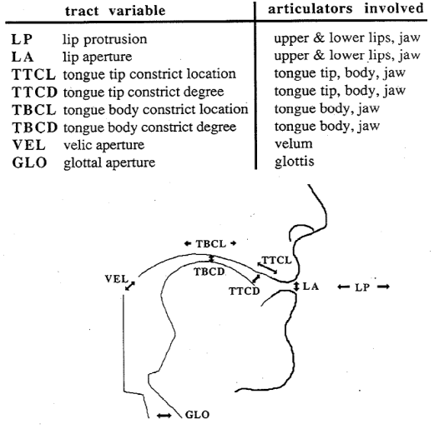

Figure 1: Browman and Goldstein 1989: 96
Looking at the Figure above, it can be noticed that Browman and Goldstein (1986) present the motions of the tongue during speech sound production as complex actions in the oral cavity. Besides, the sound being examined in this discourse involves tongue tip constrictions at the same position in the oral cavity. Invariably, the realisation of such double articulation poses challenges to the speaker.
Deletion of the alveolar sounds in a clustering environment is a universally acknowledged linguistic practice (Guy, 1980; Raymond, Dautricourt & Hume, 2006; Myers, 2020; Tamminga, Wilder, Lai & Wade, 2020; Temple, 2003). The phenomenon of /t/ deletion is pronounced in the phonological literature of English due to the aerodynamics of consonant clusters in the language (Agboyinu, 2018). It is assumed that /t/ and /d/ is the most liable to deletion in a clustering environment because they are the least sonorous among English sounds. Guy (1980), explicating the various motivations and factors conditioning the deletion of /t/ and /d/ in the English language, identifies, among others, preceding segments, following segments, speech rate, the length of the cluster, articulatory complexity of the cluster, and so forth. Stressing further on this process, Guy 1980:33-34 says:
Another significant aspect of this rule is the universality and uniformity of its force. It applies to a greater or lesser extent to virtually all native speakers of English in almost all social settings. I have noticed its effects in the speech of university professors lecturing their classes and linguists delivering papers before LSA Nixon delivering the State of the Union message to congress….

It is evident from the standpoint highlighted in the quotations above that /t/ deletion is robustly validated by many phonological rule discussions over the years. Thus, describing the disappearance of the sound in the pre-dental environment as deletion should be discounted, especially if there is no acoustic evidence of its realisation in such an environment.
In almost all instances of assimilation, there is always an acoustic substance that confirms the existence of the affected sound (target) in juxtaposition with the environment (trigger). This truth can be verified from the ordering of rule formalization, which is usually rendered in the order exemplified in the format /n/ becomes /m/ in the environment before a labial sound. This implies that the effect of the influence of the trigger is only evident in the concrete sound, which retains its syntactical position, though with an altered feature. More examples can be found in cases like nasalization of vowels before nasal sounds, homorganic nasal rules altering the alveolar sound to agree in place feature with the following stop sound, etc. Exponents of dentalisation rule seem to reason that /t/ becomes dentalised before a dental sound, [+alveolar + fortis] →[+ dental]/ --[+dental]; or /t/ → [t̪]/ ---[ð]. Going by this arrangement, one would expect that there should be a concrete realisation of the dentalised form before the conditioning dental sou; otherwise, the notion of dentalisation regarding predental /t/ can be better regarded as a mental assumption.
Some available instances cited as dentalisation in phonological discussion present conflicting reports. For instance, Gasser (2020, p.2), in an argument that dentalisation occurs when /t/ comes before a dental fricative, illustrates with the phrase at the top, claiming that the /t/ in ‘at’ becomes dentalised as a result of the influence of the following dental sound /ð/ at the word boundary. Gasser further supports his claims with other examples such as eighth and width, transcribed respectively as [eɪt̪θ] and [wɪt̪θ]. Similarly, Williamson (2015) claims that the pre-dental /t/ is usually produced by retracting the tongue to the back of the upper incisors and articulating the /t̪/ at the same place as the dental sound it precedes. Williamson also transcribed eighth and width as [eɪ t̪^{h}θ] and wɪdθ]. Looking at the two obstruent sounds juxtaposed in the transcriptions above, one cannot but query the prospect of achieving a complete gestural execution of these sorts of clusters without running into an articulatory mess. In another development, Febriyanti (2015, p.18), in his phonological analyses of the song lyrics of Avenged Sevenfold, identified predental /t/ as an incidence of elision. This was illustrated with phrases like it through, left the, which were transcribed as [ɪθru:] and [lefðə], respectively. In this situation disappearance of the coronal fortis /t/ before the dental sound is noticeable, thus making the gestural manoeuvres easy to perform. Although its discussions appear to be scarce in the phonological literature, the contradictions inherent in the tenets of dentalisation of pre-dental /t/ and its concomitant gestural dilemma motivated this study with a view of juxtaposing the effect of teaching-learning of English phonology in the second language context.
3.0 Methodology
Ten English sentences with various cluster contexts form data sample. The choice of words explores alveolar and dental fricatives. The tokens are either at the sentences' beginning, medial or final positions. The words include cut the cake, fast thinker, lift this…. The meaning of the words is known to the first and second English users. The participants have varied language backgrounds and their English proficiencies were not uniform. The participants include a native English (Briton) speaker (35years) whose production serves as the control, 5 Dutch English Speakers (DESs), 5 Ghanaian English Speakers (GESs), and 10 Nigerian English Speakers (NESs). The Nigerian speakers have Hausa, Igbo, and Yoruba as their first languages. Apart from the native speaker, other speakers have English as a second language. The non-native speakers were university graduates in Ghana, Nigeria, and Dutch. The Dutch speakers were postgraduate students at Wakeningen University. As of the time of data collection, the native speaker was residing in Canada. A text containing 20 simple sentences, each of which has words or phrases involving clusters with predental /t/, to check whether the predental /t/ would be phonetically realised with acoustic evidence or get deleted before the dental sounds. The data were collected from the participants through reading a text comparing targeted tokens in different word and syllable positions of phrases and simple sentences. The production of the Native English speaker was labelled as Control’s model to provide the benchmark for the indorsed production. Instances where pre-dental /t/ was deleted and participants failed to delete the targeted phonemes were noted. Praat (Boersma & Weenink, 2017) were used for sound file processing and acoustic analysis. For the acoustic analysis, intensity (dB) and duration (ms) were manually aligned on Praat to determine the targeted segments. The frequencies of such instances were counted respectively to derive numerical data for descriptive and inferential statistical analysis through IBM SPSS 25. The data obtained through this process were subjected to Chi-Square analyses for the relationship between the variables for a significant difference, and the p-value was set at ≤.05.
4.1 Statistical Data Analysis
The clustering units extracted from the semi-spontaneous utterance obtained from each group of participants were juxtaposed with the production of a native speaker, tagged Control’s Model (CM), to verify the viability of dentalisation or deletion of the pre-dental /t/ and appraise the non-native speakers’ performances on this benchmark. Forms that were found to approximate the Control’s Model in the speeches of the three groups, Dutch, Ghanaian and Nigerian English Speakers, were converted into numerical data and were subjected to statistical analyses using Chi-Square statistical tool as presented in separate Tables 1-18 below.
Table 1: Production of /t+θ/ by Dutch English Speakers
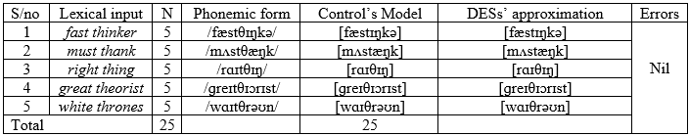

Table 2: Production of /t+θ/ by Native and Dutch English Speakers crosstabulation
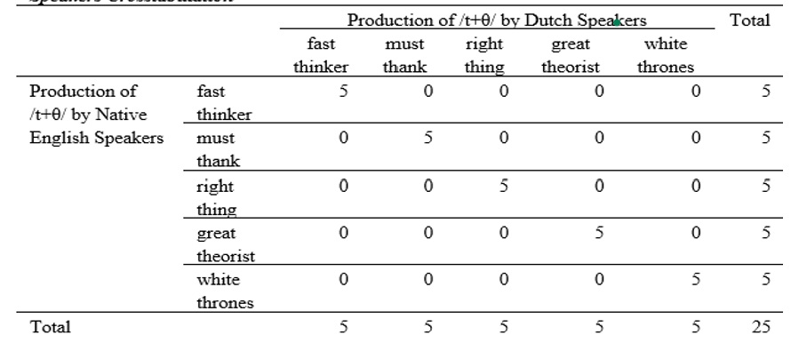
Table 3: Chi-Square Test on production of /t+θ/ by Native and Dutch English Speakers crosstabulation
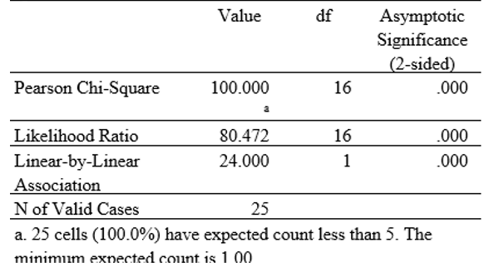
Table 3 revealed the chi-square result of the calculated value greater than the critical table value at p > 0.05, at df = 16, with a minimum expected count of 1.00 at Pearson Chi-Square of 100.000 Since p-value .000 < 0.05, the result was therefore significant at alpha level of .05. From table 3, it was observed that there was no statistically significant difference between the production of /t+θ/ obtained from Native English Speakers and the production of /t+θ/ obtained from Dutch Speakers as the results were similar (no variation). The chi-square revealed the respondents’ position of significant difference.
In Table 1 above, it is observed that the native speaker’s data, which is tagged Model, the first two phrases, fast thinker and must thank, were rendered as [fӕstɪŋkə], and [mʌstæŋk]. This reflects that the dental fricative, /θ/ was rendered as /t/ in this situation (Oyebola, Ho, & Li, 2019). This is consistent with the generative phonological concept of dissimilation, which holds that adjacent sounds avoid taking on the same features to enhance differences that can make the sounds more auditorily distinct (Agboyinu, 2018; Aldrete, 2003; Katamba, 1996). Thus, the frication existing between /s/ and /θ/, which are fused due to the deletion of the medial /t/, licensed the substitution of the dental fricative with alveolar fortis, /t/ (Wilson, 2001). In the same vein, the performance of the Dutch English speakers, as displayed in Table 2 above, showed that the participants observed /t/ deletion before the dental fricative and also performed the dissimilation process by substituting /θ/ with /t/ because of the absence of voiceless dental fricative in Dutch consonant chart. Generally speaking, for the five phrases containing /t/ before voiceless dental fricative sounds, the native English speakers deleted all the pre-dental alveolar fortis, /t/; this was likewise observed in the rendition of all the phrases by the Dutch English speakers. Thus, the notion of dentalisation of predental /t/ is negated by the rendition of the phrases by the English native and the Dutch English.
Table 4: Production of /t+ð/ by Dutch English Speakers
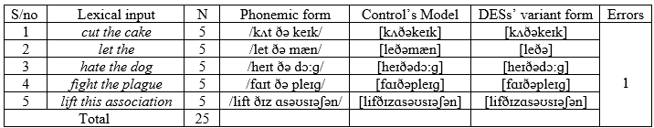
Table 5: Production of /t+ð/ by Native English and Dutch English Speakers crosstabulation
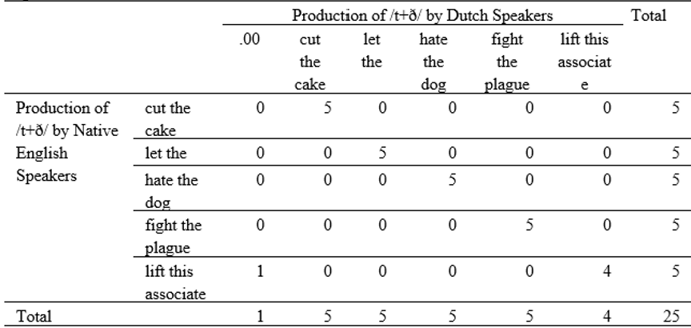

Table 6: Chi-Square Test on production of /t+ð/ by Native English and Dutch English Speakers crosstabulation
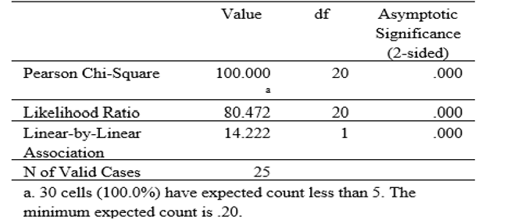
Table 6 revealed the chi-square result of calculated value greater than the critical table value at P < 0.05, at df = 20, with minimum expected count of 0.20 at Pearson Chi-Square of 100.000 Since P-value .000 < 0.05, the results is therefore significant at alpha level of .05. from table 6 it was observed that there was no statistically significant difference between the production of /t+ð/ by Native English Speakers and production of /t+ð/ by Dutch English Speakers, as the results were almost similar (only one error - variation), ‘.00’ from Table 5 justifies the number of errors(variations) committed by the Dutch English speakers in the Production of /t+ð/. The chi-square revealed the respondents’ position of significant difference. In the phrases involving clusters of /t+ð/ as displayed in the Table above 4, the Control’s Models show that pre-dental /t/ was deleted by both native speaker and the Dutch participants. Only one out of the five Dutch speakers however mispronounced the phrase, fight the, by articulating the pre-dental /t/ alongside the dental sound. This resulted in only 1 error, while in the rest 24 instances the coronal fortis /t/ was deleted. This implies that the notion of assimilation of predental /t/ into dental place does not hold true for the Dutch English Speakers, as they all elided the sound before the voiced dental fricative, as similarly observed in the native speaker’s speech (Control Model).
Table 7: Production of /t+θ/ by Ghanaian English Speakers
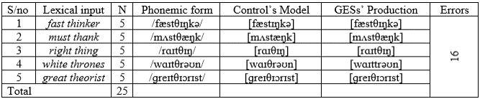
Table 8: Production of /t+θ/ by Native English and Ghanaian English Speakers crosstabulation
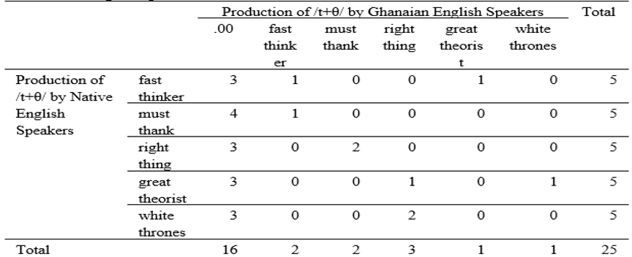

Table 9: Chi-Square Test on the production of /t+θ/ by Native English and Ghanaian English Speakers crosstabulation

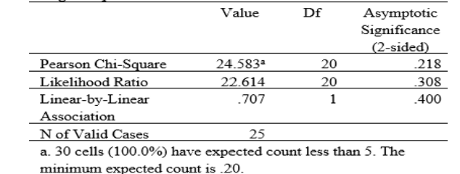
Table 9 revealed the chi-square result of the calculated value less than the critical table value at p > 0.05, at df = 20, with a minimum expected count of .20 at Pearson Chi-Square of 24.583 Since P-value .218 > 0.05, the result is therefore not significant as the significant level is greater than .05. results in Table 9 revealed a statistically significant difference between the Production of /t+θ/ obtained from Native English Speakers and articulation of /t+θ/ obtained from Ghanaian speakers as the number of errors were sixteen. ‘.00’ in Table 4.8 justifies the number of errors committed by the Ghanaians in the Production of /t+θ/. The chi-square revealed the respondents’ position of significant difference.
Table 7 above showed the production of the phrases by Ghanian English speakers. It was discovered that, of the 25 instances produced by the 5 participants, the predental /t/ was pedantically articulated along with the dental sound 16 times. This is revealed by the sharp contrast observed between their phonetic components with those of the Control Model in Table 7. While some of them produced the /t/ in quick succession with /θ/, some of them repeated the occlusion for /t/ in quick succession, /t+t/ which is a manifestation of /t/ substitution for /θ/. This suggests that the Ghanaian English speakers are more concerned with the perceptibility of the predental /t/ irrespective of its tongue twisting influence on their articulatory effort.
Table 10: Production of /t+ð/ by Ghanaian English Speakers
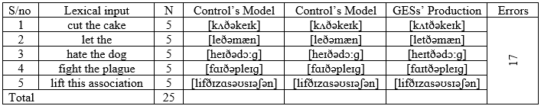
Table 11: Production of /t+ð/ by Native English and Ghanaian English Speakers crosstabulation
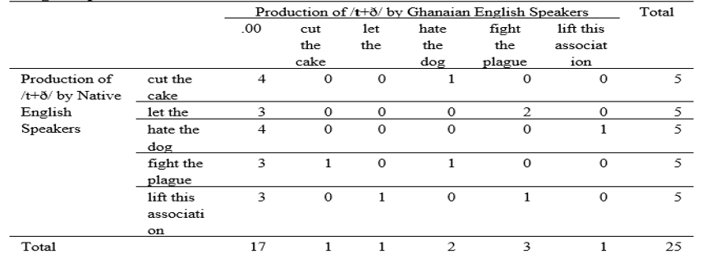
Table 12: Chi-Square Test on production of /t+ð/ by Native English and Ghanaian English Speakers crosstabulation
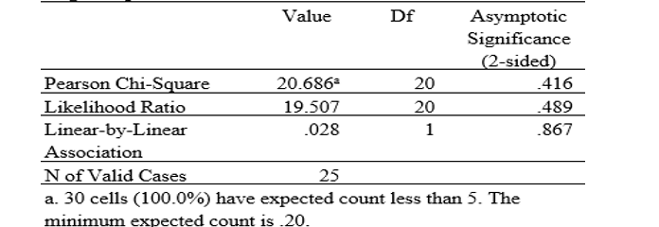
Table 12 revealed the chi-square result of calculated value less than the critical table value at p-value is greater than .05, at df = 20, with a minimum expected count of .20 at Pearson Chi-Square of 20.686. Since p-value .416 > 0.05, the result is therefore insignificant as the significant level is greater than .05. results from Table 12 revealed a statistically significant difference between the Production of /t+ð/ by Native English Speakers and the production of /t+ð/ by Ghanaian English Speakers as the number of errors was seventeen (17). ‘.00’ from Table 4.11 justifies the number of errors committed by the Ghanaians in the Production of /t+ð/. The chi-square revealed the respondents’ position of significant difference.
Table 10 above shows that the Ghanaian English speakers pedantically produced the pre-dental /t/ along with the voiced dental fricative, /ð/ in similar order with their production of the sound in Table 3 above. Of the 25 pre-dental /t/instances in the text read by 5 participants, there were 17 incidents of meticulous pronunciation of [t+ð]. This confirms that while the native speaker’s model clearly indicate deletion of the sound /t/ in pre-dental position, the Ghanaian speakers of English struggle to ensure that the two sounds are produced.
Table 13: Production of /t+θ/ by Nigerian English speakers
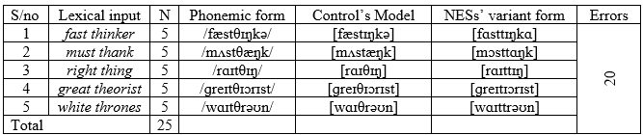

Table 14: Production of /t+θ/ by Native English and Nigerian English Speakers crosstabulation

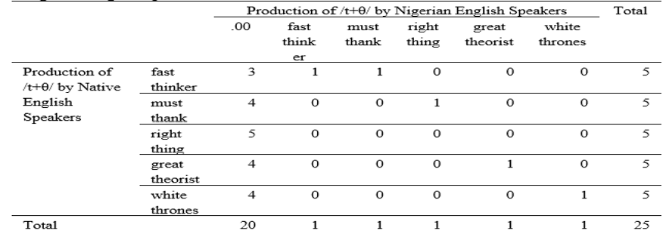

Table 15: Chi-Square Test on production of /t+θ/ by Native English and Nigerian English Speakers crosstabulation
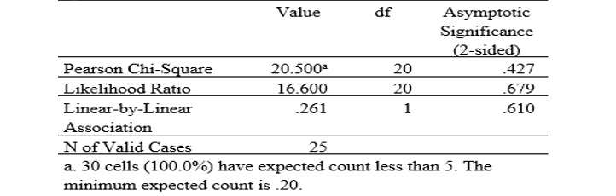
Table 15 revealed the chi-square result of calculated value less than the critical table value at P > 0.05, at df = 20, with minimum expected count of .20 at Pearson Chi-Square of 20.500 Since P-value .427 > 0.05, the result is therefore not significant as significant level is greater than .05. results from Table 4.15 revealed a statistically significant difference between the production of /t+θ/ obtained from Native English Speakers and Production of /t+θ/ obtained from Nigerian Speakers as the number of errors were twenty (20). ‘.00’ from Table 4.14 justifies the number of errors committed by the Ghanaians in the Production of /t+θ/. The chi-square revealed the respondents’ position of significant difference.
Meanwhile, in Table 13 above, it is observed that the Nigerian English speakers produced the pre-dental /t/ along with the voiced dental fricative, /ð/ 20 times in similar order with their Ghanaian counterparts. The Nigerian English speakers’ production of the two phrases fast thinker and must thank was observed to be fraught with repetition of /t/ in the cluster. Thus, demonstrating crucial manifestation of articulatory struggle. Their failure to delete /t/, as observed in the forms rendered by the Control in the Table added to the struggle in cost them to achieve the double occlusion of /t/ in their speeches.
Table 16 Production of /t+ð/ by Nigerian English speakers
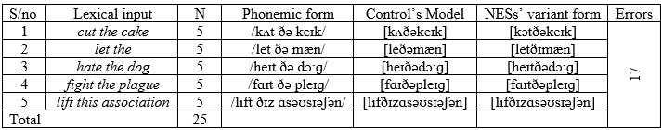
Table 17: Production of /t+ð/ by Native English and Nigerian English Speakers crosstabulation
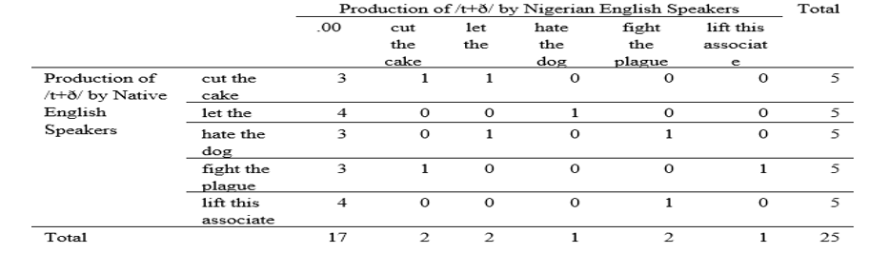
Table 18: Chi-Square Test on production of /t+ð/ by Native English and Nigerian English Speakers crosstabulation
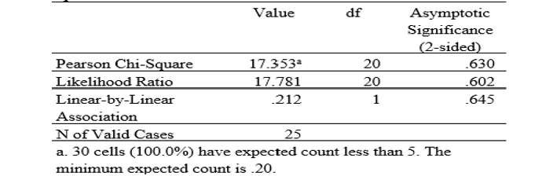
Table 18 revealed the chi-square result of calculated value less than the critical table value at p> 0.05, at df = 20, with minimum expected count of .20 at Pearson Chi-Square of 17.353 Since p-value .630 > 0.05, the result is therefore not significant as significant level is greater than .05. results from table 18 revealed that there was a statistically significant difference between the Production of /t+ð/ by Native English Speakers and Production of /t+ð/ by Nigerian English Speakers as the number of errors were seventeen (17). ‘.00’ in Table 17 justifies the number of errors committed by the Nigerians in the production of /t+ð/. The chi-square revealed the respondents’ position of significant difference.
In Table 16 it is observed that the rendition of the phrases tested by the Nigerian English speakers was marked with meticulous occlusion of /t/ in clusters with /ð/ in 17 instances. This means they were able to delete the pre-dental /t/ in only 8 instances. Their struggle to articulate the pair of the two coronal sounds, /t+ð/, can be described as the usual pedantic linguistic behaviour of Nigerian English speakers.
4.2 Acoustic Analyses
To demonstrate the acoustic distinctions between the native speaker’s pronunciation of phrases containing pre-dental /t/ and that of the non-native speakers, selected extractions of their productions were subjected for acoustic analyses, using Praat (Boersma & Weenink, 2014). Only the amplitudes were focused upon to establish acoustic evidence of the presence or absence of /t/ in the syntactic position preceding the dental sounds in extractions of four phrases which include fast thinker, right thing, cut the cake and let the man speak. The acoustic values of the productions of the selected phrases uttered by the three groups (non-native speakers) were checked against the extractions from the native speaker to confirm the veracity or otherwise of dentalisation hypothesis.
4.2.1 Acoustic analyses of fast thinker
The phrase, fast thinker, as rendered by the native speaker and the three groups of non-native speakers are vertically arranged in Figure 4.1-4.4 below to show the differences in their acoustic properties, especially at the amplitude level.

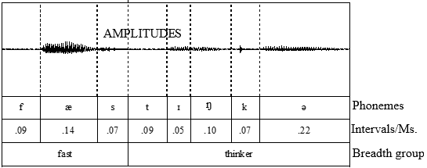
Figure 2: native speaker production of “fast thinker”

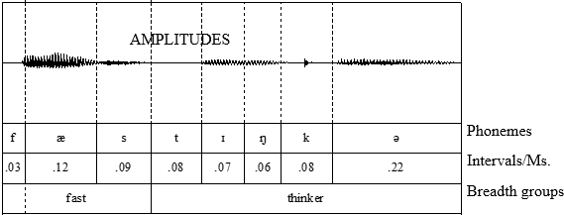
Figure 3: Dutch English speaker’s production of fast thinker

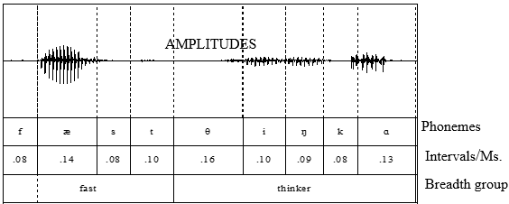
Figure 4 Ghanaian English speaker’s production of fast thinker

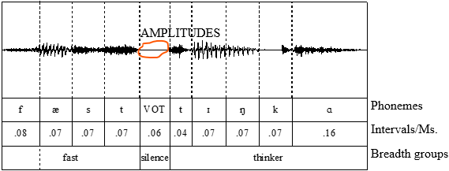
Figure 5 Nigerian English speaker’s production of fast thinker
The acoustic analysis displayed in the Figures 2-5 (above) divulged obvious symmetries between the production of fast thinker by the native speaker and the Dutch speakers of English in Figures 4.1 and 4.2. Both group elided the predental /t/ and also substituted the dental segment with /t/ as a result of the contiguity warranted by the disappearance of the intervening segment between /s/ and /θ/ which created environment for fricative dissimilation. On the contrary, the acoustic display extracted from the speeches of the Ghanaian and Nigerian English speakers showed that the two groups preserved the two segments, /t/ and /θ/ in contiguous relations. While the Ghanaian produced the two contiguous sounds, /t+θ/, distinctly, the Nigerian English speaker substituted /t/ for the dental sound (Oyebola, Ho, & Li, 2019), thus repeating /t/ in quick succession. This is evident in the amplitude region of the Figure above which shows the occurrence of the first /t/ followed by silence indicating a silence prompted by VOT before the acoustic release of the second /t/ at the initial position of the word, thing.
4.2.2 Acoustic Analyses of right thing
The phrase, right thing, as rendered by the native speaker and the three groups of non-native speakers are vertically arranged in Figure 6-9 below to show the differences in their acoustic properties, especially at the amplitude level.
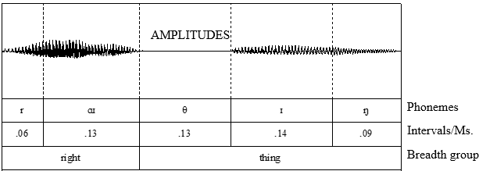
Figure 6: Native English speaker production of right thing,

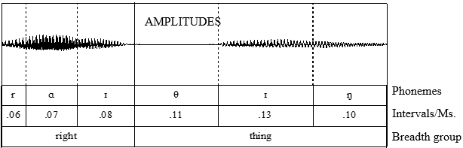
Figure 7: Dutch English speaker’s production of right thing

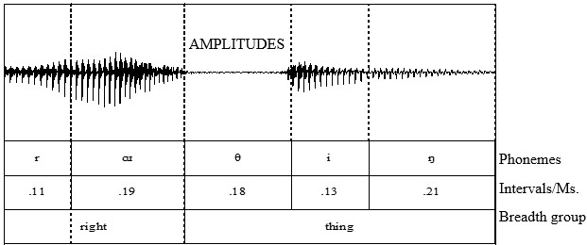
Figure 8 Ghanaian English speaker’s production of right thing

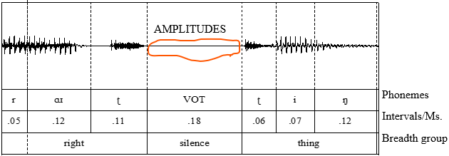
Figure 9: Nigerian English speaker’s production of right thing

4.2.3 Acoustic analyses of let the man speak.
The spectrograph representation of the unit let the man speak rendered by the participants, i.e., Native English speaker, Dutch English speaker, Ghanaian English speaker and Nigerian English speaker are presented below with specific focus on the amplitude values of each display to highlight the differences observed in the phonetic manifestation in the portion syntactically occupied by the predental /t/ in the lexical unput. The native speaker forms the baseline for other speakers (Fig. 10 – 13)
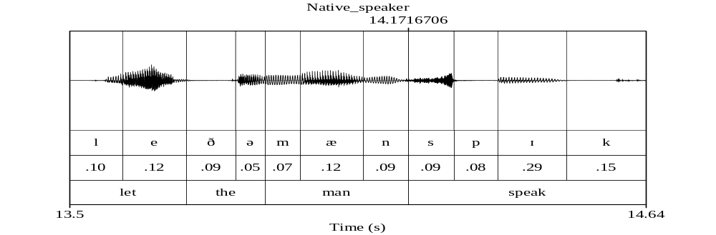
Figure 10: Native speaker’s production of let the man speak

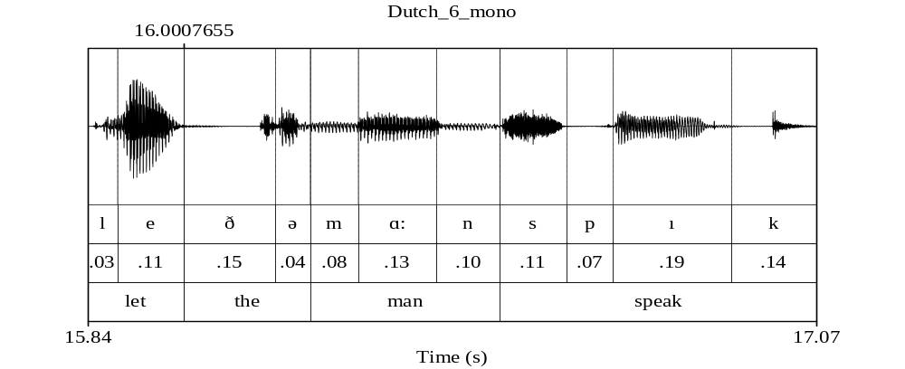
Figure 11: Dutch speaker’s production of let the man speak

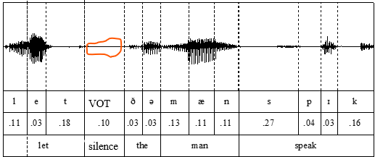
Figure 12: Ghanaian speaker’s production of let the man speak

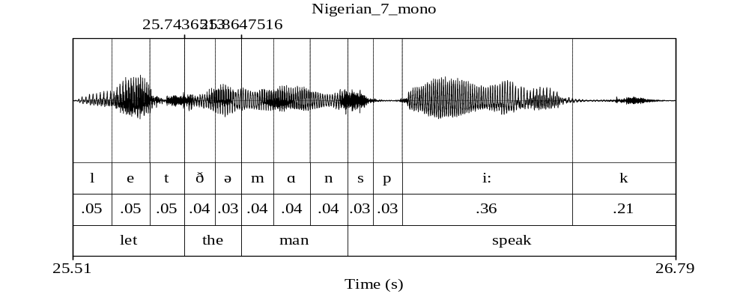
Figure 13: Nigerian English speaker’s production of let the man speak

5.1 Summary of findings
Based on the analyses presented above, it is established that the native speaker’s production of the phrases tested consist of deletion of pre-dental /t/ in all the incidents. This was also observed in the productions of the Dutch English speakers. However, in the production of Ghanaian and Nigerian English speakers, the predental /t/ was meticulously pronounced in most of the instance except few. This implies that the linguistic behaviour of ‘bookish’ pronunciation earlier reported by scholars about Nigerian English speakers are preponderantly responsible for the performances of the Nigerian English speakers and their Ghanaian counterparts in this study.
The current study contrasts with Gasser, 2020 and Williamson, 2015 who emphasize dentalisation as an assimilatory process in the alveolar and dental fricative context. This study shows that non-native English speakers either delete or produce alveolar before the dental fricative or alveolarized the dental fricative while native deletes it. Furthermore, the production of /t+θ,ð/ at the final and initial boundary of words does not in any way describe or support dentalization, rather deletion of voiceless alveolar that precedes dental fricative (Febriyanti, 2015). The preference for alveolar over dental may have been triggered by language preference or articulatory factors. For example, Ghana English speakers prefer to substitute voiced fricative with alveolar and retain the default alveolar.
The study has described that the phonological rule of dentalisation may be evident in single word context, especially among the native as identified by Williamson (2015) but the current study argues that our findings do not align with dentalisation tag, rather there is a deletion or substitution of a sound for another. This further shows that the theory of phonological rule for dentalisation cannot be universal, otherwise, the participants for the study will misapply the concept of dentalisation.
Our findings further argue that the production of eight [eit̪θ], width [wɪd̪θ], tenth [t^{h}n̪θ] and health [hel̪θ] for dentalised alveolar, nasal and approximants can only be obtained in a single clear word context with slow speech tempo. The study has established such a rare production among non-native English speakers in phrase/sentence contexts. Also, L2 English speakers without dental sounds delete or substitute dental for similar sounds (Christine & Adrian, 2019). The findings of Christine and Adrian are similar to the current study on the production of dental in Dutch English. Their study asserts that Dutch English speakers often substitute voiced dental fricative with [d], [f] and [s] (Aoki, 2011). Our study and Christine & Adrian, 2019 contrast Grasser 2020 & Williamson 2015. Therefore, generalising dentalisation in native and non-native, clear and spontaneous speech, single word, and phrasal context requires a re-analysis.

5.2 Conclusion
Granted that the concept of dentalisation of pre-dental /t/ was evident in the English language, the evidence produced by the native speaker in the texts used in this study shows that /t/ is not produced in a cluster with the dental sounds. Rather it was elided in all instances of their clusters. This behaviour of deletion was also evidenced in the rendition of the same texts by Dutch English speakers. This showed that the pedantic articulation of these forms observed in the productions of Nigerian English speakers and their Ghanaian counterparts is not to be regarded as an instance of dentalisation but their usual meticulous pronunciation. It is also interesting to note that the native speakers and Dutch English speakers observed dissimilation in the phrases, fast thinker and must thank. This occurred probably because of the deletion of /t/, which brought /s/ closer to the dental fricative, /θ/, as a result of which an environment was created to apply the dissimilation rule to make a distinction between two voiceless fricative sounds. This instance also deserves discussion in teaching and learning English in a second language environment like Nigeria to moderate the generalisation of rules relating to phonemic differentiation in non-native settings. The hypothesis shows that dentalisation does not occur in [t] environment, especially in phrasal/sentence context; rather, deletion occurs both among speakers of English as a first and second language. The future direction could examine dentalisation in word isolation in Englishes to hypothesise if dentalisation only occurs in the native or non-native English context as well. Similarly, the speech tempo could be explored. This will enhance understanding of dentalisation in Englishes.

5.3 Recommendation
The underlying motivation of this work is to establish the prototypical phonological situation about /t/ dentalisation notion to provide an avenue for disambiguating the realities around the cluster of /t/ and the dental sounds. The results gathered in this study have confirmed that the native speakers, as well as non-native Dutch English speakers, whose language originated from the same proto-language family as English, do delete the coronal fortis before dental sounds rather than execute the assimilation process in such an environment. In light of this, it is relevant to recommend that the deletion of /t/ when it occurs in clusters (of phrases/sentences, especially) with the dental sound should be taught to students at all levels of education. The tenets of dentalisation may be applied to sounds like /n/ and any other valid ones (Williamson, 2015), but its application to /t/ should be avoided, as repeated gestural execution at these closely located coronal points would complicate gestural manoeuvres, hence, it is usually resolved by the native speakers through deletion.

References
Agboyinu, A. M. (2018). Application of Standard British English phonological rules among
senior secondary school teachers of English language in Ogun state, Nigeria. (Ph.D. thesis. University of Ibadan).
Anderson, S. R. (1975). On the interaction of phonological rules of various types. Journal of Linguistics, 11(1), 39-62.
Anttila, A. (2002). Variation and phonological theory. The handbook of language variation and change, 206-243.
Aoki, R. (2011). Influential Factors on the production of English/θ/by Japanese Learners of English. Poznań Studies in Contemporary Linguistics, 47(1), 15.
Awonusi, V.O. (2004). The English language in global context. Nigerian English: influences and characteristics. A.B.K. Dadzie and S. Awonusi Eds. Lagos. Concept Publications.
Awonusi, S., Ademola-Adeoye, F. and Adedeji, K. (2015). Essentials of English phonetics and
phonology. Lagos: Concept Publications.

Birjandi, P., & Salmani-Nodoushan, M. A. (2005). An introduction to phonetics. ERIC Clearinghouse, Iran: Zabankadeh Publications.
Boersma, P, and Weenink, D. 2017. Praat: Doing Phonetics by Computer (Version 5.3.35) [Computer Software]. Retrieved on from http://www.praat.org
Browman, C. P., & Goldstein, L. (1989). Articulatory gestures as phonological units. Phonology, 6(2), 201-251.
Browman, C. P., & Goldstein, L. M. (1986). Towards an articulatory phonology. Phonology, 3, 219-252.
Bybee, J. 2003. Phonology and language use. Cambridge. Cambridge University Press.
Chomsky, N. and Halley, M. (1968). The sound pattern of English. London. Harper and Row, Publishers.
Chomsky, N. (1980). Rules and representations. Behavioral and brain sciences, 3(1), 1-15.
Christine G; Leemann, Adrian (2019). Between-speaker variation in English Learners' Realisation of Dental Fricatives. In: 19th International Congress of Phonetic Sciences, Melbourne, Australia, 5 August 2019 - 9 August 2019. Australasian Speech Science and Technology Association Inc, 974-978.
Dziubalska-Kolaczyk, K. (2001). Phonotactic constraints are preferences. Trends in Linguistics Studies and Monographs, 134, 69-100.
Febriyanti, D. N. (2015). Assimilation, reduction and elision reflected in the selected song lyrics of Avenged Sevenfold. Journal of Language and Literature, 15(1), 14-19.

Fromkin, Rodman and Hyams, (2011). An introduction to language. Wadsworth: Cencage Learning.
Gasser, E. (2020). Borrowed Color and Flora/Fauna Terminology in Northwest New Guinea. Journal of Language Contact, 12(3), 609-659.
Giegerich, A. C. (1992). English phonology: an introduction. Cambridge: Cambridge University press.
Gunawan, C. (2018). Mahir Menguasai SPSS (Mudah Mengolah Data Dengan IBM SPSS Statistic 25). Deepublish.
Guy, Gregory R. (1980). Variation in the group and the individual: The case of final stop deletion. In William Labov (ed.), Locating language in time and space. New York: Academic Press, 1-36.
Katamba, F. (1996). An introduction to phonology. (8th impression) London: Longman.
Ladefoged, P. (1972). Phonological features and their phonetic correlates. Journal of the International Phonetic Association, 2(1), 2-12.
Myers, P. D. (2020). A Grammar of Transcriptions in 2 Esdras: Text, Philology, Phonology (Doctoral dissertation, University of Cambridge).
Oyebola, F., Ho, S. Y. B., & Li, Z. (2019). "A sociophonetician study on TH variation in Educated Nigerian English." (“Zeyu Li - Nankai University”) In Proceedings of the 19th International Congress of Phonetics Sciences, Melbourne, Australia (pp. 2320-2323).
Pavlík, R. (2009). A Typology of Assimilations. SKASE Journal of theoretical linguistics, 6(1).
Pierrehumbert, J. (1990). Phonological and phonetic representation. Journal of phonetics, 18(3), 375-394.
Schane, S. A. (1973). The formalization of exceptions in phonology. In M. Groos, M. Halle and M.P. Schutzenberger (Eds), The Formal Analysis of Natural Languages. Moutous, Paris.
Raymond, Dautricourt, and Hume, (2006). Word-internal /t, d/ deletion in spontaneous speech:
Modelling the effects of extra-linguistic, lexical, and phonological factors. Language Variation and Change, U.S.A. Cambridge University Press retrieved Sept. 12, 2018 from http://buckeyecorpus.osu.edu/pubs/raymondetal2006.
Tamminga, M., Wilder, R., Lai, W., & Wade, L. (2020). Perceptual learning, talker specificity, and sound change. Papers in Historical Phonology, 5, 90-122.
Temple, R. A. M. (2003) What is “-t,d deletion”? A new look at an old sociolinguistic variable
retrieved Sept. 12, 2018 from https://www.internationalphoneticassociation.org/icphs proceedings/ICPhS2003/papers/p15_1835.pdf

Williamson, G. (2015) Dentalization of plosives. FacebookTwitterPinterest Blog publication.
Retrieved from https://www.sltinfo.com/allo101-dentalization/
Wilson, C. (2001). Consonant cluster neutralisation and targeted constraints. Phonology, 18(1), 147-197.
Appendix
- My English teacher is a fast thinker.
- We must thank our boss for granting us the request.
- That is the right thing to do in this circumstance.
- My daughter will cut the cake.
- Let the man speak.
- No one cat hate the dog for barking.
- Fight the plague before it spreads over the town.
- The African monarchs love sitting on white thrones.
- Let us lift this association to a laudable height.
- My English teacher is a great theorist.

