A MINIMALIST ANALYSIS OF CONSTITUENT QUESTION FORMS IN YORÙBÁ

Abstract

Constituent interrogatives are employed to request for more than yes/no answers from interlocutors. Extant works on constituent interrogatives in Yorùbá are yet to pay adequate attention to the syntactic behaviour of question nouns (QNs), question verbs (QVs) and interrogative qualifiers in the language. Therefore, this paper investigated the syntax of constituent interrogatives in Yorùbá with a view to providing plausible evidence showing QNs, QVs and interrogative qualifiers as constituent interrogative markers in the language. Primary and secondary data were collected and subjected to syntactic analysis within the confines of Minimalist Program (MP). Yorùbá uses the following to form its constituent interrogatives: QVs (dà, ńkọ́), QNs (ta, kí, èwo, mélòó, èló, ìkelòó) and interrogative qualifiers (wo, kelòó). A QN is copied to the clause left peripheral position in a content-word question unlike an echoed question. Wo as the interrogative qualifier, that is the question marker (QM) in ìgbà wo “when” ibo (ibi è(wo) “where”, báwo (bá wo) “how” has its [+Q], the question feature percolated through the entire DPs, that is the question phrases (QPs). A QN does more than satisfying focus requirement in the language while the QVs (dà and ńkọ́ perform predicate function. A QN qualifies a preceding noun just like a nominal qualifier does in an affirmative sentence in the language.

Keywords: Question nouns, Question verbs, Question feature, Interrogative qualifiers,
Feature percolation, Yorùbá

1. Introduction

Question formation is a universal phenomenon. Interrogatives are used to elicit information from interlocutors. Question types are classified into two based on the types of response triggered from interlocutors. König and Siemund (2007: 291) and Issah (2013: 4) opine that interrogatives across word languages can be classified into constituent and polar interrogatives based on their syntactic and semantic properties. According to Saito (1992), wh-feature exists in all languages and is consequently responsible for the attraction of interrogative constituents to the clause left periphery for feature checking purpose. Ouhalla (1996) opines that wh-questions in natural languages differ with respect to their morphological and semantic properties while Siemund (2001), according to the positions of occurrence of interrogative words in content word questions, classifies human languages into fronting, in-situ and optionally fronting languages. It is discovered that Yoruba preposes its QNs to the clause left periphery, Also, QNs can be base-generated in the canonical positions associated with their grammatical functions, where they are legible to the PF level, especially when rhetorical/echoed questions are operated. Bocc, Blanchi. and Cruschina (2021) claim that a wh-phrase is inherently endowed with [+focus] feature as one of the bundles of features specified on every wh-phrase in a direct constituent question. They are of the view that focus feature is assigned to a wh-phrase in its first merge, that is, its base-generated position. Contrary to Ouhalla’s position above, it is discovered that some latest scholarly works have taken a radical departure from the traditional position on the semantic status of question nouns (QNs) in Yorùbá. Therefore, discussing detailed semantic properties and syntactic behaviour of the markers involved in the three method of forming constituent interrogatives in the language (question nouns, question verbs and interrogative qualifiers) is necessitated. The paper comprises five sections. Section one focuses on the introduction. Section two discusses the literature review which forms the main rationale behind this paper, particularly, the recent positions that are consered for a rethink. Section three discusses the methodology adopted for this paper. Section four discusses how constituent interrogatives are formed in Yorùbá within the confines of the Minimalist Program (MP) while conclusions are drawn in section five.

2. Literature Review On Interrogatives in Yorùbá

Awóbùlúyì (1978) classifies question forms in Yorùbá into two: content word and non-content word (yes/no) questions. The following three ways of marking constituent interrogatives are identified in Yorùbá: interrogative nouns, interrogative verbs and interrogative qualifiers (Awobùlúyì, 1978; Bámgbóṣé, 1990).

2.1 Comments on QVs in Yorùbá

Àkànbí (2011:8) also identifies dà and ńkọ́ as verbs performing dual roles in Yorùbá sentences: predicate and question marking functions. This view is in line with Munro’s (2012) assumption that ‘an interrogative verb is embedded with wh-feature, and used in a wh-question (Awóbùlúyì, 1978; Bángbóṣé, 1990; Táíwò and Abímbọ́lá, 2014 and Ọláńrewájú, 2022 among many others). Àkànbí (2011) also claims that dà and ńkọ́ exhibit some dissimilarities with respect to their semantics, also, they are not mutually exclusive as shown in the examples below:

(1) a. Ìgbà wo ló dà?
Time QM FOC-it become
‘When will it be/When next?’

b. *Ìgbà wo ló ńkọ́?
Time QM FOC-it QV (Àkànbí, 2011: 8)

Àkànbi’s opinion on 1a and b above needs a rethink based on the following two reasons:

i. The ontological specification of dà in the examples (1a) above is defective. The item (dà) is wrongly identified as a QV. Dà “become” in 1a does not have [+Q] feature. For a clearer understanding, let us consider the examples below:

(2) a. Ó di ọ̀la.
It become tomorrow
‘Till tomorrow/We shall see/met tomorrow.’

b. O di ìgbà wo?
It become time QM
‘Till when?/Whe shall we see/met?’

c. Ìgbà wo ni ó dì/dà?
Time QM FOC it become
‘Till when?/When shall we see/met?’

Dà/Dì in above examples are ontologically different from dà/ńkọ́ (specified [+Q] feature), a QV in Yorùbá.

ii. Akànbí’s position regarding 1 above also fails to consider that QVs in Yorùbá have high restriction with respect to their distribution (Awóbùlúyì, 2013; Abímbọ́lá and Táíwò, 2014; Ọláńrewájú, 2017), therefore, the language disallows collocation of two question markers in an interrogative clause as depicted in the examples below:

(3) a. *Ibo dà/ ńkọ́?
Where QV

b. *Èwo dà/ńkọ́?
Where QV

c. Ẹ̀yin dà/ńkọ́?
You QV
‘Where are you?’

The implication borne out of the comments above is that Akànbí 2011 wrongly identifies dà (dì) “become/change or turn to” as a QV in Yorùbá.

Awóbùlúyì (2013) disregards dà and ńkọ́ as question verbs in Yorùbá and refers to them as (interrogative) qualifiers. His arguments are based on distributional restriction placed on these items. He classified dà, and ńkọ́ alongside kọ́, ni, kẹ̀ and wẹ̀ as shown (in 4) below:

4 a. Ìwọ ni (You are)
b. Ìwọ kọ́ (You are not ...)
c. Ìwo dà (Where are you?)
d. Ìwọ ńkọ́ (What of you)
e. Ìwọ kẹ̀ (You!)
f. Ìwọ wẹ̀ (You!) (Awóbùlúyì, 2013:72)

Now, a cursory look at 5 below evidently reveals that Awóbùlúyi (2013) does not adequately account for the categorial status of each of the items. The question begging for an explanatory adequacy is ‘what are the italicised items qualifying in 5a and b below?’

(5) a. Òjò tún ń rọ̀ kẹ́/wẹ̀.
Òjò still are fall PSM
‘The rain is still falling.’

b. Òjò tún ń rọ̀ ni (.....).
Òjò still are fall FOC
‘The rain is still falling …’

The example (in 5b) above is identified as an elliptical (sluiced) form of a focus construction (Owólabí, 1983, 1987, 1989). Therefore, for a more plausible grammar, all environments where all these items occur must be surveyed and discussed before we can determine their grammatical functions or categorial status. It is discovered that only examples in 4c-d are predicate clauses.

The same items are also identified as preverbal modifiers (Awóbùlúyì, 2013: 72-73). Let us consider the examples below:

(6) a. Iwọ tiẹ̀ dà?
You PRM QV
‘Where are you again?’

b. Iwọ tiẹ̀ kọ́ ni.
You PRM NEG FOC
‘You are ...’ (Awóbùlúyì, 2013: 73)

It is discovered that the examples above are not plausible enough to determine the categorial status of QVs in Yorùbá, or equate their categorial status with kẹ̀, kọ́, ni and wẹ̀ as claimed by the Author. The examples (in 6a and b) above have dissimilar structures. Therefore, dà as the predicate in 60a collocates with pre-modifiers just like some other lexical verbs in the language do in a simple clause (Táíwò and Abímbalá, 2014; Ọláńrewájú, 2020, 2022) while 6b is an elliptical form of a focus construction. Therefore, to adequately capture the syntactic behaviour of Yorùbá QVs and their collocation with pre-modifiers, we need to explore some other technical details on the syntactic or semantic similarities/dissimilarities among the QVs (dà and ńkọ́) and kẹ̀, kọ́, ńkọ́, ni and wẹ̀ (items classified alongside the QVs by Awóbùlúyì (2013). In line with this, let us consider the examples below:

(7) a. Olú tún wá.
Olú still come
‘Olú still came.’

b. Olú tún dà/ńkọ́?
Olú still QV
‘Where is Olú again?’

c. Olú tún ni ó wá.
Olú still FOC he come
‘OLÚ still came.’

d. Olú ni mo tún ri.
Olú FOC I still see
‘I still saw OLÚ.’

e. Olú tún lọ wẹ̀/kẹ̀!
Olú still go PSM
‘Olú went again!’

All the examples above feature pre-modifiers. They are all sentential, and fully represented at the PF interface except 8c which is the elliptical form of 8d. In 8e above, kẹ̀ and wẹ̀ function as post modifiers. Ẹ̀wẹ̀ (Ẹ̀-wẹ̀), a nominalised form of wẹ̀ functions as a (nominal) qualifier (in 9) below:

(9). Ẹ̀yin náà ẹ̀wẹ̀, ẹ kò fẹ́ lọ.
You the also, you not like go
‘You also did not want to go.’

Dà and ńkọ́ unlike kẹ̀ and wẹ̀ co-occur with wá, a premodifier in Yorùbá.

(10) a. Ayọ̀ wá dà/ńkọ́?
Ayọ̀ PRM QV
‘Where is Ayọ̀ now?’

b. Ayọ̀ wá fẹ́ ìyàwó.
Ayọ̀ PRM marry wife
‘Ayọ̀ later got married?’
c. Ayọ̀ wá gbọ́ ọ̀rọ̀ mi.
Ayọ̀ PRM hear word me
‘Ayọ̀ later listened to me.’

d. *Ayọ̀ wá kẹ̀/wẹ̀
Ayọ̀ PRM PSM

The italicised items (in 10a-c) above are verbs. Ni is a focus marker (in 11a) below which is an elliptical version of 11b, where ri “see” functions as the sentence predicate.
(11) a. Olú náà ni ....
Olú the FOC
‘It was also Olú.’

b. Olú náà ni mo ri.
Olú the FOC I see
‘It was alo OLU I saw.’

QVs do not collocate with other regular verbs unlike kẹ̀ and wẹ̀, as shown below:

(12) a. Olú lọ kẹ̀/wẹ̀/*dà/*ńkọ́.
Olú go PSM
Olú still went!’

b. Olú sùn kẹ̀/wẹ̀/*dà/*ńkọ́.
Olú sleep PSM
‘Olú still slept!’

The implication borne out of 12a and b above is that dà and ńkọ́ do not function as pre-modifiers unlike their counterparts (kẹ̀ and wẹ̀). As shown in 12a and b above, the native speakers of the language use kẹ̀ and wẹ̀ to mark surprise in their expressions.

QVs also select prepositional complements similarly to other lexical verbs (Táíwò and Abínbọ́lá, 2014; Ọláńrewájú, 2017, 2020, 2022) as depicted in the examples below:

(13) a. Ọ̀rẹ́ rẹ dà/ńkọ́ nínú wọn?
Friend your QV at-inside them
‘Where is your frieng among them?’

b. Ọ̀rẹ́ rẹ ni mo pè nínú wọn?
Friend your FOC I call at-inside them
‘It was your friend I called among them?’

Suffice to note that 13a and b are structurally dissimilar to 14a and b below. Kẹ̀/Wẹ̀ does not select the prepositional complement in 14a.

(14) a. Ọ̀rẹ́ rẹ kẹ̀/wẹ̀, nínú wọn!
Friend your also at-inside them
‘Your friend also, among them!’

b. Ọ̀rẹ́ rẹ yìí, nínú wọn!
Friend your this at-inside them
‘This your friend, among them!’

2.2 Comments on QNs in Yorùbá

Awóbùlúyì (1978, 2008, 2013), Bámgbóṣé (1990) and Ọláńrewájú (2017) amongst others identify ta “who”, kí “what” èwo “which”, mélòó “how many” and so on in Yorùbá. They are referred to as interrogative nouns in Awóbùlúyì (1978). Ọláògún (2016) and, Ọláògún and Aṣiwáju (2016) take a radical departure from the above position claiming that items like ta, kí and so on in Yorùbá content word questions never mark interrogative. Therefore, in line with Cheng (1991) Nkemnji (1995), Aboh and Pfau (2011), they assert that QNs only satisfy focus requirements, based their principal argument Ọláògún (2016) has the assumption that Yorùbá operates overt or abstract question morpheme to mark content word questions as also evident in some other languages. He claims that, just like some other languages under Kwa, Yorùbá operates an abstract question morpheme, and not a wh-phrase to mark a content word question. According to him, this question morpheme either occurs after subject DP (or at the clause final position) as evident (in 15a) below:

(15) a. Ìwọ a mọ̀?
You INTER know
‘Did you know?’
(Ọláògún, 2016: 14)

b. Ǹjẹ́ ìwọ a mọ̀?
YNQM You PRM know
‘Did you know?’

According to Ọláògún him, overt realisation of a question morpheme a after the subject DP in 15a above is an evidence that Yorùbá also also attest its abstract equivalent. It is however discovered that a is wrongly identified as a question morpheme based on the facts that the same item still co-occurs with other question markers in the language as depicted in 15b and (16) below:

(16) a. Ǹjẹ́/Ṣé ìwọ a gbà á?
YNQM you PRM take it
‘Did you really take it?’

b. Ẹlẹ́rìí rẹ ha dà?
Owner-witness your PRM QV
Where is your witness?

c. Báwo ni ẹ̀yín ha ti ṣe mọ̀?
QN FOC you PRM PERF do know
‘How did you get to know?’

d. Níbo ni ẹ̀yín a ti gbọ́?
QN FOC you PRM PERF hear
‘Where did you hear?’

The wrongly identified question morpheme a collocates with a yes/no question marker (ǹjẹ́/ṣé) in 16a, a QV in 16b and QNs in 16c and d above. A serious question begging for a plausible answer is, considering a as a question morpheme (in 16) above, how many question markers does each of the constructions (in 16) above have, or what exactly mark interrogative in the clauses? Suffice to note that the examples in 16 are not clause-typed as questions by a. Therefore, the item a (ha) is identified as a pre-modifier just like other premodifiers italicised in the examples below:

(17) a. Ǹjẹ́/Ṣé ẹ̀yin tilẹ̀ gbà á?
YNQM you PRM take it
‘Did you really take it?’

b. Ẹlẹ́rìí rẹ tilẹ̀ dà?
Owner-witness your PRM QV
‘Where is your witness?

c. Báwo ni ẹ̀yín yóò ti ṣe mọ̀?
QN FOC you will PERF do know
‘How will you get to know?’

d. Níbo ni ẹ̀yín yóò ti gbọ́?
QN FOC you will PERF hear
‘Where did you hear?’

It is equally important to note that a as a premodifier occurs only in interrogative constructions just like mọ́, a post-modifier is restricted to negative sentences as shown below:

(18) a. Ìyàwó rẹ kò wá mọ́.
Wife your not come PSM
‘Your wife is not coming again.’

b. Ìyàwó rẹ kò wá. .
Wife your not come
‘Your wife did not come.’

c. *Ìyàwó rẹ wá mọ́.
Wife your come PSM

Mọ́ functions as a post-modifier in 18a above while the example 18c is ill-formed.

Ọláògún (2016), and Ọláògún and Aṣiwájú (2016) in line with Nkemnji (1995) and, Aboh & Pfau (2011), opine that focus and clause typing are teased apart; therefore, the question morpheme clause-types while a QN satisfies focus requirements. It is discovered that a QN in Yorùbá does more than satisfying focus requirement (Yusuf, 1990; Oláńrewájú & Táíwò, 2020) as shown in 19a and 20a.

(19) a. Ilé wo ni Adé rà ____?
House QM FOC Adé buy
‘Which house did Adé buy?’

b. Ilé yẹn ni Adé rà ____.
House that FOC Adé buy
‘Adé bought THAT HOUSE.’

In 19a above, the interrogative qualifier wo performs interrogative function not scope marking. The [+Q] feature on wo percolates through the entire phrase (QP), ilé wo (Bámgbóṣé, 1990; Ajíbóyè, 2005; Ọláńrewájú & Táíwò, 2021). The implication borne out of this is that once wo is the question marker in 19a, ta also marks question in 20a below (Ọláńrewájú & Táíwò, 2020, 2021; Ọláńrewájú, 2022) .

(20) a. Iṣẹ́ ta ni Ọlá n ṣe?
Work QN FOC Ọlá PROG do
‘Whose work was Ọlá doing?

b. Isẹ́ Akin ni Ọlá ń ṣe.
Work Akin FOC Ọlá PROG do
‘Olá was doing Akin’s work.

Two or more question makers do not co-occur in a clause in Yorùbá. Therefore, Ọláògún (2016), and Ọláògún and Aṣiwájú (2016) still need to adequately account for why the wrongly identified question morpheme a (and its abstract form) still collocates with YNQMs, QVs, QNs and and interrogative qualifiers in the language. There is also a need to survey the technicalities underlying the formation of constituent interrogatives in Yorùbá to be able to determine the correct distribution of the said item a and its abstract equivalent.

Another plausible evidence revealing that QNs do more than focus marking is shown in the example from ifẹ̀ (a Central Yorùbá dialect) below:

(21) Ka ibi o gbé ọmọ mi sí?
QN place you carry child me to
‘Where did you put my child?’
(Ọláńrewájú, 2022: 76)

The example (in 21) above is phrase-marked as 22 below for more explanatory adequacy.

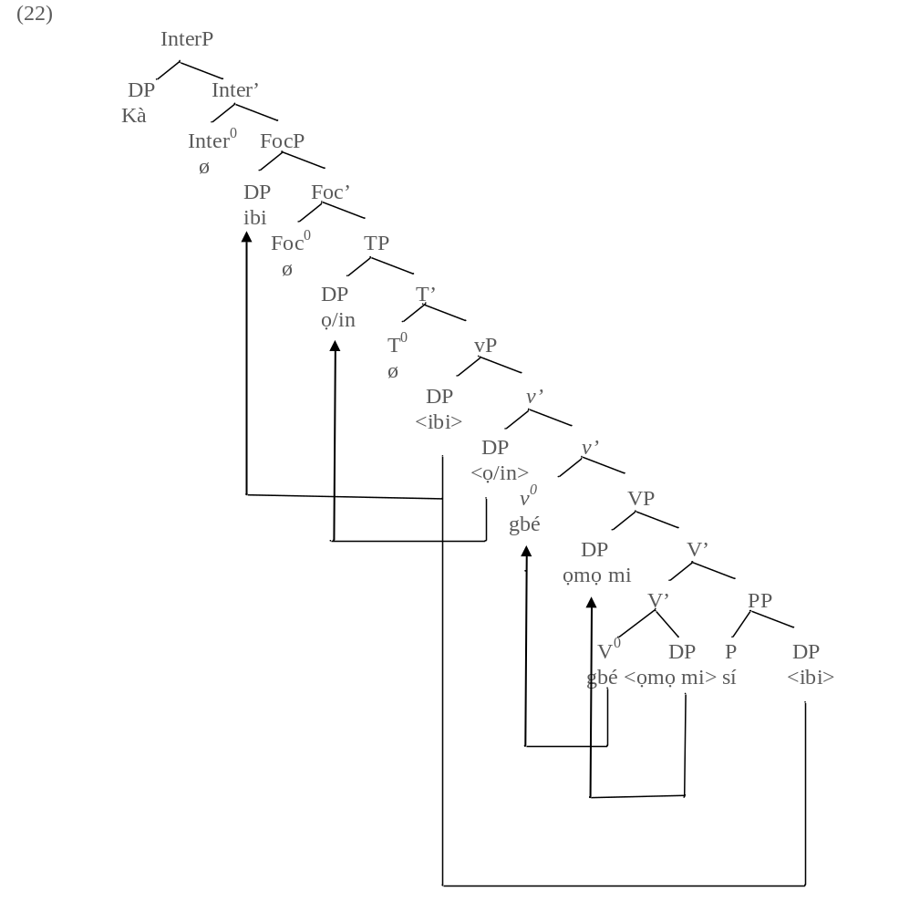
The derivation (in 22) above goes thus: The verb gbé “carry” merges with the DP ọmọ mi “my child” , and consequently projects the lower V-bar. The lower V-bar merges with the PP sí ibi to project the higher the V-bar. The object DP ọmọ mi “my child” is copied to the spec VP by Operation Copy and Delete so as to have its case feature checked through specifier and head agreement. After this, the null performative light verb v⁰ is externally merged with the VP to project the v-bar, while the strong vF feature on the light v⁰ attracts the lexical verb gbé “carry” to adjoin to itself while the subject DP (second person plural subject pronoun) o “you” is selected from the numeration and merged as the inner specifier of the light vP to conform to the Predicate-Internal Subject Hypothesis (PISH). The outer spec vP then becomes the escape hatch for the DP ibi “place” so as to be licensed from Phase Impenetrability Condition (PIC), The abstract non-future marker is merged with the light vP to project the T-bar while the subject DP o “you” is probed to the specifier position of the TP where its [+EPP, case] feature is checked. The derivation proceeds by merging the abstract Foc⁰ to project the Foc-bar. The Foc⁰ as a probe also attracts the DP ibi “place” to the spec FocP to value its [+Focus] feature. The derivation still proceeds by merging the abstract Inter⁰ with the FocP to project the Inter-bar. The QN ka is externally merged at the spec InterP to value the unvalued [+Q, EF] on the Inter⁰ through specifier and head agreement. At this point, the derivation is spelt-out as interrogative. This implies that only the DP ibi “place” and not kà (QN) undergoes focusing in (106) above. Kà is externally merged at the spec InterP in line with Radford’s (2009: 124) proposal in (23) below:

(23) A clause is interpreted as a non echoic question if (and only if) it is a CP with an interrogative specifier i.e a specifier with an interrogative word.

2.3 Comments on Interrogative Qualifer Wo.

Two claims are made by Àkànbí (2016) on how Yorùbá operates wo as an interrogative marker: one, the entire italicised phrases (in 24) below functions as a question marker, and two, wo is derived from èwo by deleting the initial vowel è’. Let us consider his first assertion in the examples below:

(24). Ilé wo ni Olú kọ́?
House QM FOC Olú kọ́?
‘Which house did Olú build?’
(Àkànbí, 2016: 419)

In Àkànbí’s opinion, the entire DP (QP) in 24 is regarded as the question marker. Corroborating this position, he assumes that the entire italicised phrase (in 24) above is undetachable and undergoes pied-piping to the clause left periphery, as evident in the ungrammaticality of 25b below:

(25) a. Ayọ̀ sùn ní igbà wo?
Ayọ̀ sùn at time QP
‘When did Ayọ̀ sleep?’

b. *Wo ni Ayọ̀ sùn ni igbà ____?
QP FOC Ayọ̀ sleep at time

However, if Àkànbí’s assumption above holds water, how do we account for ilé “house” and ìwé “book” as question markers (in 26a-b) below?

(26) a. Ilé kí ni Olú kọ́?
House QM FOC Olú kọ́
‘What type of house did Olú build?’

b. Ìwé mélòó ni wọ́n rà?
Book QM FOC they buy
‘How many books did they buy?’

The QNs (kí and mélòó) in the examples above cannot be detached from their head nouns. The head nouns and their complements form the DP just like we have in 25a-b above. The QNs in 26a-b above also function as qualifiers, just like a noun (nominal qualifier) qualifies its head noun, as shown (in 27) below:

(27) Bàbá Adé lọ sí ilé ìwé.
Father Adé go to house book
‘Adé’s father went to school.’

Adé qualifies bàbá while ìwé qualifies ilé (in 27) above. Therefore, what happens in 24 or 26a-b unlike 27 above is that the question markers ( the interrogative qualifier wo and the QN kí/mélòó) have their interrogative feature percolated through the entire phrases. Q-feature percolation is a feature copying process whereby a constituent that does not possess Q-feature (a non Q-word) inherits Q-feature from its immediately adjacent complement (Ajíbóyè, 2005). Under minimalist assumption, atraction of the entire phrase to the clause left periphery is accounted for by Attract Possible Smallest Maximal Projection (in 28) below:

(28) An interrogative C attracts the smallest possible maximal
projection containing an interrogative word to become its
specifier.
(Radford, 2006: 128)

Now, let us return to Àkànbí’s second assertion, where he claims that wo is derived from èwo after deleting the initial vewel è. On the contrary, èwo is derived by prefixation of è- and wo (è+wo). Both of them are of different categorial status: ewo is a QN while wo is an interrogative qualifier (Ọláńrewájú, 2016; Ọláńrewájú & Táíwò, 2021). They do not occur in free variation as evident in the examples below:

(29) a. [_{FocP} Èwo [_{Foc’}ni [_{TP} ẹ [_{T’} [_{vP}<èwó> [_{v’}<ẹ> [_{v’} rí [_{VP}<èwo> [_{V’}<ri>
[_{DP}<èwo>]]]]]]]]]]?
QN FOC you see.
‘Which one did you see?’

b. *[_{FocP} Wo ni ẹ rí <wo>]?
QM Foc you see

Two things cause 29b to crash unlike 29a: Firstly, in Yorùbá, the spec FocP only hosts a DP, therefore, any lexical item specified [-nominal] never occupies the spec FocP (Ìlọ̀rí, 2010; Ọláńrewájú 2022). This invariably disqualifies wo occupying the left periphery of the clause (in 29b). Secondly, wo unlike èwo does not satisfy the c-selection reuirement of the lexical verb ri “see” as evident in ungrammaticality of 30a below:

(30) a. *Olú ra wo?
Olú buy QM

b. Olú ra èwo?
Olú buy QN
‘Olú bought WHICH ONE?’

3. Methodology

This paper adopted both primary and secondary methods of data collection to source for data. Eight (8) native speakers of the standard dialect (Yorùbá) aged 65 and above were purposively selected for structured oral interview and based on their proficiency. Data were also sourced from relevant texts, articles, journals and so on, both from libraries and the internet. The Phase Theory of Noam Chomsky’s Minimalist Program served as the framework for the syntactic analysis.

4. Minimalist Analysis of Constituent Interrogatives in Yorùbá
Yorùbá operates three methods to form its constituent interrogatives. They are: the use of QVs, QNs and interrogative qualifiers. These three methods are used to request for a response more than a yes/no answer from an interlocutor.

QVs in Yorùbá
QVs are used to ask after the location of a referent or to request for something from an interlocutor. The two QVs in Yorùbá are dà and ńkọ́ (Awóbùlúyì, 1978; Táíwò & Abímbọ́lá, 2014; Ọláńrewájú, 2022). According to Munro’s (2012), a QV is a verb spcified wh-feature. The two QVs in Yorùbá have high restriction on their distribution (Awóbùlúyì, 1978). Let us consider them in the example below:
(31) a. Ìwé mi dà/ńkọ́?
Book me QV
‘Where is my book?
b. Owó rẹ dà/ńkọ́?
Money you QV
‘Where is your money?
Example (31a) is illustrated (in 32) below, for a clearer understanding.
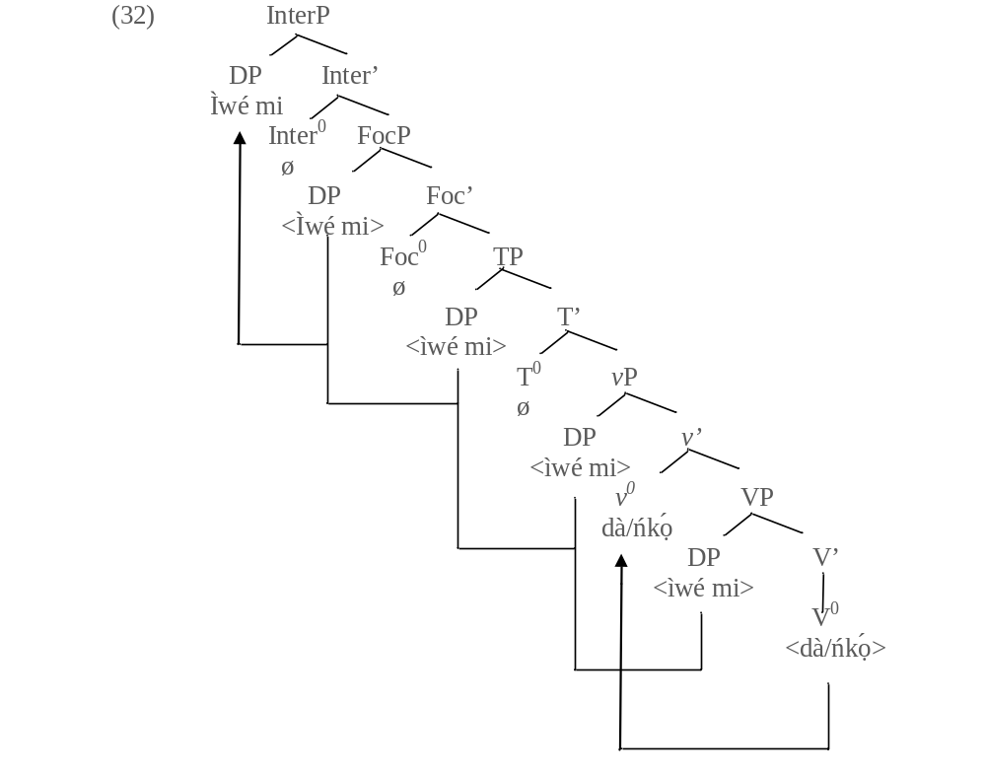
The derivation in 32 goes thus: The DP ìwé mi “my book” externally merges with the QV dà/ńkọ́ to project the VP in line with the PISH. The null performative light verb v⁰ externally merges with the VP to project the v-bar, while the strong vF on the light performative verb v⁰ attracts the QV dà/ńkọ́ to adjoin to itself. The DP ìwé mi is attracted to the spec vP for external argument role. After this, the abstract T⁰ merges with the light vP to project the T-bar. The T⁰ as a probe attracts the DP iwé mi to the spec TP to value its unvalued [+EPP, case] feature. Ìwé mi is therefore valued nominative case. Following question and answer pair of this interrogative type, focus projection is activated. Therefore, the abstract Foc⁰ externally merges with the TP to project the Foc-bar while the Foc⁰ probes the DP iwé mi to the spec FocP to value its [+Focus] feature. The derivation still proceeds by activating the interrrogative projection by merging the abstract Inter⁰ with the FocP to project the Inter-bar. The Inter⁰ as a potential probe attracts the DP iwé mi to the spec InterP to check its [+Q, EF] through specifier and head agreement. In line with the derivation above, Ọláńrewájú (2022: 166) proposes 34 below for Yorùbá and related languages in the place of Radford’s (2009:124) proposal in 23 above repeated as 33 below for ease of reference:
(33) A clause is interpreted as a non echoic question if (and only if) it is a CP with an interrogative specifier i.e a specifier with an interrogative word).
(Radford, 2009:124)

(34) A clause is interpreted as a non echoic question if (and only if) it is an InterP with either an interrogative specifier or a QV.
(Ọláńrewájú, 2022:166)

QNs in Yorùbá
QNs in Yorùbá are ta “who”, kí “what”, èwo “which” , ìkelòó “what number/frequency” mélòó “how many”, èló “how much”. Apart from ta and kí other QNs in Yorùbá have more than a syllable and they are derivational (Ọláńrewájú, 2016). Ibo (ibi + wo) “where”, ìgbà wo, “when” báwó (bá + wo) “how” are all question phrases (QPs). Wo the interrogative item in them has its [+Q] feature percolated through the entire QPs. The same thing is applicable to ẹ̀ẹ̀kelòó (ẹ̀rìn + kelòó) “what number/frequency”, ẹ̀ẹ̀melòó (ẹ̀rìn + mélòó). QNs can be base-generated in the canonical position associated with their grammatical functions in the language especially in rhetorical questions. Also, two QNs can be stacked in a constituent interrogative. QNs are specified [+Q, focus] feature (Kroeger, 2004). Below are example of how some of these QNs are operated.
(35) a. Ta ni wọ́n rí?
QN FOC they see
‘Who did they see?’

b. Kí ni Oyè rà?
QN FOC Oyè buy
‘What did Oyè buy?’

c. Mélòó ni wọ́n ń fẹ́?
QN FOC they are like
‘How many do they want?’

The examples above are non-echoic questions, QNs are copied to the clause left peripheral position for feature valuation on the Foc⁰ and the Inter⁰. This is referred to as ex-situ strategy in the previous model of generative syntax. Example 35a is represented in the tree diagram below.

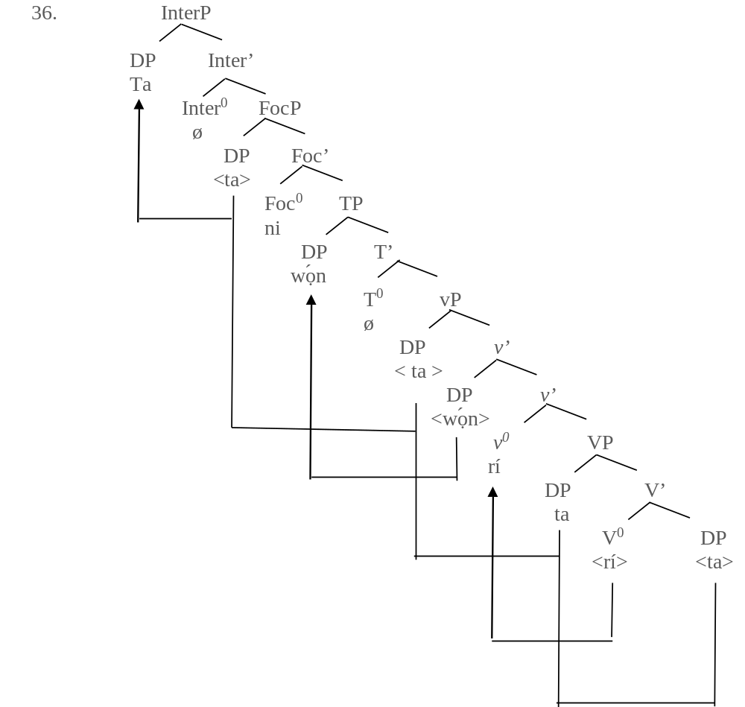
The derivation (in 36) goes thus: The lexical verb rí “see” merges with ta “who” to project the V-bar ri ta “see whom” in line with c-selection requirement of the verb. After this, the QN ta “who” is copied to the spec VP by the Operation Copy and Delete so as to check its case feature through specifier and head agreement. The derivation proceeds by merging the null performative verb v⁰ with the VP to project the v-bar, while the strong vF feature on the light v⁰ attracts the lexical verb rí “see” to adjoin to itself. The third person plural subject pronoun wọ́n is externally merged as the inner specifier of the light vP in line with the PISH. The QN ta is copied to the outer spec vP, an escape hatch from PIC. This invariably makes it visible to further operations in the course of the derivation. The derivation proceeds by externally merging the abstract T⁰ with the vP to project the T-bar. The T⁰ as a probe attracts wọ́n to the spec TP to check the [+case, EPP] featureon the T⁰. The abstract Foc⁰ merges with the TP to project the Foc-bar. The Foc⁰ as a potential probe searches its c-command domain and attracts the QN (an active goal) to the spec FocP to have its [+Foc] feature checked. The derivation still proceeds by externally merging the absract Inter⁰ with the FocP to project the Inter-bar. The Inter⁰ as a potential goal attracts the QN ta to the spec InterP to check its [+Q, EF] through specifier and head agreement.

Interrogative Qualifiers in Yorùbá

Yorùbá uses interrogative qualifiers in two ways: one, it uses either of the interrogative qualifiers wo and kelòó with a head noun, and two, it uses any of its QNs identified above to qualify a (head) noun. Let us consider the examples below on the first method.

(37) a. Aṣọ wo ni Oyè rà?
Cloth QM FOC Oyè buy
‘Which cloth did Oyè buy?’

b. Ipò kelòó ni Oyè ṣe?
Position QM FOC Oyè do
‘What is Oye’s position?’

c. Ìgbà wo ni ẹ dé?
Time QM FOC you arrive
‘When did you arrive?’

d. Ba-wo ni ẹ ti ṣe é?
Like-QM FOC you PERF do it
‘How did you do it?’

Wo and kelòó are interrogative qualifiers, their [+Q] feature percolates through the entire QPs in 37a-d above. Let us consider the examples below on the second method.

(38) a. Ilé ta ni wọ́n rà?
House QN FOC they buy
‘Whose house did they buy?’

b. Ìlú ibo ni à ń lọ?
Town QN FOC we are going
‘Which town are we going?’

c. Bàtà mélòó ni Olú rà?
Shoe QN FOC Olú buy
‘How many shoes did Olu buy?’

The QNs (in 38a-c) above function as qualifiers similarly to the italicised nouns (nominal qualifiers) (in 39a-b) below:
(39) a. Bàbá Oyè lọ sí ìlú Ìbàdàn
Father Oyè go to town Ìbàdàn
‘Oyè’s father went to Ìbàdàn.’

b. Ọmọ olùkọ́ ṣe ipò kìn-ín-ní.
Child teacher do position first’
‘The techer’s child came first.’

In line with Wh-Attraction Condition (WAC), the entire QPs in 38 and 39 are copied to the clause left periphery for feature valuation.

5. Conclusion

This paper discussed the syntactic behaviour of constituent interrogative markers in Yorubá. The paper adopted QNs, QVs and interrogative qualifiers in the place of wh-phrases adopted in some extant works.. With this, we were able to identify the class (of word) that each of these interrogative words belongs. Unlike wh-phrases in English which are also operated in relativisation and adverbial clauses, these items are restricted to interrogatives only. QNs are specified [+Q, focus] feature while QVs perform both interrogative and predicate functions in the language.

References

Aboh, E.O. & Pfau, R. 2011. What’s a Wh-word Got to Do with It? The Cartography of Syntatic Structures, B. Paola. Ed. New York: Oxford University Press. 5.

Ajíbóyè, O. 2005. Topics on Yorùbá Nominal Expressions. Ph.D Thesis. University of British Columbia.

Àkànbí, T. A. 2011. The syntax and Semantics of Interrogative Verbs “Dà” and “Ńkọ́” in Yorùbá. Inquiry in African Languages and Literatures. 8. 1-26.

Àkànbí, T. A. 2016. On the Wh-Question Particle [Wo] in Yorùbá. European Scientific Journal. Vol. 12 no. 17 ISSN 1857-7881 (Print) e-ISSN 1857-7431.

Awóbùlúyì, O. 1978. Essentials of Yorùbá Grammar. Oxford University Press Ibadan,
Nigeria.

Awóbùlúyì, O. 2008. Ẹ̀kọ́ Ìṣẹ̀dá-Ọ̀rọ̀ Yorùbá. Montem Paperbacks, Akúrẹ́, Oǹdó state.

Awóbùlúyì, O. 2013. Eko Girama Ede Yoruba. ATMAN Ltd. Osogbo.

Bámgbóṣé, A. 1990. Fonólójì àti Gírámà Èdè Yorùbá; Ibadan. University Press PLC.

Bocci G. et al 2021. Focus in Wh-Question Evidence from Italian in Natural Language and Linguistic Theory. https://dol.org101007/s11049-020-09483-x

Cheng, L. 1991. On the Typology of Wh-Questions. PhD Dessertation. MIT.

Chomsky, N. (1995. The Minimalist Program. Cambridge, MA: MIT Press.

Citko, B. 2014. Phase Theory: An Introduction. Cambridge University Press.

Ìlọ̀rí , J. F. 2010. Nominal Constructions in Ìgàlà and Yorùbá. Ph.D Thesis. Department of Linguistics and Languages, Adékúnlé Ajásin University, Àkùngbá-Àkókó.

Issah, A. S. 2013. Focus and Constituent Question Formation in Dagbani. Ghana Journal of Linguistics 2.1: 39-62.

König, E. & Siemund, P. 2007. Speech Acts Distinctions in Grammar. Timothy Shopen (ed.). Language Typology and Syntactic Description Vol. 1. Cambridge: Cambridge University Press.

Kroeger, P.R. 2004. Analysing Syntax: A Lexical-Functional Approach. Cambridge University Press.

Munro, P. 2012. Interrogative Verbs in Takic. UCLA Working Papers in Linguistics: Theories of Everything. volume 17, article 32: 274-284.

Nkemnji, M. 1995. Heavy Pied-Piping in Nweh. Doctoral Dissertation, UCLA.

Ọláńrewájú, E.O. 2016. Ìṣẹ̀dá Àwọn Wúnrẹ̀n Aṣèbéèrè nínú Èdè Yorùbá. Paper presented at the Conference of the Yorùbá Studies Association of Nigeria, University of Lagos, Lagos, October 11-13.

Ọláńrewájú, E. O. 2017. A syntax of Interrogatives in Central Yorùbá Dialects as Compared with Standard Yorùbá. M.Phil. Dissertation. University of Ìbàdàn.

Ọláńrewájú, E. O. 2022. A Syntax of Focus and Interrogatives in Central Yorùbá. Ph.D Thesis. University of Ìbàdàn, Ìbàdàn.
Ọláńrewájú, E, O. & Taiwo, O. 2020. A Minimalist Analysis of Question Forms in the Ifẹ̀ Dialect of Yorùbá. Journal of Linguistics Association of Nigeria, Supplement IV
(ed.) P.O Táíwò. pp 137-158.

Ọláńrewájú, E, O. & Taiwo, O. 2021. A Minimalist Analysis of Polar Questions in Yorùbá. JOLAN Volume 24 No 2 (ed.) P.O Táíwò. pp 234-248.

Ọláògún, S. 2016. Information Structure Categories of Ǹjọ̀-kóo Language in Àkókó North- West of Oǹdó state, Nigeria. PhD Thesis. University of Ìbàdàn.

Ọláògún, S. & Aṣiwájú, J. 2016. Ọ̀rọ̀-orúkọ Aṣèbéèrè nínú Èdè Yorùbá. Paper presented at the Conference of the Yorùbá Studies Association of Nigeria, University of Lagos, Lagos, October 11-13

Ọláògún, S. 2018. Yes/No and Wh-Questions in Ǹjọ̀kóo: A Unified Analysis. Corela 16 (1), 1-16.https://doi.org/10.4000/corela.6333
Ouhalla, J. 1996. Remarks on the Binding Properties of Wh-Pronouns. Linguistic Inquiry, 27. pp 676-707.
Owólabí, K. 1983. More on the Inadequacy of the Focus Constructions as Noun Phrases. Linguistic Analysis. vol 12, no. 4, 453-471.

Owólabí, K. 1987. ‘Focus Construction as NP: A Critique’, Yoruba (New series), No. 1 pp. 45-62.

Owólabí, K. 1989. The Non-Existence of Topical Qualifiers in Yoruba. Yoruba: Journal of the Yoruba Studies Association of Nigeria (Special Edition) pp. 1-22.

Radford, A. 2006. Minimalist Syntax Revisited. http:/course.essex.ac.uk/lg/lg524.

Radford, A. 2009. An Introduction to English Sentence Structure; Cambridge University Press.

Saito, M. 1992. Long-Distance Scrambling in Japanese. Journal of East Asian linguistics. 1, 69-118.

Siemund, P., 2001. Interrogative Constructions. Martin Haspelmath, Ekkehard König,Wulf esterreicher, and Wolfgang Raible (eds.), Language Typology and Language Universals pp. 1010–1028. Berlin: Mouton de Gruyter.

Táíwò, O. & Abímbọ́lá, O. 2014. On the Two Interrogative Verbs in Yorùbá. Research. African Languages and Linguistics Vol. 13, pp1-14.

Yusuf, O. 1990. Yorùbá Copula Ni. Journal of West African Languages, 20(1):83-93.

The following abbreviations are used in the examples: FOC (focus marker), INTER (interrogative marker), NEG (negative marker), PERF (perfect aspect marker), PRM (pre-modifier), PROG (progressive aspect marker), PSM (post-modifier), QM (question marker), QN (question noun), QP (question phrase), QV (question verb), RES (resumptive pronoun) and YNQM (yes/no question markers).

