DIRECTIVES AND REFERENCES IN SELECTED CORONAVIRUS-MOTIVATED INTERNET MEMES

Abstract
The use of directives in communicating the nature of the pandemic and reference to social experiences were promoted through the use of images on social media platforms. The images or memes are used to create awareness and reinforce the criteria for safety during the pandemic. Extant studies on internet memes have concentrated on humour generation, speaker-hearer shared knowledge, neologism, multimodality among others, with insufficient attention paid to the use of directives and references in such coronavirus-motivated memes. This paper, therefore, examines how directives and references are employed in conveying expected social responsibilities through coronavirus-motivated Internet memes. For data, one hundred coronavirus-motivated memes were purposively selected from Facebook, and eight representative memes were subjected to pragmatic analysis using aspects of Jacob Mey’s (2001) pragmatic acts theory to unearth insights from them. The paper observes that the various spheres of life that are relatable to an online audience help to express what the pandemic is about, enhance the meaning of the pandemic with the context of use of the memes, giving clearer perspectives to the pandemic. The paper concludes that directives and references are useful tools in conveying social responsibilities to online audience.
Keywords: directives, references, coronavirus, Internet memes, social responsibilities

- Introduction
The coronavirus (COVID-19) pandemic ravaged the world in 2020 and beyond, affecting all aspects of human life. This made great waves in all forms of traditional and social media. With large participation on social media platforms, health advice was on the rise to salvage the situation to the possible minimum. The representation of opinions and relevant information on coronavirus for public use was widely distributed with short message services (SMS), sensitisation adverts and graphic illustrations on social media. Memes are part of the graphical illustrations on social media. This is what Dynel (2021) refers to as digital humour, providing insights into varying recent, social and political issues, being vessels for public sharing of serious information and opinion. The interactive and participatory nature of social media (Manning, 2014; Huntington, 2017), most especially Social Networking Sites (SNSs), allows unconstrained sharing of knowledge about contents created and shared, and further triggers frequent online participation, that is, the viewing and sharing of contents.
The term ‘meme’ is a coinage that was first used by Dawkins (1976) in his book, The Selfish Gene. He explains that memes, like genes, are produced, repopulated and survive in (social) environment. They are cultural units that spread from one person to another and have become a culture of the Internet (Huntington, 2017; Diedrichsen, 2019). Internet memes express a representation or view towards a phenomenon that is familiar and shared among a community of linguistic related individuals. They are capable of revealing ideas, intentions, attitudes, situations or minds of users on topical issues such as health, marriage, education, sport, career, religion and different cultures (Falade, 2022). Features that characterise memes include: text, text and image, and dialogue. This channel of communication may be age specific considering the coinages, neologisms and slangs but the phenomenon remained constant. Shared knowledge is accessed through what we view and share and meme generators spice the creation of memes to make references, give directives or just for humourous purposes. Coronavirus-motivated memes are not limited to a particular age because of the peculiarity of the pandemic. As a global outbreak, coronavirus (otherwise known as COVID-19) became a familiar language used by all social class, religious setting, political class and so on. According to XXXX (2022:61) the “media constitute one of the main means through which text consumers get to know more about coronavirus and its escapades”. Social media, alongside the mass media, was greatly employed to sensitise the public about the pandemic, give preventive measures and to create a forum for interactions during the lockdown. The forum for interaction includes the use of memes to explore different aspects of the pandemic, including reference to the phenomenon and structured instructions to curb its expansion.
Directives generally refer to commands or instructions given in order to perform a particular action. Linguistically, it involves the understanding of communicative events to bring out commands or instructions. This may be done through direct or indirect speech acts with the hope of eliciting prompt and appropriate response(s). In utterance analysis, Austin’s (1962) recognizes three constituent elements which are otherwise regarded as three types of force. The three types of force of the speech acts theory are: locutionary, illocutionary and perlocutionary acts. Searle (1976) further discusses illocutionary acts to include commissives, directives, expressives, representatives and declarations. These illocutionary acts are the actions in a speaker’s utterance. Directives, with in relation to speech acts, represent a significant dimension of human communication where speakers employ language to prompt, persuade or instruct listeners to undertake specific actions or behaviours. These communicative acts constitute a foundational element of language and interpersonal interactions, wielding substantial influence over the dynamics of human discourse. Contemporary research and scholarly contributions within linguistics and pragmatics studies have enriched the comprehension of directives, giving an array of insights into their classification, functions and the intricacies that give basis for their deployment. Directive, as one of the classifications of illocutionary speech act, encompasses a set of fundamental principles that elucidate how speakers use language to convey their intentions and influence the actions or behaviours of their interlocutors. These tenets are germane to understanding the nature and functions of directives in communication. Directives have specific illocutionary force, which is the speaker's intention or communicative purpose behind the utterance. This force typically entails the speaker's desire to have the listener perform a particular action or respond in a certain way. The illocutionary force can range from requests and commands to suggestions and invitations.
Reference, on the other hand involves the use of language to identify, point to, or describe objects, entities, events, or concepts in the world. It is a fundamental aspect of communication and serves the purpose of enabling speakers to convey information, share thoughts, and establish a common understanding with their listeners. Effective reference requires shared knowledge and the ability to make inferences based on linguistic and contextual cues. Inferences may involve accommodating new information or resolving ambiguities in reference to arrive at the intended meaning. Reference serves to identify and specify the entities or actions that are the targets of directives, ensuring that the communication is clear, contextually relevant and conducive to successful action or compliance. The effective use of reference and directives is vital for conveying the speaker’s intentions and achieving the desired response from the listener. These two elements, when combined, aid the understanding of the messages being passed by internet memes.
There are numerous non-linguistic studies on coronavirus (Shereen et al., 2020; Wiersinga et al, 2020; Ayodele et al., 2021, etc.). These studies have explored the emergence, pathophysiology, diagnosis, transmission, treatment of coronavirus. Linguistic studies on coronavirus have considered other data (newspaper editorials, articles, books, etc.) but have not given consideration to Internet memes. Such linguistic studies were guided by different theories and methodological engagements. Studies on Internet memes have considered mostly politics (Denisova, 2016), humour (Tella, 2018; Onanuga, 2019), multimodality (Dynel, 2021), common ground (Falade, 2022) and tertiary education (XXXX and XXXX, 2023), with insufficient attention paid to the use of directives and references in coronavirus-motivated memes. In spite of the various studies, much work is needed to examine the references made and directives used in the production of coronavirus-motivated Internet memes.
With respect to discourses on the pandemic, XXXX (2022) examined media representation of COVID-19, identifying the discourse representations, structures and strategies deployed by selected newspapers, guided by van Dijk socio-cognitive model of critical discourse analysis. The study argues that the negative portrayal of COVID-19 and other constructs create “a cognitive awareness in the minds of the citizenry, bringing consciousness to the readers on the negative capability and destructive strength of the life threatening disease” (pp. 76-77). Examining neologism during the outbreak of COVID-19, Asif et al (2021) observed that word formation was in form of verbs, nouns and adjectives, alongside abbreviations and acronyms, which were frequently used on social media to portray lexical deviation used in societies and various cultural practices. Similar to this is Asiru and Bello’s (2021) study on the linguistic and literary analyses of cartoonists’ depiction of COVID-19, where text and images show shared socio-cultural knowledge. The study reveals that humourous images, which are important ways by which the pandemic was discussed, show the beliefs of Nigerians about COVID-19. These studies have shown the creation of awareness about the pandemic, especially on discourse representation, neologism and humourous images, which overall gives room for more study on communicating social responsibilities. Despite the thought-provoking nature of the different scholarly engagements on COVID-19, a gap that is identified in this study is the consideration of coronavirus-induced communication via the deployment of Internet memes. This study, therefore, fills this gap by examining how meme creators deploy directives and references to communicate different opinions on coronavirus-induced Internet memes.

- Theory and method
This analysis in this paper is guided by aspects of Mey’s (2001) Pragmatic acts theory. The model is presented in Fig.1. The first part (activity part) highlights the part of the interactants i.e. the speech, indirect speech acts, conversational (Dialogue) Acts, psychological acts (emotion), prosody (intonation, stress, …), physical acts (body moves: gestures, physiognomy: facial expression, bodily expressions of emotions). The second part is the textual part that discusses inference, reference, relevance, voice, shared situation knowledge, metaphor and metapragmatic joker. In the opinion of Kecskes (2010:2890), “the emphasis is not on conditions and rules for an individual speech act, but on characterising a general situational prototype (…) that can be executed in the situation”. In other words, pragmatic acts theory was necessitated by the need to situate utterances in their particular environment and not just attribute meaning simply by the speech acts. Aspects of the textual part (reference) and the activity part (indirect speech acts) were used to establish these insights from the selected memes. The activity part shows what is available to language users in communication, while the textual part reveals features that influence communication. Both are essential to the understanding of communicative events because words are used to perform certain actions. This work focuses on Internet memes that express directives (the level of interaction in the memes) and references (items that influence the directives made in the memes).
Directives can be either direct or indirect in their formulation. Direct directives explicitly state the desired action, such as "Please turn off the AC." Indirect directives, on the other hand, employ more subtle or polite language to convey the same request, like "Would you mind turning off the AC?" The choice between directness and indirectness depends on factors like social norms, politeness, and the power dynamic between the speaker and listener. Some of its fundamental principles include politeness strategy, pragmatic competence, context, social roles and power dynamics.
- Politeness theory plays a significant role in directives. Speakers often employ politeness strategies, such as mitigating devices (e.g., "Could you possibly...") or deferential language (e.g., "I would appreciate it if you could..."), to make their directives less imposing and to preserve face – both their own and the listener's.
- The effectiveness and appropriateness of directives are influenced by the social roles and power dynamics between the speaker and the listener.
- The interpretation and effectiveness of directives can vary significantly across cultures and contexts. Different cultures have distinct norms regarding politeness, assertiveness, and the use of indirect language.
- Both speakers and listeners need pragmatic competence to navigate the nuances of directives effectively. Pragmatic competence involves the ability to infer implied meanings, recognize indirectness, and understand the social and cultural context in which directives are exchanged, which is understood by references used in the utterance.
From the activity part, speech acts help to examine functions performed by an utterance rather than the structure of the utterance. Indirectness in speech acts is what the environment of the utterance makes it to be. Indirectness may not be expressed simply by the utterance. In most cases, speech acts create the appropriate context for understanding. Direct speech acts are occasioned by the environment of the communicative event. Indirect speech act is the speaker’s act of communicating more than what is said. The knowledge or background information about an utterance that is shared help to enhance direct or indirect speech acts. The key components of references, from the textual part, includes identifying entities (concrete objects), deictic expressions, definite and indefinite articles (specific/nonspecific), proper nouns, anophora and cataphora (backward or forward reference), pronouns, common ground, ambiguity and vagueness. These components serve as bedrock for conveying meaning and establishing clarity in communication. In other words, reference serves as a vital communicative tool.
For data, eight coronavirus-motivated memes out of hundreds available, were purposively selected from Facebook – one of the most popular social media platforms – and subjected to pragmatic analysis. The selected data are believed to have been generated, viewed and shared from February 2020 – December 2020. The study employs a descriptive research method that highlights the directive and reference tools as evident in the selected data.

- Analysis and discussion of findings
The memes examined are coronavirus-motivated, indicating implicit and explicit reference to virus. Directives and references, as earlier mentioned, are ways of communicating social responsibilities, especially on social media. Items that are available to language users promote the identification and influences they communicate. The actions performed by the memes, as well as the functions performed by the utterances beyond the structure are used to encode the directives, especially as found in the memes. Most typical strategies used to encode directives include the use of imperatives and interrogation. References are indicated through verbs (tenses), action voices and persons, deictic expressions, definite and indefinite articles (specific/nonspecific), proper nouns, anaphora and cataphora (backward or forward reference), pronouns, common ground, ambiguity and vagueness. These references are used to perform the pragmatic function of promoting clarity.
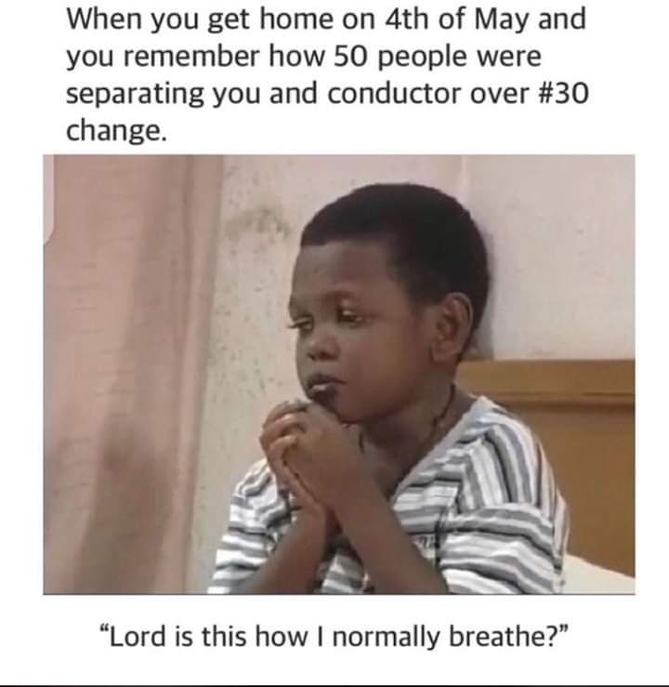
Meme 1
Meme 1 shows a text and image meme of a remorseful act, whose interpretation is attached to the text in the meme. The character in the meme is seen reflecting on an event that must have occurred during the coronavirus outbreak, which, from description, is a fight over transport fare balance. The event also characterise the attitude of some people, especially when the public was warned to stay away from large gatherings as this may cause the virus to spread faster. This meme communicated the need to abide by the preventive measures of social distancing that was emphasised during the pandemic. The image performed the action that warns against regret. The directives tool employed in this meme include background knowledge of the pandemic, the instructions channeled through the media and the knowledge of interrogation with which this meme expresses expected indirect way of telling the public that they may regret their defiance to instruction as represented in the image. More specifically, the question influenced the directive employed in the meme.
“Lord is this how I normally breathe?”
The action performed here is with rhetorical question where answers are not necessarily provided but can elicit detailed response. Rather than instruct the audience on the need to stay off the public, the meme employed politeness, a facesaving strategy where there is a shift of focus from a situation; in this case, fighting for ‘change’ during the period of lockdown. This strategy is further reinforced by pragmatic competence of interrogation (rhetorical question), which as an indirect act of invoking shared knowledge that helps to communicate expected social responsibility of adhereing to guidelines for a healthy society, first from individuals, communicating more than what has been said. The nouns and pronouns used in the two expressions serve as reference tools in the meme. ‘Your’ and ‘you’ were vaguely used to refer to no one in particular because they are pronouns that can refer to an individual or a group of persons, while ‘conductor’ and ‘Lord’ are definite and direct reference. While the pronouns promote clarity and precision of the referent as refering to viewers of the meme, the nouns directly address personalities. To maintain cohesion and guide inference, anaphora was employed to encourage active engagement with the meme. “4th of May” was used to guide the pragmatic competence of viewers and sharers to the period of the pandemic.

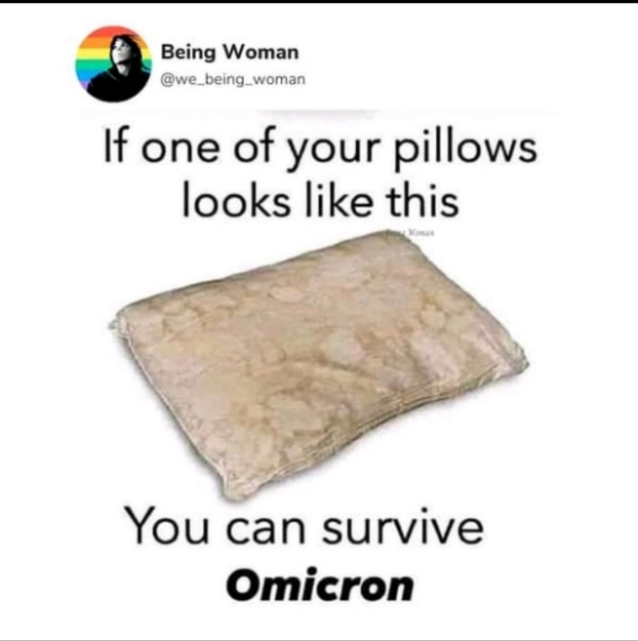
Meme 2
Meme 2 shows a text and image meme. This meme shows a dirty pillow, which may be due to sweat or splashes of water. It also reveals the fact that it has not been properly taken care of. The text reinforces the nature and state of the pillow by stating indirectly the danger of using this kind of pillow. This meme indirectly condemns the use of this type of pillow and calls on his audience to be social responsible for their health by ensuring a hygienic environment. Reference is made to coronavirus with the mention of Omicron which is a variant of the virus. The sentence in the meme contains a directive speech act that can be understood through the background knowledge of a dirty pillow and the foregrounding of Omicron. This knowledge is shared by the meme generator and viewers. The required information was succintly given and relevant to the period. Indirectness was employed as no question was explicitly asked, and request to avoid infection and stay hygienic was not (ordered) explicitly given, but it can be inferred. The utterance subtly and indirectly suggests or advises a hygenic environment. The directive has been framed in a metaphorical and humourous context, rather than offering a serious survival strategy for dealing with the Omicron variant of coronavirus. The use of indirect recommendation was appropriate to pass the idea of each individual’s responsibility for his/her health. The pronouns ‘your’ and ‘you’ were vaguely used to refer to no one in particular. On the other hand, “one of your pillows” is a more specific (anaphoric) reference to the type of pillow that exists in some people’s house by the virtue of being accommodated in people’s houses, hostels or in some cases, when spread outside. “Looks like this” refers to a particular appearance or condition of the pillow, which is explicitly described in the sentence but is implied. “Omicron” has been used as a proper noun, which is another reference tool that refers to the subject of discussion in the sentence, a variant of COVID 19. These reference tools help convey the message that there is a connection or condition related to the appearance of a pillow and one’s ability to survive the pandemic. Rather than provide actual medical advice, the references used metaphorically communicated the intention.

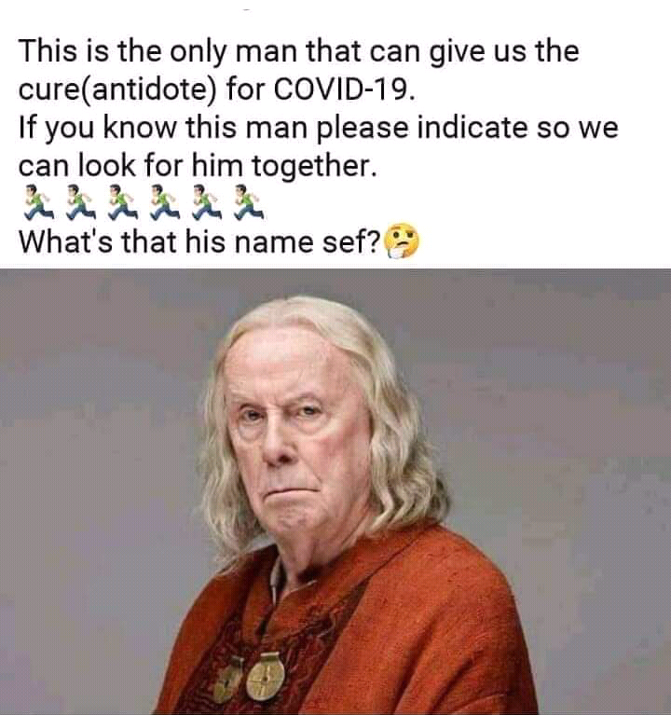
Meme 3
In Meme 3, language users are made to see the man in the picture as the solution (cure/antidote) to the ravaging panademic. This influences the communication of COVID 19, its dangers and “cure”. The man in the meme acted as Gaius in a movie series titled “Merlin”. In the movie, he was the court physician and advisor to King Uther Pendragon, who ruled the kingdom of Camelot. Gaius is a wise and knowledgeable figure who plays a crucial role, both as a healer and as a mentor to the young wizard Merlin. Gaius is known for his extensive knowledge of magic and the supernatural, which he often imparts to Merlin as the young wizard learns to harness his magical abilities. The utterance contains request for identification of the man, who may figuratively be in possession of the healing power to the pandemic. The initial part of the statement made in the meme provides context and background information, explaining why the speaker is making the request. Direct speech act is employed which requires a desired action. The speaker asks for help in identifying the man who is believed to hold the cure or antidote for COVID 19. The use of ‘please’ has relieved the utterance of the directive of request, employing politeness to know how the pandemic can be curbed, especially as the audience of the meme are assumed to be familiar with the role played by the man in movie. As common ground is employed, “What’s the man’s name sef?” is another request for information about the man’s name; “sef” adds an informal tone to the question, possibly indicating a sense of curiousity or urgency. Identifying the man is metaphorically constructed, who is potentially crucial in the fight against COVID-19.
Demonstrative pronoun “this” is used to refer to a specific person, indicating that the utterance is assumably made to a known person. “the only man”, at the phrasal level, is an indefinite pronoun used to refer to a specific and singular person; the one beliefed to posses the antidote for COVID 19. It narrows done the reference to a unique person. “What” on the other hand is an interrogative pronoun, asking for the name of the specific man in the meme. If this man is not identified, the implicit meaning in the meme is that everyone should comply with the preventive antidote to reduce the spread, until “the man” is identified. These reference tools and directive acts component help to clarify who and what the speaker is referring to and facilitating effective communication.

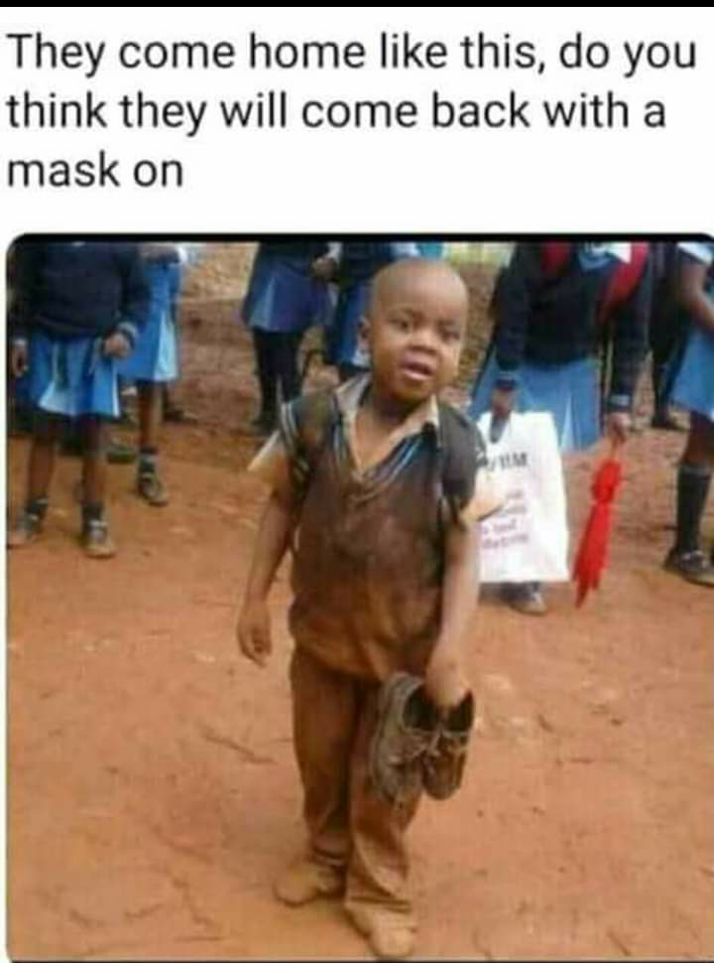
Meme 4
Meme 4 shows a school pupil in uniform. He is still in school because the background shows other pupils in uniform. His expression shows that he had played and had dirtied his uniform. The text attached to the image makes reference to COVID-19 through the use of the word ‘mask’. ‘Mask’ became an essential item used as a preventive measure to curb the spread of coronavirus and this influences the communication of COVID19. The text and the image enhance the advice of social distance during the outbreak. The phrases “come home”, “you think” are what performed the actions in the text. These create a level of interaction for meme viewers that the lockdown should be sustained, a kind of instruction given to the audience about the benefit of the lockdown. This indirect way of reinforcement of benefit gives the structure of the utterance the needed backup which was promoted by the graphic illustration. The warning to prevent the spread of the virus expresses indirectness in the mode of communication of social responsibility to the meme audience is best applied as there were suggestions on the end to the lockdown. The speaker’s act communicated more than what was said in that the pronoun “they” makes reference to children who return home dirty, which is complimented by the diectic element “this”. “Mask” is however a definite reference and a common ground tool to COVID19.

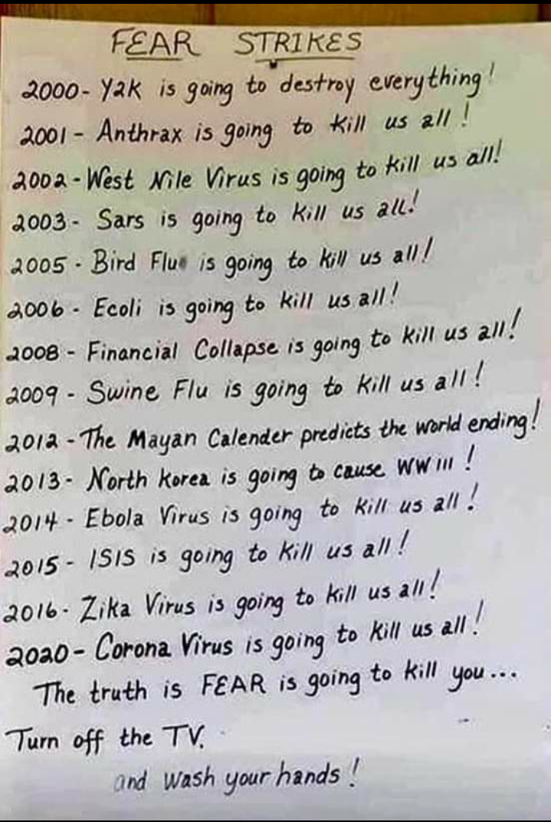
Meme 5
Meme 5 chronicles endemic/pandemic since 2000. It shows 14 life-threatening challenges which included viruses and other causes of fear. Background knowledge of the years, the utterances made in the cause of those years, the fear associated with the different utterances, and the repetition at the end of each sentence points to the interpretation of the meme. These years serve as anchors that ground the utterances in a particular historical or situational context. The meme mentions fear associated with the various utterances and years. This fear could arise from a multitude of sources, such as societal norms, political climate, or personal consequences. It's important to delve into the specific reasons behind this fear and how it relates to the utterances made during those years. The meme employs repetition as a stylistic device, with the phrase "kill us all" being reiterated. This repetition serves as a rhetorical tool, signifying emphasis, irony and the particular message within the meme. Understanding the purpose and effect of this repetition aids in deciphering the directives, which is revealed through emphasising the responsibility to “wash your hands”. It is through the interplay of the specified years, the content of utterances, the associated fear and the use of repetition that the meme conveys its underlying message. The meme also underscores the situational nature of shared knowledge. Reference tools employed include pronoun “us”, which is used to refer to no one in particular, nouns (specific names of diseases), anaphora (the previous years) and common ground of the message being passed.

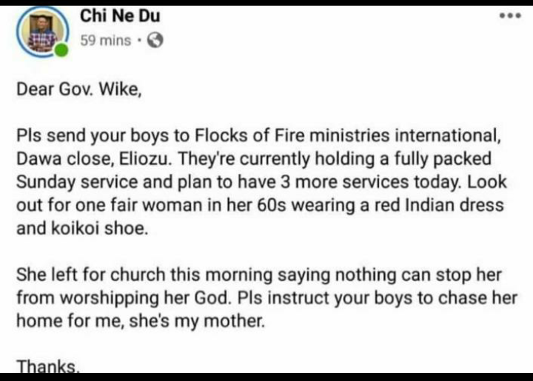
Meme 6
This meme serves as a visual representation of a proactive and direct measure taken to combat the spread of the virus during the pandemic. It shows a pivotal moment in the collective response to the global health crisis, reflecting the implementation of lockdowns as a preventive strategy. However, within this broader narrative, it also hints at the complexity of human behaviour and motivations during such challenging times, particularly when it intersects with deeply held religious beliefs. The central imagery of the meme depicts a scene where a child is shown actively ensuring lockdown measures for his/her mother. This include the closure of public spaces. The visual emphasis on these measures underscores their significance in limiting the transmission of the virus and safeguarding public health. The meme alludes to a contrasting response among some individuals who resisted or opposed these preventive actions. Some population were unwilling to comply with lockdowns due to their religious beliefs or convictions. This aspect introduces a layer of complexity, as it highlights the interplay between public health imperatives and deeply ingrained cultural or religious practices. The meme employed direct speech acts of requesting for the enforcement of the lockdown, irrespective of religious beliefs, and reference tools through pronouns, nouns and common ground to aid the effective interpretation of expected social responsibility.
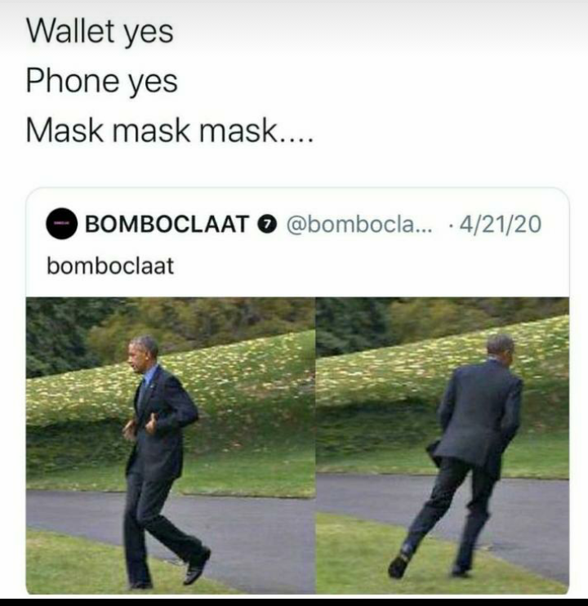
Meme 7
The meme above indicates the need to use a facemask during outings. Barrack Obama’s picture in the meme serves as a potent visual symbol that underscores the need and importance to use a mask irrespective of your age, social standing or political status during the pandemic. By featuring Barack Obama, a prominent and universally recognized figure, the meme sends a powerful signal that wearing a face mask is a responsibility shared by individuals from all walks of life. Regardless of one's age, social background, or political beliefs, the need to protect oneself and others from the transmission of infectious diseases, including COVID-19, is a shared obligation. Barack Obama's inclusion in the meme as a mask-wearer conveys the idea of leading by example. As a former head of state and influential public figure, his choice to wear a mask underscores the seriousness of the pandemic and sets a positive example for the broader community. This aligns with public health recommendations and guidelines that encourage influential figures to demonstrate responsible behaviour to inspire others. Here, direct speech act of persuading the audience is employed. The meme uses a visual medium to drive home the point that in the face of a global health crisis, individual actions matter significantly. It serves as a reminder that responsible behaviour is beyond social and political divisions and emphasizing that safeguarding public health is a collective endeavour that requires cooperation from everyone. Furthermore, the meme implicitly challenges any misconceptions or resistance to mask-wearing that may have arisen during the pandemic. By highlighting a respected and admired public figure practicing this preventive measure, it aims to promote a sense of unity and shared responsibility in the battle against infectious diseases, promoting the broader adoption of mask usage as a simple yet effective means of mitigating the virus's spread. Proper nouns as well as common ground were used to drive home the point.

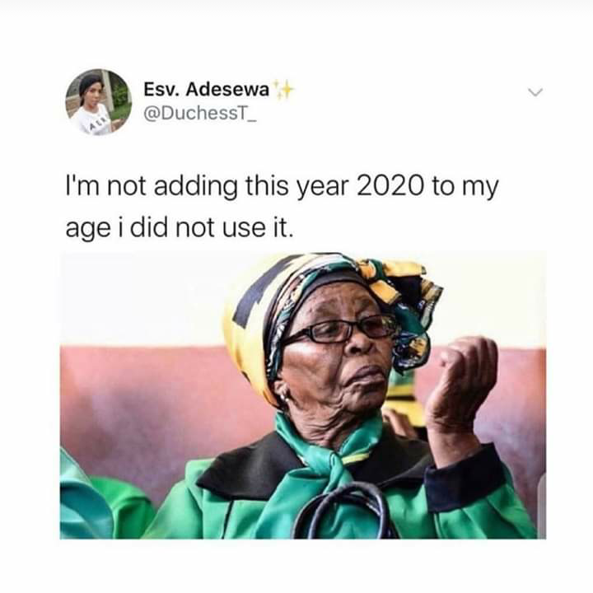
Meme 8
Amidst the global COVID-19 pandemic, a prevailing sentiment among many was a poignant desire to metaphorically "delete" the year from existence due to the extraordinary and unprecedented circumstances that unfolded. During this tumultuous period, a substantial portion of the population found themselves grappling with the stark reality that a significant portion of the year had been marred by the pervasive impact of the pandemic. This sentiment emerged as a reflection of the profound disruptions to daily life and the broader societal landscape that occurred throughout the year. Lockdowns, travel restrictions, business closures, and the tragic loss of lives cast a shadow over the year, leaving people with a sense of stagnation and uncertainty. For many, the absence of typical social activities, travel experiences, and celebratory events rendered the year devoid of the usual markers of progress and achievement. The sentiment of wanting to "delete" the year signifies the collective emotional response to the unprecedented challenges faced. It underscores the human inclination to seek a reset or a fresh start in the face of adversity. This sentiment is not solely an expression of frustration or resignation but also a testament to resilience and the yearning for a return to normalcy. On the one hand, directive act is employed through pragmatic competence of the situation, satirically calling on others to share the same concern and indirectly communicating the preventives measures applied throughout the year. Reference tools, on the other hand, include pronoun (I) and cataphora (I did not use it).

- Discussion of findings
The extent to which each meme was related to coronavirus was consistently revealed through components of directives and references in lexical indicators. Some words/expressions in the selected memes clearly made recourse to the coronavirus pandemic, while others were implicitly identified. Comparison strengthens the effect of the message passed across by the memes. The directives were seen through the background knowledge of references and the speech acts of the utterances. These are used to communicate social responsibility. Social responsibility is the expected behaviour of individuals as a member of a society. With respect to coronavirus-motivated memes, the social responsibilities communicated are good hygiene while the virus lasted, obedience to preventive mechanisms to avoid the spread and modest behaviour in public places. References were made to COVID-19 without the mention of it in the selected memes and directives were seen in the way the memes are used to convey social responsibilities. This study corroborates XXXX’ (2022) submission that there is an awakening in the mind of citizenry, especially meme viewers of coronavirus-motivated memes, on the destructive strength associated with the pandemic, if proper attention is not paid to the subtle yet noticeable directives woven into the creation of the memes. Also, pronouns and nouns are predominant word classes used as reference tools to portray social media use of deviation in the society and various cultural practices as pointed out by Asif et al’s (2021) study on neologism during the outbreak of COVID-19. The images that accompany each meme show shared social and cultural knowledge of what is communicated through the memes, an idea that is evident in Asiru and Bello’s (2021) work on the linguistic and literary analyses of cartoonists’ depiction of COVID-19.

- Conclusion
This study set out to examine how meme creators deploy directives and references to communicate different opinions on coronavirus-induced Internet memes. It observes that the various spheres of life that are relatable to an online audience help to express what the pandemic is about, through direct acts. These acts include invoking shared knowledge, warning viewers, suggesting ways to prevent the spread of the virus, recommending ways to reduce the spread, requesting enforcement of preventive mechanisms and persuading the meme audience on the need to follow guidelines regarding the curbing of the virus. Similarly, there are more indirect references in the selected memes. The meaning of the memes is enhanced through the context of use, giving clearer perspectives to the pandemic. The paper concludes that directives and references are useful tools in conveying the expected social responsibilities to the online audience. Besides creating humourous effect, memes serve as conveyor belt for social responsibilities by social media users.

References
Asif, M., Zhiyong, D., Iram, A. and Nisar, M. 2021. Linguistic analysis of neologism related to coronavirus (COVID-19). Social Sciences and Humanities Open 4. DOI:10.1016/j.ssaho.2021.100201
Asiru, H. T. & Bello, S. 2021. A linguistic and literary analyses study of selected cartoons on the novel Covid-19 pandemic in Nigeria. African Identities, DOI:10.1080/14725843.2021.1963671.
Ayodele, O., Ren, O., Zhao, J., Signorovitch, J., Jonsson Funk, M., Zhu, J., et al. 2021. Real-world treatment patterns and clinical outcomes for inpatients with COVID-19 in the US from September 2020 to February 2021. PLoS ONE 16(12): e0261707. Doi:10.1371/journal.pone.0261707
Dawkins, R. 1976. The selfish gene. Oxford, UK: Oxford University Press.
Denisova, A. 2016. Political memes as tools of dissent and alternative digital activism in the Russian-language twitter. PhD Thesis. Communication and Media Research Institute. University of Westminster. i-473.
Diedrichsen, E. 2019. On the interaction of core and emergent common ground in Internet memes. Internet Pragmatics. 3 (1). 223-259
Dynel, M. 2021. COVID-19 memes going viral: On the multiple multimodal voices behind face masks. Discourse & Society, Vol. 32(2) 175–195.
Falade, T.M.A. 2022. Context, Discourse Issues and Common Ground Strategies in selected dialogic internet memes. MPhil. Diss. Department of English, University of Ibadan, Nigeria. Pp. i-160.
Huntington, H. E. 2017. The affect and effect of internet memes: assessing perceptions and influence of online user-generated political discourse as media. Diss. Department of Journalism and Media Communication. Colorado State University Fort Collins, Colorado.
Kecskes, I. 2010. Situation-bound utterances as pragmatic acts. Journal of Pragmatics. 42:2889-2897.
Manning, J. 2014. Social media, definition and classes of. Encyclopedia of social media and politics. Ed. K. Harvey. Thousand Oaks, CA: Sage. 1158 – 1162.
Onanuga, P. 2019. Transnationalizing humour on social media: A linguistic analysis of ideology, identity and didactics in Robert Mugabe Quotes memes. Digital Scholarship in the Humanities, doi:10.1093/llc/fqz019.
XXXX, A. 2022. “This Virus is a Common Threat to All Humans”: Discourse representation of COVID-19 in selected newspaper editorials. Athens Journal of Mass Media and Communications. Vol. 8(1): 57-78.
XXXX, & XXXX T.M., 2023. Identity construction and representation in education-centred internet memes. DOI: 10.4018/978-1-6684-8122-6.ch003.
Searle, J. R. (1976). A classification of illocutionary acts. Language in society, 1-23.
https://doi.org/10.1017/S0047404500006837
Shereen, M. A., Khan, S., Kazmi, A., Bashir, N., & Siddique, R. 2020. COVID-19 infection: Emergence, transmission and characteristics of human coronaviruses. Journal of Advance Research. Vol. 24. Pp. 91-98.
Tella, A. 2018. Humour generation and multimodal framing of political actor in the 2015 Nigerian presidential election campaign memes. European Journal of Humour Research 6(4) 95-117.
Wiersinga, W. J., Rhodes, A., Cheng, A. C., Peacock, S. J., Prescott, H. C. 2020. Pathophysiology, transmission, diagnosis, and treatment of coronavirus disease 2019 (COVID-19): A review. JAMA. 324(8):782-793. Doi:10.1001/jama.2020.12839.

