Readability index assessment of COVID-19-related online newspaper op-eds

Abstract
This study aimed to assess the readability of selected online newspaper editorials (op-eds) and investigate the factors affecting their readability during the COVID-19 pandemic. Data was collected using a mixed methods approach. Forty-four op-eds published between March 2020 and the end of August 2020 were purposively selected and subjected to an online readability test, after which qualitative content analysis was conducted to determine what accounted for their readability or otherwise. It was also observed that easy-to-read texts had between 11 and 12 words in a sentence and between 728 and 1723 words in a full text, while difficult-to-read texts ranged between 21 and 34 words in a sentence and between 851 and 3231 words in a full text. Qualitatively, factors that affected the readability of text were the use of simple sentences, familiar words, subheadings and punctuations. It is recommended, among others, that online op-eds be written in plain English, free of technical terms, and with subheadings for easy reading.
Keywords: Readability, Newspapers, Opinion Pieces, Readability Assessment, COVID-19 Pandemic

1. Introduction
Readability is the ease with which we read and understand a particular written text (DuBay, 2004). Patel (2021) relies on Edgar Dale and Jeanne Chall’s 1949 publication to explain readability as grounded in four factors: personal interest, content component, style factor, and text structure. Based on these variables, formulas have been created over time that make it possible to quantitatively test the readability of texts. Some of the formulas allow for determining the readability of a given text by quantitatively measuring linguistic parameters such as word and sentence length. Qualitative analysis involving the text’s readers’ personal interest, content factor, style factors, and text organisation can also be conducted.
A text's readability can be used in a variety of settings and disciplines. However, it has been widely used in the field of education to better match readers with texts, create digital reading programmes that suggest books to students that they are more likely to read and comprehend, get a more objective idea of text readability, sort texts for different themes on a reading level scale, and make sure that assessments are as readable as the students' reading levels (Patel, 2021). In the context of media and communications, the concept of readability has been used, among others, to measure social media engagements (Pancer et al., 2019), crisis communications by governments, non-governmental organisations, and mainstream media (Temnikova, Vieweg & Castillo, 2015), and to compare the readability of tweets from the members of the US Senate and that of average citizens (Ahmed et al., 2020). However, it appears that few studies have been done specifically on the readability of media texts in the Ghanaian setting, making this study valuable and important.
We argue that newspapers and other media products offer quality coverage of national and local news events that cover a variety of subjects. Thus, media texts must be intelligible to their intended readers because they primarily write about events, people, and places to inform, teach, and educate. In contemporary times, almost every major printed newspaper has digital versions that are disseminated online, and electronic media now distribute print copies of their news online through their websites and online news portals. The availability of online versions of news has expanded the audience reach of news organisations beyond the previously defined geographic boundaries media firms could serve.
It is impossible to overstate the importance of the media in educating and enlightening the public as well as assisting them in making protective judgments and taking appropriate actions in the event of widespread disease, as was the case of the COVID-19 pandemic. Melki et al. (2022) argue that increased media exposure during a health crisis is strongly correlated with taking preventative action. This is especially true during an outbreak of a novel disease such as COVID-19 when the public tends to “perceive risk as being greater than it actually is due to uncertainty brought on by incomplete and erroneous information” (Paek, 2016, p. 1). It is, hence, understandable why there was a sharp increase in mainstream media audiences in the wake of the Covid-19 pandemic (Laungani et al., 2020), as people anxiously looked to dependable media sources for information on the disease and safety precautions (Luge, 2020; Finset et al., 2020).
2. Problem
As audiences turned to the media for information on the COVID-19 pandemic, there was also a near-equal rise in scientists, academics and individuals also turning to the media to share their knowledge, offer advice to the public, express their fears, and occasionally alert important decision-makers, such as governments and state institutions, about potential mistakes they may have made which needed to be corrected. To encourage the public to take the proper precautions to keep safe, they also offered advice through opinion pieces (op-eds) on mainstream and digital media platforms. Reference can be made to several efforts by individual scientists as well as concerted efforts of public health experts, virologists and science associations to get the public informed and to influence policy direction related to the pandemic as in the case of China (Nature Research Custom, n.d) and South Africa (Della Togna et al., 2021).
In Ghana, online and mainstream media were also awash with diverse opinions on the pandemic from diverse perspectives, disciplines, and angles. One such platform that hosted such op-eds written by experts was myjoyonline.com, which is the official website of Joy FM, a privately- owned radio station in Accra and named the online news portal, for the second year running in 2023 at the 34th Chartered Institute of Marketing Ghana (CIMG) Awards (Ibrahim, 2023). These experts shared opinions on how risk communications were handled, how to stay safe, the impact of the pandemic on different facets of life, and how to sail through the uncertainties.
As the subject of public intellectualism, and how accessible they were, became topical during the pandemic, several studies on the readability of news articles, editorials and op-eds, both online and offline were conducted (Shehata & Ali, 2020; Kwekowe & Ezeifeka, 2022; Sparks & Hmielowski, 2023). However, limited studies have been conducted in Ghana with the COVID-19 public intellectualism context in mind. A study conducted before the pandemic on four Ghanaian newspapers (print) found that the majority of the articles were difficult to read (Galaa, Nanglakong & Ganaa, 2018). This revealed a rather grave situation of the Ghanaian newspapers whose targets include readers without university degrees. However, unlike our study that comprehensively analyses the readability of online op-eds with seven readability formulas, only one readability formula was used to assess the articles. In addition, our study employed qualitative content analysis to complement the results from the readability test scores.
Without a doubt, the lessons learned from mounting successful science communications will persist long after COVID-19. However, the question that begs is whether scientists, who took the giant step to fill the huge communication gap, were able to communicate effectively to the public or whether their communication was bridled with jargons, terminologies, or sentences that did not enhance comprehension. One way of testing this is through readability tests. Thus, in this study, we analyse op-eds of scientists, academics, and other public intellectuals which were published on myjoyonline.com to determine how readable they were and by extension the ease with which readers may have read, interpreted, or understood the texts, bearing in mind that Ghana’s 2021 Population and Housing Census found that 7.9 million of the about 30 million people who were 6 years and older are illiterate (Ghana Statistical Service, 2022), but required critical information to make informed decisions. Specifically, we aimed to apply seven readability formulas to selected online COVID-19-related op-eds that offered advisories from varied experts to quantitatively determine their readability levels and appropriateness and to examine the factors that affected their readability through qualitative analysis. To realise the objectives, the following research questions grounded the study:
- What were the readability levels and appropriateness of selected COVID-19-related op-eds written by experts on myjoyonline.com?
- What factors affected the readability of selected COVID-19-related op-eds?
- What was the nature of the texts that made the op-eds readable or otherwise?
3. Literature Review
Several studies have determined the readability of health-related information leaflets (Portier 2008; Boles, Liu & November-Rider 2016; Buthun et al., 2021; Brennan et al., 2021; Hunt et al., 2022). However, Portier (2008), assessed the readability of speech therapy leaflets and found them to have improved dramatically when they were revised using a standardised toolkit. Similarly, Boles, Liu and November-Rider (2016) found that the readability index of information leaflets for dental patients had improved after they were revised to conform to readability standards. They however bemoaned the generally low level of readability of pharmaceutical patient leaflets. In a study that employed three readability tests on web-based articles relating to the top 5 leading causes of death in America, Walsh and Volsko (2008) found that most of the information was difficult to read. All these studies accentuate the importance of readability assessment of patient information materials to determine their suitability for their intended audience.
Similarly, studies on COVID-related materials were found to have varying readability levels. For instance, in a study that employed the Flesch Reading Ease score to determine the readability of patients’ information leaflets on the approved COVID‐19 vaccine, Moore and Millar (2021) found that leaflets were readable for 7th to 9th graders which represented the reading public in the UK. However, Emanuel and Boyle (2021) found that patient informed consent documents for voluntary participation in COVID-19 vaccine trials were above the 9th-grade expected level of readability.
Another study by Ratzan et al. (2021) to assess the readability of COVID-19 vaccine information on the websites of seven US states and seven major US cities showed that the majority of the webpages had a high readability level for the general public. Using five sets of readability tests, Costantini and Rie (2022) evaluated the readability of textual information on the COVID-19 vaccination that could be found online and in newspaper articles in Singapore, Hong Kong, and the Philippines. They discovered that a small percentage of URLs consistently scored below the suggested readability thresholds, regardless of the locations and types of sources. Despite the recommendation that information be presented to the general public at a sixth-grade reading level, Dani and Agrawal's (2023) assessment of the accessibility of healthcare websites for disabled users revealed that the majority of websites addressing COVID-19 information and advice presented content at a level higher than the suggested reading level. They consequently concluded that many people trying to use the Internet to help educate their decisions about their behaviour and health may find it difficult to read the substantial amount of online information about COVID-19.
We contend that any op-ed advisories regarding the pandemic ought to have been accessible to senior high school students, who are typically between the ages of 14 and 18, at the very least, so that they could pass on suggestions or crucial information from the op-eds to others who might not be able to understand the texts. Overall, the studies reviewed show that the readability of COVID-19-related op-eds is generally high, and this indicates that they may not be accessible to a wider audience, especially those with lower levels of education. However, there is a paucity of data supporting what applies in Ghana, which strengthens the rationale for our investigation.
4. Conceptual framework: The Text and Reader Interactive model
Readability is an old concept defined by Dale (1975), as the elements in a text which are associated with comprehension or lack of it by a reader. Parts of the concept also refer to a person’s ability to read a given text at an optimum speed based on motivational factors like a reader’s interest in a text and the style of writing. Accordingly, the readability of a text is dependent on three elements (the text, the reader and comprehension) which are intertwined (Chen & Meurers, 2018). Therefore, to determine the readability of online newspapers, this paper examines the relationship between the key concepts of readability; text, reader, and comprehensibility using the Text and Reader Interactive Model (TRI) by Doherty (2012).
According to Doherty (2012), there exists a relationship between the text, reader and comprehension though they are different concepts. Doherty explains that to ascertain the reader’s understanding of the text it is important to examine the relationship between the text, reader and comprehensibility. He argues that though readability affects comprehension, comprehension does not depend fully on readability.
Doherty (2012) argues that while readability is an attribute of text and focuses on textual difficulty and text variables, comprehensibility is an attribute of the reader because it is reader-centered, a view shared by Kolahi and Shirvani (2012). The relation between text, readability and its comprehensibility are illustrated in Figure 1 below:

Figure 1: TRI Model (Doherty, 2012, p. 93)
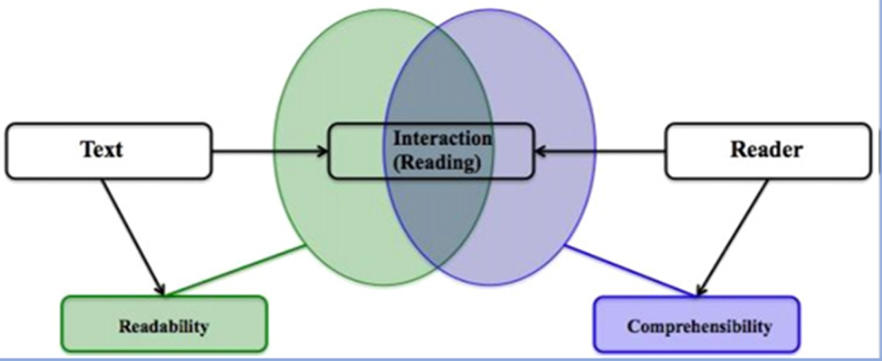
In other words, text readability depends on factors such as the average length of sentences, the number of new words it contains, and the grammatical complexity of the language used while comprehensibility is characterised by the extent to which a text is understandable. Thus, the TRI model is suitable for this study because it examines the relationship between a text, a reader and comprehensibility, and how these affect readers’ level of comprehension.
5. Methods
This study employed a mixed methods approach. The quantitative approach involved applying seven readability formulas to quantitatively determine the complexity or simplicity of the wording and sentence structure of selected online op-eds on myjoyonline.com. The reason for choosing myjoyonline.com is that the news website emerged as the online news portal of the year for the past two consecutive years at the prestigious Chartered Institute of Marketing Ghana (CIMG) Awards (Ibrahim, 2023). Also, it is owned by the Multimedia Group, the biggest private media outlet in Ghana.
5.1 Sample and selection procedures
Op-eds published from March 2020 to August ending 2020 were retrieved. This time frame was informed by the first incidence of COVID-19 in Ghana, reported in March 2020. The peak period was in May 2020 and lockdown restrictions were lifted in August 2020. Within this period, there was a concentration of op-eds on COVID-19 in mainstream and digital platforms due to uncertainties around the disease at the time.
We used relevant keywords, such as COVID-19 and CoronaVirus, to retrieve op-eds published on the opinion page of myjoyonline.com for the period under study. A total of 274 articles published within that period were retrieved. Out of this number, 44 articles written by experts in various fields of specialisation, such as health and finance, psychology, economics, agriculture, cybersecurity and strategic communication, were purposively selected. The articles provided expert advice on how the public could cope with different aspects of their lives that had been affected by the pandemic. Table 1 below provides an overview of articles (op-eds) selected for the study.
Table 1: Description of selected op-eds
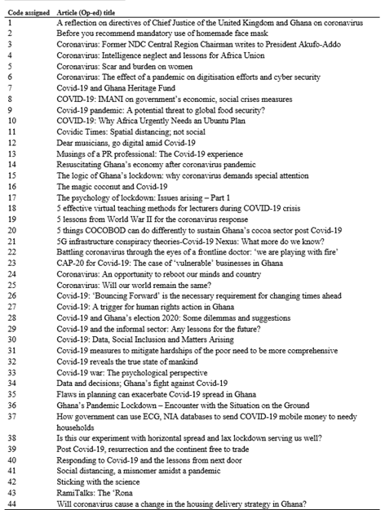
Source: Field data, 2023
5.2. Data analysis
Testing readability using readability formulas can help op-ed writers identify areas where the text may be difficult to understand and adjust accordingly (Lee, 2017). The selected op-eds were uploaded and subjected to an Online Check Test Readability Calculator to measure their readability levels and appropriateness for the reading public. The Online Check Text Readability Calculator is a software application that can receive a sample size text between 150-3000 words of plain text for conducting readability tests. We generated the results of the readability test by applying seven (7) online readability formulas - the Gunning Fog Index (G-FOG), Flesch-Kincaid Grade Level (F-KGL), Flesch Reading Ease score (FRE), The Coleman-Liau Index, The SMOG Index (SMOG), Automated Readability Index (ARI), Coleman-Liau Index (CLI), and Linsear Write Formula (LWF) - to measure the readability levels of each text or article. The classic formulae of FRE, G-FOG, and FKGL have been employed in the majority of studies to date, however, research indicates that using several readability formulas is more reliable and efficient, which is why seven formulas were used (Owu-Ewie, 2014; Hassan et al., 2016; Johnson, 2000; Fordjour, 2021). The results of the readability tests included the ‘Readability Consensus’ which gave an average score of the seven readability formulas for each of the forty-four op-eds used in the study. According to Johnson (2000), when comparing the readability of reading text / materials, it is important to use the average of more than one readability index formula. The triangulation of these seven readability formulas in this study therefore enhanced credibility.
Following the identification of each op-eds’ readability levels through the online readability text, a qualitative analysis was conducted on each text to identify the factors that affected each article's readability or otherwise. These were guided by the tents of the TRI model of what accounts for a text’s readability as well as relevant literature. According to the TRI model strategies, using plain language, shortening sentences and paragraphs, breaking up long sentences and paragraphs into shorter ones, using active voice instead of passive voice, including visual aids and providing context make a text readable (Green, 2018; Johnson, 2022; Brown, 2020; Jones, 2019).
Further, the op-eds were qualitatively analysed to examine the factors that affected the readability or otherwise. The results were then matched against the quantitative readability consensus results of the op-eds.
5.3 Ethical considerations
One major challenge in gathering data is ensuring the legality of using the data (Youyou et. al., 2015; Ahmed & Rajput, 2020; Ahmed, 2019). All the data used for the study were available from public sources and therefore did not require permission before using them for the study. It was also difficult to contact the authors to seek their consent before using their texts as the majority of them did not include their contact details in their bylines. To forestall potential ethical concerns, we have therefore anonymised the names of authors when referring to specific examples in the results and discussion sections.

6. Findings and discussion
6.1 Levels of Readability
Each readability formula was used to determine the readability level of each of the forty-four (44) op-eds that underwent the readability test. The readability test results were coded on a scale of 1 to 7, guided by Wyath and Schnelbach’s (2008) FRE score description as indicated in Table 2 below.
Table 2: Interpretation of readability index based on Wyath and Schnelbach’s reading score
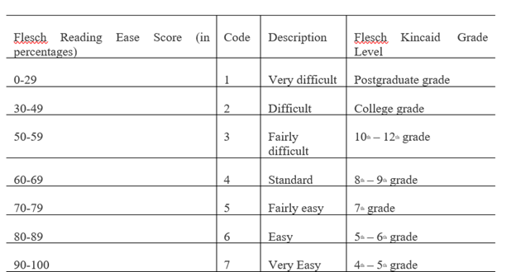
Source: Wyath and Schnelbach (2008)
Based on Wyath and Schnelbach’s table above, 1 represents above 17th grade (that is, postgraduate level); 2 represents 13th – 17th grade (that is, college/university level); 3 represents 10th – 12th grade which can be likened to the Ghanaian educational system where 3 is SHS 1 – SHS 3; 4 represents Junior High School (JHS) 2 – 3; 5 represents JHS 1; 6 represents Primary 5 – 6; and 7 represents Primary 4 – Primary 5.
The readability test results, using the seven readability formulas, were conducted, and the consensus of all the seven formulas was tabulated as shown in Table 3 below:

Results for readability levels and appropriateness to readers of op-eds
Table 3: Readability Consensus (RC)
Code |  | Frequency | Percent | Interpretation | Age appropriateness
 | 1  2 | 2  28 | 4.5  64 | Very Difficult  Difficult | Above 22 years  18 – 22 years
 | 3 | 10 | 23 | Fairly Difficult | 15 – 18 years
 | 4 | 2 | 4.5 | Standard | 13 – 15 years
 | 5 | 1 | 2 | Fairly easy | 12 – 13 years
 | 6 | 1 | 2 | Easy | 10 – 12 years
 | Total | 44 | 100
Source: Field data, 2023
Taking a cue from Wyath and Schnelbach’s (2008) reading score proposition, Table 3 shows that the readability consensus across all seven formulas employed in the statistical analysis revealed that 28 out of 44 articles were difficult to read, 10 were fairly difficult to read, two were standard and one was fairly easy to read, while another one was easy to read. Age appropriateness however is a crucial factor in determining the suitability of reading materials for students (Peng, 2015). A text that is above the age of readers tends to stress them, while a too easy text does not challenge readers’ abilities (Fatirwati & Syarif, 2017; Kasule, 2011; Westwood & Holliday, 2019). Based on this, we interpreted the age appropriateness in Ghanaian grade level and found that 64% of the articles were difficult to read for persons aged between 15 and 22 years (and above).
Except for the 8.5% of articles that were standard, fairly easy, and easy to read, the rest are generally difficult for most of the reading class of the op-eds, which in our study, we assume should, at minimum, be attending, junior high or senior high school. This means that 64% of the reading public would have found it difficult to read and required a university or college education to fully understand the texts. Senior High and Junior High students were not likely to have read and understood texts well enough to be able to interpret or share learnings with their uneducated relations or younger siblings, considering that the 2021 Ghanaian Population and Housing Census revealed that 7.9 million of the approximately 30 million individuals aged 6 and above are illiterate (Ghana Statistical Service, 2022).
In other words, the majority of the reading class would have been denied critical information regarding their health and well-being during the COVID-19 pandemic as the statistics show in Table 3. The results of our analysis confirm that op-eds that were written during the pandemic were not targeted at the appropriate reading levels of the reading public. This may have added to the already complex management of the health crisis resulting in communication gaps which possibly left some handicapped in terms of best health practices (Ghanem & Brinkhurst, 2019; Kwon, Lee & Sung, 2020).

6.2 Factors Affecting Readability
6.2.1 Word Count
The Check Text Readability Calculator was used to calculate the average word count of each sentence per op-ed. According to Vincent (2014), when an average sentence length is 14 words, readers understand more than 90% of what they are reading. At 43 words, comprehension drops to less than 10%. Ultimately, the Check Text Readability Calculator equally shows Graph Statistics of the various grade levels scored for a text as shown in Table 4.
Table 4: Op-ed statistics
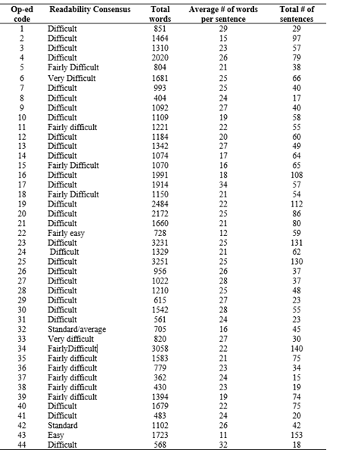
Source: Field data, 2023
The average word count plays a critical role in the readability of a text (Cutts, 2020). The word count for the op-eds reviewed ranged from 11 and 34 words per sentence, and these affected the levels of readability. Generally, it was found that the texts that were marked as easy to read had an average word count of 11 and 12 words in a sentence, as Vincent (2014) postulated. An example of a paragraph that the readability test considered easy to read was:
Speaking of all this social distancing, it’s creating a new lifestyle for all of us, innit?! How come no one has suggested a virus party? You know, just for stupid reasons. As you may have realised, the virus has shown just how deep the stupidity runs in some people. So why not have a party to showcase your efforts towards attracting the virus? No one has suggested it yet? Oh wait! (Op-ed 43)
The sentences in the above paragraph were also punctuated appropriately to allow for easy reading. The author used simple sentences and familiar words. However, total word count that ranged between 404 and 3251 words were graded as difficult to read. An example of a sentence from an op-ed what was graded difficult is found below:
On the 23 of March 2020, The OLCJ not satisfied with the first and second directive issued its 3rd directive calling for not more than 10 persons to be in the court (taking into account the judge, court staff) and where there is space to accommodate recommended social distancing measures should be applied (Op-ed 1)
Cutts, (2020) submits that readers rate difficulty levels based on the number of words per sentence. Any text that has 29 words and above in a sentence is considered very difficult to read and that affects readers’ level of comprehension. The above is a single sentence also punctuated correctly; however, it was deemed unreadable since it is rather too long (53 words) and complicated for a sentence.
The factors that have been widely reported to aid readability are familiarity of words, accurate spelling, correct grammatical spellings, simple sentence structure and text structure (Freahat, 2014; Dubay, 2004; Zamanian & Heydari, 2012; Zantoni, 2018; Kasule, 2011). As a result of the nature of op-eds, they usually undergo rigorous grammar and spelling checks by editors of the media outlets before they are published. Therefore, factors relating to accurate spelling and correct grammatical spellings are irrelevant to this study. However, it is evident from our data that other textual factors affected the readability of op-eds. These factors were the use of familiar words, simple sentence structures and the use of subheadings which are discussed below.

6.2.2 Familiar Words (simple language)
One undeniable characteristic of easy to comprehend text is previous knowledge of the content of the text (McCarthy & McNamara, 2021; Goldman et al., 2012). In effect, for readers to comprehend a text, it must contain words that they already know (Fountas & Pinell, 2001). This characteristic becomes even necessary when the text is not directed at a particular audience per se, but to the general public which is made up of different readers with different backgrounds. For instance, in Op-ed 42 which is rated standard, the writer consistently used familiar words as shown in the following excerpt:
I met a policewoman this morning who did not have a mask on when she stopped me. I was not wearing a mask myself, because I had been sitting alone in an air-conditioned car. Our separation was just about a metre. I showed her my cards. She waved me on. And then I asked her where her mask was. She said she did not have one. I picked up a spare N95 in my bag, gave it to her and drove on, my mind teeming with questions.
Yesterday, the neurosurgical world lost a giant. I was privileged to sit in Prof Goodrich’s lecture in October last year. He was talking about his experience in leading work all over the world to separate craniopagus twins. These are babies born joined at the head (Op-ed 42)
As shown in the excerpt, the use of familiar words contributed to the easy understanding of the text. It appears the writer is aware of the importance of using familiar language to his readers and was intentional with the choice of words used. Thus, when the writer inevitably had to use a technical and an unfamiliar word, the writer took the initiative to explain the term to the “lay” reader as shown in the quote below
He was talking about his experience in leading work all over the world to separate craniopagus twins. These are babies born joined at the head (0ped-42)
It appears that the deliberate attempt by the writer to use familiar and simple language contributed to the readability of the text. According to Frisson and Pickering (2007), the reason familiar words are easier to comprehend is that cognitively, familiar words require less processing effort to comprehend. However, unfamiliar words require more processing time to comprehend as shown from an excerpt from Op-ed 19 below:
By then, industries large and small had joined the war effort: Washing machine manufacturers made artillery shells. Vacuum cleaner companies made bomb fuses. Tanks, airplanes, and anti-aircraft guns rolled off assembly lines that had once produced automobiles. American industry produced more than 96,000 planes in 1940 alone — a 26-fold increase over the 3,611 airplanes produced in 1940. An official military history credits American war production in its heyday with “virtually determining the outcome of the war.”
Words such as “artillery shells”, “anti-aircraft guns” and “assembly line” are technical terms that are related to war and may be understood mostly by readers who are familiar with war or military terminology. Since the article is targeted at the public, the text is rated “difficult” because cognitively, it will take more processing time to comprehend the text.
Many studies affirm that background knowledge plays a significant role in reading and understanding a text (Pulido, 2007; Brantmeier, 2005). For example, lack of cultural familiarity in L2 readers’ reading of text has a greater impact on reading comprehension.

6.2.3 Simple Sentence Structure
Another important feature that affects the readability of text is structure (DuBay, 2004; Freahat, 2014). The simpler the sentence structure of a text, the more readable the text is. Simplicity here refers to both the length and the nature of the sentence. A close look at the easy to read, fairly easy to read and standard op-eds shows that the authors used simple text structures usually consisting of simple and compound sentences. For instance, in the following standard-readable text, the author used mostly simple sentences to convey his opinion:
Listen to the experts’ advice. Social distancing, stay at home. Fruits and vegetables should dominate your dinner table. You’re to live and be part of the history makers. The pandemic has given a clear cut to the job we have ahead of us. We have no other place to go than our homes when everyone slums shut his doors (0p-ed 32)

It is also worth noting that the op-eds with simple sentence structure used familiar words. This is an indication that an author who wants to make their text readable must rely on more than one of these characteristics. On the contrary, more difficult to read texts appear to have complex sentence structures as shown in the following excerpt:
The informal sector has been part of Ghana’s economic activities since the post-independence era. In fact, it is worth noting that the terminology “informality” which is used to describe activities in the sector in academic/policy dialogues emerged from the Ghanaian experience. Seen as illegal and a nuisance, many African Governments ignored the presence of the sector because the thinking was that it would die out naturally once formal employment expanded. Sixty years on, the so-called illegal and temporal phenomenon has grown to become the largest job creation sector in African economies, accounting for as much as 80% employment and 50% to GDP (Op-ed 29)
Sentences 2, 3, and 4 in the above excerpt have 27, 29, 32 words, respectively. These figures are far higher than the average needed to make a text readable. The overarching evidence of the effect of the complex sentence structures on comprehension can be seen from the fact that Op-ed 29 makes use of familiar words and the total word count is only 615 (one of the shortest op-eds used in the study) but uses a lot of long and complex sentences. Thus, in spite of the familiarity of words and the brevity in text length, the complexity of sentences is enough to engender Op-ed 29 as a difficult to read text. This observation confirms the results of the readability index test which showed that the average word count in a sentence can affect readability.
Therefore, the more words in a sentence, the more complex it is likely to be and the more difficult it will be to comprehend. Similarly, Zamanian and Heydari (2012) suggest that text readability depends on many factors including the average length of sentences, the number of new words it contains, and the grammatical complexity of the language used in the passage. These factors are greatly centred on the fact that writing style is a prime determiner of readability and hence the factors are based on linguistic variables.

6.2.4 The use of subheadings
Another factor that improves the readability of a text is the use of subheadings. We found out that most of the difficult to read texts were not only lengthy but also lacked subheadings altogether. Since the majority of the readable text were not lengthy, they did not seem to require subheadings. However, one article (#42) that was analysed to be easily readable had an article length of 1,090 which is higher than the average number of words needed to make a text readable. A closer look at the text reveals that the author used subheading and this greatly aided the readability of the text as shown in Figure 2 taken from Op-ed 42:
Figure 2: Figure showing a clipped part of an article with subheadings (op-ed 42)
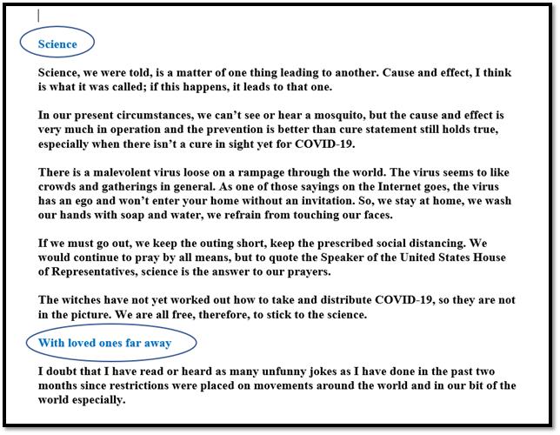
Thus, the use of subheadings in Figure 2 aids in the comprehension of the text. Similarly, Cekiso (2012) shows that headings and subheadings are effective strategies used by 11th graders in comprehension tasks. In contrast, articles that were rated as difficult to read did not only long, but also subheadings were not used in organising the text as shown from a clipped section of Op-ed 6:
Figure 3: Figure showing a clipped part of article with no subheadings (op-ed 6)

A comparison between Figure 2 and Figure 3 shows that both op-eds organised the ideas in paragraphs. However, Figure 3 does not use subheadings although it appears to have a more dense paragraph structure. Thus, organising ideas in paragraphs may not be enough to simplify a text especially when the text is long. The use of subheadings appears to be a more effective method. This is evident when we compare Figure 3 above and Figure 4 below (Op-ed 11).
Figure 4: Figure showing a clipped part of the article with subheadings but graded difficult to read (Op-ed 11)
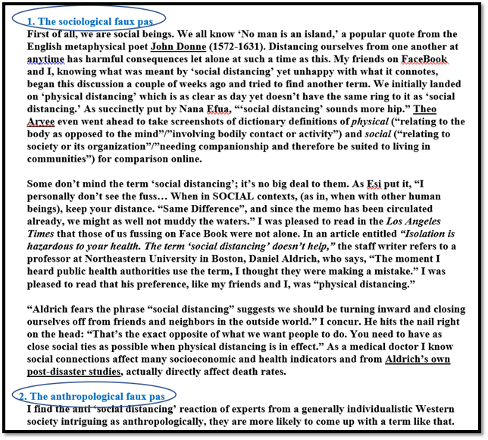
The comparison shows that Figure 3 and 4 have similar characteristics in their use of longer sentences, dense paragraph structure and unfamiliar words. However, while Figure 3 is rated as “very difficult”, Figure 4 is rated as “fairly difficult”. That leaves the question as to why they are rated differently in spite of their similar characteristics. The answer, we believe, lies in the use of subheadings in Figure 4. This is because the use of subheadings as shown improves the readability of a text (Cekiso, 2012).
Critics such as Zantoni (2018), argue that the determination of readability focuses solely on writing style which concentrates on the syntactic and lexical elements and excludes issues such as content, coherence, and organisation in the text. This assertion by Zantoni (2018) is weakened by the use of subheadings as argued by Cekiso and demonstrated in Figure 4. Thus, text organisation and in this context, the use of subheadings, can aid text comprehension.
In addition, DuBay (2004) asserts that writers can improve the readability of their text by using familiar words, accurate spelling, correct grammatical and simple sentence structures, culture-and-gender-neutral language, punctuation, active voice, and present tense. Even though DuBay’s list of factors is not about average word per syllables, nor average sentence length variables, the fact that the factors still consider the linguistic aspect of readability is undeniable. These considerations that are text and reader-centred are of great importance to op-eds readability, as our study found since readers are supposed to engage in interactive reading to enhance comprehension of the text.
It has been argued that when the interest of a reader is low, the readability of the text tends to influence the comprehension of the text by the reader (Tabatabaei & Bagheri, 2013). However, we contend that although the pandemic welled up interest in COVID-19-related information and necessitated the readability of texts, they were difficult to comprehend. Thus, we conclude that if interest in a text is high and other factors that affect readability are absent, comprehension is likely to be low as evidenced by our study.
7. Conclusion and recommendations
The results of the study showed that the lesser the overall word count and average word-per-sentence, the easier it is to read and comprehend texts. Based on this, it is recommended that the word count for op-eds should contain an average total word count of 600 - 800 to make them readable. This is supported by King (2014) who recommends a word count of 600 - 750. His recommendation was based on data across five media publication sources and traditional print newspaper standards which are mostly between 400 – 600-word count. This is in sharp contrast to some of the difficult to read articles that this study found which had as high as 3251 words. Alternatively, to facilitate the reader's navigation of the text and to enhance readability, we recommend that op-eds longer than 800 words should be divided into subheadings. We believe that subheadings serve as a signal to readers when an author switches to a different or related topic and helps readers maintain focus enough to comprehend the text.
The study also recommends the breaking up of long sentences and paragraphs into shorter ones and using familiar words to help readers understand the main points in articles better. The study further recommends the use of active voice instead of passive voice to make the text more engaging, clear, concise, and easier to understand. Additionally, the study found two op-eds to be easy to read. These op-eds contained pictures that illustrated their messages so, based on this finding, the study recommends that visuals such as charts, graphs, and images be used to improve readability. Visual aids can help readers understand complex information and make the article more visually appealing.
More so, op-eds writers should provide context in the form of background information to enhance readers’ understanding of the information. Ultimately, it will be useful for op-ed writers to conduct readability tests to identify areas or potentially difficult to understand texts and make adjustments accordingly, as suggested by Lee (2017).
Limitations and future research
This study examined the readability of particular publications that were deemed advisories from a variety of professional perspectives in an effort to educate the public about the COVID-19 pandemic's consequences and how to manage them. Although the online readability index assessment tool employed to analyse data allowed us to achieve our goals, it needs to be noted that the tool was created for first language readers (L1) and may have influenced the outcomes of tests. However, the test is still helpful and instructive because it means that second language (L2) speakers will have a harder time reading the texts than L1 speakers did. Regardless, it would also be useful for scholars to look into developing a readability assessment tool that caters to L2 speakers of the English language.
For future research, we propose studies comparing the readability indices of op-eds published in print and online to see if there are any discrepancies and what might account for that. Studies examining the readability of editorials, media reports, and op-eds unrelated to COVID-19 are also recommended. Finally, research comparing readers' perceptions of text readability with the readability of articles could bring new insights to the scholarship on readability.

References

Ahmed, S., Rajput, A.E., Sarirete, A., & Chawdhery, T. J., (2020) Social Media Platform:
Measuring Readability and Socio-Economic Status. Academic Press.

Ahmed, S., & Rajput, A., (2020). Threats to Patients Privacy in Smart Healthcare
Environment. In Innovation in Health Informatics (pp. 375-393). Academic Press.

Ahmed, S. (2019). BYOD, personal area networks (PANs) and IOT: Threats to patients
privacy. In The International Research & Innovation Forum (pp. 403-410). Springer, Cham.

Boles, C. D., Liu, Y., & November-Rider, D. (2016). Readability levels of dental
patient education brochures. American Dental Hygienists' Association, 90(1), 28-34.

Bothun, L. S., Feeder, S. E., & Poland, G. A. (2021, August). Readability of Participant
Informed Consent Forms and Informational Documents: From Phase 3 COVID-19 Vaccine
Clinical Trials in the United States. In Mayo Clinic Proceedings (Vol. 96, No. 8, pp. 2095-
2101). Elsevier.

Brantmeier, C. (2005). Anxiety about L2 reading or L2 reading tasks? A study with advanced
learners. The Reading Matrix 5(2), 67-85.

Brennan, O. C., Moore, J. E., Nutt, T. W., Moore, P. J., & Millar, B. C. (2021). Improving
meningococcal MenACWY and 4CMenB/meningococcal group B vaccine‐related health
literacy in patients: Importance of readability of pharmaceutical Patient Leaflets. Journal of
Clinical Pharmacy and Therapeutics, 46(4), 1109-1116.

Brown, A. (2020). Linguistic analysis as a method for assessing the readability of op-eds. Journal
of Communication Research, 45(2), 123-136.

Cekiso, M. (2012). Reading comprehension and strategy awareness of Grade 11 English Second
Language learners. Reading & Writing-Journal of the Reading Association of South Africa,
3(1), 1-8.

Cekiso, M. (2012). Reading comprehension and strategy awareness of Grade 11 English Second
Language learners. Reading & Writing-Journal of the Reading Association of South Africa,
3(1), 1-8.

Costantini, H. & Rie F. (2022). Health Information on COVID-19 Vaccination: Readability of
Online Sources and Newspapers in Singapore, Hong Kong, and the Philippines. Journalism
and Media (3), 228–237. https://doi.org/10.3390/journalmedia3010017

Cutt, M (2020) Oxford guide to plain English (5th ed.) In Mary M. (Ed.) Oxford, UK: Oxford
University Press.

Della Togna, M., Garman, A., Adjin-Tettey, T. D., Diale, M., Hyera, F., Bukula, T., Halse, P.,
Petersen, F., Bombi, T. & Kleyn, L., (2021). Chapter 4. Communication. South Africa Covid-
19 Country Report [First edition]. DPME (Department of Planning, Monitoring and
Evaluation), GTAC (Government Technical Advisory Centre) & NRF (National Research
Foundation), Pretoria: June.

Doherty, S. (2012). Investigating the Effects of Controlled Language on the Reading and
Comprehension of Machine Translated Texts: A Mixed-Methods Approach. Thesis submitted
for the degree of Doctor of Philosophy School of Applied Language and Intercultural Studies
Dublin City University.

DuBay, W. H. (2004). The Principles of Readability. Costa Mesa, CA: Impact Information.
https://files.eric.ed.gov/fulltext/ED490073.pdf

Emanuel, E. J., & Boyle, C. W. (2021). Assessment of length and readability of informed consent
documents for COVID-19 vaccine trials. JAMA network open, 4(4), e2110843-e2110843.

Finset, A., Bosworth, H., Butow, P., Gulbrandsen, P., Hulsman, R. L., Pieterse, A. H., … van Weert,
J. (2020). Effective health communication – A key factor in fighting the COVID-19
pandemic. Patient Education and Counselling, 103 (5), 873–876.
doi:10.1016/j.pec.2020.03.027

Freahat, N. M. (2014). A Comparison of Reading Levels of High School and Freshmen University
Students in Jordan. Theory & Practice in Language Studies, 4(10), 2042-2050.

Fordjour, V. E. (2021). Readability index assessment of non-prescribed supplementary English
language textbooks in selected Ghanaian private senior high
schools. http://hdl.handle.net/11602/1682.

Fountas, I. & Pinell, G. S. (2001). Guiding Readers and Writers Grades 3-6: Teaching
Comprehension, Genre, and Content Literacy. Portsmouth, NH: Heinemann.

Frisson, S., & Pickering, M. J. (2007). The processing of familiar and novel senses of a word: Why
reading Dickens is easy but reading Needham can be hard. Language and
Cognitive Processes, 22(4), 595-613.

Galaa, E., Nanglakong, C. D., & Ganaa, C. (2018). Readability Index on various Ghanaian News.
American Academic Scientific Research Journal for Engineering, Technology, and Sciences,
39(1), 62-72.
Ghana Statistical Service (2022), Illiteracy in Ghana: Trends, patterns and correlates.
https://census2021.statsghana.gov.gh/subreport.php?readreport=MTM0NTk2MjQzOS4yMDE1 &Illiteracy-in-Ghana-Trends-Patterns-and-Correlates.

Ghanem, L., & Brinkhurst, M. (2019). Readability index assessment of COVID-19-related op-eds.
Journal of Opinion Research, 42(4), 78-92.

Goldman, S. R., Braasch, J. L., Wiley, J., Graesser, A. C., & Brodowinska, K. (2012).
Comprehending and learning from Internet sources: Processing patterns of better and poorer
learners. Reading Research Quarterly, 47(4), 356-381.

Green, S. (2018). The role of visual aids in improving the readability of op-eds. Journal of Visual
Communication, 21(4), 67-81.

Hunt, W. T. N., Sofela, J., Mohd Mustapa, M. F., British Association of Dermatologists’ Clinical
Standards Unit, Levell, N. J., McDonald, B., ... & Mohd Mustapa, M. F. (2022). Readability
assessment of the British Association of Dermatologists’ patient information leaflets. Clinical
and Experimental Dermatology, 47(4), 684-691.

Ibrahim, A. (2023, 1 October) The Multimedia Group wins big at 34th CIMG Awards.
https://www.myjoyonline.com/the-multimedia-group-wins-big-at-34th-cimg-awards/

Johnson, K. (2000). Readability and reading ages of school science textbooks.
http://www.timetabler.com/reading.html

Johnson, R. (2022). Providing context in op-eds to improve readability. Journal of Opinion
Writing, 19(1), 23-37.

Jones, M. (2019). Shortening sentences and paragraphs in op-eds to improve readability. Journal
of Opinion Research, 44(3), 56-69.

Kasule, D. (2011). Textbook readability and ESL learners. Reading & Writing, 2(1), 63-76.

King, R. (2014). More than you wanted to know about op-ed length. https://phairadvantage.com/2014/09/more-than-you-wanted-to-know-about-op-ed-length/

Kolahi, S., & Shirvani, E. (2012). A Comparative Study of the Readability of English Textbooks
of Translation and Their Persian Translations. International Journal of Linguistics, 4(4), 344-
361.http://dx.doi.org/10.5296/ijl.v4i4.2737

Kwekowe, U. P., & Ezeifeka, C. R. (2022). The readability level of selected Nigerian newspaper
editorials. Nigerian Journal of Arts and Humanities (NJAH), 1(1), 121-125

Kwon, S., Lee, M., & Sung, Y. (2020). Role of online newspapers in providing information during
the COVID-19 pandemic. Journal of Mass Communication, 32(4), 78-91.

Laungani, R., Chen, I., Lui, C., Gong, J., Yoo, D. & Miyamoto J. (2020,). The Impact of COVID-
19 on Media Consumption Across North Asia. (Nielsen Global Media). https://www.nielsen.com/apac/en/insights/report/2020/the-impact-of-covid-19-on-media consumption-across-north-asia/

Lee, H. (2017). Testing readability using formulas for COVID-19 op-eds. Journal of
Communication Research, 40(2), 134-148.

Lee, H. (2019). Readability software for analyzing the readability of op-eds. Journal of Computer-
Assisted Communication, 52(1), 45-59.

Luge, T. (2020). Covid-19: How to keep your audience informed. https://www.dw.com/en/covid- 19-how-to-keep-your-audience-informed/a-52952384

McGeehan, J., & Foster, K. (2018). Variation in readability of op-eds by expert writers. Journal of
Opinion Writing, 16(2), 87-101.

Melki, J., Tamim, H., Hadid, D., Farhat, S., Makki, M., Ghandour, L., & Hitti, E. (2022). Media
exposure and health behavior during pandemics: the mediating effect of perceived knowledge
and fear on compliance with COVID-19 prevention measures. Health communication, 37(5),
586-596. https://doi.org/10.1080/10410236.2020.1858564

Moore, J. E., & Millar, B. C. (2021). Improving COVID‐19 vaccine‐related health literacy and
vaccine uptake in patients: Comparison on the readability of patient information leaflets of
approved COVID‐19 vaccines. Journal of Clinical Pharmacy and Therapeutics, 46(6), 1498-
1500.

Nature Research Custom. (n.d.). Science communication in the COVID-19 pandemic.
https://www.nature.com/articles/d42473-020-00329-z

Owu-Ewie, C. (2014). Readability of Comprehension Passages in Junior High School (JHS)
English Textbooks in Ghana. Ghana Journal of Linguistics, 68, 35-68.

Paek, H. J., 2016. Effective risk governance requires risk communication experts. Epidemiology
and Health, 38, e2016055. doi: 10.4178/epih.e2016055

Pancer, E., Chandler, V., Poole, M., & Noseworthy, T. J. (2019). How readability shapes social
media engagement. Journal of Consumer Psychology, 29(2), 262-270.

Patel, N. (2021, July), The Concept of Readability by Edgar Dale and Jeanne Chall, 1949. https://www.linkedin.com/pulse/concept-readability-edgar-dale-jeanne-chall-1949-nirmal-patel/

Peng, C. C. (2015). Textbook Readability and Student Performance in Online Introductory
Corporate Finance Classes. Journal of Educators Online, 12(2), 35-49.

Perez, M., et al. (2021). Readability assessment of COVID-19-related social media posts. Journal
of Health Communication, 36(4), 112-126.

Pothier, L., Day, R., Harris, C., & Pothier, D. D. (2008). Readability statistics of patient
information leaflets in a Speech and Language Therapy Department. International Journal of
Language & Communication Disorders, 43(6), 712-722.

Pulido, D. (2007). The effects of topic familiarity and passage sight vocabulary on L2 lexical
inferencing and retention through reading. Applied Linguistics, 28: 66-86.

Ratzan, S., et al. (2021). Readability assessment of COVID-19 vaccine information on US state
and city websites. Journal of Health Communication, 36(1), 23-37.

Shehata, M., & Ali, M. (2020). Study of the impact of newspaper layout on readability of Egyptian
newspapers. International Design Journal, 10(1), 177-189.

Sparks, J. F., & Hmielowski, J. D. (2023). At the extremes: Assessing readability, grade level,
sentiment, and tone in US media outlets. Journalism Studies, 24(1), 24-44.

Tabatabaei, E. & Bagheri, M., S. (2013). Readability of Reading Comprehension Texts in Iranian
Senior High Schools Regarding Students' Background and Interest. Journal of Language
Teaching and Research, 5, 1028-1035.

Temnikova, I., Vieweg, S., & Castillo, C. (2015). The case for readability of crisis communications
in social media. Proceedings of the 24th International Conference on World Wide Web, pp.
1245-1250.

Vincent, S. (2014). Sentence length: Why 25 words is our limit. https://insidegovuk.blog.gov.uk/2014/08/04/sentence-length-why-25-words-is-our-limit/

Walsh, T. M., & Volsko, T. A. (2008). Readability assessment of internet-based consumer health
information. Respiratory Care, 53(10), 1310-1315.

Wyatt, E. S., & Schnelbach, S. D. (2008). Calculating Reading and Writing Levels. Tameri Guide
for Writers. https://www.tameri.com/teach/reading-levels/

Youyou, W., Kosinski, M., & Stillwell, D. (2015). Computer-based personality judgments are more
accurate than those made by humans. Proceedings of the National Academy of Sciences,
112(4), 1036-1040.

Zamanian, M., & Heydari, P. (2012). Readability of Texts: State of the Art. Theory & Practice in
Language Studies, 2(1), 43–53.

Zantoni, M. (2019). The readability level of reading texts in the english textbook entitled “English
on sky 2” used by the Eighth Grade students of SMP Budaya Bandar Lampung in the
Academic Year of 2017/2018. Doctoral dissertation, UIN Raden Intan Lampung.

