Impact of Intonational Cues on Legal Witnesses' Credibility in Nigerian Courtroom Trials

Abstract

This study examines intonation patterns in Nigerian courtroom trials, focusing on prosecution and defense lawyers, as well as litigants. Grounded in forensic linguistics and prosodic theory, the research investigates how paralinguistic features are strategically manipulated to manage credibility, express emotion, and persuade.
Using high-fidelity audio recordings from Magistrate and Federal High Courts in Osun State, the data were analysed using Praat software and qualitative discourse analysis. The findings reveal that legal professionals deploy specific intonation contours to challenge credibility. For example, a rising tone (L* H%) was used to imply an ulterior motive, while a fall-rise intonation (H* L-H%) highlighted a contradiction in testimony.
The study also demonstrates how litigants use intonation to convey emotional states, impacting their perceived credibility. A petitioner's low falling tune (L_L%) signaled defensiveness, reducing credibility. In contrast, a respondent's rising-falling intonation (L+H_ L-L%) built pathos and moral indignation, strengthening her perceived moral standing.
The study concludes that intonation is a potent, strategic tool in Nigerian courtroom discourse, far exceeding a merely ancillary role. Lawyers align their prosodic patterns with their institutional roles, prosecution favouring falling tones for assertion and certainty, and defense utilising a wider range of rising and complex contours to express doubt and empathy. Similarly, litigants’ intonational choices, whether deliberate or not, significantly shape judicial perceptions of their honesty and integrity. This research underscores the critical importance of paralinguistic communication in the pursuit of justice and contributes valuable insights to the field of forensic linguistics in non-Western contexts.

Keywords: Intonation, Credibility, Nigerian Courtroom, Forensic Linguistics, Prosody, Acoustic Analysis, Persuasion, Legal Discourse.

1.0 Introduction

In the adversarial legal system that characterises Nigerian criminal trials, the roles of the prosecution and defense are fundamentally distinct. The prosecution bears the burden of proving the defendant's guilt beyond a reasonable doubt, while the defense aims to create reasonable doubt and secure an acquittal. These opposing objectives necessitate different persuasive strategies, which are not only reflected in the content of their arguments but also in their linguistic and paralinguistic delivery. Intonation, as a key component of prosody, is a powerful tool for conveying stance, attitude, and emphasis, and it is hypothesised that prosecution and defense lawyers will exhibit distinct intonation patterns that align with their respective adversarial roles. While the rhetorical strategies of prosecution and defense have been extensively studied, the specific role of intonation in differentiating their communicative styles remains under-investigated, particularly within the Nigerian legal context. This study aims to fill this gap by conducting a comparative acoustic analysis of the intonation patterns employed by prosecution and defense lawyers in Nigerian courtroom trials. By examining how these legal actors strategically manipulate their vocal delivery, this research will provide valuable insights into the nuanced communicative dynamics of adversarial legal proceedings and contribute to a deeper understanding of forensic linguistics in a non-Western setting.

1.2 Statement of the Problem

The existing body of research on courtroom discourse and intonational cues, largely situated within Western legal systems and other fields (e.g., Akindele et al. 2024; Supardi, 2016; Pomerantz & Fehr, 2012; Tannen, 2005), has established that intonation is a critical strategic tool for persuasion. However, a significant gap exists in the application of this research to non-Western contexts, particularly Nigeria, where unique sociolinguistic norms, cultural nuances, and legal traditions may influence communicative practices. Within the Nigerian courtroom, the strategic deployment of language is paramount, yet the specific prosodic features namely intonation patterns used by legal professionals to achieve their adversarial goals remain empirically unexamined. It is unclear how Nigerian prosecutors and defense attorneys acoustically modulate pitch, stress and rhythm to assert authority, express skepticism, challenge credibility or invoke empathy. Furthermore, the role of intonation in conveying the emotional states and moral positions of litigants themselves, and how this affects their perceived credibility, is not understood. This lack of localised research limits a comprehensive understanding of persuasive communication in Nigerian judicial processes. Consequently, this study addresses this problem by investigating the distinctive intonation patterns used by prosecution and defense lawyers, as well as litigants, to determine how these paralinguistic features function as instruments of persuasion, credibility management, and emotional expression in Nigerian criminal trials.

1.3 Aim and Objectives

This study aims to conduct a comparative acoustic analysis of the intonation patterns employed by prosecution and defense lawyers in Nigerian courtrooms. Therefore, the study seeks to achieve the following objectives:

- to identify how intonation patterns are used by legal professionals (counsel) to challenge or undermine the credibility of opposing parties or witnesses
- to explore the use of intonation patterns by litigants (Petitioners/Respondents) to express defensiveness or moral indignation, and their impact on their perceived credibility

2.0 Literature Review

Institutional roles have a profound impact on linguistic choices and communicative styles. In the courtroom, the roles of prosecutor and defense attorney are clearly defined, and their language use is shaped by the institutional and strategic demands of these roles (Cotterill, 2003). The prosecution, representing the state, is expected to present a narrative of certainty and authority, constructing a case that leads to a conviction. Their language is often characterised by declarative statements, assertive language, and a focus on factual evidence (Couper-Kuhlen, 1986). In contrast, the defense, representing the accused, often employs a strategy of questioning, challenging, and creating alternative narratives. Their language may be more interrogative, empathetic, or even confrontational, depending on the specific context of the trial (Couper-Kuhlen, 2014). This role-based differentiation in communication is not limited to lexical choices but extends to paralinguistic features as well. The intonation patterns used by lawyers can signal their alignment with their institutional roles. For example, a prosecutor might use a consistently falling intonation to convey finality and authority, while a defense lawyer might use more varied intonation to express a range of emotions, from empathy for their client to skepticism towards the prosecution's case.

Supardi's 2016 study on Language Power in Courtroom: The use of Persuasive Features in Opening Statement presents language as a powerful instrument of persuasion, particularly within the legal framework. Although several studies have been dedicated to understanding how language functions within the courtroom, a setting where the strategic use of words can determine the liberty, rights and fate of individuals. A central tenet of this field is the recognition that lawyers employ language not merely to inform but to strategically persuade the jury of their client's position and to secure a favorable verdict. However, despite the breadth of scholarship on courtroom discourse, a significant gap persists. This study identifies the specific mechanisms through which language is constructed to achieve power and persuasion during the critical trial opening statement remain understudied. The opening statement represents the first and often most impactful opportunity for legal counsel to frame the narrative of the case for the jury, making its linguistic construction a subject of paramount importance. The study uses qualitative research methods to conduct a rigorous textual analysis of the linguistic patterns employed in a landmark opening statement using the defense's opening statement from the O.J. Simpson trial. Findings show that the persuasive power of language in this context is materially realised through specific literary and rhetorical devices. The analysis reveals that strategic use of metaphor provides relatable narrative frameworks for the jury, repetition (anaphora) is deployed to emphasise core themes and arguments, and rhetorical questions are employed to implicitly challenge the opposition's case and actively engage the jury's critical thinking.

Pomerantz and Fehr (2012) employ Conversation Analysis (CA) to dissect the subtle yet powerful role of intonational patterns in managing interactional dynamics within Australian courtroom exchanges. Their analysis focuses on how prosodic cues, especially final rises and falling intonations, contribute to the orchestration of turn-taking mechanisms, speaker alignment and the negotiation of institutional power relationships. A central finding is that final rises, particularly at the end of declarative statements, are frequently used by legal participants to signal uncertainty, request confirmation, or invite elaboration. These rising contours, while sometimes interpreted as a lack of confidence, also strategically keep conversational turns open, encouraging further dialogue. In contrast, falling intonation is associated with finality, decisiveness and authoritative stance-taking, often employed by judges and counsel when asserting control or concluding arguments. They argue that such intonational strategies are fundamentally tied to institutional norms and power asymmetries. For example, lawyers using rising intonation may subtly coerce witnesses into elaborating, while falling tones can signal the end of permissible discourse. This reflects how prosody structures courtroom participation, regulates conversational flow and reinforces or resists legal hierarchies. Their CA approach underscores how intonation interacts with turn-construction units (TCUs) and transition relevance places (TRPs), influencing when and how participants claim or yield the floor. This management of turn-taking is crucial in adversarial settings where utterance timing, length and nature significantly affect persuasiveness and perceived legitimacy. While insightful, the focus on Australian courtrooms limits direct transferability to other legal systems, particularly those with different legal traditions and linguistic backgrounds.

Tannen (2005) offers a compelling discussion on intonational modulation as a persuasive strategy in legal contexts, particularly how lawyers adapt their prosody to establish rapport and credibility with juries. Drawing from her foundational work in discourse analysis and sociolinguistics, Tannen argues that lawyers deliberately manipulate intonation, especially rising and falling contours—not merely for linguistic clarity but to enhance rhetorical effectiveness through appeals to ethos and pathos. According to Tannen, warm, rising tones are often used by attorneys to foster trust, build interpersonal connections and project openness, serving a relational function during narrative portions or emotionally sensitive content. Conversely, falling intonation projects certainty, control and authority, particularly during closing statements or factual aﬃrmations. This strategic use allows lawyers to calibrate their delivery, aligning affective tone with argumentative intent. Her work reveals how prosodic nuance complements verbal content, with intonation reinforcing or softening messages based on rhetorical goals. A statement of fact delivered with a falling tone asserts finality, while the same statement with a rising tone might invite doubt. This dual function of intonation as both linguistic and affective marker underscores its critical role in persuasive courtroom speech. Tannen situates intonation within narrative framing and performance, observing that lawyers balance advocate and storyteller roles, using vocal modulation to engage jurors logically and emotionally. This resonates with Aristotelian rhetorical theory, strengthening ethos and pathos, making intonation a crucial phonological tool for persuasive impact. However, Tannen's analysis, while comprehensive, is largely based on Western communicative norms and its direct applicability to diverse cultural contexts like Nigeria requires further empirical validation.

Recent developments in the study of intonation and legal discourse reflect a move toward interdisciplinary methodologies that combine corpus linguistics, prosody and argumentation theory. Among the most significant contributions are the studies by Gozd́z-Roszkowski (2021) and Coutinho et al. (2023), both of which bring fresh insights into the nuanced use of intonation in legal persuasion, particularly through empirical and technology-assisted approaches.
Gozd́z-Roszkowski (2021) examines judicial discourse with a particular focus on evaluation, stance-taking and persuasive framing, emphasising how prosodic emphasis interacts with discursive patterns in legal argumentation. Building on corpus-assisted discourse studies (CADS), he analyses courtroom speech for modal expressions, evidentiality markers and prosodic cues that enhance persuasive impact. Although the study focuses largely on the lexicogrammatical dimension, it acknowledges the role of intonation in guiding interpretation, especially in judicial summations and legal instructions, where pitch movement may signal authority, mitigate face-threatening acts, or foreground legal reasoning. This work provides a valuable methodological approach for analysing large datasets of legal discourse, which could be adapted for the Nigerian context.

Complementing this, Coutinho et al. (2023) offer a more technologically grounded phonetic and acoustic analysis of legal speech, using speech signal processing tools to analyse how intonational contours function in legal questioning and defense strategies. Their study reveals that pitch accents and boundary tones are systematically employed by legal actors to mark information structure, emphasise contradictions and manage turn-taking. Notably, they identify that high-rising terminals (HRTs) in cross-examinations often co-occur with strategic challenges or invitations to elaborate, reinforcing prior findings from interactional prosody literature. This empirical approach, leveraging advanced acoustic analysis, provides a robust model for investigating the precise phonetic realisations of intonation patterns in courtroom settings, which is directly relevant to the proposed
study in Nigeria.

3.0 Methodology
3.1 Method of Data Collection
The primary source of data will be high-fidelity audio recordings of spoken interactions between lawyers, judges and witnesses in the courtroom. To ensure a diverse and representative sample of legal disputes, the study will examine two different courtroom cases. These specific case types were chosen due to their inherent adversarial nature and the high stakes involved, which are conducive to the strategic deployment of persuasive intonation patterns. The recordings will be obtained from the Magistrate and Federal High Courts in Osun State, Nigeria, providing a localised and culturally specific context for the study. This approach is essential for accurate acoustic analysis, particularly for capturing subtle nuances of intonation, such as pitch variation, stress placement and rhythmic patterns. Ethical considerations will be strictly adhered to throughout the data collection process. Prior permission will be obtained from the relevant judicial authorities to record courtroom proceedings. All participants, including lawyers, judges, witnesses and jurors, will be fully informed of the study's purpose and procedures and their informed consent will be secured. The recordings will be stored securely and any identifying information will be meticulously removed from the transcripts to protect the privacy and anonymity of all participants.

3.2 Research Design
The research design will be a comparative study using 2 audio recordings from Nigerian criminal trials will be compiled, and the speeches of prosecution and defense lawyers will be systematically analysed and compared. The focus will be on identifying statistically significant differences in their use of various intonational features.
3.3 Participants
The participants for this study will be prosecution and defense lawyers whose speech is captured in the audio recordings of Nigerian criminal trials. The study will examine two different courtroom cases. These specific case types were chosen due to their inherent adversarial nature and the high stakes involved, which are conducive to the strategic deployment of persuasive intonation patterns.

3.4 Method of Data Analysis

The audio recordings will be subjected to a rigorous acoustic analysis using the specialised software Praat (Boersma & Weenink, 2023 and Akindele & Fabunmi, 2023). This analysis will focus on several key prosodic elements: Pitch Variation, i.e Examination of pitch contours of speech to identify patterns of intonation (rising and falling), which are necessary for conveying emphasis, emotion and authority (Couper-Kuhlen 1986). This will involve measuring fundamental frequency (F0) movements over time. This includes stress Placement (analysis of the prominence given to certain syllables or words within utterances and how this contributes to the persuasive power of legal arguments).
Furthermore, a detailed transcription of the audio recordings will be performed. The transcription process will involve segmentation of utterances into intonational phrases and prosodic units to facilitate the analysis of intonation patterns. Subsequently, the transcribed data will be meticulously annotated to identify key prosodic features such as pitch accents (e.g., H, L), boundary tones (e.g., L%, H%) and stress patterns, which are fundamental to understanding the role of intonation in persuasion (Ladd 1996). The qualitative analysis will complement the acoustic analysis by focusing on the contextual use and interpretation of intonation patterns in courtroom discourse. This analysis will employ discourse analysis techniques to examine how intonation patterns interact with other linguistic and rhetorical strategies to create persuasive effects (Atkinson 1984). Additionally, the study will draw on Interactional Sociolinguistics to analyse the role of intonation in signaling contextualisation cues and guiding listener interpretation (Gumperz 1982). The integration of quantitative acoustic analysis with qualitative discourse analysis will provide a comprehensive and nuanced understanding of the complex interplay between intonation, persuasion and interactional dynamics in the Nigerian courtroom. Potential discrepancies between acoustic measurements and perceived functions will be explored through careful qualitative interpretation, ensuring a holistic understanding of the data.

4.1 Data Analysis
4.2 Discussion of Findings
Trial 1: Comparison of Intonation Patterns in a Divorce hearing

This section presents a divorce proceeding heard at the State High Court of Osun State, in Town X, between Mr. A (Petitioner) and Mrs. M (Respondent). The case involves allegations of emotional cruelty, abandonment and disputes over property ownership following the breakdown of a 30-years marriage between the couple. The analysis of the interaction below represents how intonation patterns are used by different actors involved in the case.
SPEAKER | EXCERPT | INTONATION PATTERN | INTONATION FUNCTION | PERSUASIVE EFFECT
Petitioner's Counsel | “My Lord, my client… has endured years of constant quarrels…” | Falling Tune (H* L%) | Attitudinal – expresses seriousness and authority | Reinforces ethos; portrays the petitioner as calm, reasonable and justified.
Respondent's Counsel | “…he has another wife and now wants to get rid of my client…” | Fall-rise Tune (H* L-H%) | Attitudinal and discourse – expresses criticism | Invokes pathos; portrays the respondent as wronged and morally superior.
Petitioner (Mr. A) | “She locked me out of our bedroom for two years sir!” | Rising pitch on “locked me out”, falling on “two years” | Attitudinal and accentual – emphasises emotional strain | Evokes sympathy and supports the claim of emotional cruelty.
Petitioner (Mr. A) | “That's my private matter.” | Falling Tune (L* L%) | Attitudinal – reveals discomfort or defensiveness | Reduces credibility and opens room for suspicion.
Respondent (Mrs. M) | “He brought girlfriends home and stopped giving me housekeeping money.” | Rising-falling intonation (L+H* L-L%) | Attitudinal and accentual – mixes accusation with emphasis | Builds pathos and moral indignation.
Respondent (Mrs. M) | “Must a wife keep receipts?” | Rise (L* H%) - rhetorical question | Grammatical and attitudinal – challenge formal logic | Combines cultural ethos with emotional appeal.
Respondent's Counsel | “So you're divorcing your first wife because of a new wife?” | Rising tone (L* H%) | Grammatical – yes/no question with implied judgment | Weakens the petitioner's ethos by questioning his true motives.
Respondent's Counsel | “Under Section 72… unless joint contribution is proven…” | Falling tone with stressed keywords (H*L%) | Accentual and discourse – provides structure and emphasis | Appeals to logos, foregrounding statutory authority.
Respondent's Counsel | “Yoruba customary law recognises a wife's non-financial contributions." | Rising on “customary law,” falling on “contributions” | Accentual and discourse – asserts cultural logic | Connects ethos with logos and challenges Western legal formality.
Presiding Judge | “Calm down, Mrs. M. Answer the question.” | Flat and falling tone (L* L%) | Discourse and attitudinal – commands order and neutrality | Reaﬃrms judicial authority and regulates speaker conduct.

From the trial analysed above, the various patterns of tone, pitch and rhythm in the courtrooms. In courtrooms, facts are very important to win arguments. The use of tone of voice, pitch and rhythm that is, how they say things, not just what they say is very important in presenting evidence and winning arguments. Lawyers, judges and witnesses often raise or lower their voices, stress certain words or pause in specific ways. These voice behaviours send strong messages. They can show confidence, raise doubt, express anger or sadness or signal respect. This is why intonation is very important in understanding how persuasion happens in court.

For instance, when a lawyer speaks with a falling tone where the pitch of their voice drops at the end of a sentence it usually signals certainty and authority. This was seen in the way the petitioner's lawyer described the reasons for divorce: “She locked me out of our bedroom for two years sir!”. The falling tone made the statements sound final and believable.

On the other hand, a rising tone where the voice pitch goes up often shows doubt or invites a response. This pattern was used by the respondent's lawyer during cross-examination, especially when questioning the petitioner's true reasons for wanting a divorce, i.e “So you’re divorcing your first wife because of a new wife?”. The rising tone added pressure, encouraging the court to think more critically about the answers.

In witness testimonies, intonation patterns reflect emotions and mental states. For instance, when Mr. A said that his wife locked him out of their bedroom for two years “She locked me out of our bedroom for two years sir!”., his voice rose in pitch on “locked me out” and fell on “two years.” This kind of speech pattern shows that he was emotionally affected and wanted the court to see how serious the situation was. Meanwhile, when he was asked about having another wife, his response, “That’s my private matter,” was delivered with a flat tone, suggesting that he was uncomfortable or trying to avoid the topic.

Mrs. M also used her voice in powerful ways. The use of rising pitch when saying “Must a wife keep receipts?” did more than just ask a question; it challenged the fairness of the legal system using cultural logic. She was drawing attention to the idea that, in many Nigerian marriages, wives make valuable contributions that are not always documented with receipts or papers.
The judge's voice pattern was different from that of the lawyers and witnesses. Judges speak with a flat or low-falling tone, which signals control, calmness, and authority. For instance, when the Presiding Judge said, “Calm down, Madam M. Answer the question,” his tone helped manage the courtroom and reminded everyone of the expected decorum.

From the instances above, it is clear that intonation helps people to argue, convince, question or defend in court. It shapes how their words are understood and how powerful their speech becomes. It shows that Lawyers use tone to sound logical and authoritative, witnesses use tone to show emotion or defend themselves, while Judges use tone to control the flow of interaction.

Trial 2: Comparison of Intonation Patterns in a Family Land Dispute Trial

This case involves a land dispute within the extended (The K family from Y town). The issue centres on whether Mr.S. K and Mr. A.K. share the same family compound and who have the right to sell the disputed land. The respondent, referred to as "Baba," is cross-examined about family membership, leadership and property transactions. The lawyer presses him on specific compound affiliations and sales, while the defence lawyer intervenes at certain point to protect his client. This tense back-and-forth provides a background to examine how intonation patterns are used to manage courtroom dynamics.
SPEAKER | EXCERPT | INTONATION PATTERN | INTONATION FUNCTION | PERSUASIVE EFFECT
Petitioner's Counsel | “Sul…….. Ko……. wasn't a member of Olu……..'s compound; yes or no?” | Rising intonation (L* H%) | Attitudinal – expresses seriousness and authority | Pressures the witness to concede, signaling that any other answer would be surprising.
Petitioner's Counsel | “When the children sold the filling station… you were not told?” | Fall-rise intonation (H* L-H%) | Discourse and Grammatical - Polite disagreement | Underscores the discrepancy between the witness's claimed role and his actual exclusion.
Baba (Witness) | “I came here because of land issue.” | Falling (L*L%) | Attitudinal – shows his attempt to remain calm under pressure. | Conveys his focus on the subject, even as the questioning becomes aggressive.
Baba (Witness) | “They are not from same compound but same mother.” | Rise-Fall Intonation (L+H* L-L%) | Accentual - highlights key fact about sibling lineage. | Emphasises the nuance that maternal ties differ from patriarchal compound membership.
Respondent's Counsel | “Allow him to talk; you are preventing him from making clarifications.” | Falling Intonation (H*L%) | Discourse & attitudinal – reasserts courtroom etiquette. | Shifts control back to the witness, moderating the intensity of cross-examination.

As seen in this case, the lawyer’s questions serve to corner the witness, making it harder for him to cling to vague or contradictory statements. Each rise in pitch ups the pressure, signalling that an answer is expected; “Suliamon Korede wasn’t a member of Olugbede’s compound; yes or no?”; “When the children sold the filling station… you were not told?”. In contrast, Baba’s level responses show his effort to stay calm, even as the lawyer tries to rattle him “I came here because of land issue.”; “They are not from same compound but same mother.”. When he does stress important facts (like maternal vs. paternal lineage), his voice peaks and then falls, helping listeners notice and get detailed clarification.

The defence lawyer’s interventions use a falling tone to politely but firmly remind the court of respectful procedure, shifting the dynamic back from attack to fairness; “Allow him to talk; you are preventing him from making clarifications.” This case presents intonation as a powerful tool in cross-examination. Rising intonation can push a witness toward a concession; fall-rise intonation can highlight subtle distinctions, while falling intonation can reclaim decorum. These vocal strategies are just as important as the legal questions themselves, shaping how facts are perceived and how credibility is assessed.

Acoustic Presentation of Intonation Patterns
Trial 1

Figure 1: Petitioner's Counsel - Falling Tune (H*L%)
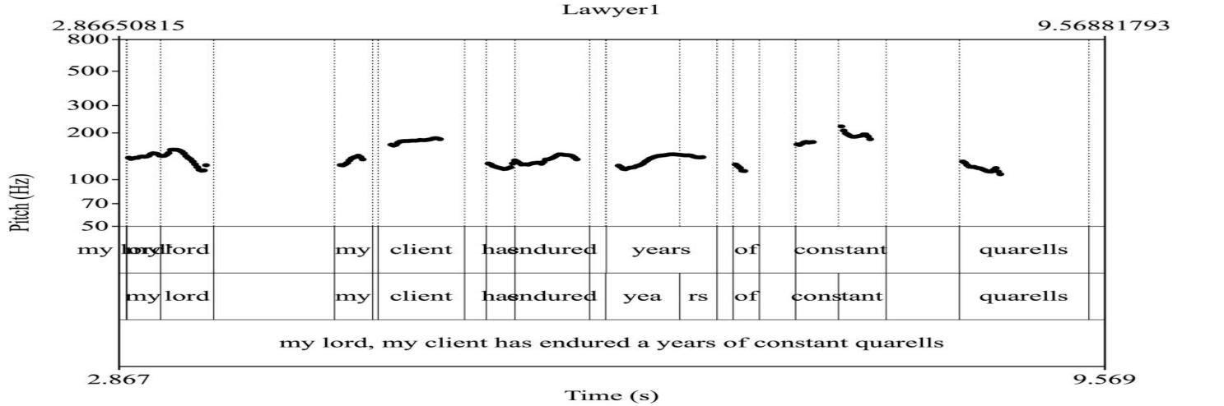
Figure 1 shows the acoustic representation of the Petitioner's Counsel's statement, "My Lord, my client… has endured years of constant quarrels…" The pitch contour shows a clear falling tune (H*L%), characterised by an initial high pitch followed by a descent to a low boundary tone. This conveys seriousness and authority, reinforcing the counsel's ethos and portraying the petitioner as calm, reasonable and justified. It signals finality and assertiveness in the legal argumentation.

Figure 2: Respondent's Counsel - Fall-rise Tune (H*L-H%)
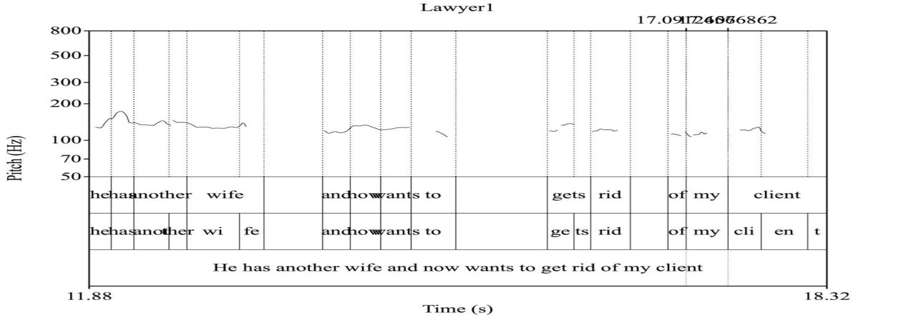
Figure 2 presents the acoustic analysis of the Respondent's Counsel's statement: "...he has another wife and now wants to get rid of my client..." The pitch contour illustrates a fall-rise tune (H*L-H%), which begins with a high pitch, falls and then rises at the end. This pattern is used to show criticism and introduce doubt, invoking pathos by portraying the respondent as wronged and morally superior. The final rise invites the listener to question the petitioner's true motives.

Figure 3: Respondent (Mrs. M) - Rising Tone (L* H%)
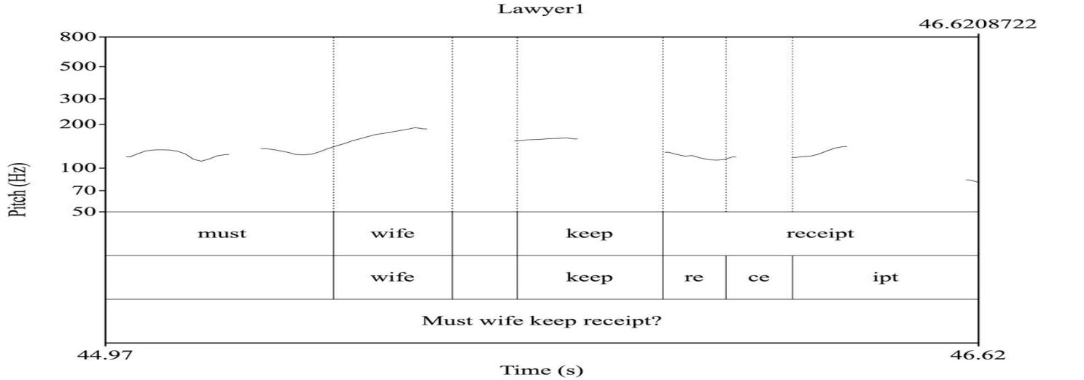
Figure 3 presents the acoustic analysis of Mrs. M’s rhetorical question: "Must a wife keep receipts?" The pitch contour shows a clear rising tone (L* H%), indicating a low pitch followed by a rise. This intonation pattern is used to combine cultural ethos with emotional appeal, challenging the formal logic of the court by invoking shared cultural understandings of marital contributions. It serves as a powerful persuasive tool to resonate with the local context and potentially influence the judge’s perception.

Figure 4: Petitioner (Mr. A) - Falling Tune (L* L%)
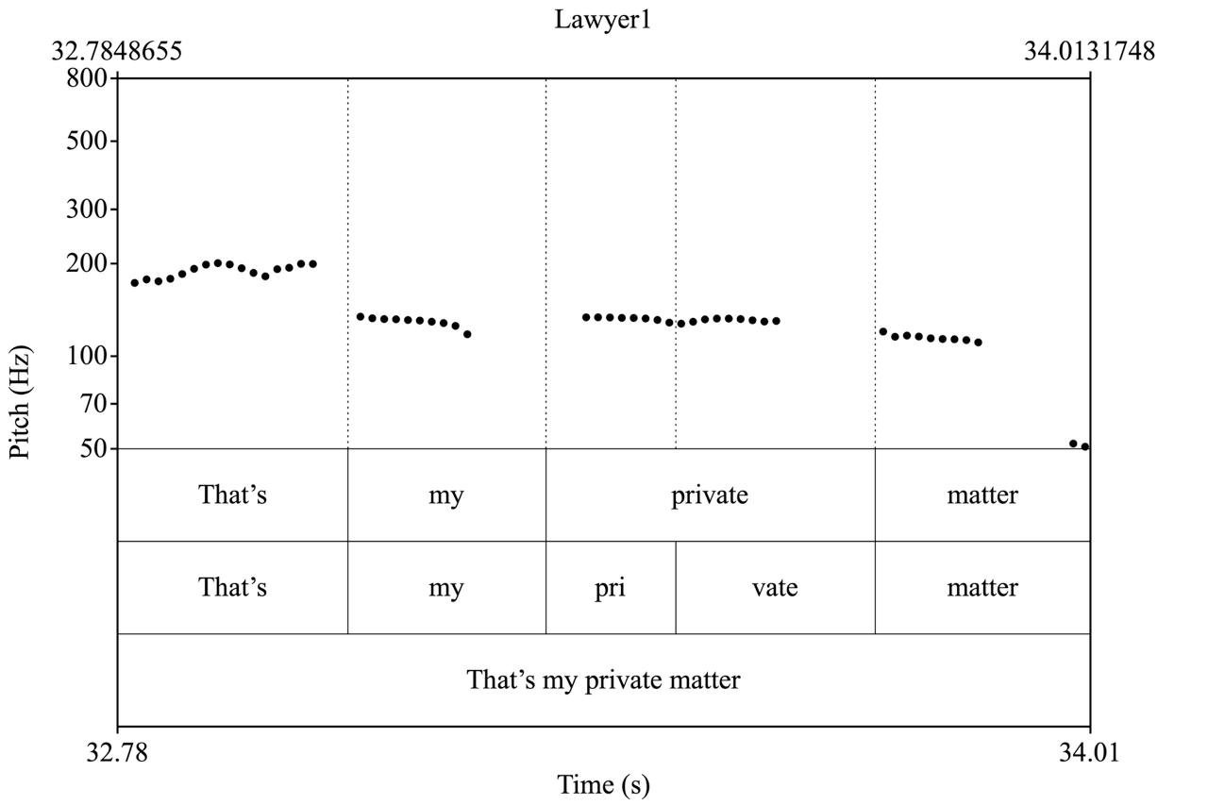

Figure 4 illustrates the acoustic analysis of Mr. A’s statement: "That’s my private matter." The pitch contour shows a low falling tune (L*L%), indicating a low pitch accent followed by a low boundary tone. This intonation pattern reveals discomfort or defensiveness on the part of the speaker. Its persuasive effect is to reduce the speaker's credibility and open room for suspicion, as this shift in intonation can betray the speaker's emotional state and influence perceptions of their testimony.

Figure 5: Respondent's Counsel - Rising Tone (L* H%)
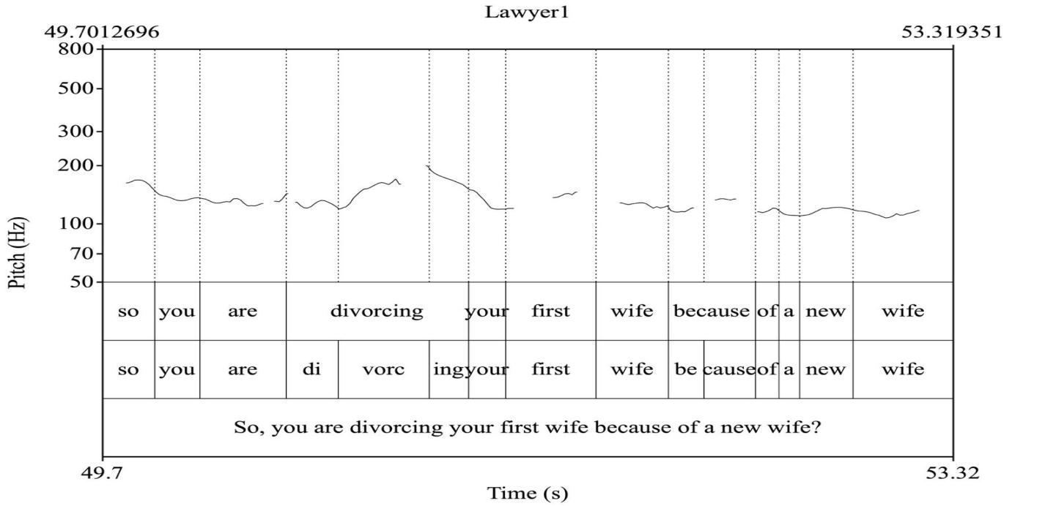
Figure 5 illustrates the acoustic analysis of the Respondent’s Counsel’s question: "So you’re divorcing your first wife because of a new wife?" The pitch contour shows a rising tone (L* H%), indicating a low pitch followed by a rise. This intonation pattern is used to challenge the petitioner’s ethos by implying a hidden, less noble motive. The rhetorical nature of the question, combined with the rising tone, forces the listener to consider the implied accusation, thereby weakening the petitioner’s credibility.

CASE B
Figure 6: Petitioner’s Counsel - Rising intonation (L* H%)
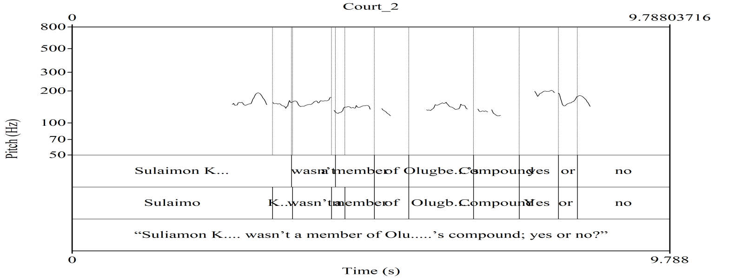
The acoustic representation in Figure 6 illustrates the acoustic analysis of the Petitioner’s Counsel’s question: “Sul…….. Ko……. wasn't a member of Olu……..'s compound; yes or no?” The pitch contour shows a rising tone (L* H%), indicating a low pitch followed by a rise. This intonation pattern is used to challenge the petitioner’s ethos by implying a hidden, less noble motive. The rhetorical nature of the question, combined with the rising tone, forces the listener to consider the implied accusation, thereby weakening the petitioner’s credibility.

Figure 7: Petitioner’s Counsel - Fall-rise Intonation (H* L-H%)
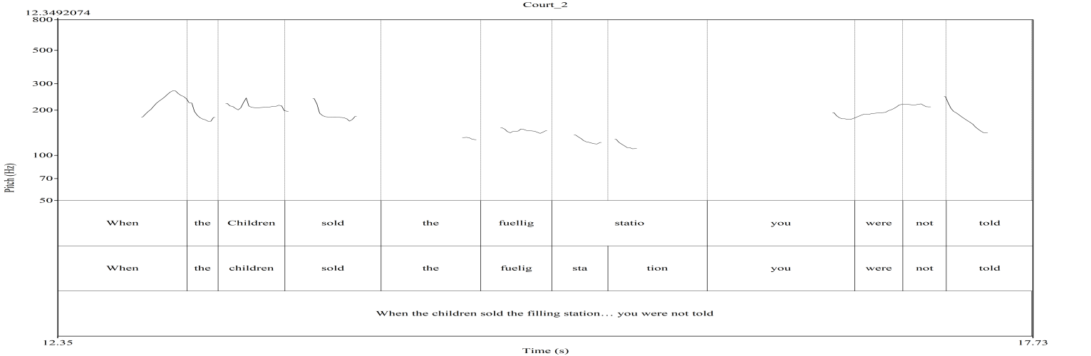

Figure 7 presents the acoustic analysis of the Petitioner’s Counsel’s question: "When the children sold the filling station… you were not told?" The pitch contour reveals a fall-rise intonation (H* L-H%), characterised by an initial high pitch, a fall, and then a final rise. This pattern is strategically used to highlight a contradiction or discrepancy. The initial fall asserts a fact, while the final rise expresses surprise or doubt, implying that the witness should have known about the sale if his claimed family role was genuine. This subtly undermines the witness’s credibility by underscoring the inconsistency between his testimony and the facts.

Figure 8: Baba (Witness) - Falling Tone (L* L%)
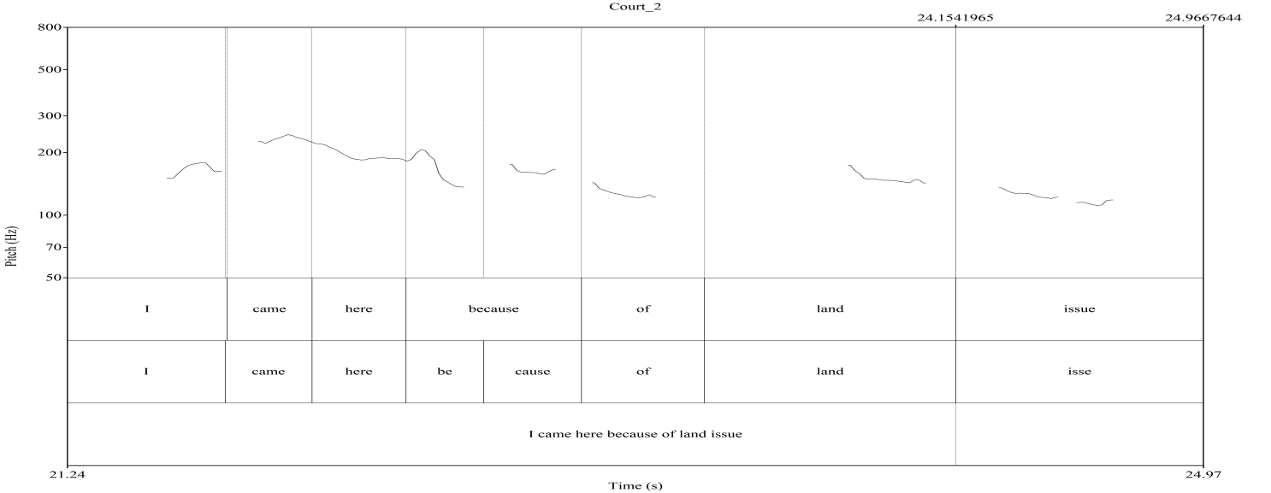

Figure 8 presents the acoustic analysis of Baba’s statement: "I came here because of land issue." The pitch contour shows a falling tone (L*L%), indicating a low pitch accent followed by a low boundary tone. This intonation pattern conveys a sense of focus and control, demonstrating Baba's conscious effort to maintain composure under aggressive questioning. It highlights his attempt to remain calm and focused on the subject matter, even as the questioning becomes aggressive.

Figure 9: Baba (Witness) - Rise-Fall Intonation (L+H* L-L%)
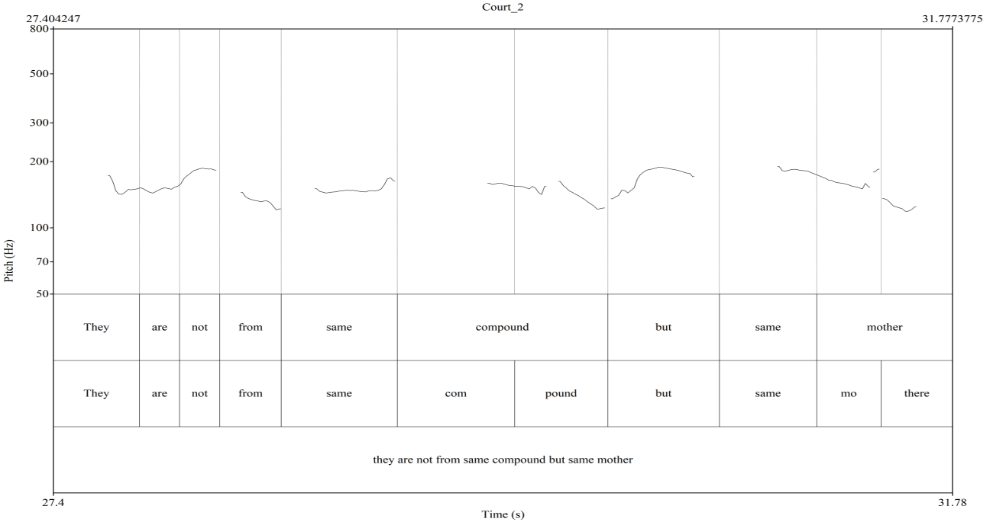

Figure 9 illustrates the acoustic analysis of Baba’s statement: "They are not from same compound but same mother." The pitch contour shows a rise-fall intonation (L+H* L- L%), which highlights a key nuance about maternal ties differing from patriarchal compound membership. This prosodic choice emphasises a crucial distinction, demonstrating how even a seemingly calm witness can use intonation strategically to assert important facts and convey a crucial distinction, potentially under emotional pressure due to the nature of the land dispute.

Figure 10: Respondent's Counsel - Falling Intonation (H*L%)
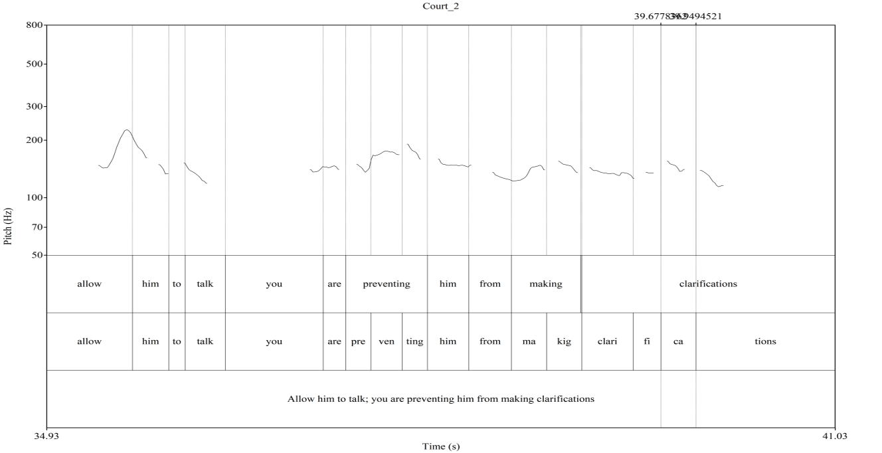
Figure 10 presents the acoustic analysis of the Respondent’s Counsel’s intervention: "Allow him to talk; you are preventing him from making clarifications." The pitch contour shows a falling intonation (H* L%), indicating a high pitch accent followed by a low boundary tone. This intonation pattern serves to reassert courtroom decorum and protect the witness. The falling tone conveys authority and finality, effectively interrupting the petitioner’s counsel’s aggressive questioning and shifting the power dynamic back towards a more balanced exchange. This highlights how intonation can be used not only for persuasion but also for managing the procedural aspects of courtroom interaction.

Discussion of Findings
Research Objective 1: to identify how intonation patterns are used by legal professionals (counsel) to challenge or undermine the credibility of opposing parties or witnesses.

The interactions involving the Respondent's Counsel in the divorce case provide instances of intonation used to challenge credibility. The Respondent's Counsel uses a Rising tone (L* H%) with the rhetorical question "So you're divorcing your first wife because…" The function is "Grammatical – yes/no question and attitudinal challenges formal logic with emotional appeal," and the persuasive effect is to "Weaken petitioner's ethos." This rising intonation on a seemingly simple question is strategically employed to imply a challenge to the petitioner's stated reasons for divorce, subtly questioning his integrity and undermining his credibility by suggesting an ulterior motive. The rhetorical nature of the question, combined with the rising tone, forces the listener to consider the implied accusation. Also, Petitioner's Counsel strategically employs Rising Intonation (L* H%) to exert pressure on the witness, Baba, with the question, "Suliamon Korede wasn't a member of Olugbede's compound; yes or no?" This classic leading question, with its rising tone, signals an expectation of a specific answer, cornering the witness and making it difficult for him to evade or provide a nuanced response. This directly challenges the witness's narrative and implied credibility regarding family membership. Furthermore, Petitioner’s counsel uses a Fall-rise Intonation (H* L-H%) in the question, "When the children sold the filling station… you were not told?" This is a subtle yet powerful way of highlighting a contradiction. The initial fall in pitch asserts a fact, while the final rise expresses surprise or doubt, implying that Baba should have known about the sale if his claimed family role was genuine. This underscores the discrepancy between his testimony and the facts, thereby undermining his credibility. This instance directly demonstrates a sophisticated use of intonation not just to ask a question, but to embed a challenge and erode the opponent's standing in the eyes of the court. The dominance of falling tones in prosecution speech shows that the prosecution lawyer significantly uses falling intonation, particularly at the end of declarative sentences. This pattern aligns with their role of asserting facts, presenting evidence and constructing a narrative of certainty and guilt.

Research Objective 2: to explore the use of intonation patterns by litigants (Petitioners/Respondents) to express defensiveness or moral indignation, and its impact on their perceived credibility

The analysis of both the Petitioner (Mr. A) and the Respondent (Mrs. M) in Case A provides insights into this objective. Petitioner (Mr. A) when stating "That's my private matter," he uses a Falling Tune (L* L%). The function is described as "Attitudinal. It reveals discomfort or defensiveness," leading to the persuasive effect of "Reduces credibility and opens room for suspicion." This instance shows how a litigant's intonation, even when attempting to assert privacy, can inadvertently signal defensiveness, which is then interpreted as a lack of transparency or an attempt to hide something, thereby negatively impacting their credibility. Respondent (Mrs. M), when stating "He brought girlfriends home and stopped giving me housekeeping money," she uses a Rising-falling intonation (L+H*L%). The function is "Attitudinal and accentual, it mixes accusation with emphasis," and the persuasive effect is to "Build pathos and moral indignation." The complex rising-falling contour is used to convey a strong sense of grievance and moral outrage, building empathy for her situation and painting the petitioner in a negative light. In case B, Baba (Witness) uses a Falling Tone (L* L%) in the statement, "I came here because of land issue," conveys a sense of focus and control, an attempt to remain calm under pressure. While not explicitly defensive or indignant, this controlled intonation can influence his perceived credibility by projecting composure in a challenging situation. This demonstrates how intonation can be used to express indignation and garner moral support. These examples directly highlight how litigants' intonational choices, whether intentional or not, can significantly shape perceptions of their honesty and moral standing. The defense lawyers employ a wider range of intonation patterns, including a higher frequency of rising and fall-rise tones. This aligns with their role of questioning the prosecution's case, expressing skepticism, and creating reasonable doubt. Their intonation use/ pattern also varied, reflecting a greater use of emotional appeals and empathetic language.

Conclusion

This research shows that Courtrooms are unique environments where language is a powerful tool in the pursuit of justice. Intonation is more than vocal accessory in courtroom discourse; it is a powerful and integral tool for legal argumentation and persuasion. Through a detailed analysis of intonation patterns in selected Nigerian courtroom proceedings, this research has illustrated the variations in pitch, stress and rhythm that are strategically employed by legal actors to achieve specific communicative and persuasive goals. This study shows a sophisticated use of intonation not just to ask a question, but to embed a challenge and erode the opponent's standing in the eyes of the court. The dominance of falling tones in prosecution speech shows that the prosecution lawyer significantly uses falling intonation, particularly at the end of declarative sentences. This pattern aligns with their role of asserting facts, presenting evidence and constructing a narrative of certainty and guilt. Also, the study findings demonstrate how intonation can be used to express indignation and garner moral support. These examples directly highlight how litigants' intonational choices, whether intentional or not, can significantly shape perceptions of their honesty and moral standing. While the defense lawyers employ a wider range of intonation patterns, including a higher frequency of rising and fall-rise tones. This aligns with their role of questioning the prosecution's case, expressing skepticism, and creating reasonable doubt. Their intonation use/ pattern also varied, reflecting a greater use of emotional appeals and empathetic language.

References
Adegbija, E. (2004). Language and communication in Nigerian law. National Institute for Nigerian Languages.
Akindele J., Akano R., Fabunmi V. & Adetunji E. (2024). Intonation cues in Doctor-patient interactions in South-West Nigeria: Implication for Nigerian Spoken English Medical Discourse. AWIYE Journal of Language, Literature and Communication Studies (AJOLLCS). Department of English and Literary Studies. UNIOSUN. Vol 4 Issue 2
Akindele, J., & Fabunmi, V. (2023). Syllable Isochrony in Selected Nigerian Hip Hops: Implication for Nigerian English Pedagogy. Revue Traduction et Langues22 (1), pp-pp. 374-399
Aldridge, M., & Luchjenbroers, J. (2007). Power and politeness in the courtroom: A discourse analysis of judge-witness interaction. Journal of Pragmatics, 39(12), Pp. 2208- 2228.
Aluko, W. (2020). Syntactic Analysis in the legal language: A case study of some selected Nigerian Court Judgements. Unpublished M.A. dissertation. UNIOSUN.
Anum, A., Mensah, M., & Ofori, S. (2024). Prosodic features and their impact on persuasive communication in Ghanaian courtrooms. Journal of African Legal Studies, 10(1), Pp. 1-20.
Atkinson, J. M. (1984). Public speaking and audience responses: Some techniques for inviting applause. In J. M. Atkinson & J. Heritage (Eds.), Structures of social action: Studies in conversation analysis. Cambridge University Press. Pp. 370-409
Balogun, T. (2017). Issues in discourse studies. Ibadan: Kraft Books Limited.
Boersma, P., & Weenink, D. (2023). Praat: Doing phonetics by computer (Version 6.3.01) [Computer software]. Retrieved from http://www.praat.org/
Bull, P. (2002). Communication under the microscope: The theory and practice of microanalysis. London: Routledge.
Cotterill, J. (2003). Language and power in court: A linguistic analysis of the O.J. Simpson trial. Palgrave Macmillan.
Couper-Kuhlen, E. (1986). An introduction to English prosody. Edward Arnold.
Couper-Kuhlen, E. (2014). Prosody in conversation. In J. K. Local, R. Ogden, & R. Temple (Eds.), Phonetics and phonology in interaction. John Benjamins Publishing Company. Pp. 101-124
Couper-Kuhlen, E., & Selting, M. (2018). Interactional linguistics: Studying language in social interaction. Cambridge University Press.
Coutinho, A., Miranda, F., & Sousa, A. (2023). Phonetic and acoustic analysis of intonational contours in legal questioning strategies. Journal of Forensic Linguistics, 29(1), 45-67.
Coutinho, E., Scherer, K. R., & Pell, M. D. (2023). The effect of prosody on listeners' perceptions in legal contexts. Legal Communication Quarterly, 19(1), Pp. 45–67.
Cutler, A., & Norris, D. (1988). The role of prosody in speech segmentation. Cognition, 32(3), 267–290.
Crystal, D. (1969). Prosodic systems and intonation in English. Cambridge University Press.
Cruttenden, A. (1997). Intonation. Cambridge University Press.
Drew, P. (1990). Strategies in the contest between lawyer and witness in cross- examination. In J. Levi & A. Walker (Eds.), Language in the judicial process. Springer. pp. 39–64
Gibbons, J. (2009). Forensic linguistics: An introduction to language in the justice system. Blackwell Publishing.
Giles, H., & Niedzielski, N. (1998). Language attitudes in the courtroom. In J. Edwards & T. S. McCorkle (Eds.), Language and the law. Dartmouth Publishing Company. pp. 123-145
Gozd́z-́Roszkowski, S. (2021). The role of prosody in constructing credibility in courtroom discourse. Forensic Linguistics International Journal, 12(3), pp. 301–322.
Gumperz, J. J. (1982). Discourse Strategies. Cambridge University Press.Holt, E., & Clift, E. (2007). The interactional management of prosody in courtroom discourse. Journal of Pragmatics, 39(12), Pp. 2185-2207.
Holt, E., & Clift, R. (Eds.). (2007). Reporting talk: Reported speech in interaction. Cambridge University Press.
Jiang, X., & Pell, M. D. (2016). Neural and behavioral evidence for the role of prosody in legal contexts. Neuropsychologia, 91, Pp. 293–301.
Labov, W. (1972). Sociolinguistic patterns. University of Pennsylvania Press.
Leben WR. D. Robert Ladd (1996). Intonational phonology. Cambridge Studies in Linguistics 79. Cambridge: Cambridge University Press. doi:10.1017/S0952675798003546
Ladefoged, P. (2003). Phonetic data analysis: An introduction to fieldwork and instrumental techniques. Blackwell.
Pennington, N., & Hastie, R. (1993). The story model for juror decision making. In R. Hastie (Ed.), Inside the juror: The psychology of juror decision making (pp. 192–221). Cambridge University Press. https://doi.org/10.1017/CBO9780511752896.010
Perelman, C., Olbrechts-Tyteca, L., Wilkinson, J., & Weaver, P. (1969). The New Rhetoric: A Treatise on Argumentation. University of Notre Dame Press. https://doi.org/10.2307/j.ctvpj74xx
Tannen, D. (2005). Conversational style: analyzing talk among friends. New ed. Oxford University Press.
Walton, D. (2006). Fundamentals of Critical Argumentation. Cambridge University Press, Cambridge.

